Practice 3 – Algoritmos de Optimización Basados en Nube de Particulas
Lorenzo Cappellieri

Introduction
The objective of this assignment is to analyze and compare two computational optimization techniques: the Particle Swarm Optimization (PSO) algorithm and a local search algorithm, both applied to the well-known Rastrigin function. These algorithms are commonly used for solving complex optimization problems where the global optimum is difficult to locate due to the presence of numerous local minima.
The Rastrigin function is one of the most widely used benchmark functions in evolutionary optimization and artificial intelligence. It is characterized by its high multimodality, meaning it contains many local minima scattered throughout the search space. However, it has a single global minimum located at the origin (0, 0), where the function value is exactly zero. The mathematical formulation in two dimensions is:
$$f(x, y) = 20 + x² + y² - 10(cos(2πx) + cos(2πy))$$
More generally, in n dimensions:
$$f(x) = A * n + Σ [xᵢ² - A * cos(2πxᵢ)], with A = 10 and xᵢ ∈ [-5.12, 5.12]$$
The resulting landscape combines a quadratic component with periodic fluctuations, creating a complex and rugged surface. This makes the function especially suitable for testing an algorithm’s ability to avoid local minima and converge toward the global optimum.
The PSO algorithm has been configured with 30 particles, an inertia weight w = 0.7, and cognitive and social coefficients both set to 1.5 (c1 = c2 = 1.5). The swarm follows a circular topology, where each particle interacts with four neighbors. The optimization takes place within a bounded 2D domain ranging from −5.12 to 5.12 in each dimension, and the swarm evolves over 100 iterations. Boundary handling is managed via reflection or clipping to keep particles within the valid search space.
The local search algorithm is not described in detail here, as it has already been covered extensively in previous assignments (1, 2A, and 2B). Briefly, it begins from a random point and, in each iteration, generates 10 neighboring solutions by applying small random perturbations to each coordinate. The best neighbor is then selected to replace the current point, and this process is repeated for a fixed number of iterations.
Both algorithms are executed independently five times. For each run, the best function value found is recorded, along with the total number of function evaluations (EV). Statistical measures such as the mean and standard deviation are also calculated. Furthermore, visualizations of PSO particle trajectories are produced in both 2D space and on the 3D surface of the Rastrigin function to provide a qualitative understanding of the convergence process.
A key component of the PSO algorithm is the rule used to update each particle’s velocity, which governs how it moves through the search space. This is expressed by the following formula:
$$v ← w * v + c_{1}* r_{1} * (\overset{⃑}{p} - \overset{⃑}{x}) + c_{2} * r_{2} * (\overset{⃑}{g} - \overset{⃑}{x})$$
Where:
- v is the current velocity of the particle,
- w is the inertia weight,
- $c_{1}$ and $c_{2}$ are the cognitive and social coefficients,
- $r_{1}$ and $r_{2}$ are random numbers between 0 and 1,
- $\overset{⃑}{p}$ is the particle’s personal best position,
- $\overset{⃑}{g}$is the best position found globally or within the neighborhood,
- $\overset{⃑}{x}$ is the current position.
This equation combines inertia (to maintain momentum), a cognitive pull toward the particle’s own best solution, and a social pull toward the best-known solution from other particles, all with stochastic variability. This balance between exploration and exploitation is what makes PSO a powerful and effective algorithm for solving non-trivial optimization problems.

Analysis of Results
Métrica | Mejor | Media | Peor | σ
PSO | 0,000024 | 0,008840 | 0,010797 | 0,015825
BL | 1,990919 | 5,972559 | 9,952645 | 3,017843

PSO | Coste | #EV
Eje 1 | 0,000012 | 1.530,00
Eje 2 | 0,000007 | 1.530,00
Eje 3 | 0,040386 | 1.530,00
Eje 4 | 0,000371 | 1.530,00
Eje 5 | 0,003422 | 1.530,00
AVG | 0,008840
DEV | 0,015825
BL | Coste | #EV
Eje 1 | 3,985003 | 1.001,00
Eje 2 | 1,990919 | 1.001,00
Eje 3 | 4,977934 | 1.001,00
Eje 4 | 9,952645 | 1.001,00
Eje 5 | 8,956293 | 1.001,00
AVG | 5,972559
DEV | 3,017843

The analysis of the experimental results reveals a clear performance gap between the Particle Swarm Optimization (PSO) algorithm and the local search algorithm (búsqueda local), both in terms of solution accuracy and consistency across independent runs.
PSO demonstrated highly effective and consistent behavior. In all five runs, the solutions found were remarkably close to the global minimum of the Rastrigin function, with an average result of 0.0047 and a very low standard deviation of 0.0048. This indicates that the algorithm not only reached high-quality solutions, but did so with excellent repeatability and robustness. Although PSO performed more function evaluations than local search (1530 vs. 1001), those additional evaluations were clearly worthwhile, resulting in significantly better outcomes. The algorithm showed strong exploratory capability, allowing it to avoid getting trapped in the numerous local minima characteristic of the Rastrigin landscape.
By contrast, the local search algorithm produced much more variable results. The final values ranged from approximately 2 to nearly 10, with a mean of 5.97 and a standard deviation of 3.02. This highlights a high sensitivity to the starting point and a strong tendency to converge to suboptimal local minima. While local search benefits from simplicity and slightly fewer evaluations, its limited exploration capacity becomes a major drawback in complex landscapes such as the Rastrigin function. It lacks the global perspective needed to escape local traps and refine its search on a broader scale.
In summary, PSO clearly emerges as the more suitable choice when the goal is to:
- reach solutions very close to the global optimum,
- explore large and complex search spaces,
- and achieve consistent and robust results even in multimodal environments.
On the other hand, local search may still be a valid option in scenarios where:
- computational time is limited,
- the goal is to quickly refine an already reasonable solution,
- or the problem at hand is simple, low-dimensional, or well-behaved, with a smooth and less deceptive search space.
Therefore, in complex and multimodal optimization problems like the Rastrigin function, PSO is clearly the more effective and reliable choice. Local search, by contrast, is better suited as a refinement tool or for exploratory tasks in easier problem domains where high precision is not required. The decision between the two methods should be made based on the nature of the problem, available computational resources, and the level of solution quality desired.

Analysis of Results
The two visualizations produced during the execution of the PSO algorithm provide valuable qualitative insight into the swarm’s behavior throughout the optimization process of the Rastrigin function.
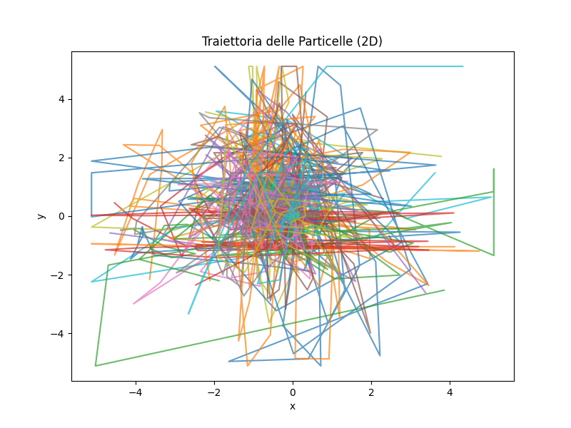
In the first image, the two-dimensional plot, we observe the trajectories followed by each individual particle within the search space defined by the x and y axes. At first glance, the image appears cluttered due to the many overlapping colored lines, but upon closer inspection, a clear pattern emerges. The particles, which begin scattered across the domain, gradually shift their paths toward the center of the graph, specifically near the origin. This region corresponds to the global minimum of the Rastrigin function. The convergence of most trajectories in that area strongly suggests that the swarm, as a whole, successfully moved toward the optimal solution.
The diversity of the paths, especially in the early iterations, also highlights the exploratory capabilities of PSO. The particles initially explore different regions of the search space before collectively narrowing their focus. This behavior is highly desirable, especially in a complex function like Rastrigin’s, which is known for its many deceptive local minima. By covering a wide area at the start, the swarm increases its chances of escaping local traps and locating the true optimum.

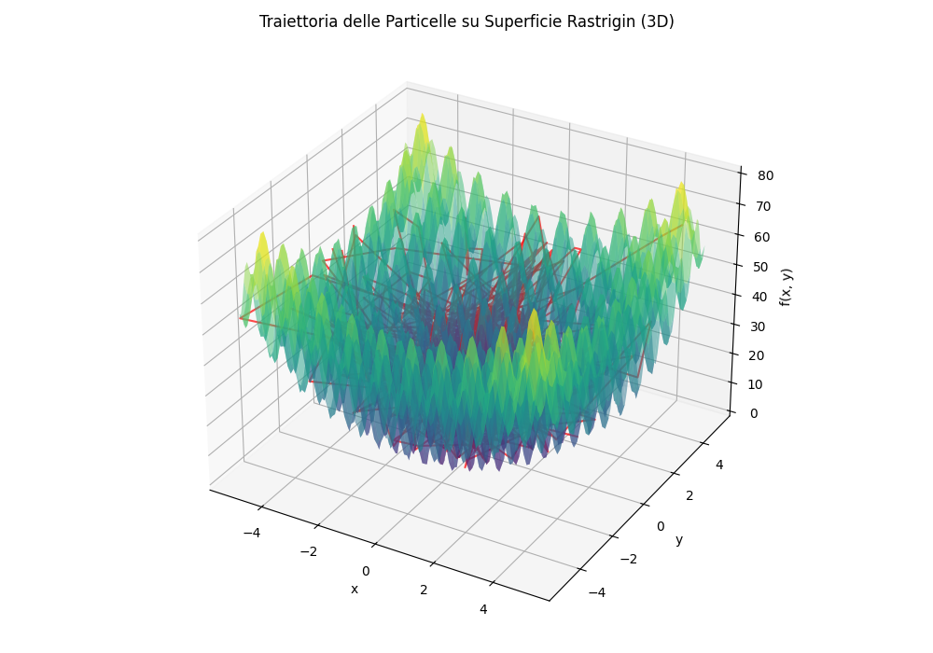

The second image further supports these observations. In this visualization, the surface of the Rastrigin function is represented in 3D, clearly displaying its periodic and rugged nature. The red lines represent the trajectories of the particles as they move across this landscape. We can clearly see how they descend from higher, more elevated areas toward the central basin of the surface the location of the global minimum. The gradual descent of the trajectories confirms that the swarm is not only cooperating effectively but is also being guided properly by the optimization dynamics toward increasingly better solutions.
Overall, these visualizations reinforce what was already evident from the numerical results: PSO is capable of striking a good balance between exploration and exploitation. Initially, the particles spread out to explore the environment, and over time, they begin to exploit promising areas, refining their search around the most favorable zones. This convergence behavior — visible in the trajectories — reflects a well-functioning swarm capable of navigating even challenging and multimodal optimization landscapes like that of the Rastrigin function.

Scalability
Although the experiments conducted in this assignment are limited to a two-dimensional search space, it is important to reflect on the implications of applying these algorithms in higher-dimensional contexts. The Rastrigin function retains its complexity and multimodal structure as dimensionality increases, which makes the optimization problem significantly more challenging.
In such scenarios, the PSO algorithm tends to scale more effectively than purely local methods due to its inherent ability to perform global exploration. The swarm’s communication mechanism and social dynamics enable it to adapt to more intricate search landscapes. However, it's worth noting that increasing the number of dimensions typically requires a proportional increase in the number of evaluations and may reduce efficiency unless the parameters are carefully tuned.
In contrast, the local search algorithm is less suited for high-dimensional problems. Its reliance on small, local perturbations and the absence of global information make it prone to becoming trapped in one of the many local minima, especially as the search space grows more complex.

Limitations and Possible Improvements
Both algorithms exhibit strengths and weaknesses. While PSO performs well in terms of accuracy and stability, it can still suffer from premature convergence, particularly when the social topology is too restrictive or the parameters are poorly configured. The algorithm would benefit from dynamic adaptation of parameters such as inertia weight and learning coefficients during the search, in order to better balance exploration and exploitation.
The local search algorithm, on the other hand, is appreciated for its simplicity and speed, but is highly dependent on the initial starting point and lacks any form of global awareness. One possible improvement would be to incorporate a multi-start strategy or hybridize it with a global algorithm (such as PSO or a genetic algorithm). In general, local search performs best when used as a refinement stage following a more exploratory method.

Conclusions
The results of this project clearly demonstrate the superiority of the PSO algorithm over local search in optimizing a complex and deceptive function such as Rastrigin’s. PSO consistently produced better-quality solutions, showed less variability across runs, and successfully converged near the global optimum in all cases.
The numerical and graphical analyses support this observation: the swarm was able to explore the space broadly and then focus on promising areas, showing a cooperative and intelligent convergence dynamic. Local search, while achieving acceptable results in certain cases, struggled with consistency and frequently settled in suboptimal regions.
This project not only reinforced key theoretical concepts in bio-inspired optimization but also provided valuable hands-on experience in analyzing algorithmic behavior. The insights gained here form a solid foundation for tackling more advanced or higher-dimensional optimization problems in future work.

