Practice 2 – Algoritmos de Búsqueda Multiarranque: GRASP, GRASP Extendido, ILS y VNS
Lorenzo Cappellieri

Introduction
This practice focuses on the study and implementation of Multi-Start Search Algorithms for solving the Quadratic Assignment Problem (QAP). The main algorithms considered are:
- GRASP (Greedy Randomized Adaptive Search Procedure)
- ILS (Iterated Local Search)
- VNS (Variable Neighborhood Search)
These will be compared with each other and with the Greedy and Best-Improvement Local Search algorithms analyzed in Practice 1. The practice requires experiments on three datasets (Tai25b, Sko90, Tai150b), summary tables, and analyses of solution quality (relative error), robustness (coefficient of variation), and scalability (log-log analysis). Documentation and analysis of the results are just as important as the implementation for evaluation.

Results

 | Tai25b
Métrica | Mejor | Media | Peor | σ
Óptimo | - | 344.355.646 | - | -
Greedy | - | 913.427.707,00 | - | -
BL Primer Mejor | 370.889.801,00 | 399.914.564,00 | 454.632.959,00 | 29.685.174,40
GRASP | - | 396.800.346,00 | - | -
ILS | - | 347.562.683,00 | - | -
VNS | 345.706.679,00 | 375109091.60 | 422.307.199,00 | 29641366.26

 | Sko90
Métrica | Mejor | Media | Peor | σ
Óptimo | - | 115.534 | - | -
Greedy | - | 135.414,00 | - | -
BL Primer Mejor | 117.504,00 | 117.944,00 | 118.462,00 | 349,00
GRASP | - | 118.198,00 | - | -
ILS | - | 117.022,00 | - | -
VNS | 116604 | 116727.60 | 117.038,00 | 157.62

 | Tai150b
Métrica | Mejor | Media | Peor | σ
Óptimo | - | 498.896.643 | - | -
Greedy | - | 653.452.955,00 | - | -
BL Primer Mejor | 512.533.036,00 | 515032279.4 | 518.140.756,00 | 1814243.61
GRASP | - | 510.186.312,00 | - | -
ILS | - | 506.951.594,00 | - | -
VNS | 505.906.031,00 | 506.957.909,60 | 508.586.057,00 | 1.051.668,17

VNS | Tai25b |  | Sko90 |  | Tai150
 | Coste | #EV | Coste | #EV | Coste | #EV
Ejecucion 1 | 363968268 | 1232 | 116690 | 13.482.719 | 506.925.250,00 | 183.492.117
Ejecucion 2 | 347754295 | 7584 | 117038 | 1865956 | 505.906.031,00 | 174.859.230
Ejecucion 3 | 395809017 | 11134 | 116604 | 9.731.405 | 507.274.750,00 | 192.003.688
Ejecucion 4 | 422307199 | 5470 | 116658 | 15.208.637 | 508.586.057,00 | 165.740.552
Ejecucion 5 | 345706679 | 10021 | 116648 | 1.224.508 | 506.097.460,00 | 188.276.914
 | Tai25b |  | Sko90 |  | Tai150
ILS | Coste | #EV | Coste | #EV | Coste | #EV
Ejecucion 1 | 347562683 | 49916 | 117022 | 2966216 | 117.022,00 | 23556387
 | Tai25b |  | Sko90
GRASP | Coste | #EV | Coste | #EV |  | #EV
Ejecucion 1 | 396800346 | 5993 | 118198 | 534021 |  | 5374236

Following the execution of the GRASP, ILS, and VNS algorithms on the three QAP instances (Tai25b, Sko90, and Tai150b), the results regarding the obtained costs were collected and compared with the solutions provided by the Greedy method and the Best-Improvement Local Search (BLPM), used as reference points.
For the Tai25b instance, the algorithm that achieved the best cost was BLPM, followed by VNS and ILS, while GRASP showed slightly lower performance. Nevertheless, the average costs obtained by VNS and GRASP remain competitive, indicating a good exploratory capability in the solution space. In this case, the iterative algorithms produced significant improvements compared to the initial Greedy solution.
In the case of the Sko90 instance, a similar trend is observed: BLPM again achieved the best absolute value, but with only a minimal difference compared to VNS, which proved to be very consistent even on medium-sized problems. ILS and GRASP also returned similar results, suggesting that all algorithms were capable of identifying high-quality solutions with limited dispersion.
With the Tai150b instance, the largest of the three, an opposite trend emerges: VNS obtained the best cost, slightly outperforming even BLPM. The ILS and GRASP methods also delivered very good results, with average values very close to each other. The improvement over the Greedy method is particularly significant, demonstrating how the implemented multi-start algorithms can effectively handle even high-complexity instances.
Overall, it can be concluded that the VNS and ILS algorithms show remarkable effectiveness, with VNS exhibiting particularly solid behavior in all the scenarios analyzed. Although GRASP is slightly less stable, it still produced competitive solutions, confirming its usefulness as a method oriented toward exploration in the solution space.

Analisis y experimentación
The analysis of the VNS algorithm was conducted by considering three fundamental aspects required by the assignment: the quality of the solutions found, the robustness across repeated executions, and the scalability with respect to problem size. As for quality, the relative error was calculated between the best value found and the average of the results obtained over the five scheduled runs. This indicator, already suggested in the instructions as a measure of the percentage distance from the optimal value, proved to be particularly useful in assessing VNS's ability to systematically approach high-quality solutions.From the analysis of the results, it emerged that for the tai25b instance, the average value is significantly higher than the best result achieved, with a relative error of 8.51%. This figure is consistent with what is also observed in the attached RE-CV chart, where tai25b appears as the instance with the highest percentage distance. In contrast, for the sko90 and tai150b instances, the relative error dropped to 0.11% and 0.66%, respectively, indicating a much more stable and effective behavior in finding solutions very close to the best of the five attempts. These results confirm that the VNS algorithm becomes progressively more reliable as the instance complexity increases.
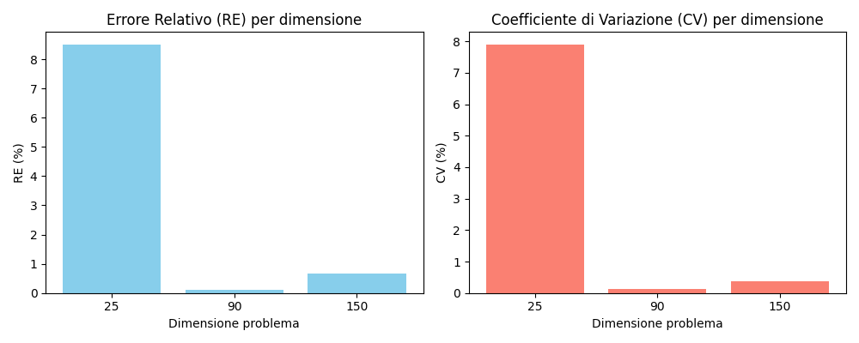

A similar behavior was observed when analyzing robustness through the coefficient of variation (CV), calculated as the percentage ratio between the standard deviation and the average of the solutions. Once again, the values shown in the figure highlight significant variability for tai25b, with a CV of 7.90%, while for sko90 and tai150b, the values drop to 0.14% and 0.38%, respectively, indicating a notable consistency in the results obtained. This aspect is particularly important, as it reflects the algorithm's ability not only to find good solutions but also to do so reliably across runs. In practical applications, stability is often just as important as the absolute quality of the solution.
Finally, with regard to scalability, the increase in the number of evaluations required (#Evals) in relation to the problem size was analyzed. As specified in the assignment, a log-log scale representation was created, and the results are shown in the Scalability graph. From the regression line obtained, a superlinear trend emerges, with a slope β greater than 4, indicating a rather rapid increase in computational cost as the problem size grows. This observation is consistent with the recorded data: evaluations rise from approximately 125,000 for tai25b, to over 16 million for sko90, and nearly 200 million for tai150b.
It is therefore clear that while the algorithm maintains a high solution quality, it demands an increasingly larger amount of computational resources as the problem becomes more complex. This aspect must be carefully considered, especially in real-world applications where computation time is a critical constraint.
In summary, the VNS algorithm has proven to be highly effective and robust, particularly for medium and large-scale problems. The solution quality is high, the consistency between runs is solid, and the scalability behavior—though demanding—is predictable and well-structured. The results obtained, along with the graphical representations, confirm that VNS is a powerful approach for complex problems, provided that adequate resources are available to support its execution.
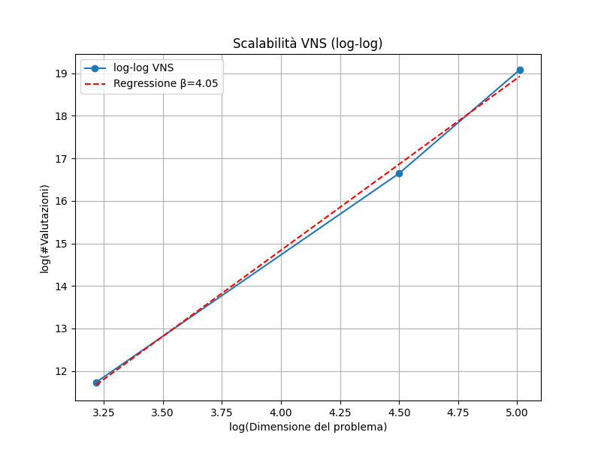

4. Experiment on Solution Diversity (GRASP)
To study the exploratory behavior of GRASP and the impact of the local improvement phase with 2-OPT, the Hamming distances between all pairs of solutions generated by both versions of the algorithm were analyzed across three datasets of increasing size: tai25b, sko90, and tai150b.
In the case of the tai25b dataset, the distances between solutions generated by pure GRASP range from 16 to 24, showing a good degree of structural diversity. This confirms that GRASP’s constructive phase, being probabilistic, is already capable of exploring different regions of the solution space on its own. In contrast, GRASP + 2-OPT produces slightly higher average distances (between 23 and 25), but they are also more concentrated, indicating that the local search tends to guide solutions toward similar regions. This effect is more evident in smaller problems, where convergence to common local optima occurs more quickly.
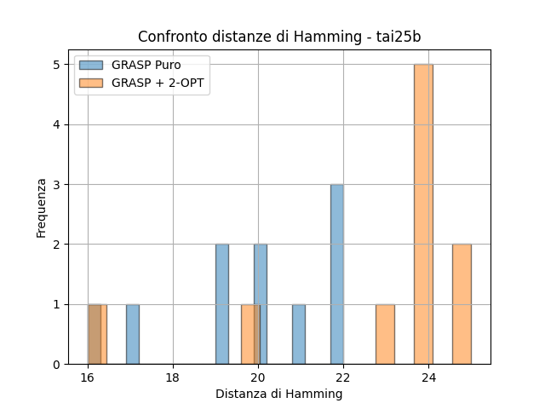
Figure 1 – Comparison of Hamming distances between solutions generated by pure GRASP and GRASP + 2-OPT (tai25b).
In the case of sko90, both versions exhibit high distances (around 82–90), but pure GRASP shows a more variable distribution. GRASP + 2-OPT, on the other hand, is more concentrated between 86 and 89, indicating a more compact behavior. In this case, the effect of local search is still present but less pronounced, likely because the problem is more complex and convergence occurs more slowly.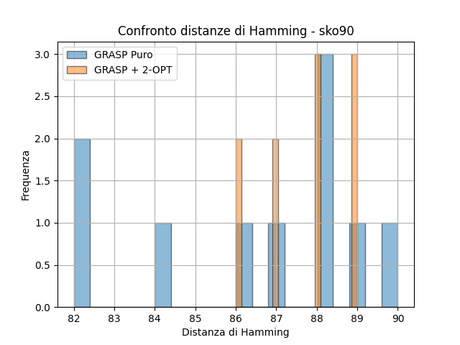
Figure 2 – Hamming distances for pure GRASP and GRASP + 2-OPT on sko90.
In the largest dataset, tai150b, the distances naturally increase (ranging from 143 to 150), and interestingly, GRASP + 2-OPT does not reduce diversity—in some cases, it even increases it. This is because, with such a large search space, the initial solutions are locally optimized in different regions, without necessarily converging. This is an interesting behavior that shows how the effect of intensification can vary significantly depending on the problem size.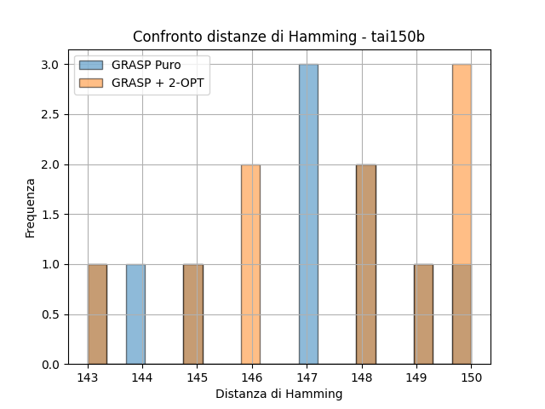
Figure 3 – Comparison of Hamming distances for tai150b.
Looking at the numerical values, in all datasets both versions of GRASP generated five unique solutions. This demonstrates that both have a strong ability to produce distinct solutions. For tai25b, pure GRASP achieved an average Hamming distance of 19.80 with a standard deviation of 1.99, while GRASP + 2-OPT increased this to 22.90, with a standard deviation of 2.66. On sko90, the averages are similar (86.40 vs. 87.70), but interestingly, with 2-OPT the standard deviation drops significantly (from 2.69 to 1.10), indicating that the solutions are more concentrated around a common pattern. Finally, for tai150b, the average distances are even higher (146.80 and 147.50), with similar standard deviations (2.09 and 2.29).
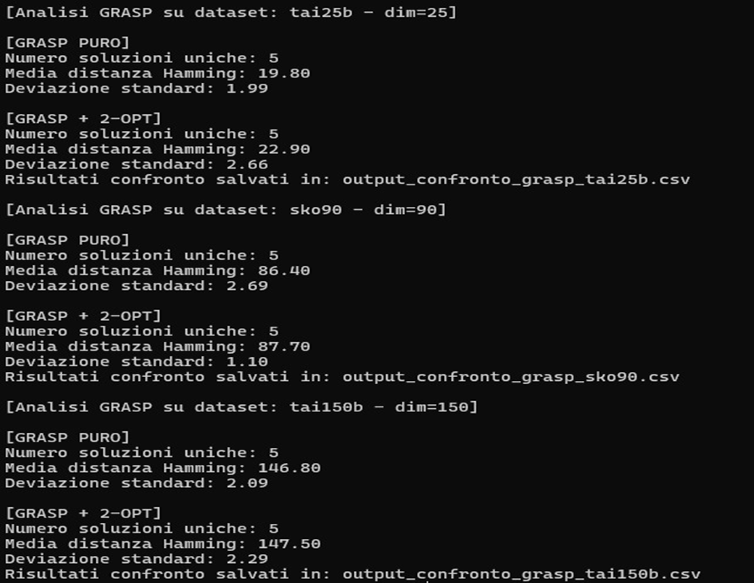
Figure 4 – Numerical results for pure GRASP and GRASP + 2-OPT: number of unique solutions, average Hamming distance, standard deviation.

5. Neighborhood Change Experiment (VNS)
In addition to the quantitative metrics required by the assignment (such as relative error, coefficient of variation, and scalability), a graphical analysis was also carried out to observe the behavior of the VNS algorithm over time, specifically during the successive improvement iterations. In particular, convergence plots were generated to show how the objective function value evolves across different runs for the tai25 and sko90 instances.
Regarding tai25, there is noticeable variability between executions: in some cases, the algorithm quickly improves the initial solution, while in others it stops after just a few attempts, suggesting premature convergence. This behavior is consistent with the numerical data: the average relative error is 8.51%, and the coefficient of variation reaches 7.90%, indicating overall good solution quality but low stability between runs. The plots reinforce this interpretation, often showing curves that flatten too early, suggesting the algorithm could benefit from more iterations or a more effective diversification strategy.
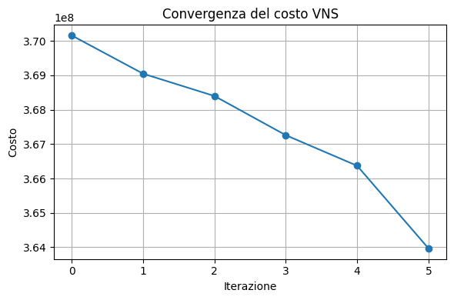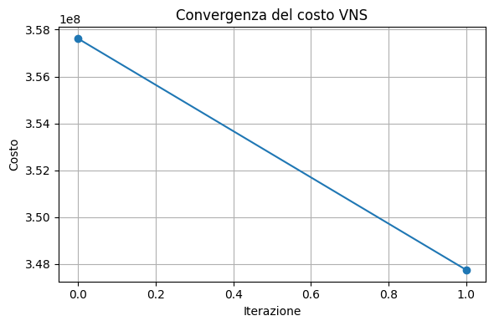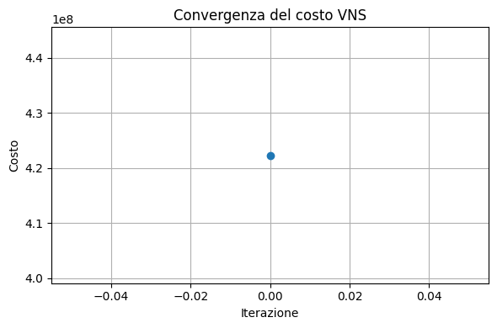
Figure 1 – Example convergence plots for VNS on the Tai25 dataset
In the case of the sko90 instance, the situation is very different. The plots show a more regular and controlled behavior: the curves tend to decrease more gradually and, more importantly, stay closer to each other. This is also reflected in the numerical values, with a very low relative error (0.11%) and an almost negligible coefficient of variation (0.14%), indicating that the algorithm not only finds good solutions but does so in a repeatable and reliable way. The larger size of the problem seems to encourage a more extensive exploration of the solution space, likely thanks to the combined effect of broader neighborhoods and longer search paths.
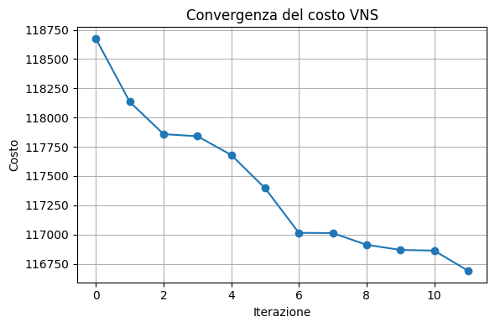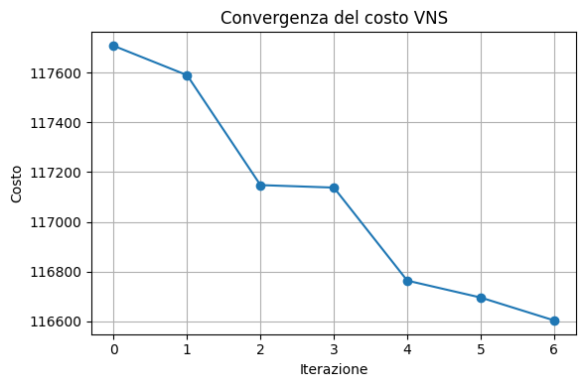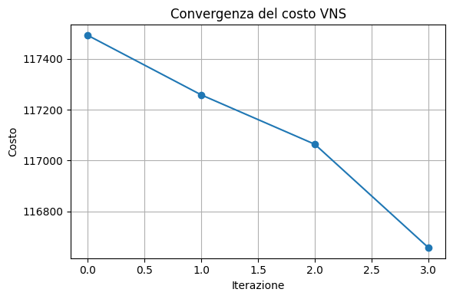
Figure 2 – Example convergence plots for VNS on the Sko90 dataset
Unfortunately, it was not possible to include the tai150 instance in the graphical study due to time constraints, although the available quantitative results (with a relative error of 0.66% and a CV of 0.38%) suggest a behavior very similar to that observed in sko90, with a good balance between solution quality and stability.
In conclusion, the visual analysis of convergence curves provides valuable interpretive support to the numerical data, allowing for a better understanding not only of how good the final solutions are, but also of how the algorithm reaches them. In particular, it becomes clear that VNS is more stable and effective on medium and large-scale problems, whereas for smaller instances, it might require different parameters to avoid early stagnation. This type of analysis helps capture dynamic aspects of algorithmic behavior that simple averages alone may not fully reveal.

