Practice 2b – Algoritmos Evolutivos I: Genéticos
Lorenzo Cappellieri

Introduction
This project focuses on the study and implementation of evolutionary algorithms, with particular emphasis on genetic algorithms. We will explore in depth some of their key features, also comparing them with a previously studied algorithm: the Greedy algorithm.
The algorithms we will examine include:
- The basic genetic algorithm, which will help us understand the limitations and typical behavior of genetic algorithms.
- The CHC algorithm (Cross-generational elitist selection, Heterogeneous recombination, and Cataclysmic mutation), which consists of three main components:
  - Cross-generational elitist selection: preserves the best individuals (solutions) from one generation to the next, promoting the retention of high-quality solutions.
  - Heterogeneous recombination: recombination occurs only between individuals that are sufficiently different from each other, in order to prevent premature convergence (i.e., when the population becomes too similar too early).
  - Cataclysmic mutation: if the evolutionary process stagnates (i.e., no improvements are observed after many generations), a drastic mutation is applied to the population to restore genetic diversity.
- The multimodal genetic algorithm, which uses a niching approach: the population is divided into niches or subgroups, each focusing on different areas of the solution space. This strategy allows the algorithm to explore multiple local optima simultaneously.

Results
 | Tai25b
Métrica | Mejor | Media | Peor | σ
Óptimo | - | 344.355.646 | - | -
Greedy | - | 913.427.707,00 | - | -
AGB | 416.064.741,00 | 443909595.40 | 472.402.906,00 | 21921945.22
CHC | 375.342.652,00 | 392151912.40 | 433.989.792,00 | 24255433.89
MMGA | 379.819.176,00 | 394514998.40 | 404.378.194,00 | 10444880.82
 | Sko90
Métrica | Mejor | Media | Peor | σ
Óptimo | - | 115.534 | - | -
Greedy | - | 135.414,00 | - | -
AGB | 124.884,00 | 125660.00 | 127.196,00 | 902.42
CHC | 902.42 | 129654.80 | 130.088,00 | 491.76
MMGA | 125.056,00 | 125611.60 | 126.024,00 | 399.02
 | Tai150b
Métrica | Mejor | Media | Peor | σ
Óptimo | - | 498.896.643 | - | -
Greedy | - | 653.452.955,00 | - | -
AGB | 558.589.084,00 | 563294861.60 | 570.635.479,00 | 5060686.68
CHC | 605.381.825,00 | 607907792.60 | 610.300.969,00 | 1763796.46
MMGA | 558.124.318,00 | 569308336.60 | 575.599.525,00 | 6850644.53

AGB | Tai25b |  | Sko90 |  | Tai150
 | Coste | #EV | Coste | #EV | Coste | #EV
Eje 1 | 416.064.741,00 | 190.190,00 | 125.166,00 | 190.190,00 | 559.502.914,00 | 190.190,00
Eje 2 | 472.402.906,00 | 190.190,00 | 124.884,00 | 190.190,00 | 570.635.479,00 | 190.190,00
Eje 3 | 437.447.253,00 | 190.190,00 | 125.436,00 | 190.190,00 | 561.489.629,00 | 190.190,00
Eje 4 | 435.060.273,00 | 190.190,00 | 127.196,00 | 190.190,00 | 558.589.084,00 | 190.190,00
Eje 5 | 458.572.804,00 | 190.190,00 | 125.618,00 | 190.190,00 | 566.257.202,00 | 190.190,00
CHC | Tai25b |  | Sko90 |  | Tai150
 | Coste | #EV | Coste | #EV | Coste | #EV
Eje 1 | 375.342.652,00 | 10.450,00 | 130.088,00 | 10.500,00 | 607.869.910,00 | 10.500,00
Eje 2 | 392.309.259,00 | 10.450,00 | 129.850,00 | 10.500,00 | 608.393.196,00 | 10.500,00
Eje 3 | 380.814.655,00 | 10.450,00 | 128.818,00 | 10.500,00 | 605.381.825,00 | 10.500,00
Eje 4 | 433.989.792,00 | 10.450,00 | 129.858,00 | 10.500,00 | 610.300.969,00 | 10.500,00
Eje 5 | 378.303.204,00 | 10.450,00 | 129.660,00 | 10.550,00 | 607.593.063,00 | 10.500,00
MMGA | Tai25b |  | Sko90 |  | Tai150
 | Coste | #EV | Coste | #EV | Coste | #EV
Eje 1 | 402.461.603,00 | 50.050,00 | 125.056,00 | 50.050,00 | 575.599.525,00 | 50.050,00
Eje 2 | 379.819.176,00 | 50.050,00 | 125.932,00 | 50.050,00 | 558.124.318,00 | 50.050,00
Eje 3 | 398.208.503,00 | 50.050,00 | 125.382,00 | 50.050,00 | 570.100.175,00 | 50.050,00
Eje 4 | 387.707.516,00 | 50.050,00 | 125.664,00 | 50.050,00 | 574.007.221,00 | 50.050,00
Eje 5 | 404.378.194,00 | 50.050,00 | 126.024,00 | 50.050,00 | 568.710.444,00 | 50.050,00

The analysis of the results obtained shows significant differences in the performance of the various genetic algorithms tested. The evaluation was based on four main metrics: best solution obtained, average value, worst solution, and standard deviation (σ), offering a complete overview of both absolute quality and algorithm robustness.
Tai25b
For this instance, the CHC algorithm achieved the best average value (392,151,912), getting closest to the known optimum. However, the MMGA algorithm stood out for its stability, with the lowest standard deviation (10,444,880) and a good average (394,514,998), showing consistent behavior across runs. In contrast, AGB, despite achieving a strong best-case result (416,064,741), had the highest variance, suggesting less reliable outcomes.
Sko90
In this instance, all genetic algorithms outperformed the Greedy approach in terms of average quality. The MMGA algorithm achieved both the best solution (125,056) and the lowest average (125,611.60), also with the lowest standard deviation (σ = 399.02), again demonstrating strong robustness. The CHC algorithm presents an anomalous “best” value (902.42), likely due to a formatting or computational error, but even disregarding this, it showed greater instability. AGB delivered intermediate performance regarding both average and variance.
Tai150b
This larger and more complex instance challenges the scalability of the algorithms. Here, the AGB algorithm yielded the most homogeneous results, with the lowest standard deviation (5,060,686) and a good best-case result (558,589,084). However, MMGA produced the best average (569,308,336), showing a slight superiority in overall quality. CHC performed the worst, with the highest average (607,907,792) and the largest variance.
General Considerations
Overall, the genetic algorithms tested clearly outperformed the Greedy approach in both solution quality and stability, strongly justifying the use of evolutionary methods for complex problems like QAP.
Among the evolutionary models:
- MMGA proved to be the most balanced and robust, showing strong average performance and low variability across all instances.
- CHC was effective in specific cases but suffered from higher instability and, at times, produced results farther from the optimum.
- AGB showed potential, especially on large instances like Tai150b, but its high variance in some cases makes it less consistently reliable.
In summary, MMGA stands out as the most solid and versatile choice among the evolutionary algorithms considered, while AGB and CHC can be valid alternatives in specific scenarios or with further tuning.
Among the evolutionary algorithms, MMGA turned out to be the most consistent overall. It performed well on average and showed low variability across all problem instances, which makes it a reliable choice. CHC gave good results in some cases but was less stable, and sometimes its solutions were quite far from the optimal. AGB showed promise, especially with larger problems like Tai150b, but the results varied a lot between runs, so it's not always dependable.
To sum up, MMGA seems to be the best all-around option, while AGB and CHC could still be useful in specific situations, for example in situations where there are no time or resource constraints.

Analysis of Genetic Algorithm Parameters
This study explored how key parameters in a basic Genetic Algorithm affect its performance. Through experimentation with mutation probability, population size, and tournament selection pressure, it became clear that these settings can significantly influence both the quality of solutions and the computational cost of obtaining them.
While there are optimal values for each parameter, the performance differences are not always dramatic, meaning that in many cases, one can trade a slight drop in solution quality for faster or more efficient execution. This is especially useful in resource-constrained environments or time-sensitive applications.
Tuning these parameters with respect to the problem size and available resources is a practical and effective approach for building genetic algorithms that are not only robust but also adaptable.
Mutation Probability
Tests were conducted on the SKO90 dataset, using mutation rates ranging from 2% to 10%. The best performance was observed at 6%, which yielded the lowest average cost (124,442). Rates below this, particularly 2%, didn’t inject enough diversity into the population, often leading to early convergence and suboptimal solutions. On the other hand, higher mutation rates like 8% or 10% tended to degrade solution quality—likely due to excessive disruption of promising genetic patterns.
Overall, a mutation rate in the 5–6% range appears to strike the best balance between exploration and preservation of good structures. That said, if computational resources are constrained, slightly lower values (e.g., 4%) might be a reasonable compromise. While they don’t perform quite as well, the difference isn’t dramatic, and the savings in execution time and complexity could justify the trade-off.
Population Size
Population size was varied from 5 to 200 individuals across three datasets: tai25b, sko90, and tai150b. In each case, the best average costs were achieved with relatively large populations: 200 for tai25b, 185 for sko90, and 195 for tai150b.
These results support the idea that larger populations improve genetic diversity, allowing the algorithm to explore the solution space more thoroughly. This benefit becomes even more important in large and complex instances, such as tai150b, where broader search is essential to avoid premature convergence.
That said, the difference in performance between the best population sizes and slightly smaller ones (e.g., 150–170 individuals) wasn’t always huge. Therefore, in cases where runtime or memory is a concern, opting for a moderately large population—rather than the maximum possible—can still lead to solid results while reducing the computational burden.
Tournament Selection Parameter (k)
The selection pressure introduced by tournament size (k) was also tested, with values from 5% to 50%. Results varied depending on the dataset:
- On tai25b, the best results were with a small tournament (5%), which helped maintain population diversity.
- For sko90, a mid-range value (30%) worked best, offering a good mix of exploitation and exploration.
- In the case of tai150b, the best results were achieved with a high k (50%), where stronger selection helped accelerate convergence.
These findings suggest that the optimal k depends on the problem’s scale and complexity. In simpler problems, less aggressive selection avoids convergence to local optima too quickly. For harder problems, a higher selection pressure can speed up progress without harming diversity too much.
It’s also worth noting that in some cases—particularly sko90—the differences between the best k values were fairly small. So, when resources or runtime are limited, using a lower k may still be acceptable, especially if it simplifies the implementation or reduces overhead from repeated comparisons.

CHC
The CHC algorithm (Cross-generational elitist selection, Heterogeneous recombination, and Cataclysmic mutation) is a variant of the genetic algorithm designed to preserve diversity and delay convergence. Although originally intended for binary representations, in this practice the CHC algorithm was adapted to work with permutation-based chromosomes, using a distance metric based on the number of differing positions (Hamming distance). The algorithm avoids mutation entirely. Instead, it uses a recombination-only strategy, where only parents with a sufficient Hamming distance (greater than a dynamic threshold) are allowed to mate. This threshold starts at L/4 (with L being the chromosome length) and decreases when no new offspring are accepted, encouraging broader mating early on and stricter mating later. When the population stagnates (i.e., the threshold reaches 0 and no offspring are accepted), the algorithm performs a restart: the best individual found so far is preserved, and the rest of the population is reinitialized randomly. This mechanism allows CHC to escape local optima and restart the search with new diversity.

Down here there is a detailed analysis of the convergence behavior of the CHC Genetic Algorithm on the datasets. Each chart represents the cost (fitness) of the best individual across consecutive improvements during a single execution. A total of five runs are shown and individually discussed to highlight patterns of convergence, diversity management, and effectiveness of restarts.

Chc Tai25B Run1
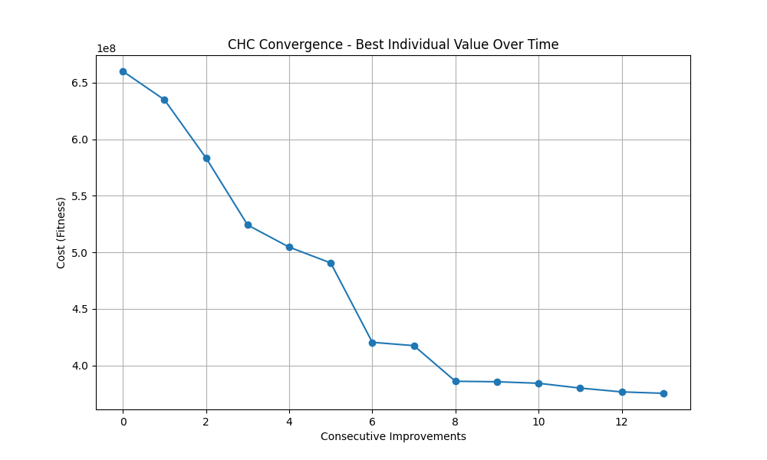
Run 1: Shows steady, consistent improvement over 13 iterations. The initial phase is highly productive, and the curve flattens gradually, indicating a balanced convergence process. Effective diversity management without abrupt restarts. A strong example of progressive convergence.

Chc Tai25B Run2
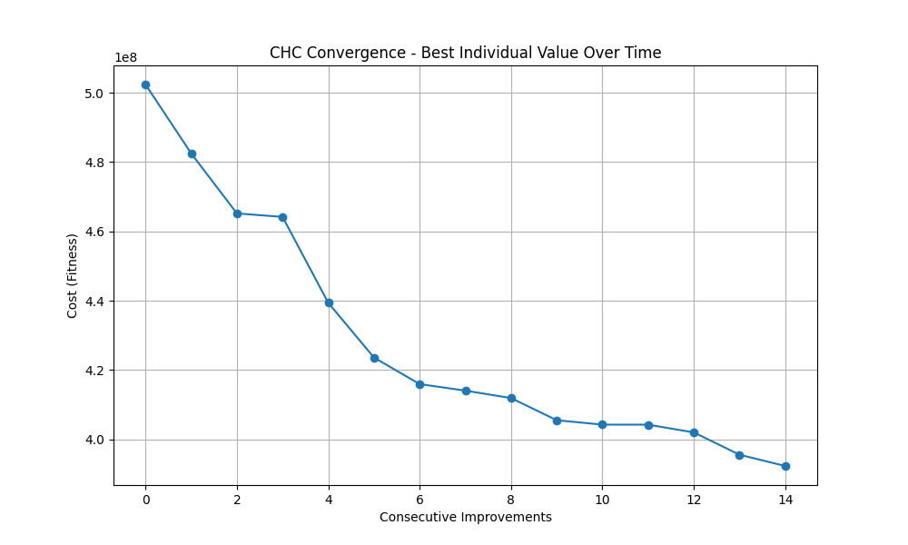
Run 2: One of the most efficient examples. Sharp improvements occur early, followed by a few plateaus. Two distinct sharp drops highlight successful restarts that escape local minima. A clear example of CHC’s restart strategy at work.

Chc Tai25B Run3
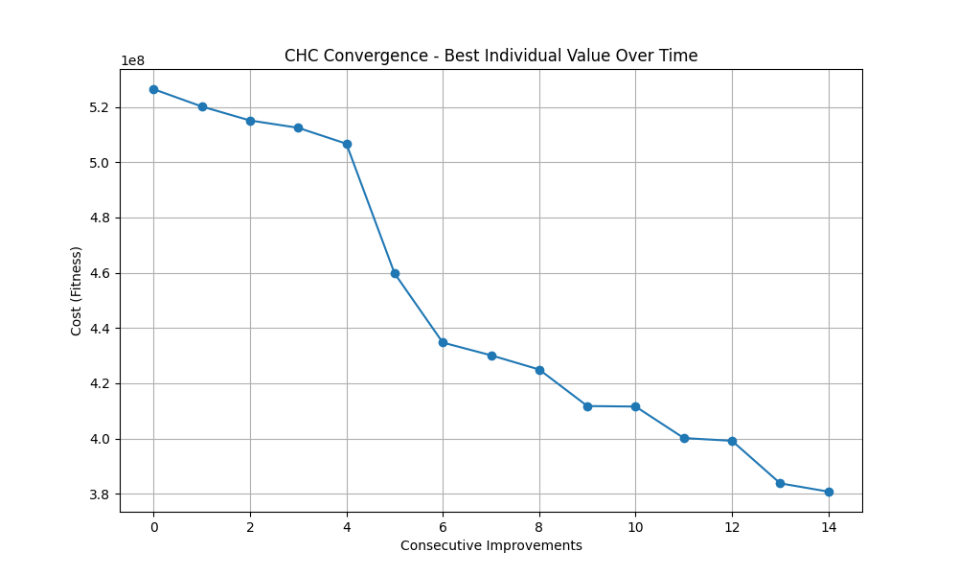
Run 3: Starts off slower but achieves consistent progress across 14 improvement steps. Improvements are smaller but steady, showing a less dramatic but stable convergence. Useful as a baseline run without major restarts.

Chc Tai25B Run4
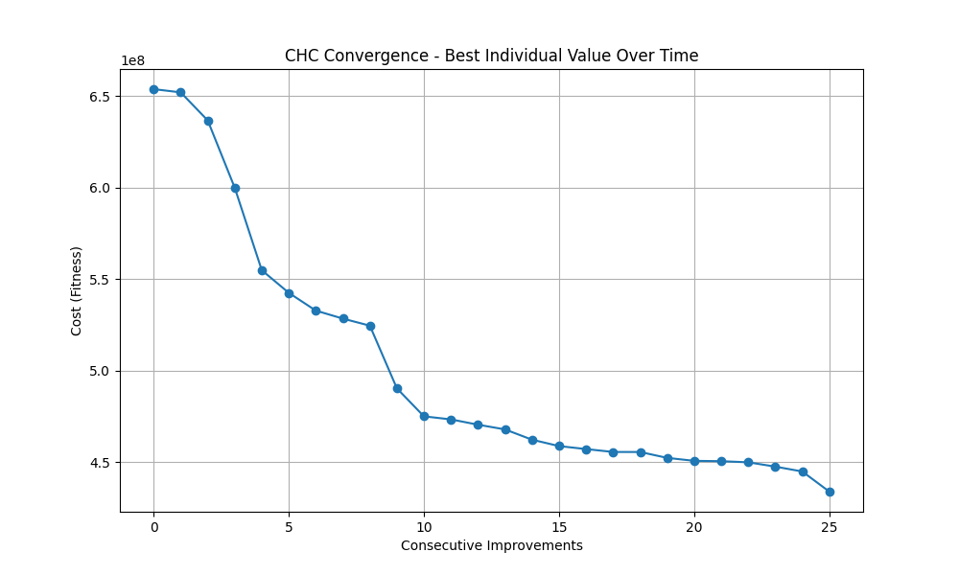
Run 4: Exhibits a relatively flat curve in the early phase. Some progress is made in the second half, but overall improvement is less pronounced. Represents a slower convergence and less impactful restart behavior.

Chc Tai25B Run5
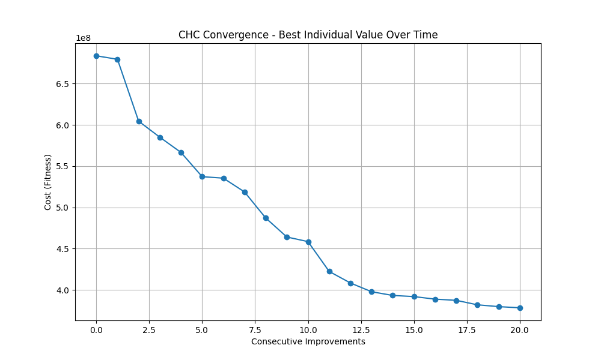
Run 5: Contains significant noise early on, with many small improvements. Although it records 25 improvements, the path to convergence is less clean and more erratic. Indicates persistent search, but with reduced clarity in restart effect.

Chc Sko90 Run1
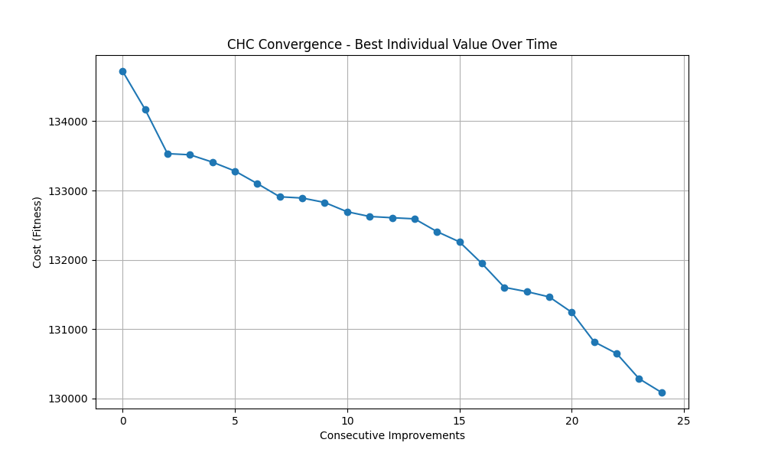
Run 1: A smooth and consistent improvement path with 13 total iterations. Notable gains in the middle suggest turning points in the search. Represents a well-balanced execution with effective convergence without major stagnation.

Chc Sko90 Run2
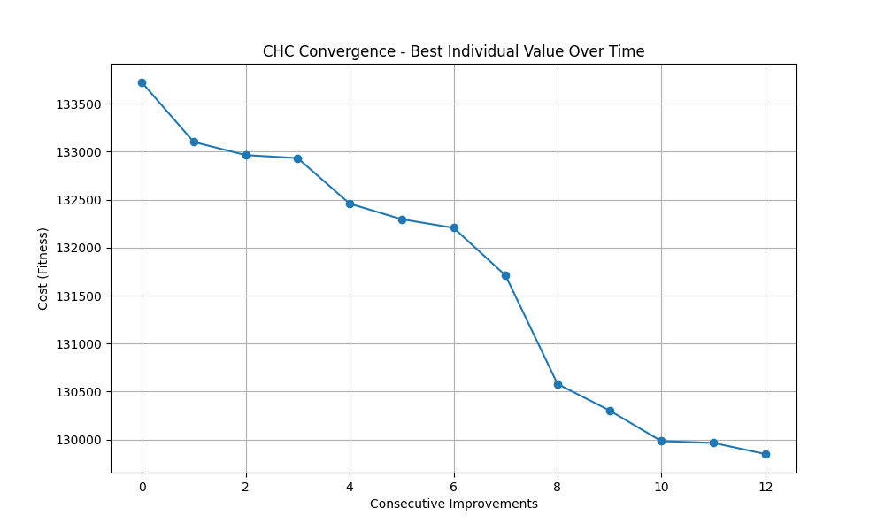
Run 2: This run stands out for its persistence, showing 24 improvements. The progress is slow but steady, demonstrating CHC's ability to explore the solution space deeply over time. It is a strong example of sustained optimization.

Chc Sko90 Run3
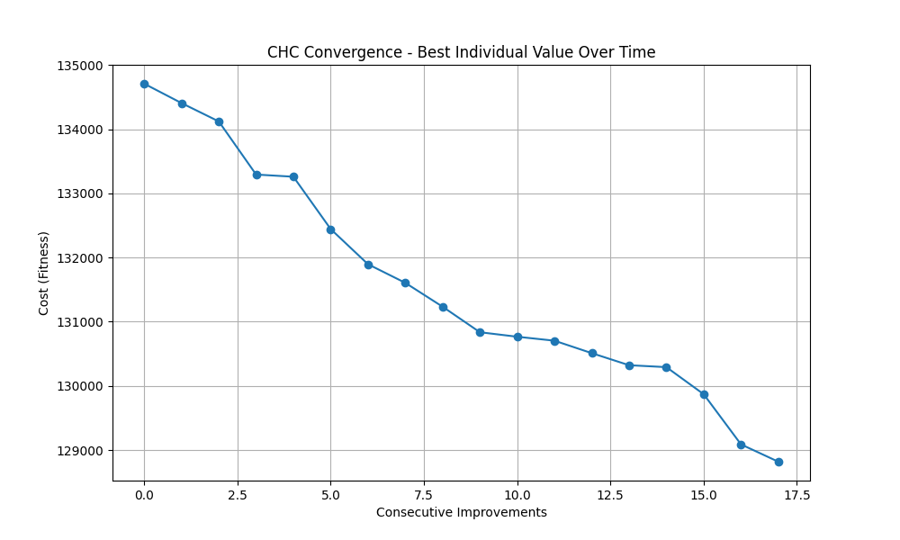
Run 3: Features a significant drop around the midpoint, likely indicating a successful restart. The curve stabilizes afterward, showing the algorithm's capacity to escape local minima and continue refining solutions.

Chc Sko90 Run4
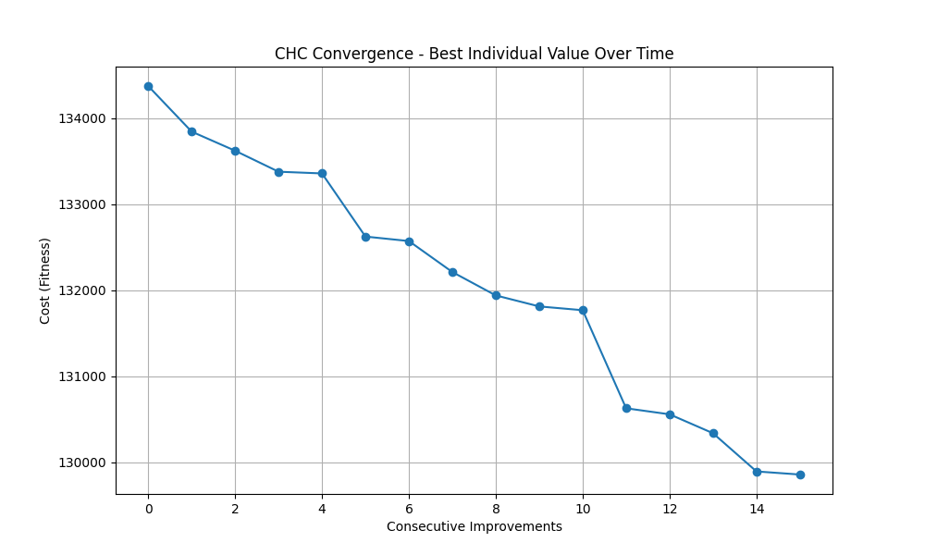
Run 4: While this execution presents steady improvement, the gains are modest and no major shift or restart is clearly visible. It offers a basic example of incremental progress, but adds limited new insight.

Chc Sko90 Run5
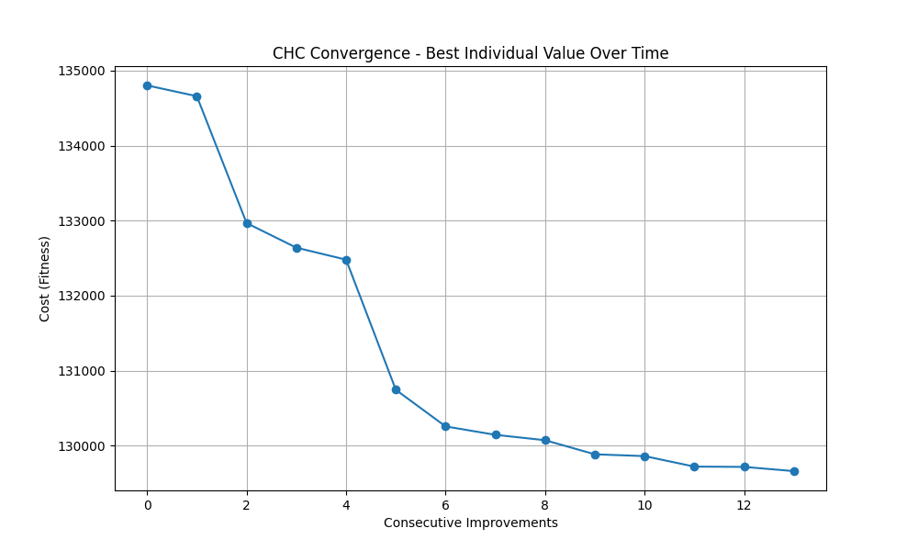
Run 5: Contains 17 improvements but follows a similar trajectory to Run 4, without introducing unique patterns. Its behavior is valid, yet not particularly distinctive.

Chc Tai150B Run1
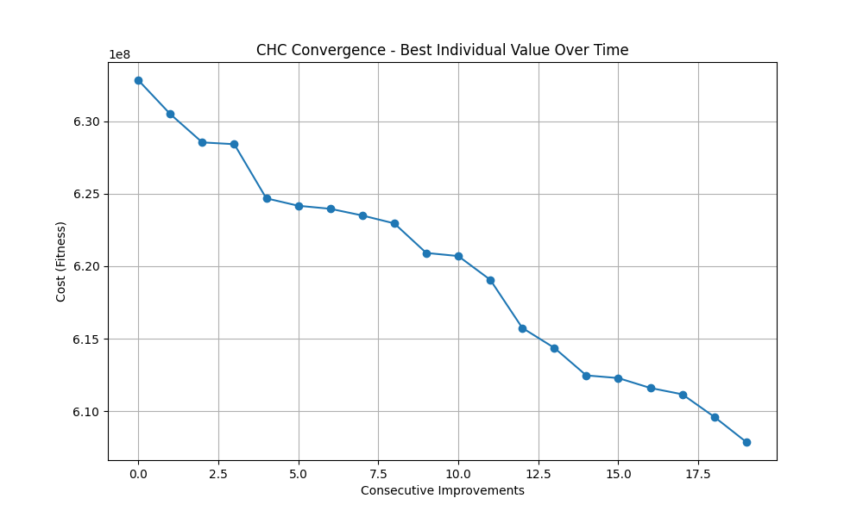
Run 1: Displays steady, uninterrupted progress across 14 improvements. The cost curve descends smoothly without major fluctuations, suggesting a consistent optimization trajectory. Good representation of stable convergence.
Chc Tai150B Run2
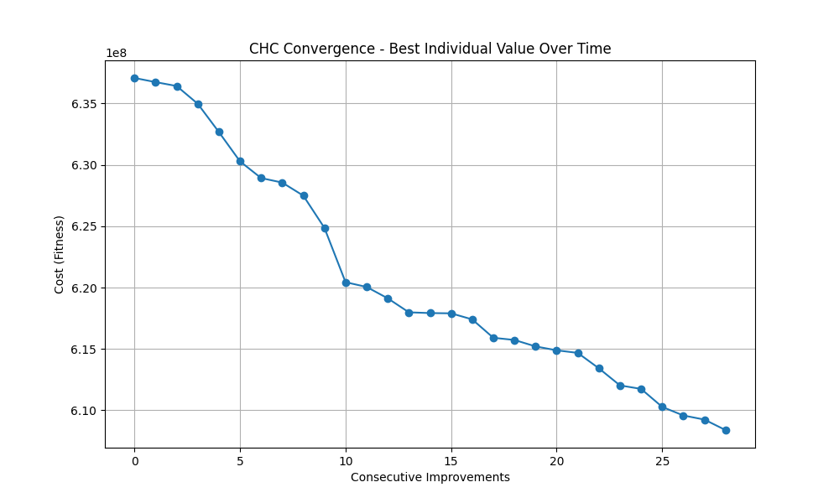
Run 2: A long and persistent execution, with 19 improvements. While individual steps are small, the continued decrease in cost indicates robust local search and avoidance of stagnation. Highly representative of CHC's reliability.

Chc Tai150B Run3
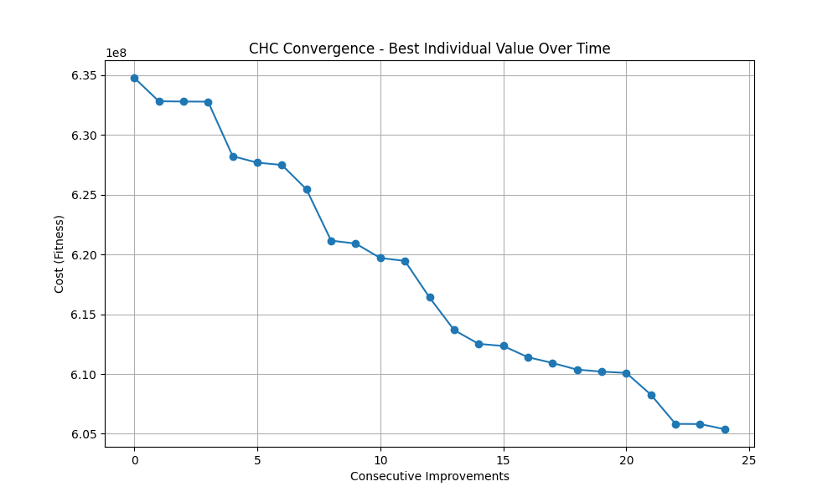
Run 3: Records 28 improvements, with a notable drop around iteration 10. This suggests a successful restart or major diversification, followed by stable refinement. Excellent example of CHC’s restart mechanism in action.

Chc Tai150B Run4
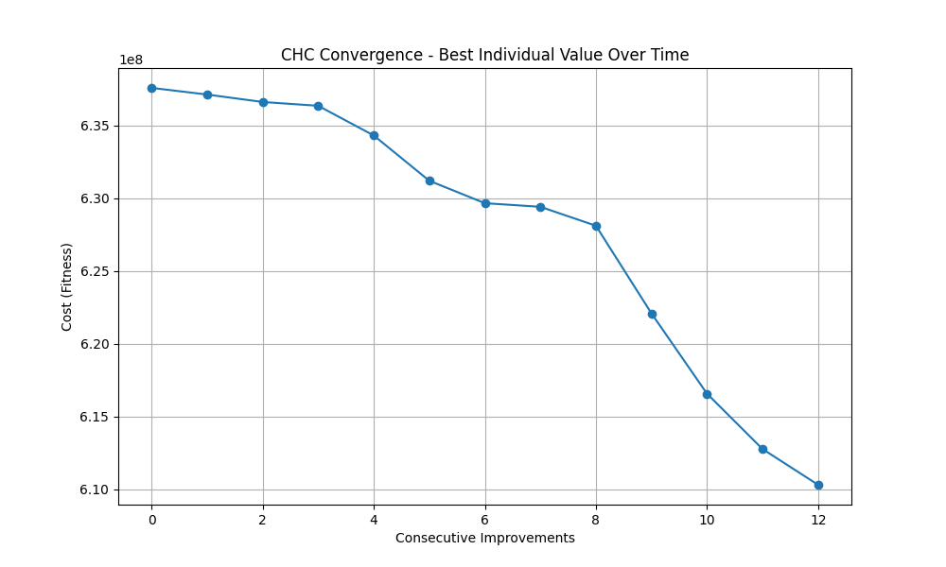
Run 4: Moderate improvements distributed across 24 steps. The curve is regular but lacks sharp transitions. Represents incremental progress, but doesn’t add distinct insights beyond previous runs.

Chc Tai150B Run5
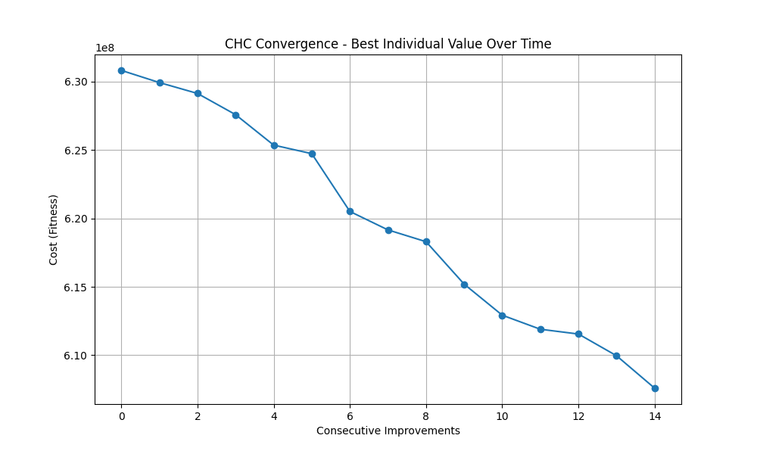
Run 5: Begins with a flat region and then improves significantly in later stages. While it shows restart behavior, the pattern is less clear compared to Run 3, making it less ideal for illustrating restart impact.

Multimodal Genetic Algorithm
For the multimodal version of the genetic algorithm, I implemented a spatial niching strategy, as required by the assignment guidelines. The main objective was to preserve diversity within the population and to promote the discovery of multiple good-quality solutions (local optima), rather than forcing convergence to a single one.I chose to apply the clearing method, which is one of the two suggested approaches (the other being sequential niching with a fixed number of subpopulations). The clearing strategy uses the Hamming distance to measure similarity between individuals. After selection or reproduction, individuals that fall within a predefined distance radius from a stronger (better) individual are cleared — meaning their fitness is set to a very low value or removed from the population.
This mechanism ensures that only the best individual in a niche survives, while others that are too similar are suppressed. As a result, it prevents overcrowding in a single region of the solution space and encourages the algorithm to explore alternative areas. The rest of the algorithm follows the structure of the basic genetic algorithm, using the same operators (selection, crossover, mutation). The only difference is the additional clearing step, which is applied after generating offspring to maintain genetic diversity. In practice, this approach helped the algorithm avoid premature convergence, especially in complex problem instances, and led to the maintenance of multiple promising solutions simultaneously.

Analysis of Quality, Robustness, and Scalability
This section presents a comparative analysis of the algorithms implemented, based on three main evaluation criteria: solution quality, robustness, and scalability. The metrics were computed according to the formulas provided in the course guidelines, namely Relative Error (RE%) for quality, Coefficient of Variation (CV%) for robustness, and evaluation growth with respect to problem size for scalability.
1. Solution Quality (Relative Error - RE%)
The relative error measures how far, on average, the solutions produced by each algorithm are from the best known result on each instance. A lower RE% indicates higher quality.
- On the tai25b instance, CHC and the Multimodal Genetic Algorithm perform well, with RE values of 4.48% and 5.11% respectively. The Basic Genetic Algorithm lags significantly behind with 18.27%.
- For sko90, the Basic GA achieves the best average cost and the lowest RE (0.62%), while CHC scores the worst (3.82%).
- On tai150b, the Multimodal GA again performs best (RE = 2.01%), followed by the Basic GA. CHC shows the highest error (8.92%), suggesting its limitations on larger problems.
These results highlight that the Multimodal GA consistently provides high-quality solutions, especially for larger and more complex instances.
2. Robustness (Coefficient of Variation - CV%)
Robustness evaluates how consistent the algorithm's results are across multiple independent runs. A lower CV indicates less variability and thus higher robustness.
- In tai25b, the Multimodal GA is the most stable (CV = 2.65%), outperforming both Basic GA (4.94%) and CHC (6.19%).
- In sko90, all algorithms show excellent consistency, with CHC being the most stable (CV = 0.38%).
- On tai150b, CHC once again has the lowest CV (0.29%), though this is less meaningful given its poor quality scores. The Multimodal GA still maintains a strong balance between stability and performance (CV = 1.20%).
While CHC tends to be the most stable, the Multimodal GA offers a better trade-off between reliability and solution quality.

3. Scalability
Scalability was assessed based on the number of objective function evaluations required by each algorithm across different problem sizes.
- CHC is the most efficient in terms of computational effort, requiring only around 10,500 evaluations regardless of instance size.
- The Basic GA is the most expensive, with approximately 190,000 evaluations per run, making it less practical for large-scale problems.
- The Multimodal GA performs a middle ground, using about 50,000 evaluations, which suggests a more favorable scalability-performance balance.
In summary, CHC is computationally light but struggles with quality in larger instances. The Multimodal GA scales better than the Basic GA while still maintaining high-quality and stable solutions.
So I’’ll add fine summary:
- Quality: The Multimodal GA delivers the best overall performance in terms of average solution quality.
- Robustness: CHC is the most stable, but its lower quality reduces its impact.
- Scalability: CHC is the least computationally demanding, but the Multimodal GA is more reliable for practical applications due to its stronger trade-offs.
Overall, the Multimodal Genetic Algorithm proves to be the most effective and balanced approach across all criteria.

