Grayscale Deep Joint Source-Channel Coding with Bottleneck-Adaptive Bandwidth Saving and a Software-Defined-Radio Proof of Concept
Nam Khanh Tran, Tom Wang, Zhitong Ni
Email: nam_khanh.tran@student.unsw.edu.au
Abstract—This paper studies a grayscale variant of deep joint source-channel coding (Deep JSCC) for wireless image transmission. Starting from the colour reference model, we adapt the system to grayscale images, reduce the amount of transmitted data by narrowing the encoder bottleneck, and demonstrate the end-to-end system as a software-defined-radio pipeline that transmits an image as a bitstream.
Index Terms—Deep joint source-channel coding, grayscale image transmission, bandwidth reduction, quantization, software-defined radio, USRP, STL-10.
I. Introduction
Wireless image transmission is traditionally built from two separate stages: source coding (for example JPEG) that compresses the image into bits, and channel coding that protects those bits for transmission. This separation works well at the signal-to-noise ratio (SNR) it was designed for, but the quality collapses sharply once the channel becomes worse than expected, an effect known as the cliff effect. Deep JSCC replaces both stages with a single neural network that maps image pixels directly to channel symbols, and it degrades gracefully as the channel changes.
In this work we focus on a grayscale version of Deep JSCC and make three contributions: (i) a grayscale model built from the colour reference; (ii) a bandwidth-saving study that reduces the transmitted data by narrowing the encoder bottleneck; and (iii) a software-defined-radio (SDR) proof of concept that sends an image as a real bitstream.
II. Background and Related Work
This section reviews the Deep JSCC model that our work builds on and places it next to classical digital transmission. We summarize the encoder-decoder architecture, the additive white Gaussian noise (AWGN) channel model, and the bandwidth ratio that measures how many channel uses are spent per source pixel.
III. System Model
We describe the end-to-end system: a convolutional encoder that maps an image to complex channel symbols under an average power constraint, an AWGN channel, and a convolutional decoder that reconstructs the image. An important clarification is that the network uses real-valued weights throughout; the complex channel symbols are formed by pairing the real outputs of the last layer into in-phase (I) and quadrature (Q) components.
For grayscale operation, a small learnable adapter maps the single luminance channel to the three-channel input that the encoder expects, so the rest of the network is reused without change.
IV. Proposed Method
Our method keeps the reference architecture and changes only what is needed for grayscale operation and for controlling the amount of transmitted data.
A. Grayscale Variant
Images are converted to luminance, and a learnable one-to-three-channel adapter is placed before the encoder. The rest of the model is unchanged, which lets us isolate the effect of moving from colour to grayscale.
B. Bottleneck-Adaptive Bandwidth Saving
The final encoder layer sets the number of transmitted symbols, k = 24 x 24 x c, where c is the bottleneck width. Reducing c lowers the transmitted data by a fixed fraction for every image and at every channel condition. We study c from 8 down to 4.
C. Quantization to Bytes
To express the transmitted data in bytes and to prepare for a digital radio link, each symbol value is quantized to a small number of bits. We find that seven bits per value is near lossless.
V. Experimental Setup
All experiments use the STL-10 dataset at 96 by 96 resolution, an AWGN channel, and a training SNR of 19 dB. Reconstruction quality is measured by peak signal-to-noise ratio (PSNR) on a held-out test set of 8000 images.
VI. Results
We first reproduce and strengthen the baseline, then present the grayscale bottleneck sweep, the quantization analysis, and a comparison against a classical JPEG plus modulation baseline.
A. Baseline and Training
Under the corrected training recipe, the colour reference model reaches 30.25 dB validation PSNR at 19 dB SNR, above the 28.99 dB obtained with the original configuration. The grayscale models train stably to convergence with the same recipe. Fig. 1 shows the validation PSNR during training for the five grayscale bottleneck widths.
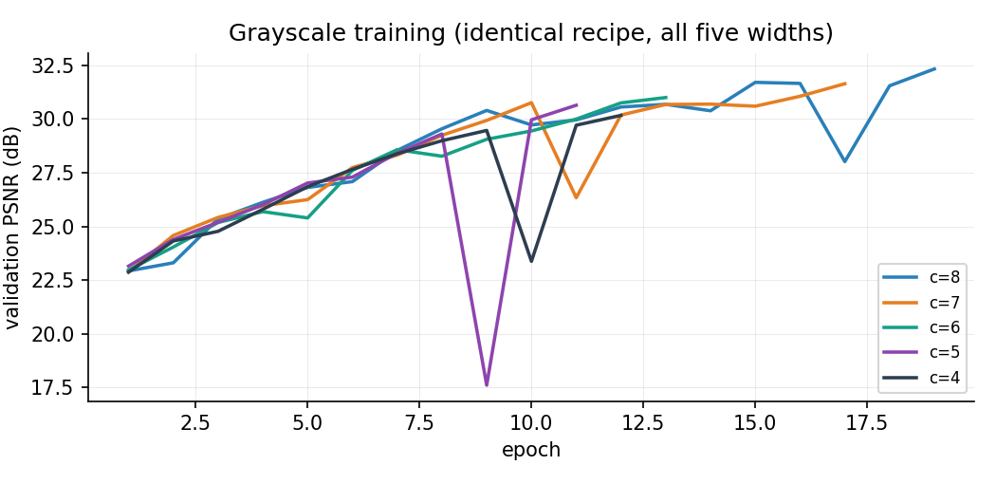
Fig. 1. Validation PSNR during grayscale training, widths c = 8 to 4, identical recipe.
B. Grayscale Bottleneck Sweep
Table I reports the transmitted data and reconstruction quality for bottleneck widths c from 8 down to 4. Reducing c lowers the number of channel uses k = 24 x 24 x c proportionally, from 4,608 symbols at c = 8 to 2,304 at c = 4, a 50 percent reduction. All five models stay at or above 30 dB at the 19 dB operating point, and quality decreases smoothly as c is reduced. Fig. 2 shows PSNR against channel SNR.
TABLE I. Grayscale bottleneck sweep (PSNR at 19 dB SNR).
c | k (symbols) | Data saved | PSNR (dB)
8 | 4,608 | ref. | 32.32
7 | 4,032 | 12.5% | 31.63
6 | 3,456 | 25.0% | 30.99
5 | 2,880 | 37.5% | 30.63
4 | 2,304 | 50.0% | 30.16
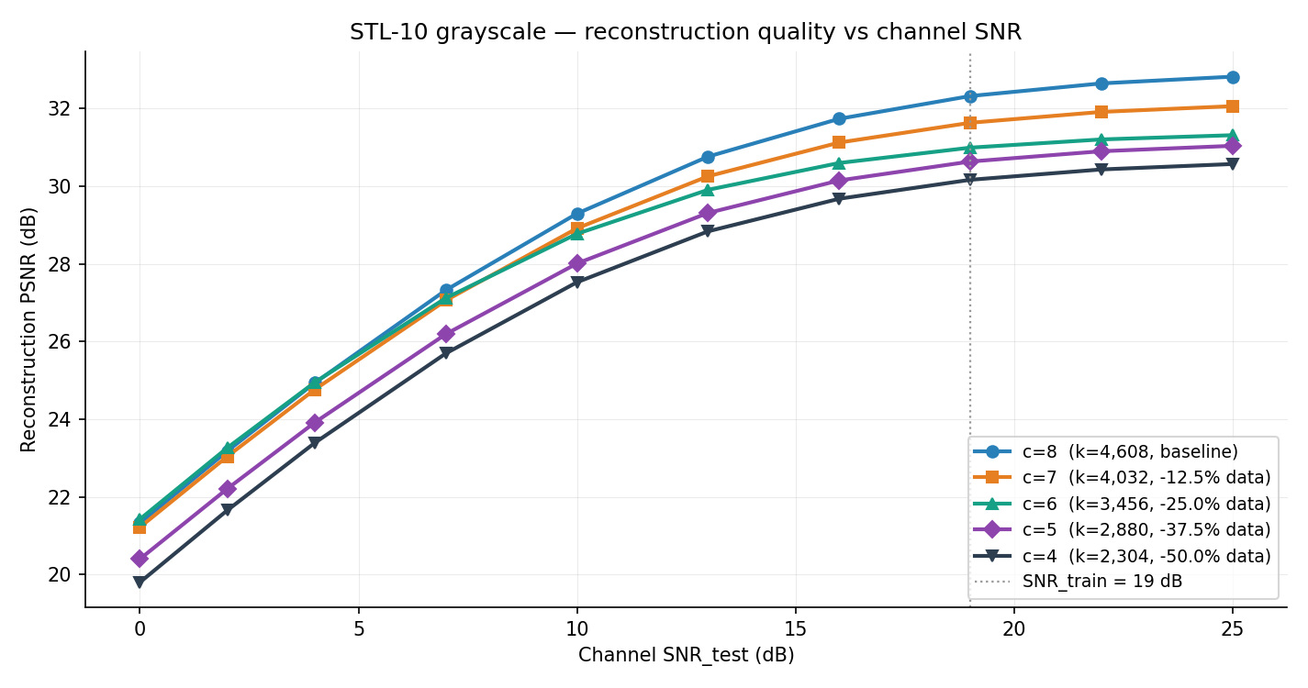
Fig. 2. Grayscale PSNR versus channel SNR for c = 8 to 4. Wider c gives higher PSNR; all curves degrade gracefully.
C. Quantization Analysis
To send the symbols as bits, each symbol value is quantized with N bits over the range that covers the symbol distribution. Table II reports the effect on the chosen c = 4 model. Seven bits per symbol is near lossless, costing only 0.03 dB, and gives a data-transfer footprint of k x 7 / 8 = 2,016 bytes per image. Below five bits the quality falls quickly. Fig. 3 shows the same trend.
TABLE II. Quantization of the c = 4 model (channel at 19 dB SNR).
Bits | Bytes | PSNR (dB) | Loss (dB)
8 | 2,304 | 30.15 | 0.01
7 | 2,016 | 30.13 | 0.03
6 | 1,728 | 30.04 | 0.12
5 | 1,440 | 29.71 | 0.45
4 | 1,152 | 28.49 | 1.67
3 | 864 | 24.88 | 5.28
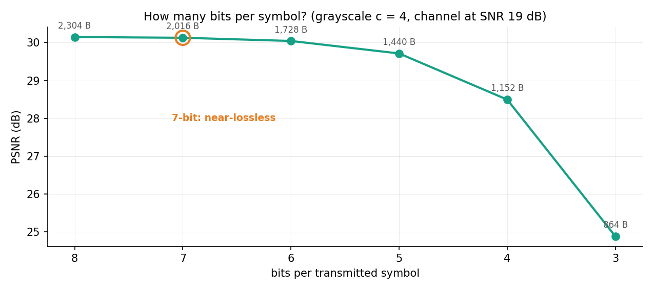
Fig. 3. Reconstruction PSNR of the c = 4 model versus bits per symbol. Quality is flat down to seven bits.
D. Comparison with a Digital Baseline
We compare grayscale Deep JSCC against a digital baseline of JPEG at quality 73 followed by uncoded BPSK over the same AWGN channel. Fig. 4 shows the result. The digital baseline shows a sharp cliff: it fails completely below about 10 dB and reaches roughly 33 dB above 13 dB. Deep JSCC degrades gracefully and stays usable across the whole range. At 19 dB the digital baseline is slightly higher in PSNR, but the c = 4 model transmits fewer bytes (2,016) than the average JPEG file (about 2,317 bytes) while avoiding the cliff.
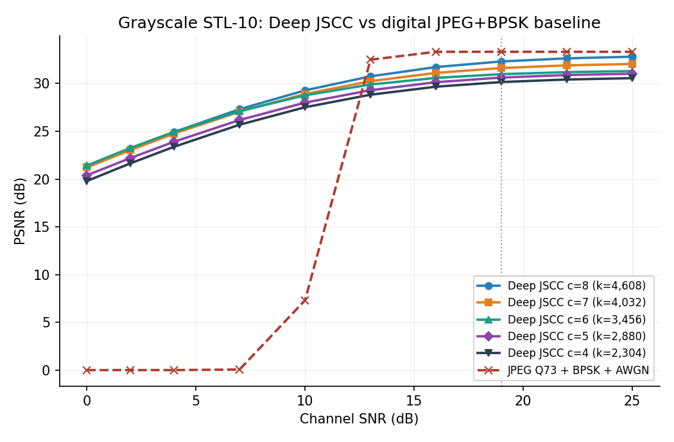
Fig. 4. Grayscale Deep JSCC versus JPEG plus BPSK over AWGN. The digital baseline fails below its cliff; Deep JSCC does not.
VII. Software-Defined-Radio Demonstration
We implement the transmitter and receiver as two functions: one maps an image to a bitstream (encoder, quantization, bit packing), and the other maps a bitstream back to an image. Bits cannot be placed on the antenna directly; they are first mapped to constellation symbols using QPSK, and then shaped into a smooth waveform by a root-raised-cosine filter before the radio transmits them. The receiver applies the matched filter, recovers timing, demodulates back to bits, and reconstructs the image. Fig. 5 shows the full pipeline.
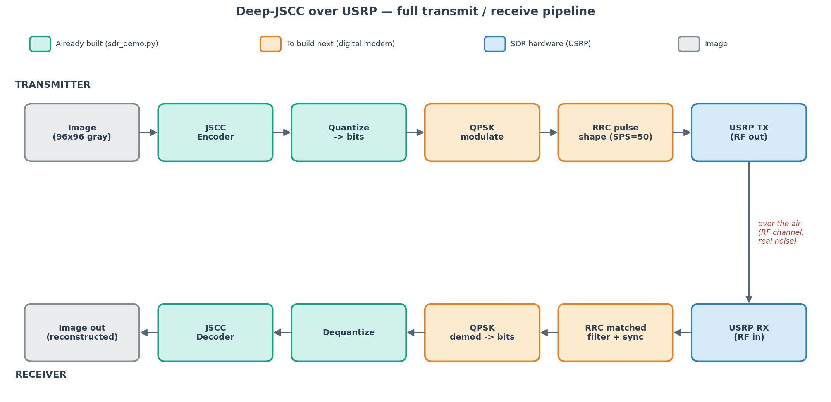
Fig. 5. Full Deep JSCC over USRP pipeline. Green blocks are built, orange blocks are the digital modem to add, blue blocks are the radio hardware.
Fig. 6 shows an image to bits to image round trip through the software pipeline. At 19 dB SNR the reconstruction is about 30 dB, matching the c = 4 model, and the picture is visually close to the original. Over-the-air transmission on a USRP is left as future work; the digital modem (QPSK plus pulse shaping) and synchronization are the next components to add.
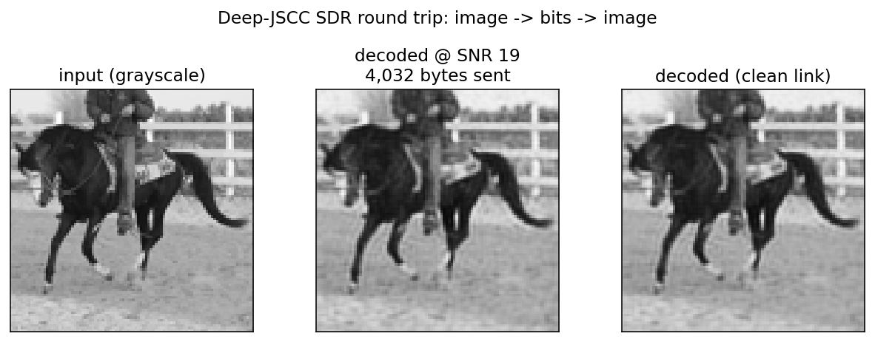
Fig. 6. Round trip through the software pipeline: input, decoded at 19 dB SNR, and decoded over a clean link.
VIII. Discussion and Limitations
We discuss the trade-off between transmitted data and reconstruction quality, and we note that grayscale PSNR is not directly comparable to colour PSNR because a grayscale image is an easier reconstruction target. We also state the current scope of the SDR demonstration.
IX. Conclusion and Future Work
We summarize the grayscale Deep JSCC system, the bandwidth savings obtained by reducing the bottleneck, and the SDR proof of concept. Over-the-air testing on a USRP is identified as the main direction for future work.
References
[1] E. Bourtsoulatze, D. Burth Kurka, and D. Gunduz, "Deep Joint Source-Channel Coding for Wireless Image Transmission," IEEE Transactions on Cognitive Communications and Networking, 2019.
[2]

