Documentation : Rcreate Ldestroy

# Creating the idea

When deciding which base game to modify and what to change, I first took to exploring what kind of core theme and emotion to apply to my title. After researching about the theory that many games deliver ‘power fantasies’ and hearing about titles that aimed to subvert, question(1) or even remove the player’s feeling of power over many elements in the virtual environment, I looked to bring those concepts into one of the base games and to change the way the player reacts to the virtual environment as an experimentation of player empowerment through game modification.

I chose to modify the Space Invader inspired base game as it has elements that highly reflect a ‘power fantasy’ such as the enemies coming towards the player, who is the only one that can destroy them. That feeling of control and power over an apparent opposing force is not a detriment to the game; it gives the player a clear idea of purpose and is a simple but engaging task to achieve, but I found that with a few small tweaks and changes to the Space Invader inspired game I could subvert and change the power the player has to deliver a more complex experience that could potentially be even more engaging than what it was before.

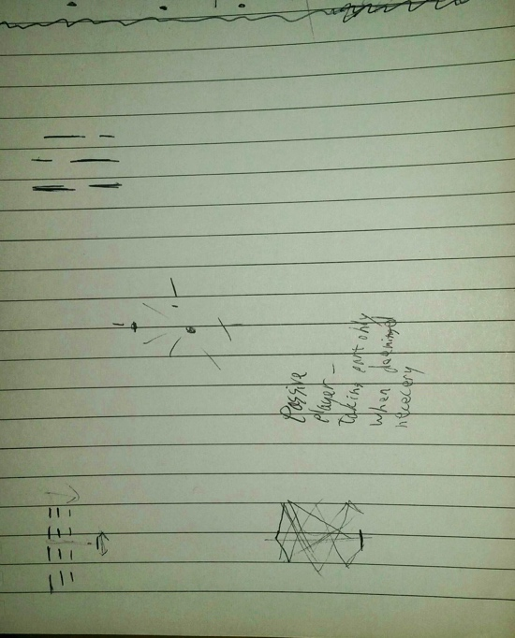

Sketches and notes I wrote to understand a way to subvert player’s power in the Space Invader inspired game.

# Developing the idea

* First, I removed the game over state. Without the threat of failure players do not have pressure to perform a task, making them free to experiment and explore the boundaries of the game.
* I changed the way the aliens move; making them bounce around the screen. I found that this made the aliens less threatening and more passive, giving player’s less of a reason to destroy them and supports the theme of subverting power fantasies.
* I changed the art and audio style to a more calmer aesthetic, which helped in making the virtual environment less daunting.
  + I decided to make the aliens blue, tying them more to being passive due to the calm implications of the colour.
  + I made the player orange; a colour that has no protagonist or antagonistic connotations which makes them neutral, allowing the player to not feel pressured into acting a certain way.
  + Sounds were made in LMMS, an open source music creation software, and I made sounds that were calming and almost ambient, but with a bass-y, ‘crisp’ feeling with the fire and explosion sound to give it weight.
  + For the music I was inspired by slowed down ambience tracks, such as a 10 times slowed down version of Aphex Twin’s ‘Stone in Focus’(2). This slow atmospheric sound was the kind of tone I thought was appropriate.
* I added the ability for the player to create as well as destroy aliens. This is a large change that gives a lot more power to the player than before, but I found that this addition compared with the objective-less and calming aesthetic makes the game almost spiritual and tranquil; something I never thought could be brought into the game in the beginning.

# Feedback of game during development

As I developed the game, I had various people play and comment on the game. My first few people who tried it had similar comments that the bouncing alien was unique but the game didn’t have anything to keep playing and any theme was somewhat lost. With this feedback I added the ability to create aliens, then received feedback on the game again. The response was more positive with people spending a while creating and destroying enemies. What was unexpected was the theme players picked up which ranged from god-like to the game being psychedelic and spiritual in tone. This response was very interesting to me and allows me to believe the game is successful as an experimentation of player empowerment and ‘power fantasies’ through game modification.

# Obstacles during development

During development I ran into many issues with the Phaser API and I had many bugs and issues that took a long time to fix. For example, the logic for the aliens to bounce off of the player took a long time to implement due to my limited experience with the API. With frequent reference to the examples and documentation search on the Phaser website allowed me to implement and change the base game to a satisfactory level, but if I had more knowledge and experience with the API I may have modified it more drastically.

# Further changing the modification

If I were to take this project further, I may take the base Space Invader inspired game and change it again, but differently. As ‘Rcreate Ldestroy’ heightens the power the player has, I may make another game that takes away that power. This would contribute to the experimentation of player empowerment and may give a better understanding than the first test.

# GitHub link

<https://github.com/Lolon/gad405-2>

<https://lolon.github.io/gad405-2/>

# References

1. Extra Credits – The Problem with Power Fantasies : <https://youtu.be/gErFdHiTBRw>
2. Aphex Twin – Stone in Focus (10x slower) by Andrew Gerrand: <https://youtu.be/eaPFyfE84Fs>