**int**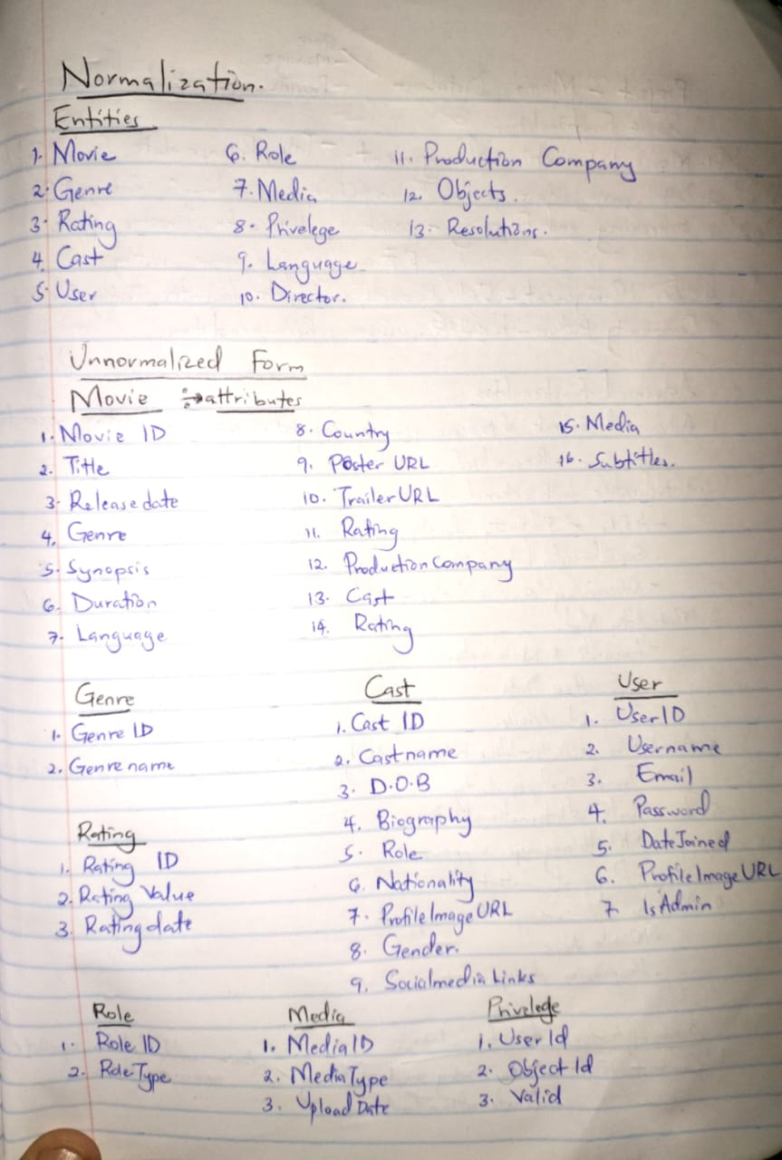

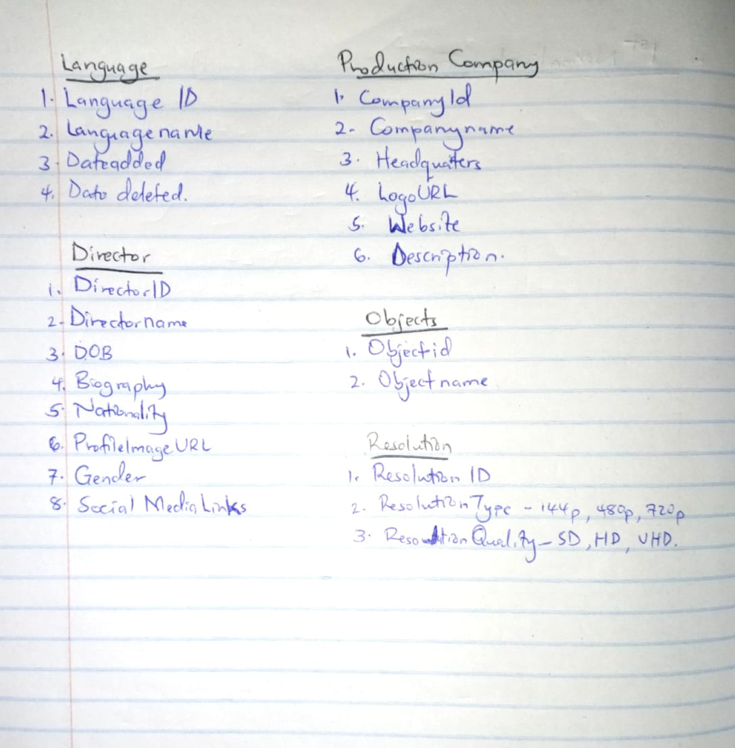

**DATA DICTIONARY**

**FIRST NORMALIZATION FORM**

**Movie Entity**

|  |  |  |  |
| --- | --- | --- | --- |
| **FIELD** | **DATATYPE** | **SAMPLE DATA** | **CONSTRAINTS** |
| movieId | int | 1 | Primarykey(not null, auto increment) |
| userid | int | 1 | Foreignkey(Not null) |
| title | Varchar(100) | inception | Not null |
| releaseDate | date | 2010-07-16 | Not null |
| synopsis | text | A thief who steals corporate secrets through the use of dream-sharing technology is given the inverse task of planting an idea into the mind of a C.E.O. | Null |
| duration | time | 2:28:00 | Not null |
| posterURL | Varchar(255) | http://example.com/posters/inception.jpg | null |
| trailerURL | Varchar(255) | http://example.com/trailers/inception.mp4 | null |
| dateadded | datetime | 2024-05-01 14:30:00 | Not null |
| deleted | boolean | true | Default false |
| deletedby | int | 2 | Not null |
| datedeleted | datetime | 2024-05-17 12:30:00 | Not null |

**User Entity**

|  |  |  |  |
| --- | --- | --- | --- |
| **FIELD** | **DATATYPE** | **SAMPLE DATA** | **CONSTRAINTS** |
| userid | int | 1 | Primarykey(not null, auto increment) |
| username | Varchar(50) | ronaldinho | Not null |
| firstname | Varchar(50) | ronaldo | Not null |
| lastname | Varchar(50) | nazario | Not Null |
| email | Varchar(100) | notnow@gmail.com | Not null |
| password | Varchar(255) | Password123 | Notnull |
| datejoined | datetime | 2024-01-15 10:00:00 | Not null |
| isAdmin | boolean | false | Default false |
| dateadded | datetime | 2024-01-15 10:00:00 | Not null |
| addedby | int | 1 | Not null |
| profileimageURL | Varchar(100) | http://example.com/profiles/ronaldinho.jpg | null |

**Genre entity**

|  |  |  |  |
| --- | --- | --- | --- |
| **FIELD** | **DATATYPE** | **SAMPLE DATA** | **CONSTRAINTS** |
| genreid | int | 1 | Primarykey(not null, auto increment) |
| genrename | Varchar(50) | Sci-fi | Not null |
| dateadded | datetime | 2024-01-15 10:00:00 | Not null |
| userid | int | 1 | Foreignkey(Not Null) |
| deleted | boolean | true | Default false |
| datedeleted | datetime | 2024-01-15 10:00:00 | Not null |
| deletedby | int | 1 | Not null |

**MovieGenre Entity**

|  |  |  |  |
| --- | --- | --- | --- |
| **FIELD** | **DATATYPE** | **SAMPLE DATA** | **CONSTRAINTS** |
| id | int | 1 | Primarykey(not null, auto increment) |
| movieid | int | 1 | foreignkey(not null) |
| genreid | int | 1 | foreignkey(not null) |
| userid | int | 1 | Foreignkey(not null, auto increment) |
| dateadded | datetime | 2024-01-15 10:00:00 | Not null |
| deleted | boolean | true | Default false |
| datedeleted | datetime | 2024-01-15 10:00:00 | Not null |
| deletedby | int | 1 | Not null |

**Language Entity**

|  |  |  |  |
| --- | --- | --- | --- |
| **FIELD** | **DATATYPE** | **SAMPLE DATA** | **CONSTRAINTS** |
| languageid | int | 1 | Primarykey(not null, auto increment) |
| languagename | Varchar(50) | English | Not null |
| dateadded | datetime | 2024-01-15 10:00:00 | Not null |
| userid | int | 1 | Foreignkey(Not Null) |
| deleted | boolean | true | Default false |
| datedeleted | datetime | 2024-01-15 10:00:00 | Not null |
| deletedby | int | 1 | Not null |

**MovieLanguage Entity**

|  |  |  |  |
| --- | --- | --- | --- |
| **FIELD** | **DATATYPE** | **SAMPLE DATA** | **CONSTRAINTS** |
| id | int | 1 | Primarykey(not null, auto increment) |
| movieid | int | 1 | foreignkey(not null) |
| languageid | int | 1 | foreignkey(not null) |
| userid | int | 1 | Foreignkey(not null, auto increment) |
| dateadded | datetime | 2024-01-15 10:00:00 | Not null |
| deleted | boolean | true | Default false |
| datedeleted | datetime | 2024-01-15 10:00:00 | Not null |
| deletedby | int | 1 | Not null |

**Ratings Entity**

|  |  |  |  |
| --- | --- | --- | --- |
| **FIELD** | **DATATYPE** | **SAMPLE DATA** | **CONSTRAINTS** |
| ratingid | int | 1 | Primarykey(not null, auto increment) |
| ratingValue | int | 5 | Not null |
| dateadded | datetime | 2024-01-15 10:00:00 | Not null |
| userid | int | 1 | Foreignkey(Not Null) |
| deleted | boolean | true | Default false |
| datedeleted | datetime | 2024-01-15 10:00:00 | Not null |
| deletedby | int | 1 | Not null |

**MovieRatings Entity**

|  |  |  |  |
| --- | --- | --- | --- |
| **FIELD** | **DATATYPE** | **SAMPLE DATA** | **CONSTRAINTS** |
| id | int | 1 | Primarykey(not null, auto increment) |
| movieid | int | 1 | foreignkey(not null) |
| ratingid | int | 1 | foreignkey(not null) |
| userid | int | 1 | Foreignkey(not null, auto increment) |
| dateadded | datetime | 2024-01-15 10:00:00 | Not null |
| deleted | boolean | true | Default false |
| datedeleted | datetime | 2024-01-15 10:00:00 | Not null |
| deletedby | int | 1 | Not null |

**productionCompany Entity**

|  |  |  |  |
| --- | --- | --- | --- |
| **FIELD** | **DATATYPE** | **SAMPLE DATA** | **CONSTRAINTS** |
| companyaid | int | 1 | Primarykey(not null, auto increment) |
| companyname | Varchar(50) | Warner Bros. Pictures | Not null |
| headquarters | Varchar(100) | Burbank, California, USA | Not null |
| LogoURL | Varchar(100) | http://example.com/logos/warnerbros.jpg | null |
| website | Varchar(100) | https://www.warnerbros.com/ | null |
| description | Varchar(255) | Warner Bros. Pictures is an American film production and distribution company. | null |
| dateadded | datetime | 2024-01-15 10:00:00 | Not null |
| userid | int | 1 | Foreignkey(Not Null) |
| deleted | boolean | true | Default false |
| datedeleted | datetime | 2024-01-15 10:00:00 | Not null |
| deletedby | int | 1 | Not null |

**MovieProductionCompany Entity**

|  |  |  |  |
| --- | --- | --- | --- |
| **FIELD** | **DATATYPE** | **SAMPLE DATA** | **CONSTRAINTS** |
| id | int | 1 | Primarykey(not null, auto increment) |
| movieid | int | 1 | foreignkey(not null) |
| companyid | int | 1 | foreignkey(not null) |
| userid | int | 1 | Foreignkey(not null, auto increment) |
| dateadded | datetime | 2024-01-15 10:00:00 | Not null |
| deleted | boolean | true | Default false |
| datedeleted | datetime | 2024-01-15 10:00:00 | Not null |
| deletedby | int | 1 | Not null |

**Cast Entity**

|  |  |  |  |
| --- | --- | --- | --- |
| **FIELD** | **DATATYPE** | **SAMPLE DATA** | **CONSTRAINTS** |
| castid | int | 1 | Primarykey(not null, auto increment) |
| userid | int | 1 | Foreignkey(not nullt) |
| castname | Varchar(50) | Leonardo Dicaprio | Not null |
| DOB | date | 1974-11-11 | Not null |
| biograpy | Varchar(255) | Leonardo Wilhelm DiCaprio is an American actor and film producer. Known for his work in biographical and period films, he is the recipient of numerous accolades, including an Academy Award, a British Academy Film Award, and three Golden Globe Awards. | Null |
| roleid | int | 1 | Not null |
| nationality | Varchar(255) | American | Notnull |
| gender | varchar | male | (NULL, CHECK (Gender IN ('Male', 'Female', 'Other'))) |
| socialmedialinks | Varchar(100) | null | null |
| datejoined | datetime | 2024-01-15 10:00:00 | Not null |
| isAdmin | boolean | false | Default false |
| dateadded | datetime | 2024-01-15 10:00:00 | Not null |
| addedby | int | 1 | Not null |
| profileimageURL | Varchar(100) | http://example.com/profiles/leonardo.jpg | null |

**MovieCast Entity**

|  |  |  |  |
| --- | --- | --- | --- |
| **FIELD** | **DATATYPE** | **SAMPLE DATA** | **CONSTRAINTS** |
| id | int | 1 | Primarykey(not null, auto increment) |
| movieid | int | 1 | foreignkey(not null) |
| castid | int | 1 | foreignkey(not null) |
| userid | int | 1 | Foreignkey(not null, auto increment) |
| dateadded | datetime | 2024-01-15 10:00:00 | Not null |
| deleted | boolean | true | Default false |
| datedeleted | datetime | 2024-01-15 10:00:00 | Not null |
| deletedby | int | 1 | Not null |

**Roleid Entity**

|  |  |  |  |
| --- | --- | --- | --- |
| **FIELD** | **DATATYPE** | **SAMPLE DATA** | **CONSTRAINTS** |
| roleid | int | 1 | Primarykey(not null, auto increment) |
| roletype | Varchar(50) | thief | Not null |

**Media Entity**

|  |  |  |  |
| --- | --- | --- | --- |
| **FIELD** | **DATATYPE** | **SAMPLE DATA** | **CONSTRAINTS** |
| mediaid | int | 1 | Primarykey(not null, auto increment) |
| mediatype | Varchar(50) | Behind-the-scenes | Not null |
| description | Varchar(255) | Behind-the-scenes footage of the making of Inception | null |
| dateadded | datetime | 2024-01-15 10:00:00 | Not null |
| userid | int | 1 | Foreignkey(Not Null) |
| deleted | boolean | true | Default false |
| datedeleted | datetime | 2024-01-15 10:00:00 | Not null |
| deletedby | int | 1 | Not null |

**MovieMedia Entity**

|  |  |  |  |
| --- | --- | --- | --- |
| **FIELD** | **DATATYPE** | **SAMPLE DATA** | **CONSTRAINTS** |
| id | int | 1 | Primarykey(not null, auto increment) |
| movieid | int | 1 | foreignkey(not null) |
| mediaid | int | 1 | foreignkey(not null) |
| userid | int | 1 | Foreignkey(not null, auto increment) |
| dateadded | datetime | 2024-01-15 10:00:00 | Not null |
| deleted | boolean | true | Default false |
| datedeleted | datetime | 2024-01-15 10:00:00 | Not null |
| deletedby | int | 1 | Not null |

**Resolution Entity**

|  |  |  |  |
| --- | --- | --- | --- |
| **FIELD** | **DATATYPE** | **SAMPLE DATA** | **CONSTRAINTS** |
| resolutionid | int | 1 | Primarykey(not null, auto increment) |
| resolutiontype | Varchar(50) | 1080p | Not null |
| resolutionquality | Varchar(25) | HD | Not null |
| dateadded | datetime | 2024-01-15 10:00:00 | Not null |
| userid | int | 1 | Foreignkey(Not Null) |
| deleted | boolean | true | Default false |
| datedeleted | datetime | 2024-01-15 10:00:00 | Not null |
| deletedby | int | 1 | Not null |

**MovieResolution Entity**

|  |  |  |  |
| --- | --- | --- | --- |
| **FIELD** | **DATATYPE** | **SAMPLE DATA** | **CONSTRAINTS** |
| id | int | 1 | Primarykey(not null, auto increment) |
| movieid | int | 1 | foreignkey(not null) |
| Resolutionid | int | 1 | foreignkey(not null) |
| userid | int | 1 | Foreignkey(not null, auto increment) |
| dateadded | datetime | 2024-01-15 10:00:00 | Not null |
| deleted | boolean | true | Default false |
| datedeleted | datetime | 2024-01-15 10:00:00 | Not null |
| deletedby | int | 1 | Not null |

**Director Entity**

|  |  |  |  |
| --- | --- | --- | --- |
| **FIELD** | **DATATYPE** | **SAMPLE DATA** | **CONSTRAINTS** |
| Diretorid | int | 1 | Primarykey(not null, auto increment) |
| userid | int | 1 | Foreignkey(not nullt) |
| Directorname | Varchar(50) | Christopher Nolan | Not null |
| DOB | date | 1970-06-30 | Not null |
| biograpy | Varchar(255) | null | Null |
| nationality | Varchar(255) | American | Notnull |
| gender | varchar | male | (NULL, CHECK (Gender IN ('Male', 'Female', 'Other'))) |
| socialmedialinks | Varchar(100) | null | null |
| datejoined | datetime | 2024-01-15 10:00:00 | Not null |
| dateadded | datetime | 2024-01-15 10:00:00 | Not null |
| addedby | int | 1 | Not null |
| profileimageURL | Varchar(100) | http://example.com/profiles/leonardo.jpg | null |

**MovieDirector Entity**

|  |  |  |  |
| --- | --- | --- | --- |
| **FIELD** | **DATATYPE** | **SAMPLE DATA** | **CONSTRAINTS** |
| id | int | 1 | Primarykey(not null, auto increment) |
| movieid | int | 1 | foreignkey(not null) |
| directorid | int | 1 | foreignkey(not null) |
| userid | int | 1 | Foreignkey(not null, auto increment) |
| dateadded | datetime | 2024-01-15 10:00:00 | Not null |
| deleted | boolean | true | Default false |
| datedeleted | datetime | 2024-01-15 10:00:00 | Not null |
| deletedby | int | 1 | Not null |

**Object Entity**

|  |  |  |  |
| --- | --- | --- | --- |
| **FIELD** | **DATATYPE** | **SAMPLE DATA** | **CONSTRAINTS** |
| objectid | int | 1 | Primarykey(not null, auto increment) |
| objectname | Varchar(50) | costume | Not null |

**Privileges Entity**

|  |  |  |  |
| --- | --- | --- | --- |
| **FIELD** | **DATATYPE** | **SAMPLE DATA** | **CONSTRAINTS** |
| privilegeid | int | 1 | Primarykey(not null, auto increment) |
| privilegename | Varchar(50) | View Content | Not null |
| description | Varchar(25) | Allows the user to view movie content. | Not null |

**UserPrivilege Entity**

|  |  |  |  |
| --- | --- | --- | --- |
| **FIELD** | **DATATYPE** | **SAMPLE DATA** | **CONSTRAINTS** |
| id | int | 1 | Primarykey(not null, auto increment) |
| userid | int | 1 | Primarykey(not null, auto increment) |
| privilegeid | int | 1 | Primarykey(not null, auto increment) |