TP3

**Project description:**

SSV – Sleep SurVeillance

SSV is a user interactive system that will help the user keep track of their sleep over the week as well as predict the quality of their sleep based of their habits. It will take data such as hours of sleep, dinner eaten, and screen time *(before bed)* as input, and will produce as an output two things.

One: using machine learning models, the system will predict the quality of the sleep of the user and if it was enough or not provided the given inputs based on previous entries and available sleep date set.

It will also provide mini recommendations for the user to help improve the quality of their sleep rather than the quantity. Two: Sleep Report portraying their habits over the week

and how it impacted their sleep using graphs and tables .

**Competitive Analysis:**

There have been many different apps that provides this kind of experience of sleep tracking, some of them even use hardware to predict the different durations of sleep cycle the user is experiencing overnight. For example, some apps such as Pillow can keep track of your sleep cycle . However, as far as my research goes, there have not been any applications that implemented the use of machine learning to predict the quality of the sleep for the given day. Majority of the applications (such as health, and other sleep applications on app stores) depend on providing logs and provide moderation to enhance sleep quantity.

Nevertheless, there is quite a few examples that combine sleep and Machine Learning . For example , a guy named [Bima Jenie](https://medium.com/@bima.jenie?source=post_page-----5d313a9d811d-----------------------------------) came up with an idea combining machine learning and sleep , nonetheless his project was not text based and appears to be mainly concerned with the use of the camera and machine learning to predict the stage of sleep based of appearance . There have been quite a few similar projects , but our ideas fail to align as the purpose of majority of the projects combining ML and sleep is to predict the stage of sleep the user is currently going through and no further exploration is usually conducted .

**Structural Plan:**

The final project will be executed by running the code and interacting with the window portraying the GUI. Entering Data for some functions that require an input would trigger another screen to show up. For example, entering 7 hours in the ‘how many hours did you sleep box ‘would lead to another screen with a different question and etc. The different sections of GUI, ML Model , and sleep report is being coded separately . However, the main functions of the Sleep report and ML will be called in GUI to include their features in the final project as outputs or options to choose from .

In advance, the data will be saved in a separate text file as the user previous logs needs to be saved in an external space as with each run , the program starts from scratch . Hence , first time users would automatically get assigned an empty txt file labeled by the name they are using to log their data on GUI . The names need to be identical, and every entry should be entered with the same name.(case sensitive, space sensitive and spelling sensitive)

**Algorithmic Plan & Timeline Plan(combined):**

For (1): STATUS : DONE

Algorithmic Plan: Creating Areas/locations to enable the user to input data in spaces where they are needed to. For example, if the interface shows a question of ‘How many Hours did you sleep ‘user input is expected and will be stored in the suitable location. The storage location should allow data editing and retrieval to be able to use it as data to draw bar graphs / straight lines graphs or curves as well as input/predicting values for ML model. The Different types of Data (such as Overall SSV users, logs of all users , and formatted data for machine learning model) is saved on different txt files and automatically edited and modified for their purpose by the program without the need to user / developer interference .

Timeline Plan: The GUI is considered to be the stem of the project since it’s user interactive so it’s expected to be done by this week specifically by 16 or 17 Nov, however the storage issue although addressed in TP1 , it was not resolved until slightly after TP2.

For (2): STATUS : DONE

Algorithmic Plan: The plan to achieve the model is to use the model created in the tech demo(RandomForestClassifier) and enhance it by using larger data set.

The Program uses 3 models :

1. *Returns if sleep was enough or not based on Hours slept*
2. *Return the scale of tiredness based on dinner eaten.*
3. *Returns the scale of tiredness based on exercise not/done .*
4. *Returns if sleep was enough or not based on avg tiredness gained from M2 and M3.*

The final outcome is produced by a separate algorithm , this algorithm takes output from M1, M4 and determines if sleep is ‘Good’,’Averge’ or ‘Poor’.

Timeline Plan: This should be achieved by TP2 as a part of the MVP

For (3): STATUS : DONE

Algorithmic Plan: The production of the graphics depends mainly on the user input for the required fields. Using matplotlib, graphs will be produced to help produce ‘sleep report ‘for the user as well as visualization of the sleep quality over a period of a week. The trickiest part in this was to produce different graphs for different categories and connect them to the main GUI as they are coded in a separate file . However , as this part is done , a new tricky part has emerged which is linked to a new feature . The feature is to show the user their sleep in comparison to other users that logged their Data.

Timeline Plan: This will either be done by TP2 or between TP2 and TP3(alongside with improving GUI to get beyond MVP)

Status of Pending Features / Future Updates:

* Show users their sleep in comparison to other users – DONE
* Incomplete feature : Quality Clarification –DONE

Quality Clarification : A features that uses the machine learning out puts to help the user get clarification on which aspect to improve more .

For example , if user got a predicted quality of Average . The PR feature should indicate that the sleep quality was downgraded from good to average due to the high tiredness scale produced by lack of exercise .

* Users Data will be used as new datasets to train model – DONE

This could not be done automatically . To edit an Excel sheet using code the format of the excel should be xlxs , meanwhile the machine learning model uses csv . Hence a solution was made ot convert the current excel sheet to txt form (File called ‘newDataSetML.txt’) , the new data from users will be automatically imported to the txt file and the developer will need to manually synchronize between both files as its not possible to be done automatically without the machine learning model crashing due to change in file format or the user interface code not owning permission to edit the csv data set.

Version Control Plan:

Uploading copies of code on GitHub repository every day.

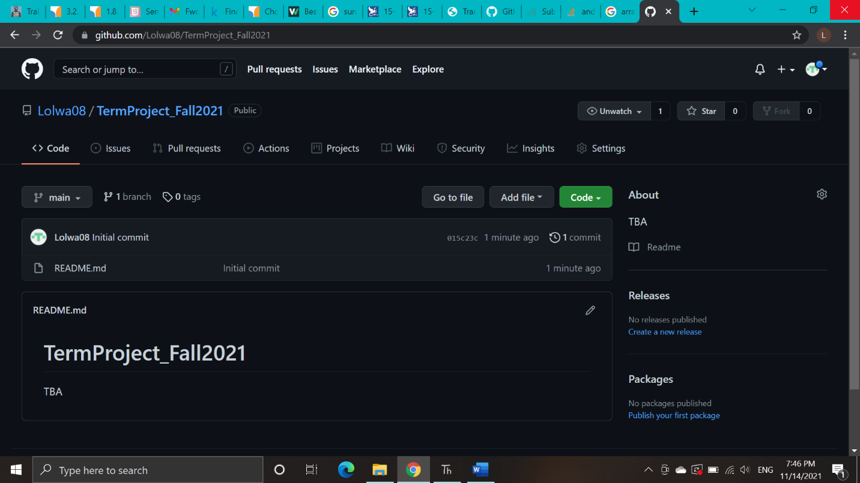

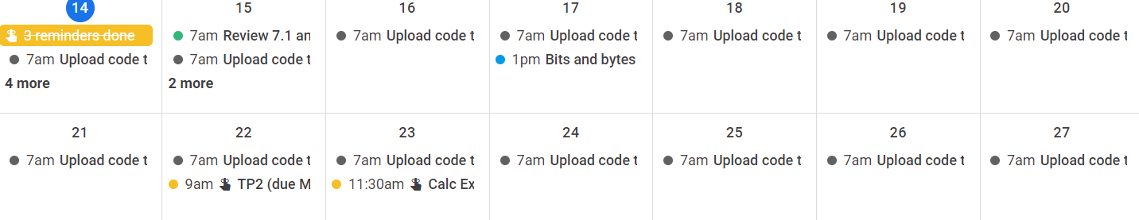

Module List:

* pandas
* basic_graphics
* matplotlib.pyplot
* ImageWriter
* cmu_112_graphics
* sklearn
* random