Market Research

* US Smartphone penetration
  + 2017: Lowest income (less than $30,000 a year) 67% use cellphones
    - <https://www.statista.com/statistics/195006/percentage-of-us-smartphone-owners-by-household-income/>
  + Smartphone reliance is markedly higher among young adults, non-whites and those who live in low-income households.
    - <https://www.telecompetitor.com/pew-u-s-smartphone-ownership-broadband-penetration-reached-record-levels-in-2016/>
  + The MCWCRC at Boston Medical Center decided to build a customized mHealth app because the mHealth apps available on the US market do not meet all the needs for an integrated psychiatric facility embedded within an OB-GYN clinic. Apps that track mood and help patients cope with their psychiatric conditions do not provide other essential functions, such as appointment tracking, community engagement, or prenatal and postnatal education. On the other hand, apps aimed specifically at prenatal and postnatal education, appointment tracking, and community engagement lack the crucial aspect of mental health engagement.
    - <https://www.ncbi.nlm.nih.gov/pmc/articles/PMC5650672/>
  + MERCKfor Mothers apps: <https://reports.merckformothers.com/>
* Prevalence of PPD

Perinatal mood and anxiety

delivery. They include depression, anxiety, and affective disorders with psychotic episodes and psychosis.

Our understanding of maternal mental illness is negatively impacted by the frequency of under-diagnosis

and misdiagnosis. The result can be inappropriate care, potentially leading to missed opportunities for

treatment and increased risk of morbidity and mortality. In addition, the metabolic changes of pregnancy

may require adjustments to adequate pharmacological treatment dosage—especially beginning in the

second trimester—but many providers are hesitant to treat depression and anxiety with antidepressants in

pregnancy.[18, 19] Mental illness relapse occurs more frequently when a woman’s dosage of pharmacological

treatment is decreased in pregnancy, maintained at pre-pregnancy levels, or completely discontinued.[20]

Providers are challenged because both pharmacotherapy use and non-use carry risks, necessitating a

potentially complex risk-benefit analysis when considering the treatment of mental health conditions during

pregnancy and the postpartum period. Adding to this challenge is variability in patient risk tolerance.

Psychosocial and environmental risk factors associated with maternal mental health conditions

* Chronic stressors, such as racism and poverty
* Lack of access to insurance, transportation, and providers
* Substance use disorder
* Chronic Disease
* Obesity
* Unplanned pregnancy
* Delay or failure to seek prenatal care
* Social isolation and lack of social support
* Childcare-associated stress
* Homelessness
* Exposure to violence and trauma
* By searching for these keywords in the data from the Nine Committees, we found that mental health
* conditions and substance use disorder contributed to 12.9% and 8.2% of pregnancy-related deaths,
* respectively; 6.5% of pregnancy-related deaths were suicides. In comparison, when looking at PMSS-MM
* codes only, the percentage of pregnancy-related deaths with an underlying cause of death of mental health
* conditions was 7.0%, as shown in **Figure 4**. This shows that mental health conditions and substance use
* can contribute to deaths even when they are not the underlying cause. As more MMRCs use checkboxes,
* more complete analyses of deaths where mental health conditions or substance use disorder contributed
* to the death, but did not cause the death, will be possible.
* https://www.cdcfoundation.org/sites/default/files/files/ReportfromNineMMRCs.pdf

Partnerships

Competition

TABLE LISTING

https://www.ncbi.nlm.nih.gov/pmc/articles/PMC5650672/table/table1/?report=objectonly

Clinics

Research Community

**Medicaid for Pregnant Women**

<https://medicaid.ncdhhs.gov/medicaid/get-started/learn-if-you-are-eligible-medicaid-or-health-choice/medicaid-income-and>

Study in boston:

The patient population of Boston Medical Center is diverse in terms of socioeconomic status and ethnic and racial background: 71.52% are nonwhite, 33.3% are Hispanic, and 82.49% are Medicaid patients (detailed demographics of the MCWCRC patient population are provided in [Figures 1](https://www.ncbi.nlm.nih.gov/pmc/articles/PMC5650672/figure/figure1/) and [​and2).2](https://www.ncbi.nlm.nih.gov/pmc/articles/PMC5650672/figure/figure2/)). Women who fit into these demographic categories are more likely to report institutional and stigma-related barriers to accessing mental health care when visiting an OB-GYN clinic, despite high interest in receiving some form of psychiatric care. In fact, the no-show rate at the MCWCRC is approximately 50% and patients identify lack of transportation options as a major barrier to accessing care (unpublished internal research).

https://www.ncbi.nlm.nih.gov/pmc/articles/PMC5650672/

**A pregnant woman may apply for this program before or after she delivers. A woman who has experienced a recent pregnancy loss also may be eligible. Medicaid for Pregnant Women covers only services related to pregnancy:**

* **Prenatal care, delivery and 60 days of postpartum care**
* **Services to treat medical conditions that may complicate pregnancy**
* **Childbirth classes**
* **Family planning services**

**Medicaid spending in NC:**

https://ballotpedia.org/Medicaid_spending_in_North_Carolina

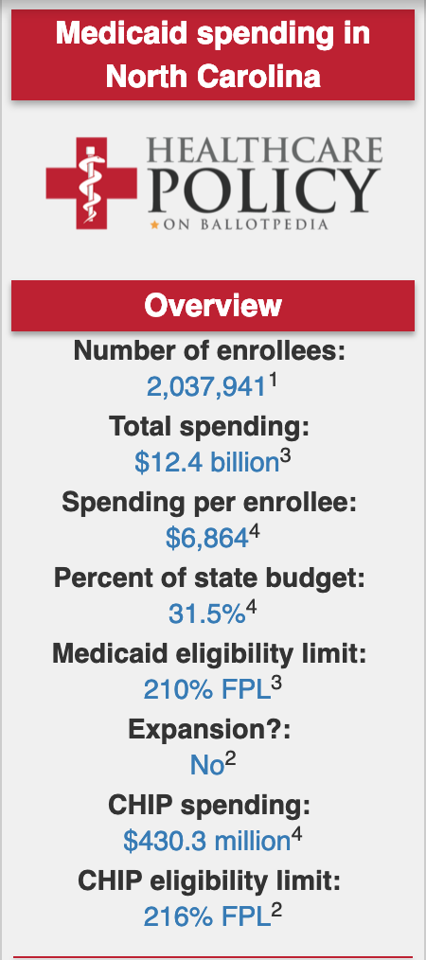

# How much does Low Socioeconomic Status Increase the Risk of Prenatal and Postpartum Depressive Symptoms in First Time Mothers? 2010

California State University

[**https://www.ncbi.nlm.nih.gov/pmc/articles/PMC2835803/**](https://www.ncbi.nlm.nih.gov/pmc/articles/PMC2835803/)

Sample of 198 first time mothers assessed for depressive symptoms in their third trimester of pregnancy and at 1, 2, and 3 months postpartum.

Results

Low SES was associated with increased depressive symptoms in late pregnancy and at 2 and 3 months, but not at 1 month postpartum. Women with four SES risk factors (low monthly income, less than a college education, unmarried, unemployed) were 11 times more likely than women with no SES risk factors to have clinically elevated depression scores at 3 months postpartum, even after controlling for the level of prenatal depressive symptoms.

Conclusion

Although new mothers from all SES strata are at risk for postpartum depression, SES factors including low education, low income, being unmarried, and being unemployed increased the risk of developing postpartum depressive symptoms in this sample.

Economic Costs of Untreated Mental Illness

https://www.achp.org/wp-content/uploads/Economic-Costs-Associated-with-Untreated-Mental-Final.pdf

* Estimates place the total economic cost of untreated behavioral health issues between $150 and $200 billion per year (Rampell, 2013).
* The costs associated with untreated depression account for a $26.1 billion expense to the health care industry and a total economic loss of over $83 billion (Leahy, 2010; Greenberg et al., 2003).
* In the workplace, depressed individuals account for $51.5 billion in losses (Greenberg et al., 2003). This is calculated by the loss of 5.6 hours of productivity per week, 1.5-3.2 more days of short-term disability per month and 2.17 times greater risk of taking a sick day for depressed people (Leahy, 2010).