Docker and K8s assignment

Docker File

FROM openjdk

WORKDIR /usr/src/myapp

COPY . /usr/src/myapp

CMD ["java","-jar","assignment-0.0.1-SNAPSHOT.jar"]

EXPOSE 8081

Screenshot of Docker Image Created Successfully & Total Number of Docker images.

Share the Image path from Docker Hub Repo.

<https://hub.docker.com/repository/docker/harshitlomas/nagarro-assignment/general>

Share Both the Yamls Files (Deployment & Service).

Deployment.yaml

apiVersion: apps/v1 *#version of the Kubernetes API you're using to create this object*

kind: Deployment  *#What kind of object you want to create*

metadata: *#deployment name, helps uniquely identify the object*

   name: assignment-app

spec:

  selector:

    matchLabels:

      app: assignment-app

  replicas: 2 *# tells deployment to run 2 pods matching the template*

  template:

    metadata:

      labels:

        app: assignment-app

    spec:   *#What state you desire for the object*

      containers:

      - name: assignment-app *#container name*

        image: 'harshitlomas/nagarro-assignment' *#image name*

        ports:

        - containerPort: 8081 *# demo runs on port 8081*

Service.yaml

apiVersion: v1

kind: Service *#What kind of object you want to create*

metadata: *#service name,Data that helps uniquely identify the object*

  name: assignment-app

spec: *#What state you desire for the object*

  selector:

    app: assignment-app

  ports:

    - port: 8081 *#port at which service is internally available*

      targetPort: 8081 *#port of container*

*#nodePort: 30001  # port at which service is externally available  range 30000- 32767*

      name: http

  type: LoadBalancer

Two Screenshots: One for Deployment Created Successfully and Second for Total Number of Deployments



Two Screenshots: One for Screenshot of Service Created Successfully and Second for Total Number of Running services.



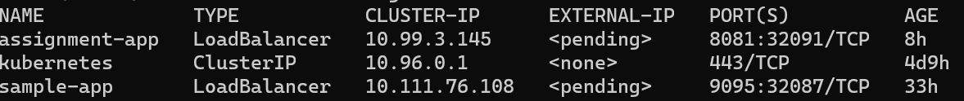

Screenshot for Number of Running Pods



Screenshot of Running Application. (Show Endpoint is accessible successfully through browser)

