Элтекс, 2лаба, сети, отчет.

Асташова Полина Дмитриевна.

1. Для заданной на схеме schema-lab2 сети, состоящей из управляемых коммутаторов и персональных компьютеров

настроить протокол STP, назначив явно один из коммутаторов корневым настройкой приоритета

Для свичей 2-5

enable

config t

spanning-tree mode ? //узнать какие протоколы поддерживает stp, выбираем режим pvst

spanning-tree mode pvst

spanning-tree vlan 1 включаем stp на коммутаторе

exit

show spanning-tree // проверяем приоритет когда вышли из конфига

Для свича 1

enable

config t

spanning-tree mode pvst

spanning-tree vlan 1 priority 4096 \\ включаем stp на коммутаторе

exit

2) Проверить доступность каждого с каждым всех персональных компьютеров (VPCS), результаты запротоколировать

|  |  |
| --- | --- |
| 1 | 192.168.1.101 |
| 2 | 192.168.1.103 |
| 3 | 192.168.1.104 |
| 4 | 192.168.1.105 |
| 5 | 192.168.1.106 |

1 пк

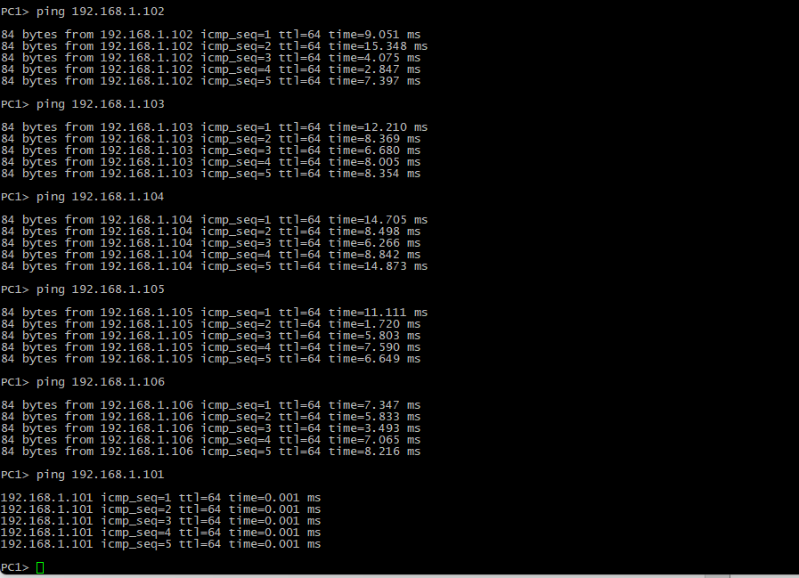

2ой

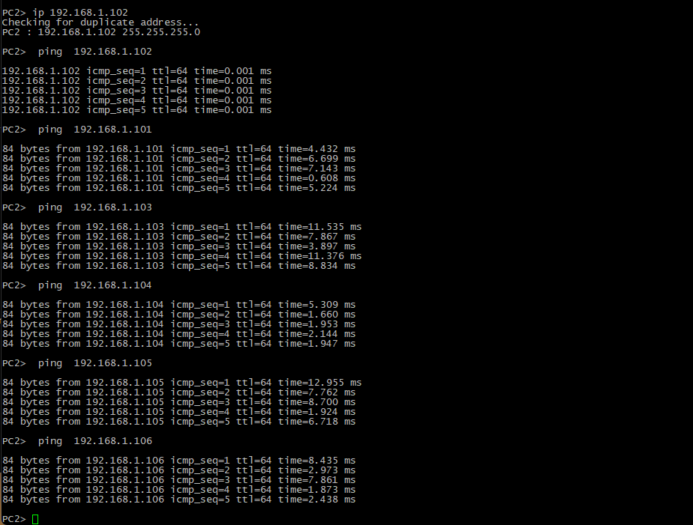

3

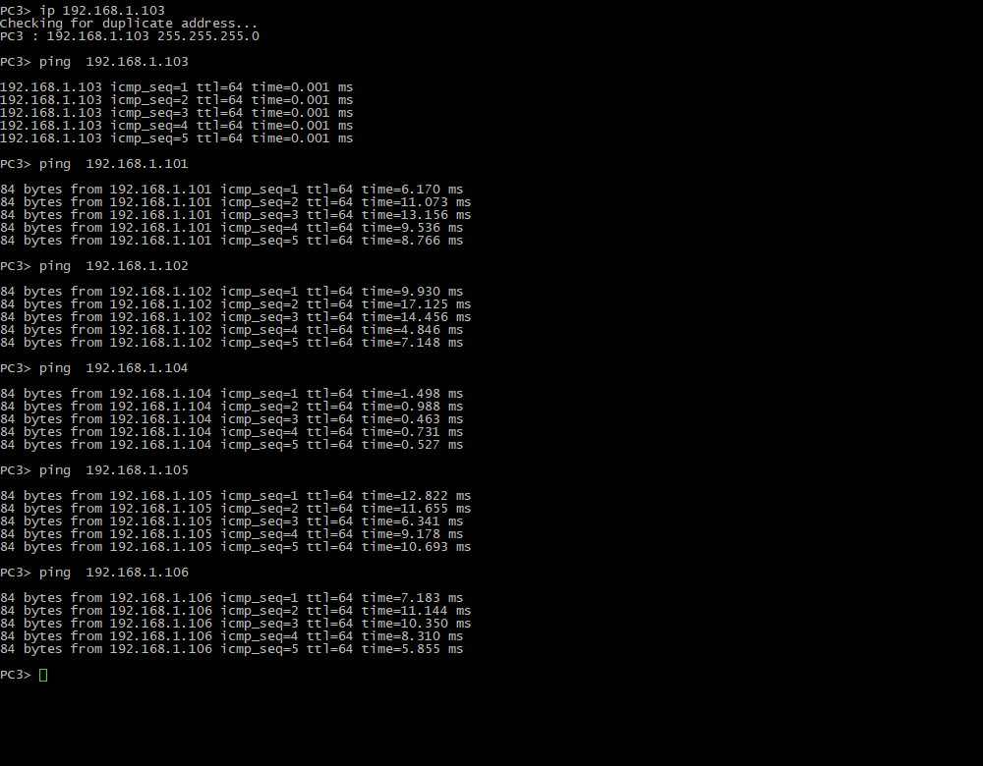

4

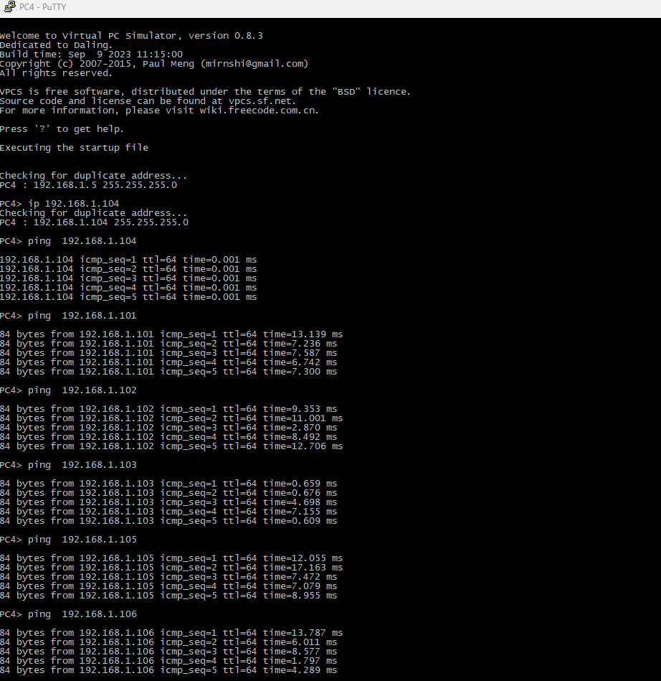

5fz

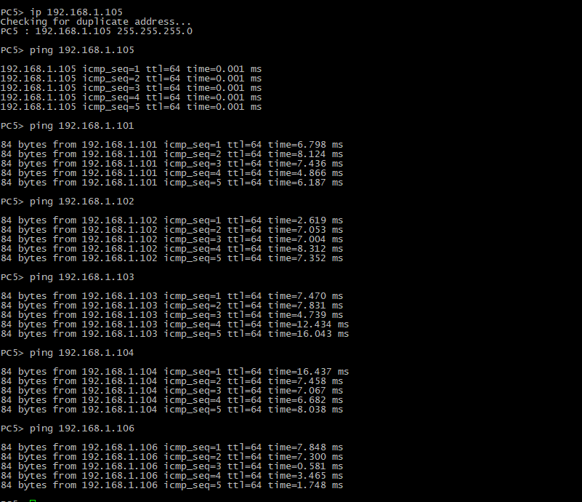

6fz

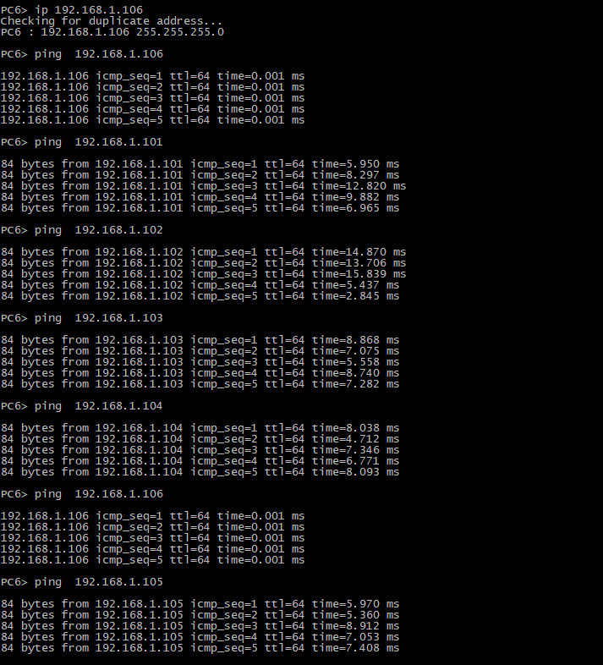

3) На изображении схемы отметить BID каждого коммутатора и режимы работы портов (RP/DP/blocked) и стоимости маршрутов, результат сохранить в файл

show spanning-tree // проверяем приоритет когда вышли из конфига

1свич 1. RP/DP/blocked 2- BID,стоимости маршрутов

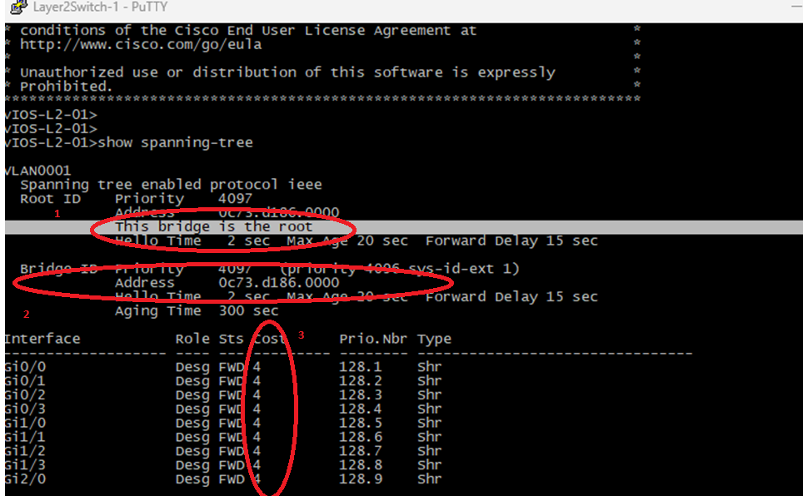

2ой свич

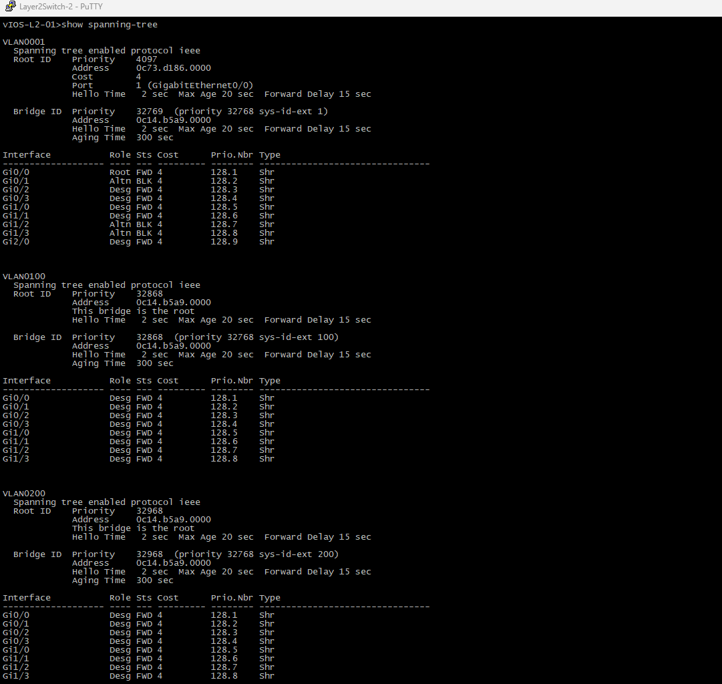

3ий свич

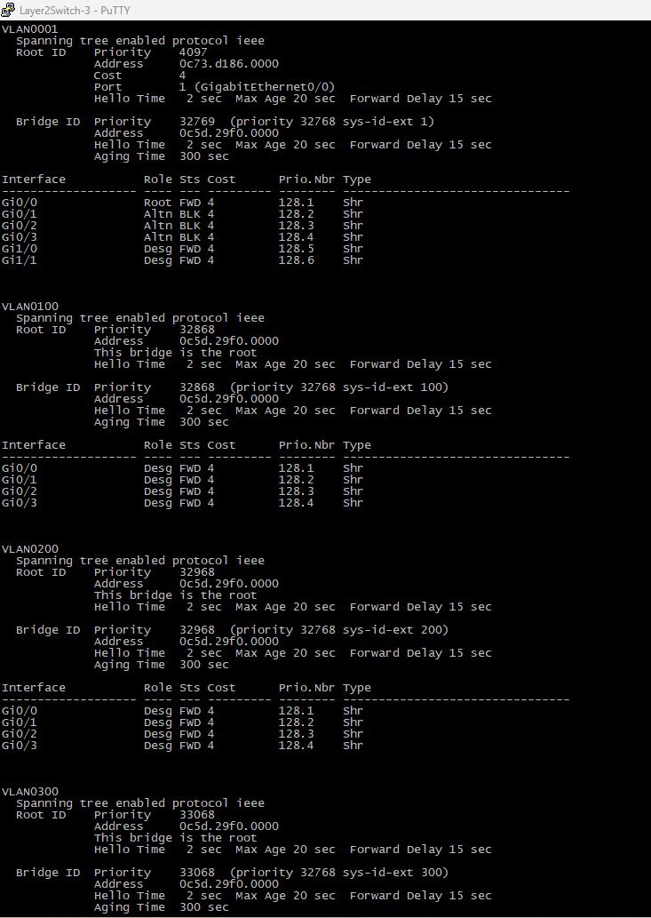

4ый свич:

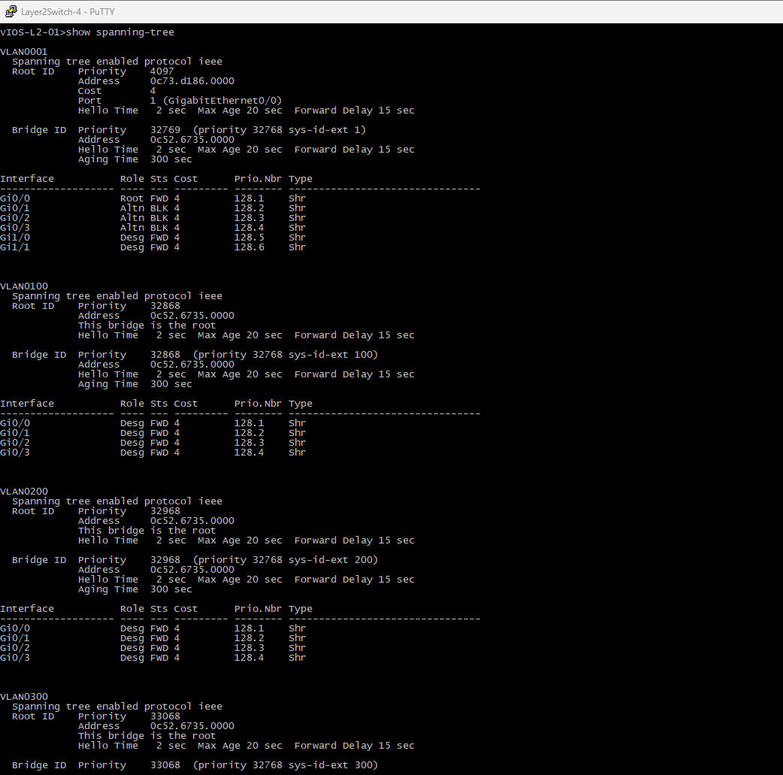

5ый свич

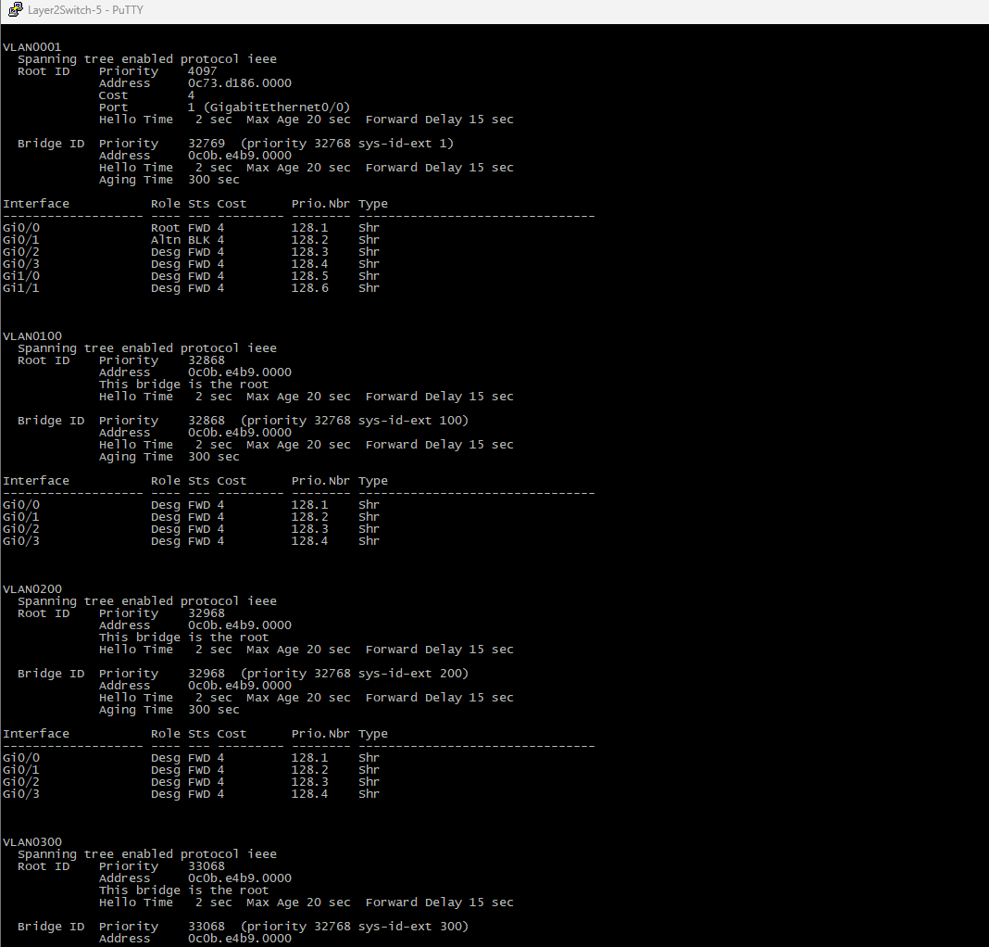

4) При помощи wireshark отследить передачу пакетов hello от корневого коммутатора на всех линках (nb!), результаты включить в отчет

1 линк

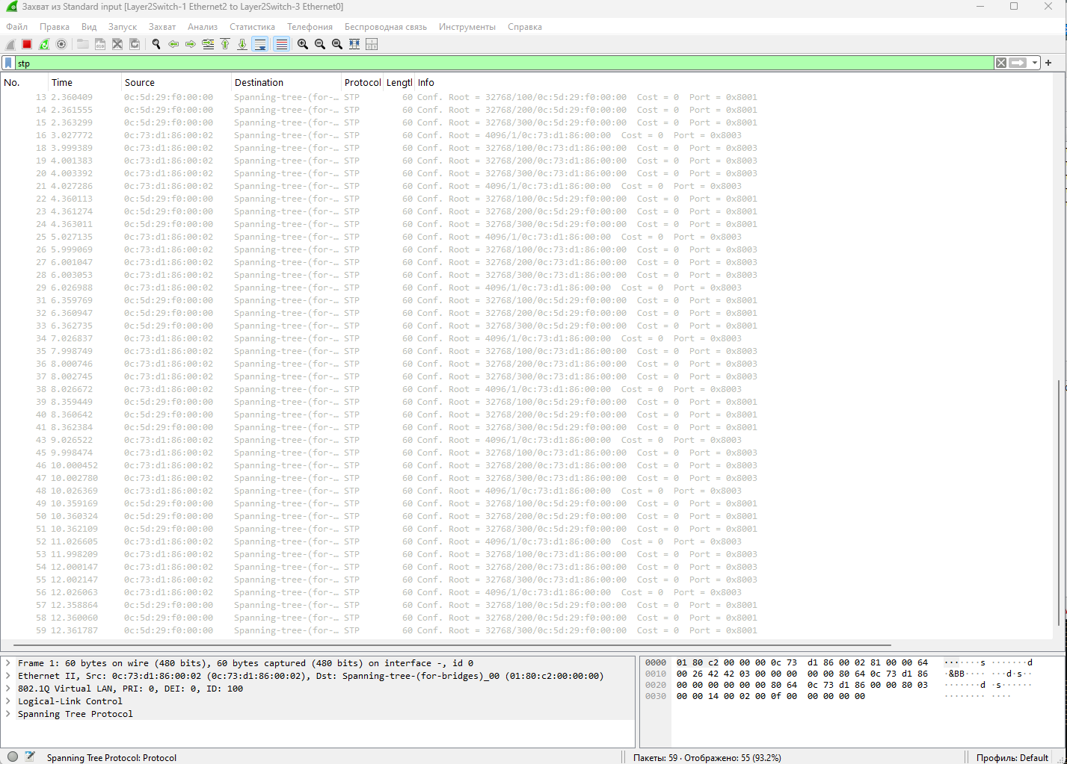

2 линк

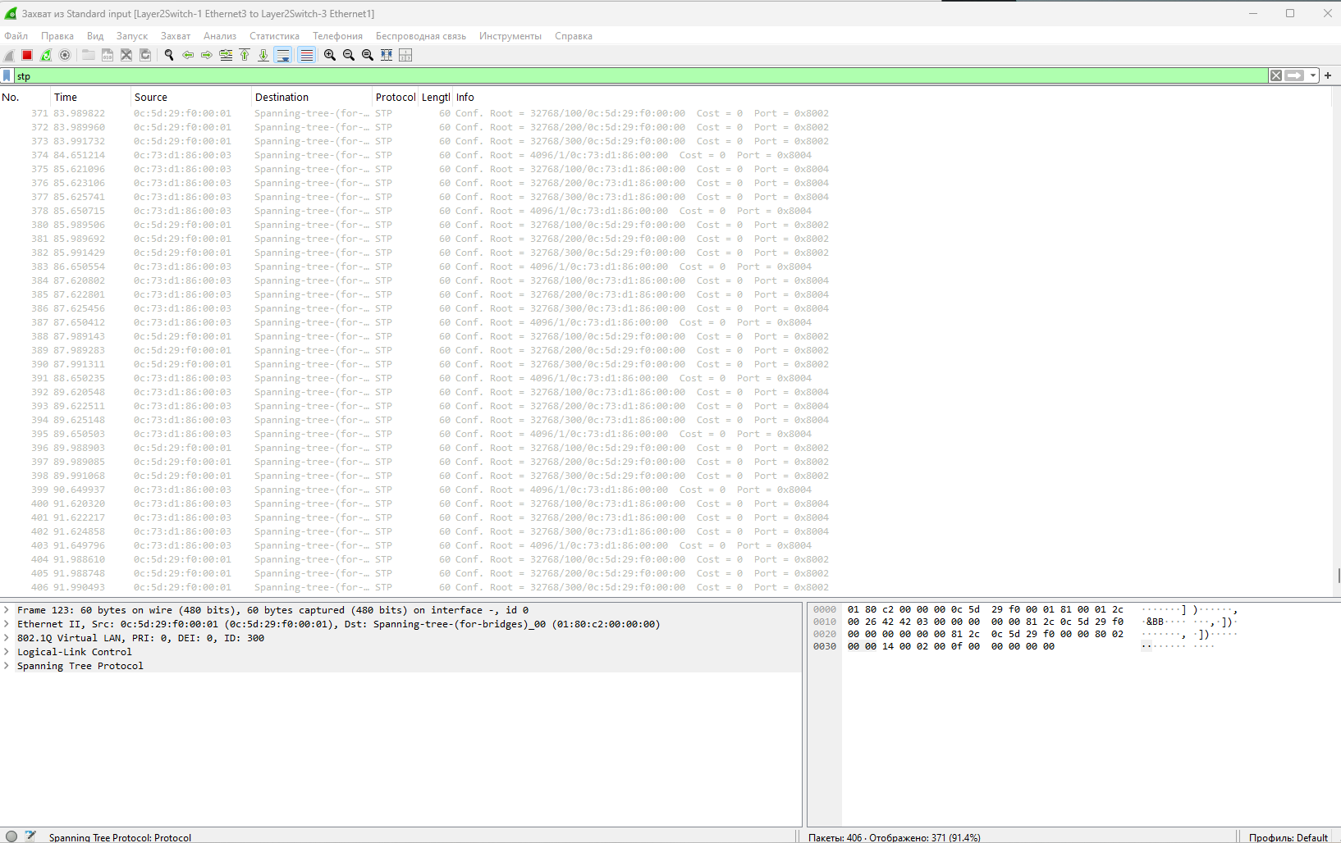

3 линк

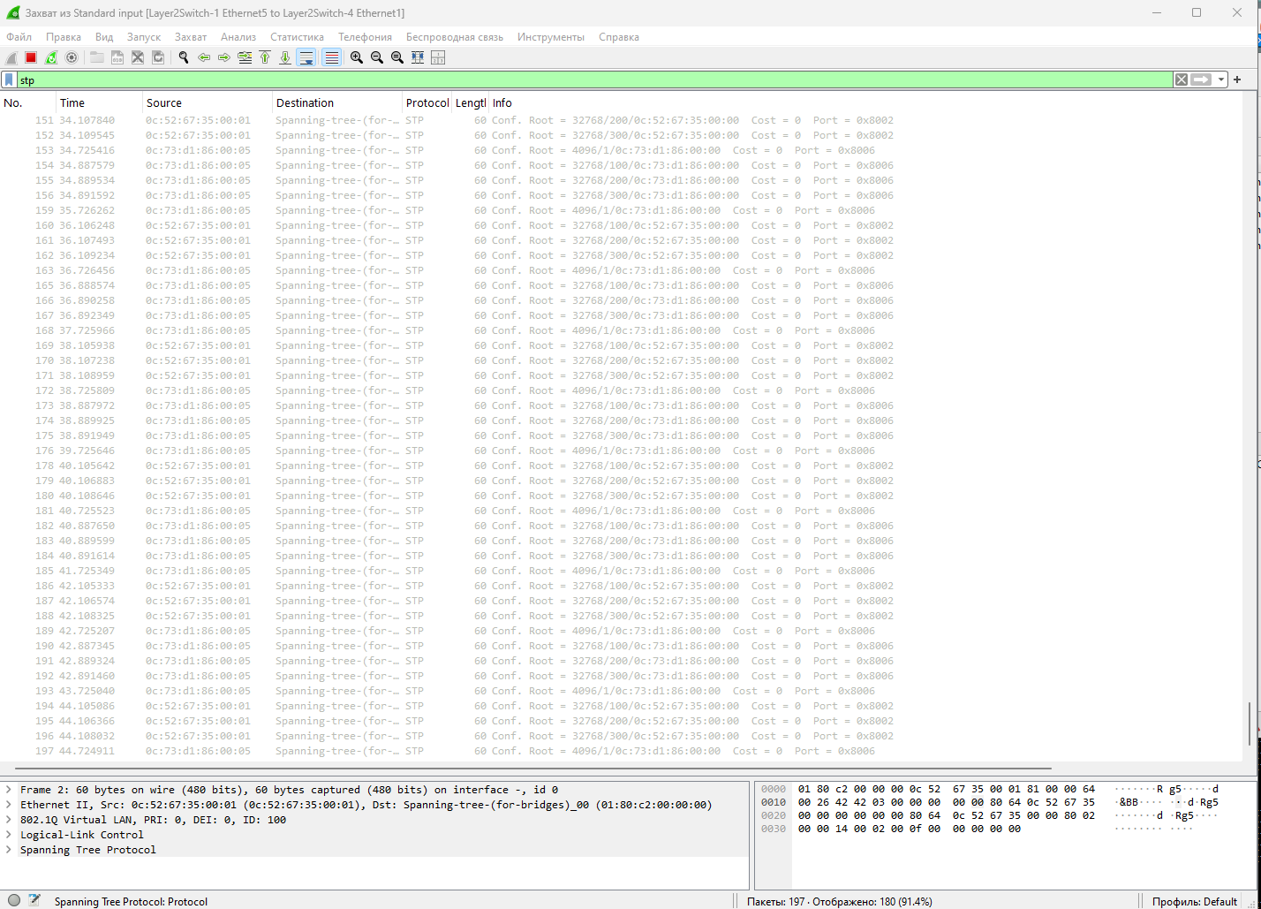

4 линк

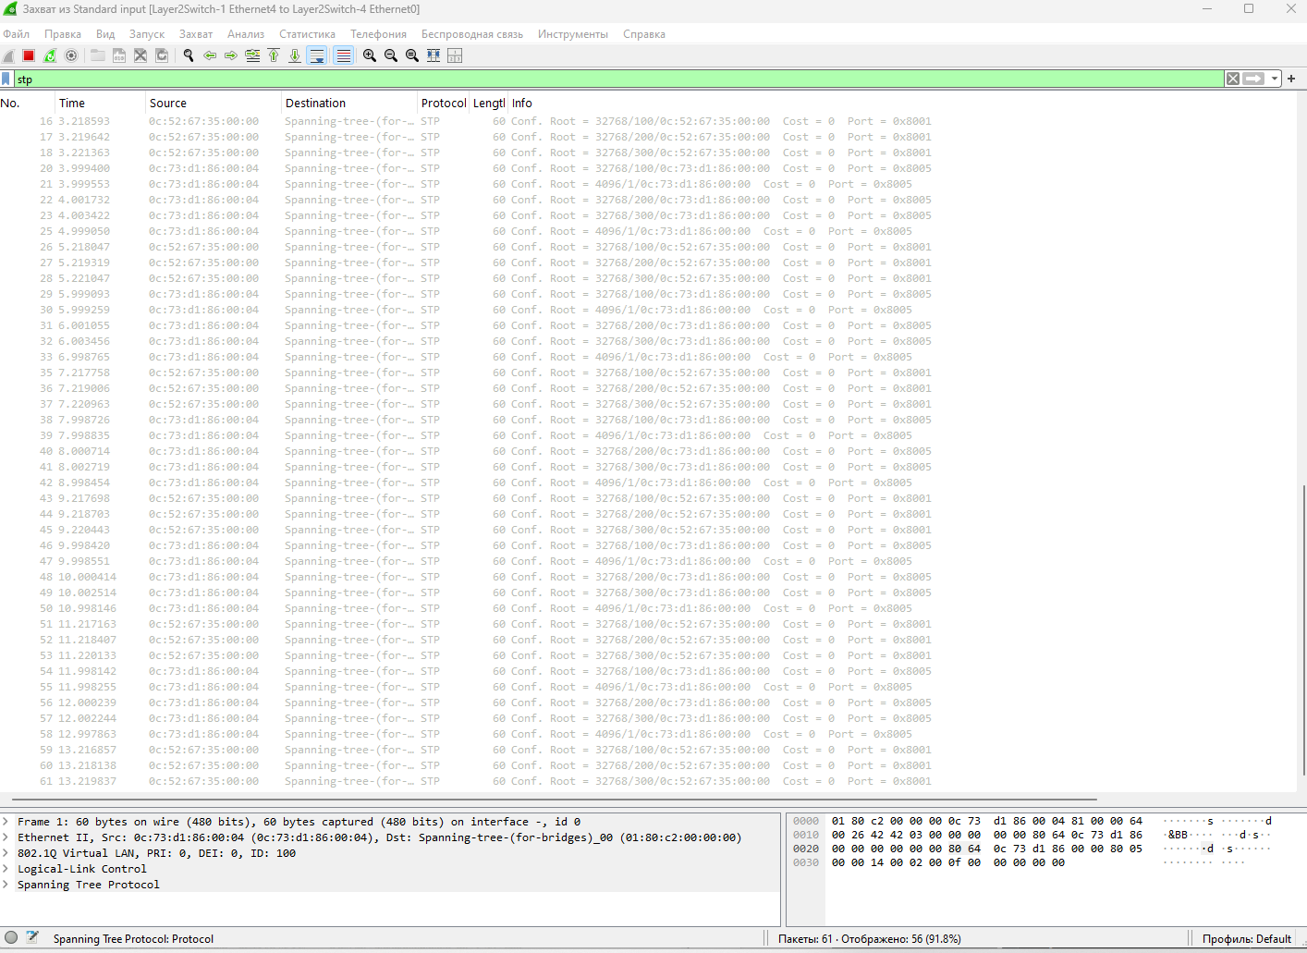

5 линк

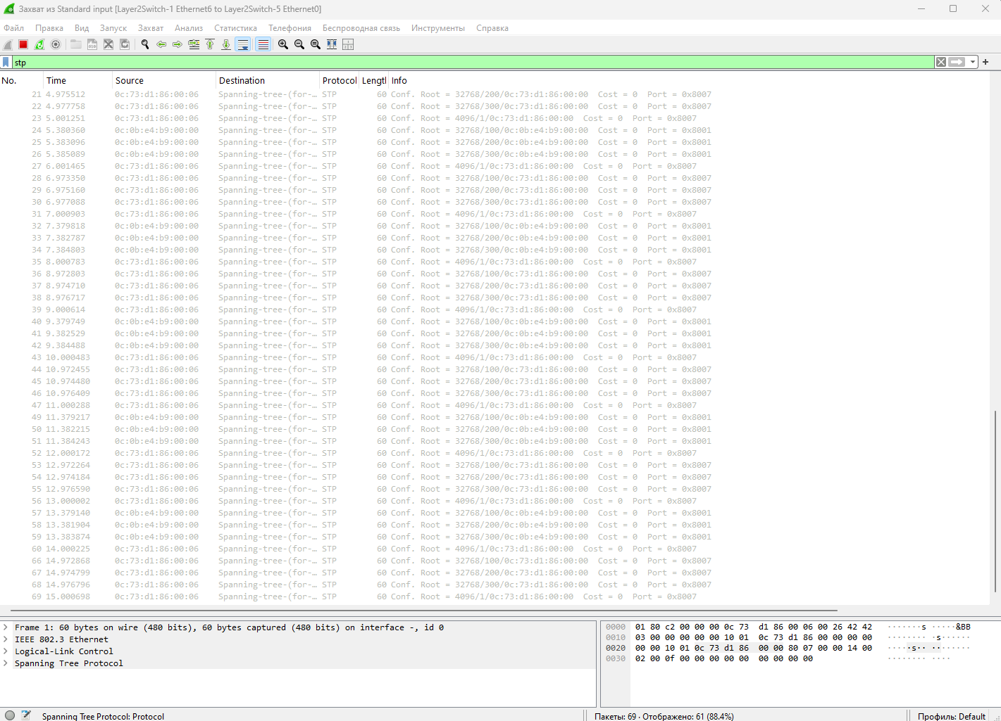

6линк

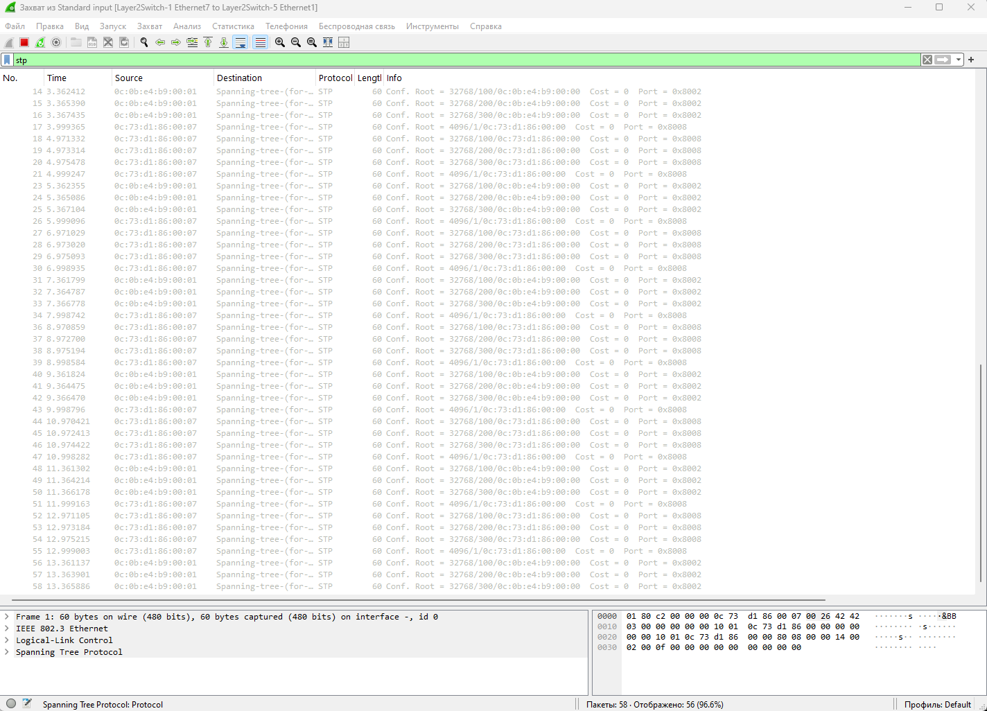

7линк

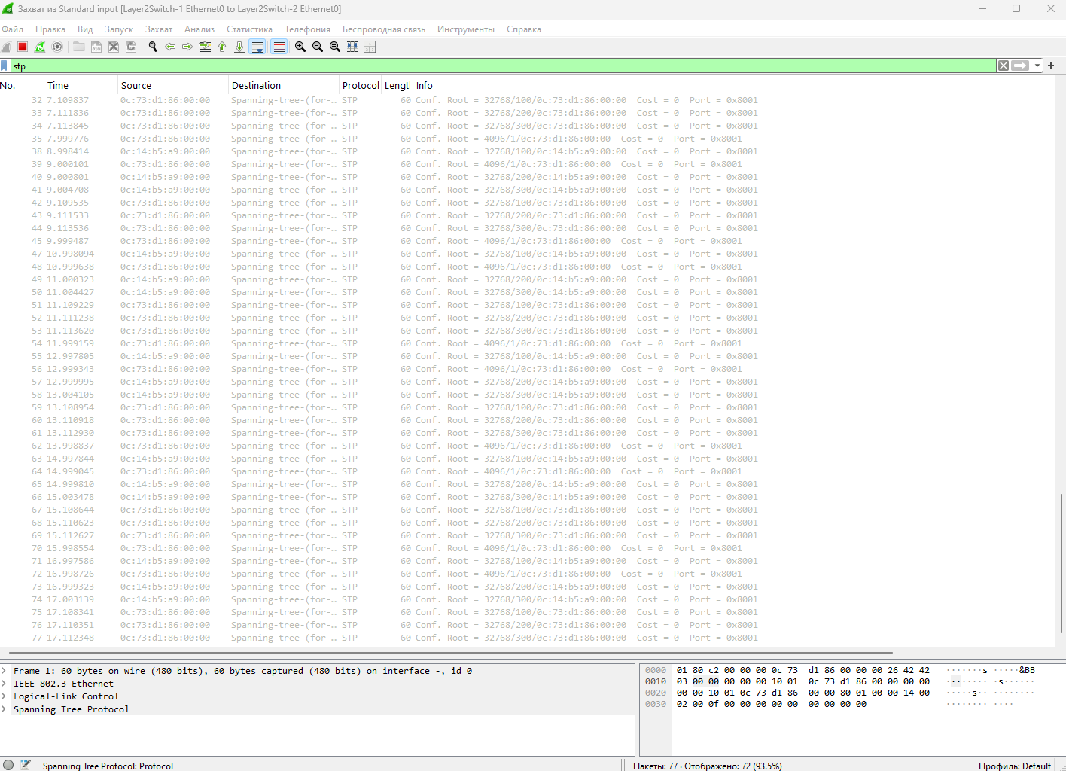

8линк

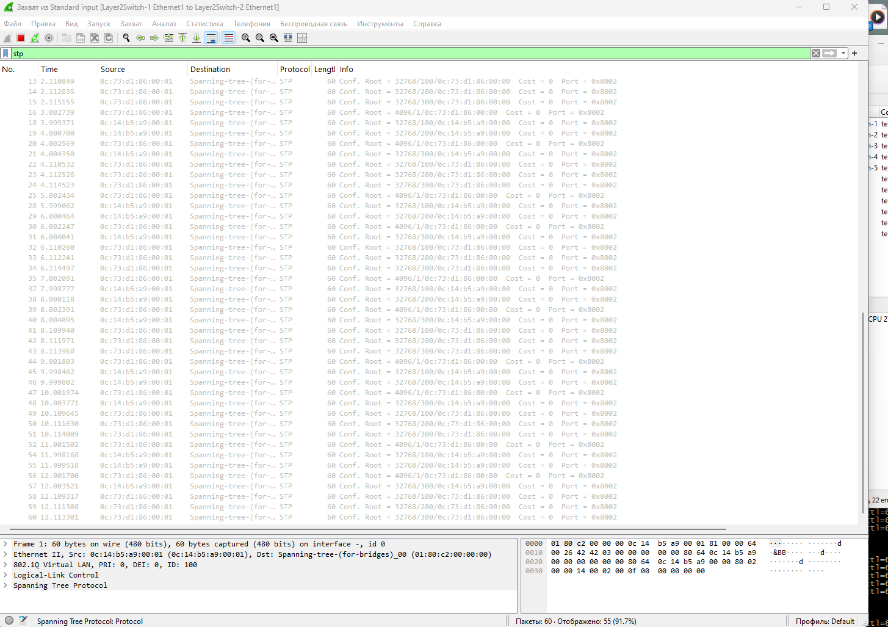

5) Изменить стоимость маршрута для порта RP произвольного назначенного (designated) коммутатора, повторить действия из п.3, результат сохранить в отдельный файл

show interface // посмотреть список доступных интерфейов

enable

config t

interface GigabitEthernet0/0

spanning-tree cost 50 //устанавливаем цену

show spanning-tree //cмотрим резултат

результат:

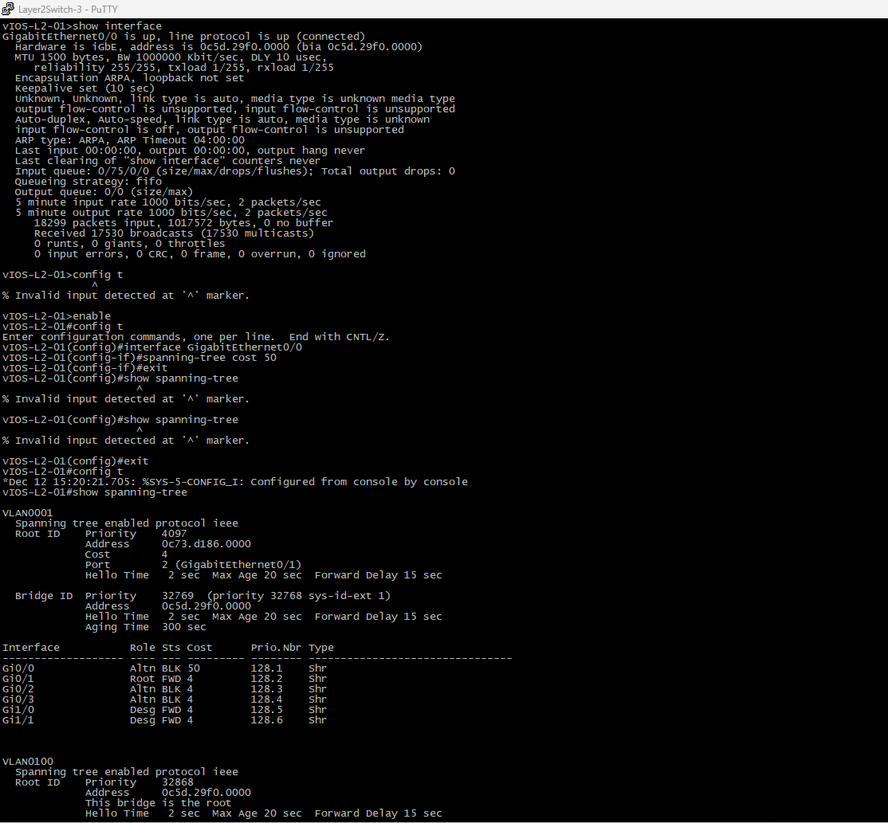

6) Сохранить файлы конфигураций устройств в виде набора файлов с именами, соответствующими именам устройств

7*) Опциональное задание: заменить STP на RSTP (IEEE 802.1w), повторить 1-6, отметить резервные порты в п.3 и п.5,

отличие работы протокола RSTP от протокола STP в п.4

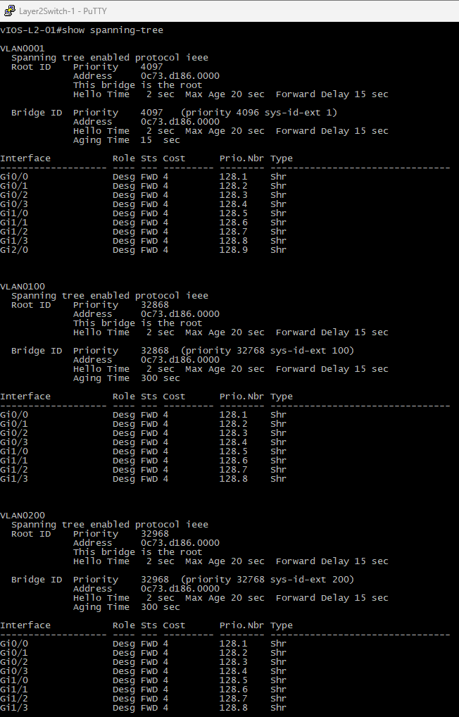

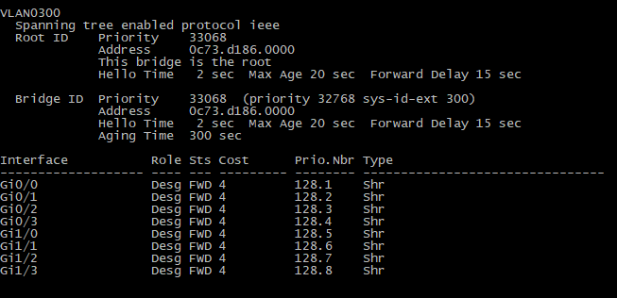

конфиг файл 3ий

Building configuration...

Current configuration : 5065 bytes

!

! Last configuration change at 15:20:21 UTC Thu Dec 12 2024

!

version 15.0

service timestamps debug datetime msec

service timestamps log datetime msec

no service password-encryption

service compress-config

!

hostname vIOS-L2-01

!

boot-start-marker

boot-end-marker

!

!

!

no aaa new-model

!

!

!

!

!

vtp domain CISCO-vIOS

vtp mode transparent

!

!

!

ip cef

no ipv6 cef

!

!

spanning-tree mode pvst

spanning-tree extend system-id

!

vlan internal allocation policy ascending

!

vlan 100

name VLAN100

!

vlan 200,300

!

!

!

!

!

!

!

!

!

!

!

!

!

interface GigabitEthernet0/0

media-type rj45

negotiation auto

spanning-tree cost 50

!

interface GigabitEthernet0/1

media-type rj45

negotiation auto

!

interface GigabitEthernet0/2

media-type rj45

negotiation auto

!

interface GigabitEthernet0/3

media-type rj45

negotiation auto

!

interface GigabitEthernet1/0

media-type rj45

negotiation auto

!

interface GigabitEthernet1/1

media-type rj45

negotiation auto

!

ip forward-protocol nd

!

no ip http server

no ip http secure-server

!

!

!

!

!

!

control-plane

!

banner exec ^C

**************************************************************************

* IOSv - Cisco Systems Confidential *

* *

* This software is provided as is without warranty for internal *

* development and testing purposes only under the terms of the Cisco *

* Early Field Trial agreement. Under no circumstances may this software *

* be used for production purposes or deployed in a production *

* environment. *

* *

* By using the software, you agree to abide by the terms and conditions *

* of the Cisco Early Field Trial Agreement as well as the terms and *

* conditions of the Cisco End User License Agreement at *

* http://www.cisco.com/go/eula *

* *

* Unauthorized use or distribution of this software is expressly *

* Prohibited. *

**************************************************************************^C

banner incoming ^C

**************************************************************************

* IOSv - Cisco Systems Confidential *

* *

* This software is provided as is without warranty for internal *

* development and testing purposes only under the terms of the Cisco *

* Early Field Trial agreement. Under no circumstances may this software *

* be used for production purposes or deployed in a production *

* environment. *

* *

* By using the software, you agree to abide by the terms and conditions *

* of the Cisco Early Field Trial Agreement as well as the terms and *

* conditions of the Cisco End User License Agreement at *

* http://www.cisco.com/go/eula *

* *

* Unauthorized use or distribution of this software is expressly *

* Prohibited. *

**************************************************************************^C

banner login ^C

**************************************************************************

* IOSv - Cisco Systems Confidential *

* *

* This software is provided as is without warranty for internal *

* development and testing purposes only under the terms of the Cisco *

* Early Field Trial agreement. Under no circumstances may this software *

* be used for production purposes or deployed in a production *

* environment. *

* *

* By using the software, you agree to abide by the terms and conditions *

* of the Cisco Early Field Trial Agreement as well as the terms and *

* conditions of the Cisco End User License Agreement at *

* http://www.cisco.com/go/eula *

* *

* Unauthorized use or distribution of this software is expressly *

* Prohibited. *

**************************************************************************^C

!

line con 0

logging synchronous

line aux 0

line vty 0 4

logging synchronous

login

line vty 5 15

logging synchronous

login

!

!

end

1ой

Building configuration...

Current configuration : 5277 bytes

!

! Last configuration change at 15:28:17 UTC Thu Dec 12 2024

!

version 15.0

service timestamps debug datetime msec

service timestamps log datetime msec

no service password-encryption

service compress-config

!

hostname vIOS-L2-01

!

boot-start-marker

boot-end-marker

!

!

!

no aaa new-model

!

!

!

!

!

vtp domain CISCO-vIOS

vtp mode transparent

!

!

!

ip cef

no ipv6 cef

!

!

!

spanning-tree mode pvst

spanning-tree extend system-id

spanning-tree vlan 1 priority 4096

!

vlan internal allocation policy ascending

!

vlan 100

name VLAN100

!

vlan 200,300

!

!

!

!

!

!

!

!

!

!

!

!

!

interface GigabitEthernet0/0

media-type rj45

negotiation auto

!

interface GigabitEthernet0/1

media-type rj45

negotiation auto

!

interface GigabitEthernet0/2

media-type rj45

negotiation auto

!

interface GigabitEthernet0/3

media-type rj45

negotiation auto

!

interface GigabitEthernet1/0

media-type rj45

negotiation auto

!

interface GigabitEthernet1/1

media-type rj45

negotiation auto

!

interface GigabitEthernet1/2

media-type rj45

negotiation auto

!

interface GigabitEthernet1/3

media-type rj45

negotiation auto

!

interface GigabitEthernet2/0

media-type rj45

negotiation auto

!

ip forward-protocol nd

!

no ip http server

no ip http secure-server

!

!

!

!

!

!

control-plane

!

banner exec ^C

**************************************************************************

* IOSv - Cisco Systems Confidential *

* *

* This software is provided as is without warranty for internal *

* development and testing purposes only under the terms of the Cisco *

* Early Field Trial agreement. Under no circumstances may this software *

* be used for production purposes or deployed in a production *

* environment. *

* *

* By using the software, you agree to abide by the terms and conditions *

* of the Cisco Early Field Trial Agreement as well as the terms and *

* conditions of the Cisco End User License Agreement at *

* http://www.cisco.com/go/eula *

* *

* Unauthorized use or distribution of this software is expressly *

* Prohibited. *

**************************************************************************^C

banner incoming ^C

**************************************************************************

* IOSv - Cisco Systems Confidential *

* *

* This software is provided as is without warranty for internal *

* development and testing purposes only under the terms of the Cisco *

* Early Field Trial agreement. Under no circumstances may this software *

* be used for production purposes or deployed in a production *

* environment. *

* *

* By using the software, you agree to abide by the terms and conditions *

* of the Cisco Early Field Trial Agreement as well as the terms and *

* conditions of the Cisco End User License Agreement at *

* http://www.cisco.com/go/eula *

* *

* Unauthorized use or distribution of this software is expressly *

* Prohibited. *

**************************************************************************^C

banner login ^C

**************************************************************************

* IOSv - Cisco Systems Confidential *

* *

* This software is provided as is without warranty for internal *

* development and testing purposes only under the terms of the Cisco *

* Early Field Trial agreement. Under no circumstances may this software *

* be used for production purposes or deployed in a production *

* environment. *

* *

* By using the software, you agree to abide by the terms and conditions *

* of the Cisco Early Field Trial Agreement as well as the terms and *

* conditions of the Cisco End User License Agreement at *

* http://www.cisco.com/go/eula *

* *

* Unauthorized use or distribution of this software is expressly *

* Prohibited. *

**************************************************************************^C

!

line con 0

logging synchronous

line aux 0

line vty 0 4

logging synchronous

login

line vty 5 15

logging synchronous

login

!

!

end

2JQ

Building configuration...

Current configuration : 5240 bytes

!

! Last configuration change at 15:10:52 UTC Thu Dec 12 2024

!

version 15.0

service timestamps debug datetime msec

service timestamps log datetime msec

no service password-encryption

service compress-config

!

hostname vIOS-L2-01

!

boot-start-marker

boot-end-marker

!

!

!

no aaa new-model

!

!

!

!

!

vtp domain CISCO-vIOS

vtp mode transparent

!

!

!

ip cef

no ipv6 cef

!

!

spanning-tree mode pvst

spanning-tree extend system-id

!

vlan internal allocation policy ascending

!

vlan 100

name VLAN100

!

vlan 200,300

!

!

!

!

!

!

!

!

!

!

!

!

!

interface GigabitEthernet0/0

media-type rj45

negotiation auto

!

interface GigabitEthernet0/1

media-type rj45

negotiation auto

!

interface GigabitEthernet0/2

media-type rj45

negotiation auto

!

interface GigabitEthernet0/3

media-type rj45

negotiation auto

!

interface GigabitEthernet1/0

media-type rj45

negotiation auto

!

interface GigabitEthernet1/1

media-type rj45

negotiation auto

!

interface GigabitEthernet1/2

media-type rj45

negotiation auto

!

interface GigabitEthernet1/3

media-type rj45

negotiation auto

!

interface GigabitEthernet2/0

media-type rj45

negotiation auto

!

ip forward-protocol nd

!

no ip http server

no ip http secure-server

!

!

!

!

!

!

control-plane

!

banner exec ^C

**************************************************************************

* IOSv - Cisco Systems Confidential *

* *

* This software is provided as is without warranty for internal *

* development and testing purposes only under the terms of the Cisco *

* Early Field Trial agreement. Under no circumstances may this software *

* be used for production purposes or deployed in a production *

* environment. *

* *

* By using the software, you agree to abide by the terms and conditions *

* of the Cisco Early Field Trial Agreement as well as the terms and *

* conditions of the Cisco End User License Agreement at *

* http://www.cisco.com/go/eula *

* *

* Unauthorized use or distribution of this software is expressly *

* Prohibited. *

**************************************************************************^C

banner incoming ^C

**************************************************************************

* IOSv - Cisco Systems Confidential *

* *

* This software is provided as is without warranty for internal *

* development and testing purposes only under the terms of the Cisco *

* Early Field Trial agreement. Under no circumstances may this software *

* be used for production purposes or deployed in a production *

* environment. *

* *

* By using the software, you agree to abide by the terms and conditions *

* of the Cisco Early Field Trial Agreement as well as the terms and *

* conditions of the Cisco End User License Agreement at *

* http://www.cisco.com/go/eula *

* *

* Unauthorized use or distribution of this software is expressly *

* Prohibited. *

**************************************************************************^C

banner login ^C

**************************************************************************

* IOSv - Cisco Systems Confidential *

* *

* This software is provided as is without warranty for internal *

* development and testing purposes only under the terms of the Cisco *

* Early Field Trial agreement. Under no circumstances may this software *

* be used for production purposes or deployed in a production *

* environment. *

* *

* By using the software, you agree to abide by the terms and conditions *

* of the Cisco Early Field Trial Agreement as well as the terms and *

* conditions of the Cisco End User License Agreement at *

* http://www.cisco.com/go/eula *

* *

* Unauthorized use or distribution of this software is expressly *

* Prohibited. *

**************************************************************************^C

!

line con 0

logging synchronous

line aux 0

line vty 0 4

logging synchronous

login

line vty 5 15

logging synchronous

login

!

!

end

4sq

Building configuration...

Current configuration : 5042 bytes

!

! Last configuration change at 13:24:41 UTC Thu Dec 12 2024

!

version 15.0

service timestamps debug datetime msec

service timestamps log datetime msec

no service password-encryption

service compress-config

!

hostname vIOS-L2-01

!

boot-start-marker

boot-end-marker

!

!

!

no aaa new-model

!

!

!

!

!

vtp domain CISCO-vIOS

vtp mode transparent

!

!

!

ip cef

no ipv6 cef

!

!

spanning-tree mode pvst

spanning-tree extend system-id

!

vlan internal allocation policy ascending

!

vlan 100

name VLAN100

!

vlan 200,300

!

!

!

!

!

!

!

!

!

!

!

!

!

interface GigabitEthernet0/0

media-type rj45

negotiation auto

!

interface GigabitEthernet0/1

media-type rj45

negotiation auto

!

interface GigabitEthernet0/2

media-type rj45

negotiation auto

!

interface GigabitEthernet0/3

media-type rj45

negotiation auto

!

interface GigabitEthernet1/0

media-type rj45

negotiation auto

!

interface GigabitEthernet1/1

media-type rj45

negotiation auto

!

ip forward-protocol nd

!

no ip http server

no ip http secure-server

!

!

!

!

!

!

control-plane

!

banner exec ^C

**************************************************************************

* IOSv - Cisco Systems Confidential *

* *

* This software is provided as is without warranty for internal *

* development and testing purposes only under the terms of the Cisco *

* Early Field Trial agreement. Under no circumstances may this software *

* be used for production purposes or deployed in a production *

* environment. *

* *

* By using the software, you agree to abide by the terms and conditions *

* of the Cisco Early Field Trial Agreement as well as the terms and *

* conditions of the Cisco End User License Agreement at *

* http://www.cisco.com/go/eula *

* *

* Unauthorized use or distribution of this software is expressly *

* Prohibited. *

**************************************************************************^C

banner incoming ^C

**************************************************************************

* IOSv - Cisco Systems Confidential *

* *

* This software is provided as is without warranty for internal *

* development and testing purposes only under the terms of the Cisco *

* Early Field Trial agreement. Under no circumstances may this software *

* be used for production purposes or deployed in a production *

* environment. *

* *

* By using the software, you agree to abide by the terms and conditions *

* of the Cisco Early Field Trial Agreement as well as the terms and *

* conditions of the Cisco End User License Agreement at *

* http://www.cisco.com/go/eula *

* *

* Unauthorized use or distribution of this software is expressly *

* Prohibited. *

**************************************************************************^C

banner login ^C

**************************************************************************

* IOSv - Cisco Systems Confidential *

* *

* This software is provided as is without warranty for internal *

* development and testing purposes only under the terms of the Cisco *

* Early Field Trial agreement. Under no circumstances may this software *

* be used for production purposes or deployed in a production *

* environment. *

* *

* By using the software, you agree to abide by the terms and conditions *

* of the Cisco Early Field Trial Agreement as well as the terms and *

* conditions of the Cisco End User License Agreement at *

* http://www.cisco.com/go/eula *

* *

* Unauthorized use or distribution of this software is expressly *

* Prohibited. *

**************************************************************************^C

!

line con 0

logging synchronous

line aux 0

line vty 0 4

logging synchronous

login

line vty 5 15

logging synchronous

login

!

!

end

5sq

Building configuration...

Current configuration : 5042 bytes

!

! Last configuration change at 13:24:42 UTC Thu Dec 12 2024

!

version 15.0

service timestamps debug datetime msec

service timestamps log datetime msec

no service password-encryption

service compress-config

!

hostname vIOS-L2-01

!

boot-start-marker

boot-end-marker

!

!

!

no aaa new-model

!

!

!

!

!

vtp domain CISCO-vIOS

vtp mode transparent

!

!

!

ip cef

no ipv6 cef

!

!

spanning-tree mode pvst

spanning-tree extend system-id

!

vlan internal allocation policy ascending

!

vlan 100

name VLAN100

!

vlan 200,300

!

!

!

!

!

!

!

!

!

!

!

!

!

interface GigabitEthernet0/0

media-type rj45

negotiation auto

!

interface GigabitEthernet0/1

media-type rj45

negotiation auto

!

interface GigabitEthernet0/2

media-type rj45

negotiation auto

!

interface GigabitEthernet0/3

media-type rj45

negotiation auto

!

interface GigabitEthernet1/0

media-type rj45

negotiation auto

!

interface GigabitEthernet1/1

media-type rj45

negotiation auto

!

ip forward-protocol nd

!

no ip http server

no ip http secure-server

!

!

!

!

!

!

control-plane

!

banner exec ^C

**************************************************************************

* IOSv - Cisco Systems Confidential *

* *

* This software is provided as is without warranty for internal *

* development and testing purposes only under the terms of the Cisco *

* Early Field Trial agreement. Under no circumstances may this software *

* be used for production purposes or deployed in a production *

* environment. *

* *

* By using the software, you agree to abide by the terms and conditions *

* of the Cisco Early Field Trial Agreement as well as the terms and *

* conditions of the Cisco End User License Agreement at *

* http://www.cisco.com/go/eula *

* *

* Unauthorized use or distribution of this software is expressly *

* Prohibited. *

**************************************************************************^C

banner incoming ^C

**************************************************************************

* IOSv - Cisco Systems Confidential *

* *

* This software is provided as is without warranty for internal *

* development and testing purposes only under the terms of the Cisco *

* Early Field Trial agreement. Under no circumstances may this software *

* be used for production purposes or deployed in a production *

* environment. *

* *

* By using the software, you agree to abide by the terms and conditions *

* of the Cisco Early Field Trial Agreement as well as the terms and *

* conditions of the Cisco End User License Agreement at *

* http://www.cisco.com/go/eula *

* *

* Unauthorized use or distribution of this software is expressly *

* Prohibited. *

**************************************************************************^C

banner login ^C

**************************************************************************

* IOSv - Cisco Systems Confidential *

* *

* This software is provided as is without warranty for internal *

* development and testing purposes only under the terms of the Cisco *

* Early Field Trial agreement. Under no circumstances may this software *

* be used for production purposes or deployed in a production *

* environment. *

* *

* By using the software, you agree to abide by the terms and conditions *

* of the Cisco Early Field Trial Agreement as well as the terms and *

* conditions of the Cisco End User License Agreement at *

* http://www.cisco.com/go/eula *

* *

* Unauthorized use or distribution of this software is expressly *

* Prohibited. *

**************************************************************************^C

!

line con 0

logging synchronous

line aux 0

line vty 0 4

logging synchronous

login

line vty 5 15

logging synchronous

login

!

!

end

кон