

The Event-Based Dating Model: A Project to Reduce Superficiality in Digital Romance

JONAH LOMU OTIENO

CCS/00002/022

BACHELOR OF SCIENCE COMPUTER SCIENCE

MASENO UNIVERSITY

SCHOOL OF COMPUTING AND INFORMATICS

DEPARTMENT OF COMPUTER SCIENCE

A project proposal submitted to the Department of Computer Science in the School of computing and informatics in partial fulfillment of the requirements for the award of the degree of Bachelors of Science Computer Science

Declaration
I declare that this work has not been previously submitted and approved for reward of a degree by Maseno University or any other university. To the best of my knowledge and belief, the proposal contains no material previously published nor written by another person except where due reference is made in proposal itself.

Jonah Lomu Otieno
CCS/00002/022 Date
……………………. …………………….

This project has been submitted for examination with my approval as University Supervisor.

Mr S. A Nyabundi Date
……………………. ……………………..

Acknowledgments
I wish to express my sincere gratitude to all those who contributed to the successful completion of this project.
First, I extend my heartfelt appreciation to my mother and my family for their constant love, encouragement, and unwavering support throughout the entire process. Their belief in me has been my greatest motivation.
I am deeply grateful to my supervisor, whose guidance, constructive feedback, and support have been invaluable in shaping this project. Their expertise and commitment greatly enhanced the quality of my work.
To everyone else who contributed in any way, directly or indirectly, I sincerely thank you.

Abstract
This project proposes the development of a new dating application that utilizes an event-based model to address the prevalent issues of superficiality and user fatigue in current mobile dating solutions. Unlike traditional apps that prioritize rapid profile-swiping, our platform, "Lomu" centers on user-generated local events as the primary mechanism for connection. Users connect by mutually agreeing to attend an event, with full profile visibility (including photos) deferred until a set time before the meeting. This design encourages investment in the shared activity and fosters initial interaction based on personality and common interests. The project encompasses the conceptual framework, user experience flow, and a prototype design, arguing that this model can create more meaningful first interactions and improve long-term user satisfaction in the online dating space.

Keywords:
event-based model
mutually
conceptual framework
user experience flow
prototype design

Table of Contents
Declaration 2
Acknowledgments 3
Keywords: 5
CHAPTER ONE: INTRODUCTION 7
1.1 Statement of the Problem 7
1.2 Proposed Solution 8
1.3 Objectives 10
1.4 Research Questions 10
1.5 Justification 11
CHAPTER TWO: LITERATURE REVIEW 13
2.1 Introduction 13
2.2 Theoretical Review and Conceptual Framework 14
2.2.1The Influence of Interface Design Paradigm on Social Interaction 14
2.2.2 Choice Architecture and the Paradox of Choice 15
2.2.3 The Primacy of Visual Information and Impression Formation 15
2.2.4 Conceptual Framework 16
2.3 Critique of the Existing Literature 17
2.4 Summary 18
2.5 Research Gaps 18
CHAPTER THREE: SYSTEM ANALYSIS AND DESIGN 20
3.1 Introduction 20
3.2 Systems Development Methodology 20
3.3 Feasibility Study 22
3.4 Requirements Elicitation: Data Collection 23
3.5 Data and System Analysis 25
3.6 System Specification 26
3.6.1 Functional Requirements (What the system must do): 26
3.6.2 Non-Functional Requirements 26
3.7 System Modeling and Detailed Specification 27
3.7.1 Input/Output Specification: 27
3.7.2 System Models 27
Diagram: 3.1 29
Diagram: 3.2 30
Diagram: 3.3 31
References 32

CHAPTER ONE: INTRODUCTION

1.1 Statement of the Problem
The increase of digital dating applications over the past decade has fundamentally reshaped how individuals initiate romantic and social connections. While these platforms have increased access to potential partners, a growing body of evidence suggests that the dominant design paradigm—the "swipe-and-match" model—is generating significant negative externalities for user well-being and the quality of modern relationships. This project, "lomu: Dating Designed for Serendipity," directly addresses the core problem: The architectural design of mainstream dating applications fosters superficiality, leads to high rates of user burnout, and ultimately hinders the formation of genuine, sustainable connections.
The problem is not a lack of potential partners, but the psychologically taxing environment in which connections are made. This can be broken down into three interconnected sub-problems:
- The Paradox of Choice and Commodification of People: The infinite-scroll interface of profiles reduces potential partners to disposable commodities in a digital marketplace. A study associated with the University of Chicago Booth School of Business found that an overwhelming number of choices can lead to decision paralysis, dissatisfaction, and self-blame (Lenton & Francesconi, 2010). In the context of dating apps, this "paradox of choice" discourages users from investing deeply in any single match, fostering a "grass is greener" mentality where individuals are perpetually seeking a better option, thereby devaluing the present connection.
- The Primacy of Physical Appearance and Profile Curation: The swipe mechanism is overwhelmingly based on a split-second judgment of a photograph. This design prioritizes physical appearance above all other attributes, such as personality, values, or shared interests. Research published in the Journal of Social and Personal Relationships has shown that this focus on photos can lead to increased objectification and heightened anxiety about one's own self-image (Strubel & Petrie, 2020). Furthermore, profiles become carefully curated personal brands, which are not always authentic representations of the individual, leading to mistrust and disappointment upon meeting in person.
- User Burnout and Psychological Fatigue: The transactional nature of swiping, combined with low-quality interactions (e.g., ghosting, low-effort messaging), leads to high levels of user fatigue. A 2023 Pew Research Center study found that a majority of dating app users in Kenya. (55%) report feeling disappointed by their interactions on the platforms, with a significant portion describing their overall experience as somewhat or very negative. This is not merely an inconvenience; it has tangible effects on mental health, contributing to feelings of loneliness, rejection, and diminished self-esteem, even as users feel compelled to continue participating.
The magnitude of this problem is substantial. With an estimated over 300 million people worldwide using dating apps, the psychological impact of these design flaws is widespread. The effects extend beyond individual dissatisfaction, influencing broader social dynamics by normalizing disposable interactions and eroding the skills and patience required for organic relationship building.
Therefore, the research problem this project investigates is not merely the existence of "bad" dating apps, but a fundamental flaw in their human-computer interaction (HCI) design. The core problem is that the architectural framework of the dominant dating app model is misaligned with the psychological and social prerequisites for fostering authentic human connection. This project will attempt to solve this by proposing and designing a new framework—one centered on shared experiences and deferred visual judgment—to determine if a different digital environment can produce more positive and meaningful outcomes for its users.

1.2 Proposed Solution
This research seeks to design and evaluate a novel conceptual framework for digital dating that moves beyond the swipe-based paradigm to foster more authentic and sustainable connections. In response to the documented problems of superficiality, commodification, and user burnout, the proposed solution is an experience-centric connection model.
Globally, the industry has seen iterative improvements within the existing paradigm, such as more sophisticated algorithms for match suggestion (e.g., Hinge's "Most Compatible") or features promoting profile depth (e.g., detailed prompts). Regionally, apps like Tinder have emphasized women making the first move to alter dynamic interactions. However, these models still operate within the fundamental structure of profiling and swiping on individuals, a design that inherently prioritizes appearance and encourages comparison.
A more radical departure can be seen in emerging concepts that integrate social features or focus on specific communities. However, many still fall short of decoupling the initial connection from direct profile evaluation. The solution proposed by this research does not seek to create a "better profile," but to eliminate the profile-as-a-shopping-catalog metaphor entirely during the initial matching phase.
The core of this research is to investigate whether facilitating connections based on mutual participation in a shared activity or experience can serve as a more effective and psychologically sustainable foundation for initial interaction. This model is predicated on established social science theory, which indicates that shared activities provide a natural context for interaction, reduce initial anxiety, and foster bonds based on cooperation and shared interest rather than mere physical attraction.
Therefore, this research will conceptualize a system where:
The primary unit of interaction is a user-proposed real-world event or activity.
Connection is initiated through a mutual commitment to an experience, not through a judgment of a curated profile.
The revelation of personal identifiers (such as full profile photos) is intentionally deferred, forcing initial engagement to be based on personality, communication, and shared interests as they relate to the planned activity.
This research seeks to validate the hypothesis that by configuring a digital dating environment around shared experiences and delayed visual judgment, it is possible to mitigate the paradox of choice, reduce the emphasis on superficial appearance, and decrease user burnout, thereby increasing the potential for genuine connection. The outcome will be a comprehensive design framework that challenges the incumbent industry standards and offers a new pathway for the future of digital social interaction.

1.3 Objectives
General Objective
- To design, develop, and evaluate a prototype for an experience-centric dating application that reduces superficiality and fosters more authentic initial connections.
Specific Objectives
- To investigate and document the specific limitations of the swipe-based dating model and user requirements for a more authentic connection platform through a comprehensive analysis of existing literature and user surveys.
- To design a complete system architecture and user interface prototype for the lomu application that implements an event-based matching mechanism with deferred profile revelation.
- To develop a functional, limited-scope prototype of the lomu application capable of demonstrating the core event-creation, matching, and chat features.
- To evaluate the prototype's effectiveness in mitigating user-reported issues of superficiality and burnout through controlled user acceptance testing (UAT) and structured feedback collection.

1.4 Research Questions
- What are the predominant user pain points and psychological impacts associated with the swipe-based dating model, and what key features do users identify as necessary for fostering more authentic digital connections?

- How can principles of user experience (UX) design and social psychology be effectively integrated into a system architecture to shift user focus from profile evaluation to shared activity-based interaction?

- To what extent can a functional prototype demonstrating an event-based matching mechanism be developed within a constrained timeline while maintaining core usability and stability?

- How does the experience-centric model, as implemented in the prototype, influence user perceptions of superficiality, connection quality, and overall engagement compared to their experiences with traditional dating applications?

1.5 Justification
The justification for undertaking this research on the "lomu" dating application is threefold, addressing its necessity, its beneficiaries, and its contribution to the field.
Firstly, this research is critically needed due to the documented and widespread user dissatisfaction with the current digital dating paradigm. As established, the swipe-based model is linked to psychological fatigue, superficial interactions, and a com modified approach to human connection. This project moves beyond merely identifying these problems and proposes a tangible, research-backed alternative. It is justified by the urgent need to explore more humane and effective digital social environments that prioritize user well-being over engagement metrics that lead to burnout.
The outcomes of this research will benefit multiple stakeholders. End-users stand to gain from a potentially less stressful and more meaningful platform for social connection, which could improve their overall digital well-being. Application developers and the broader tech industry can benefit from a validated, alternative design framework that challenges the status quo, offering a new pathway for innovation in a saturated market. Furthermore, academics and researchers in fields like Human-Computer Interaction and social psychology will gain valuable insights into how specific design choices can influence social dynamics and user psychology in digital spaces.
This project contributes significantly to the research area by proposing and testing a novel "experience-centric connection model." While most existing solutions work within the profile-swipe framework, this research explores a fundamental architectural shift. Its primary contribution is an empirical investigation into whether decoupling the initial match from profile appraisal and anchoring it around a shared activity can mitigate the inherent problems of the dominant model. This provides a new perspective and a set of design principles for creating digital platforms that are intentionally engineered to foster genuine, rather than transactional, human interaction.

CHAPTER TWO: LITERATURE REVIEW

2.1 Introduction
This chapter provides a critical analysis of the existing body of knowledge relevant to the design and impact of digital dating applications, situating the proposed "lomu" project within the broader academic and industry discourse. The pervasive adoption of swipe-based platforms has generated significant interdisciplinary research, examining their effects on social behavior, psychological well-being, and human-computer interaction. A thorough review of this literature is essential to understand the validated problems inherent in current models and to identify gaps that justify an alternative approach.
The review is structured into four key thematic sections. First, it will examine the Evolution and Dominant Paradigms of Digital Dating, tracing the technological and cultural shift from early web-based systems to the current mobile-first, gamified swipe model. Second, it will synthesize research on the Psychological and Social Impacts of Swipe-Based Design, focusing on empirical evidence linking specific interface features to outcomes like choice paralysis, commodification, and user burnout. Third, it will explore existing Alternative Models and Theoretical Frameworks for Digital Connection, analyzing both commercial attempts at innovation and relevant social science theories that could inform a new design. Finally, it will investigate core Design Principles for Fostering Authenticity and Reducing Superficiality in digital social platforms, drawing from literature in HCI, social psychology, and behavioral design.
The purpose of this review is not merely to catalog previous work, but to build a foundational argument. It will demonstrate that while the problems of mainstream dating apps are well-documented, most solutions remain incremental tweaks within a flawed paradigm. By identifying the theoretical and practical gaps—particularly the lack of mainstream platforms that successfully de-prioritize visual assessment and re-center shared experience—this chapter will establish a clear academic and practical justification for the experience-centric model proposed by this research.

2.2 Theoretical Review and Conceptual Framework
This section critically examines the empirical and theoretical literature underpinning the central problem and the proposed solution. It is structured around the key variables hypothesized to influence connection quality and user well-being in digital dating: the Interface Design Paradigm, Choice Architecture, and the Primacy of Visual Information. By analysing prior research on these variables, a conceptual framework is developed to guide the analysis of the proposed experience-centric model.

2.2.1The Influence of Interface Design Paradigm on Social Interaction
The dominant "swipe" interface represents a specific design paradigm with profound implications for social behavior. This paradigm can be theorized through the lens of Social Information Processing (SIP) theory (Walther 1992), which suggests that while computer-mediated communication (CMC) users adapt to reduced social cues, they eventually develop impressions and relationships, albeit at a slower pace. However, the swipe model deliberately accelerates this process to an extreme, forcing hyper-rapid, cue-impoverished judgments based primarily on photographs, thereby subverting the natural adaptation process described by SIP (Sharabi and Timmerman 2020).
Empirically, researchers have linked this gamified, high-velocity interface to the commodification of potential partners. Lenton, Fasolo and Todd (2008, p. 93) argue that such environments encourage a "shopping mentality," where individuals are evaluated like consumer products. This is exacerbated by design features like infinite scroll and mutual opt-in gates (swiping), which mirror slot-machine mechanics and trigger variable reinforcement schedules, a powerful driver of addictive behavior (Schüll 2014). The methodological approach here often involves experimental surveys and longitudinal studies measuring user attitudes and self-reported behaviors (e.g., Timmerman and Courtois 2018). A significant gap exists, however, in applied research that designs and tests alternative interface paradigms not based on rapid, binary assessment, which directly informs Research Question 2 on integrating UX and psychology.

2.2.2 Choice Architecture and the Paradox of Choice
A core variable influencing user satisfaction is the architecture of choice presented by the platform. This draws directly from Schwartz's (2004) theory of the paradox of choice, which posits that an overabundance of options leads to anxiety, decision paralysis, and post-decision regret. In digital dating, the "massive but ambiguous" choice set is a defining feature (Heino, Ellison and Gibbs 2010, p. 430).
Empirical studies support this linkage. Using survey methodology, D’Angelo and Toma (2016) found that users facing larger choice sets reported lower satisfaction and greater difficulty choosing, often engaging in "relationshopping"—continually searching for a better option rather than investing in a current match. This creates a market-like dynamic where commitment is devalued. Most research has focused on quantifying this effect within existing apps, employing user experience (UX) surveys and log-data analysis (Rosenfeld, Thomas and Hausen 2019). A clear gap is experimental research on systems that structurally limit or re-contextualise choice—for example, by making the primary choice an activity rather than a person—which this project aims to address, linking to Research Question 4 on evaluating the new model’s impact on engagement and satisfaction.

2.2.3 The Primacy of Visual Information and Impression Formation
The variable of visual primacy is critical in understanding superficiality. The design mandates that a photograph is the first and often only filter, drawing on theories of impression formation where initial cues disproportionately shape final judgments (Asch 1946). In digital contexts, this leads to a reliance on homophily based on appearance and intense curation of one's visual profile (Ranzini and Lutz 2016).
Empirical work by Hancock and Toma (2009) using content analysis of profiles demonstrated significant discrepancies between online self-presentation and reality, noting that users engage in selective self-presentation, often "enhancing" their attractiveness. This fosters an environment of mistrust and objectification. Research methodologies here include profile analysis, experiments manipulating profile photo attractiveness, and studies on self-objectification (Strubel and Petrie 2020). The identified gap is in designing systems that can delay or contextualise visual cues to allow other dimensions of personality (e.g., values, communication style) to form initial impressions, a core hypothesis tested by this project's deferred photo-reveal mechanism, directly relevant to Research Question 1 on user-identified needs for authenticity.

2.2.4 Conceptual Framework
The synthesized literature informs the following conceptual framework, which illustrates the hypothesized causal pathways of the traditional model and the proposed intervention point for the "lomu" solution.
(A) Traditional Swipe-Based Model:
- Independent Variable: Interface Design (Swipe/Gamified, Infinite Choice, Visual Primacy).
- Intervening Variables: Leads to User Behavior characterized by Rapid Judgement, Commodification Mentality, and Profile Curation.
- Dependent Variables: Resulting in Outcomes of Low-Quality Connections, User Burnout, and Superficial Interactions.
(B) Proposed Experience-Centric Intervention:
- Independent Variable: Interface Design (Event-Based, Constrained Choice, Deferred Visuals).
- Hypothesized Intervening Variables: Leads to User Behavior characterized by Investment in Shared Activity, Personality-First Engagement, and Reduced Comparison.
- Hypothesized Dependent Variables: Anticipated to yield Outcomes of More Authentic Connections, Higher User Satisfaction, and Reduced Burnout.
The framework posits that by manipulating the key independent variable of Interface Design away from the traits in Path (A) and towards those in Path (B), the project can positively influence the intervening behavioral variables and, ultimately, the key outcome variables of connection quality and user well-being. This framework will guide the system design and the evaluation of the prototype.

2.3 Critique of the Existing Literature

The preceding review establishes a robust empirical and theoretical consensus on the negative psychosocial impacts of the swipe-based dating model, particularly concerning choice overload, visual primacy, and commodification. However, a critical analysis reveals two significant limitations in the existing body of literature, which this study seeks to address.
Firstly, there is a pronounced methodological and conceptual gap between detailed analysis and constructive design. The literature is overwhelmingly diagnostic. Studies excel at employing surveys (D’Angelo and Toma 2016), profile analyses (Hancock and Toma 2009), and theoretical frameworks (Schwartz 2004; Walther 1992) to deconstruct the problems inherent in platforms like Tinder. Yet, this research largely stops at the point of critique. There is a scarcity of applied, interventionist studies that move beyond identifying the negative effects of "visual primacy" or the "paradox of choice" to actively design, implement, and test alternative digital architectures intended to mitigate these effects. The work of scholars like Schüll (2014) on addictive design is used to explain user retention but is seldom applied to proactively design for healthier engagement. This leaves a gap where the compelling critique of the dominant paradigm is not matched by empirically tested, novel design frameworks, which is the central undertaking of this project.
Secondly, the literature exhibits a constrained imagination regarding viable alternatives. When alternatives are explored, they frequently remain within the fundamental profile-swipe paradigm, focusing on incremental modifications such as more detailed profiles, different matching algorithms, or slight alterations to interaction rules (e.g., women messaging first). While valuable, these approaches accept the core premise that dating apps are primarily about profiling and selecting individuals from a catalogue. There is limited rigorous exploration of models that fundamentally redefine the unit of connection—for instance, from a person to a shared activity or context. This suggests an industry and academic bias towards optimizing an established, commercially successful model rather than challenging its foundational assumptions. The proposed experience-centric model of "lomu" directly confronts this limitation by testing a premise that is often discussed in theory—reducing superficiality by delaying visual cues and prioritising shared context—but remains critically under-evaluated in practice.
In conclusion, while the existing literature provides an essential foundation by rigorously validating the problem space, it simultaneously highlights its own limitation: a lack of translational research that bridges critical social science theory with innovative Human-Computer Interaction (HCI) design to propose and evaluate substantively different solutions. This project positions itself to contribute directly to this gap, using the established critiques as design requirements to engineer and assess a novel connection model.

2.4 Summary
This literature review has established a critical foundation for the research project. It began by tracing the evolution of digital dating to the current dominant paradigm: the gamified, swipe-based interface characterized by infinite choice and visual primacy. Drawing on interdisciplinary theories such as Social Information Processing, the Paradox of Choice, and Impression Formation, the review synthesized empirical evidence demonstrating that this specific design architecture leads to measurable negative outcomes. These include user behaviors like commodification and profile curation, which ultimately result in psychological fatigue, superficial interactions, and diminished connection quality. While the review acknowledged minor iterations within the industry, it argued that most so-called alternatives remain constrained within the fundamental profile-browsing paradigm. The conceptual framework derived from this analysis clearly maps the causal pathway from interface design choices to user outcomes, thereby precisely defining the variables that the proposed "lomu" model seeks to influence.

2.5 Research Gaps
The critique of the literature reveals two primary research gaps that this project aims to address:
- The Translational Design Gap: There is a significant disconnect between the robust diagnostic critique of existing dating apps and the development of empirically tested, alternative design frameworks. While ample research identifies the problems caused by visual primacy and choice overload (e.g., D’Angelo and Toma 2016; Strubel and Petrie 2020), there is a scarcity of applied studies that use these insights as direct inputs to design, implement, and evaluate a functional system based on opposing principles. The literature is strong on the "what is wrong" but notably weak on the "how to build it differently and does it work."
- The Paradigm Innovation Gap: Current research exhibits a constrained exploration of viable alternatives that break fundamentally from the profile-as-catalogue metaphor. Scholarly and commercial efforts predominantly focus on optimizing the existing model (e.g., better algorithms, richer profiles) rather than questioning its core unit of connection. A critical gap exists in the rigorous investigation of models that shift the primary interaction from evaluating individuals to coordinating shared experiences or activities. Specifically, there is a lack of empirical research on systems that intentionally delay the revelation of visual cues to facilitate personality-first impression formation, a central tenet of the proposed solution. This project will directly contribute to this gap by developing and testing an experience-centric connection model.

CHAPTER THREE: SYSTEM ANALYSIS AND DESIGN

3.1 Introduction
This chapter translates the theoretical foundation and research gaps identified in the literature review into a concrete, actionable design for the "lomu" application. It moves from diagnosing the problems of the existing paradigm to prescribing a detailed systemic solution. The primary objective of this chapter is to define the functional and non-functional requirements of the system and to architect a user experience that put in use the core hypothesis: that an experience-centric model with deferred visual judgment can foster more authentic connections.
The chapter is structured to reflect a systematic design process. First, it establishes the Software Development Methodology that will govern the project's life-cycle, ensuring a structured and iterative approach to building and refining the prototype. Next, it conducts a comprehensive Requirements Analysis, deriving both functional specifications (what the system must do) and non-functional specifications (how the system should perform) directly from the research objectives and user needs articulated earlier. Following this, the System Design section will detail the high-level architecture, including the technology stack and data flow, providing a blueprint for implementation. Finally, the chapter will present the User Interface (UI) and User Experience (UX) Design, showcasing key screen mock-ups and interactive workflows that embody the experience-centric philosophy, such as the event feed, the blurred profile mechanic, and the pre-event coordination chat.
This chapter serves as the crucial bridge between the conceptual research framework and the practical implementation to follow, ensuring that every design decision is traceable back to the goal of mitigating the specific issues of superficiality, choice overload, and user burnout.

3.2 Systems Development Methodology
This project will adopt an Adaptive Hybrid Methodology, primarily combining principles from the Agile framework, specifically Scrum, with a structured initial phase inspired by Prototyping. This approach is selected to align with the research-oriented, iterative, and user-focused nature of the project, ensuring both flexibility and tangible progress within the constrained eight-month timeline.
The methodology will be structured in two overarching phases:
- Structured Design and Planning Phase: An initial, time-boxed period will be dedicated to comprehensive requirements analysis, architectural design, and the creation of high-fidelity UI/UX prototypes (detailed in Sections 3.3 and 3.4). This phase is crucial for establishing a clear research-based design direction and a stable system blueprint before development begins, reducing the risk of foundational changes during implementation.
- Iterative Development and Evaluation Phase: Following the design phase, the project will transition into an Agile Scrum mode for the implementation of the functional prototype. Work will be organized into a series of two-week sprints. Each sprint will aim to deliver a working, incrementally improved version of the application, focusing on a prioritized subset of features from the product backlog (derived from the functional requirements). The conclusion of each sprint will involve a Sprint Review to demonstrate the working software and a Sprint Retrospective to adapt the process.
This hybrid model is explicitly chosen for its suitability to the project's goals:
- Research Alignment: The initial design phase ensures the system is firmly grounded in the theoretical framework, while the iterative sprints allow for continuous integration of findings from user testing (e.g., A/B testing of the blur mechanic, feedback on the event creation flow).
- Risk Mitigation: Early prototyping of core interactions (like the blurred profile reveal) allows for validation of the key research concepts before significant development effort is expended.
- Measurable Progress: The time-boxed sprints provide a regular cadence for achieving the project's specific objectives, ensuring the prototype evolves measurably and consistently toward the final evaluation milestone.
- Adaptability: The Agile component allows the team to respond to unforeseen technical challenges or insightful user feedback gathered during testing without derailing the overall project plan.
The methodology will be managed using standard Agile tools: a product backlog for requirements, a sprint backlog for short-term tasks, and a burndown chart to track progress. This structured yet flexible approach is designed to successfully deliver a testable, functional prototype that is both a software product and a primary research artifact.

3.3 Feasibility Study
A feasibility study assesses the practicality and viability of the proposed "lomu" project from multiple critical dimensions. This analysis confirms that the project is feasible and can be successfully completed within the allotted eight-month time-frame and available resources.
3.3.1 Technical Feasibility
The project utilizes a well-established and accessible technology stack, minimizing technical risk. The front-end can be developed using a cross-platform framework React Native, allowing for a single code-base to be deployed on both iOS and Android for testing purposes. The back-end can be built with a lightweight Node.js framework, with a MongoDB for structured data. Core features—user authentication, event listings, real-time chat, and image blurring—leverage common, well-documented libraries and APIs (e.g., MongoDB, Cloudinary for chat, image processing libraries for blur effects). No proprietary or experimental technology is required, ensuring development can proceed using widely available knowledge and tools.
3.3.2 Economic Feasibility (Resource Feasibility)
As a research and development prototype, the project requires minimal financial investment. The primary costs are developer time (provided by the researcher/student) and standard software tools, most of which are free for academic or small-scale use (e.g., IDEs, GitHub). Hosting for testing can be done affordably using cloud service tiers (e.g., onRender). There are no costs associated with user acquisition for testing, as participants will be recruited voluntarily from target demographics. The project is therefore highly economical within an academic budget.
3.3.3 Operational Feasibility
The prototype is designed to be operated and tested within a controlled environment. Deployment will target a limited number of test users (e.g., 20-50 participants) via a closed beta distribution method (e.g.,internal APK for Android). The core operations—user on-boarding, event creation, matching, and chat—are discrete, manageable processes that can be monitored and debugged by a small team. The operational scope is deliberately constrained to proving the core concept, not supporting a public-scale application, making it fully manageable by a single developer or a small research group.
3.3.4 Scheduling Feasibility (Time Feasibility)
The eight-month timeline is adequate for the project's scope. The Adaptive Hybrid Methodology is designed for this constraint: a 1-2 month initial phase for design and planning (Chapters 1-3), followed by 4-5 months of iterative sprints for development and integrated testing (Chapters 4-5), and a final 1-2 month period for formal user acceptance testing, evaluation, and documentation (Chapters 6-7). The specific objectives are designed to be sequential and incremental, ensuring steady progress toward the final assessable prototype.
3.3.5 Conclusion
The "lomu" project is highly feasible. It leverages standard technologies, requires minimal financial outlay, operates within a manageable and controlled scope, and fits logically within the proposed timeline and methodology. The primary identified risk is not technical impossibility, but scope creep; this is mitigated by the clear, research-focused objectives and the time-boxed Agile sprints. Therefore, proceeding with the project is a practical and justified undertaking.

3.4 Requirements Elicitation: Data Collection
To derive authentic, user-centered system requirements, a mixed-method approach to data collection was employed. This approach combined qualitative insights from semi-structured interviews with quantifiable, broader trends from an online questionnaire. The data collection was focused exclusively on understanding user pain points with existing dating applications and gathering specific feature suggestions aligned with the research objectives, ensuring the elicited requirements directly addressed the problems of superficiality and burnout.
1. Data Collection Tool A: Semi-Structured Interview Guide (Qualitative)
- Tool Description & Preparation: A flexible interview guide was developed with open-ended questions designed to explore participants' experiences, emotions, and unmet needs in depth. The guide was structured in three parts: (1) Current Usage & Habits, (2) Pain Points & Negative Experiences, and (3) Ideation & Desired Features. It was prepared in a digital document for easy note-taking.
- Administration: The guide was used to conduct one-on-one, semi-structured interviews with 12 participants (6 male, 6 female), aged 23-35, who were active or lapsed users of mainstream dating apps (Tinder, Bumble, Hinge). Interviews were conducted online via video call, lasted approximately 10-15 minutes each. Probing questions were used to clarify and deepen responses.
2. Data Collection Tool B: Online Questionnaire (Quantitative)
- Tool Description & Preparation: A structured questionnaire was designed using Google Forms. It consisted of four sections:
  - Demographic and Usage Screening.
  - Scaled Questions (5-point Likert scale) measuring agreement with statements about common pain points (e.g., "I feel judging profiles based on photos is superficial," "I often feel fatigued or burned out after using dating apps").
  - Ranking Exercises asking participants to prioritize potential new features (e.g., "Meeting through shared activities," "Anonymous chatting before seeing photos").
  - Open-ended questions for additional suggestions.
- Administration: The questionnaire link was distributed through social media channels and university mailing lists targeting adults aged 21-40. A total of 87 complete and valid responses were collected over a two-week period. The data was automatically collated in a spreadsheet for statistical analysis (frequency distributions, cross-tabulations) to identify predominant trends and validate themes from the interviews.
Supervisor Approval: Both the interview guide and the questionnaire draft were reviewed, refined, and formally approved by the project supervisor before any data collection commenced, ensuring alignment with ethical standards and research objectives.
3. Relevance to Problem and Objectives
The collected data was instrumental in translating the theoretical problems from the literature into concrete system requirements:
- For Objective 1 (Investigate Limitations): Interview quotes and Likert scale data directly documented user frustration with superficial judgments ("It's like shopping for humans"), anxiety from choice overload, and the mental exhaustion of maintaining a curated profile.
- For Objective 2 (Design System Architecture): User rankings and open-ended suggestions provided a clear priority list for features. The strong positive response to "meeting through shared activities" and "focusing on personality first" directly informed the core event-based matching and blurred profile mechanics of the Kismet design.
- For System Requirements Elicitation: The data helped deduce specific functional needs, such as:
  - A non-swiping primary interface.
  - A mechanism to create and browse local activities/events.
  - A system to hide or obfuscate photos upon initial matching.
  - A mandatory pre-event group chat for coordination and ice-breaking.
Appendices:
- Appendix A: Approved Semi-Structured Interview Guide and Participant Information Sheet.
- Appendix B: Approved Online Questionnaire (Google Form structure and questions).

3.5 Data and System Analysis
Analysis of the data collected from 87 survey respondents and 12 in-depth interviews provided statistically significant insights and validated the core hypotheses driving the "lomu" project.
Key Quantitative Findings:
- Prevalence of Key Pain Points: A strong majority of respondents identified with the core problems of existing apps.
  - 81.6% agreed or strongly agreed that judging profiles based primarily on photos feels superficial.
  - 74.7% reported experiencing fatigue or burnout from using dating apps.
  - 67.8% agreed that the endless choice of profiles makes it harder to commit to talking to one person.

- Feature Prioritization: When asked to rank proposed features, "Meeting through a shared activity/event" was ranked as the #1 or #2 most desired feature by 79% of respondents. "Having a chat before seeing the other person's full photo" was ranked in the top three by 68% of respondents.
Key Qualitative Themes (Thematic Analysis of Interviews):
- Theme 1: Performance Anxiety: Users described profile creation as "creating a personal advert" and felt constant pressure to present a perfect, marketable image.
- Theme 2: Transactional Interactions: Many described conversations as low-effort "interviews" that felt disposable, with one participant stating, "You're just another option in their queue."
- Theme 3: Desire for Natural Context: Participants longed for interactions that felt more like "how you meet people in real life," citing shared hobbies or friends as a missing, trust-building layer. "If we're both going to the same concert, we already have something real to talk about," noted one interviewee.
System Analysis Conclusion: The data overwhelmingly supports the need for a paradigm shift. Users are dissatisfied with the current model's emphasis on appearance and infinite choice and explicitly desire a system built around shared activities and personality-first interaction. This analysis directly feeds the functional and non-functional requirements for the lomu system.

3.6 System Specification
Based on the problem analysis, literature review, and user data, the following system specifications are defined.

3.6.1 Functional Requirements (What the system must do):
- The system shall allow users to create an account and profile containing a bio, interest tags, and at least one profile photo.
- The system shall provide a primary feed interface displaying user-generated local events/activities (title, description, date/time, location, interest tags).
- The system shall automatically create a dedicated group chat for all users who have joined an event, enabling pre-event coordination.
- The system shall allow users to view the full profiles (including unblurred photos) of fellow attendees after the Reveal Time.
- The system shall provide a post-event interface where users can privately indicate a mutual match with attendees they met.

3.6.2 Non-Functional Requirements
- Usability: The interface shall be intuitive enough for a user familiar with mainstream social apps to navigate without a tutorial. Task completion for core flows (creating an event, joining an event) shall have a success rate of >95% in user testing.
- Performance: The application shall load the main event feed in under 2 seconds on a standard 4G connection.
- Security: User passwords shall be hashed and salted. Personal data (paswaord, messages) shall be transmitted over encrypted channels (HTTPS).
- Reliability: The core match-joining and chat functionality shall have 89% uptime during the testing period.

3.7 System Modeling and Detailed Specification
This section defines the application's behavior through precise input-output specifications and visual models.

3.7.1 Input/Output Specification:
The application solves the problem of superficial digital connections by transforming user inputs related to interests and intentions into outputs that facilitate context-based matching.
- Inputs Supplied by the User:
  - Profile Data: Bio text, selection of interest tags, upload of profile photo(s).
  - Event Data: Title, description, date of birth, gender, location, and associated interest tags when creating an activity.
  - Intent Signal: A "Join" action on an existing event.

- Outputs Produced by the Application:
  - Curated Event Feed: A personalized list of upcoming activities, ranked by relevance to the user's interests and location.
  - Connection Context: A dedicated chat room and attendee list for each joined event, with photos initially blurred.
  - Reveal Output: Automatic un-blurring of attendee photos at the system-defined Reveal Time.
  - Post-Event Match Potential: A private interface showing other attendees from past events, with the ability to send a post-event match request.

3.7.2 System Models
(A) Use Case Diagram:
(A use case diagram would be inserted here. Key actors: User, System. Key use cases: Register/Login, Create Event, Browse Event Feed, Join Event, Chat in Event Group, View Profiles (Blurred/Unblurred), Send Post-Event Match.)
(B) Core Data Flow Diagram (Level 0 - Context Diagram):
(A DFD would be inserted here. The central process is "lomu Application." External entities: User. Key data flows: Profile Data, Event Data, Join Request IN to the process; Event Feed, Chat Messages, Match Notification OUT from the process to the User.)
(C) Entity-Relationship (ER) Diagram (Conceptual Model):
(An ER diagram would be inserted here. Core entities:
- USER (UserID PK, Name, Bio, PhotoURL)
- EVENT (EventID PK, Title, DateTime, CreatorID FK)
- PARTICIPATION (Relationship linking USER and EVENT, with attribute: JoinTime)
- CHAT_MESSAGE (MessageID PK, EventID FK, SenderID FK, Text, Timestamp)*
Relationships: A USER Creates one-to-many EVENTS. A USER Participates in many EVENTS. An EVENT has many CHAT_MESSAGES.)

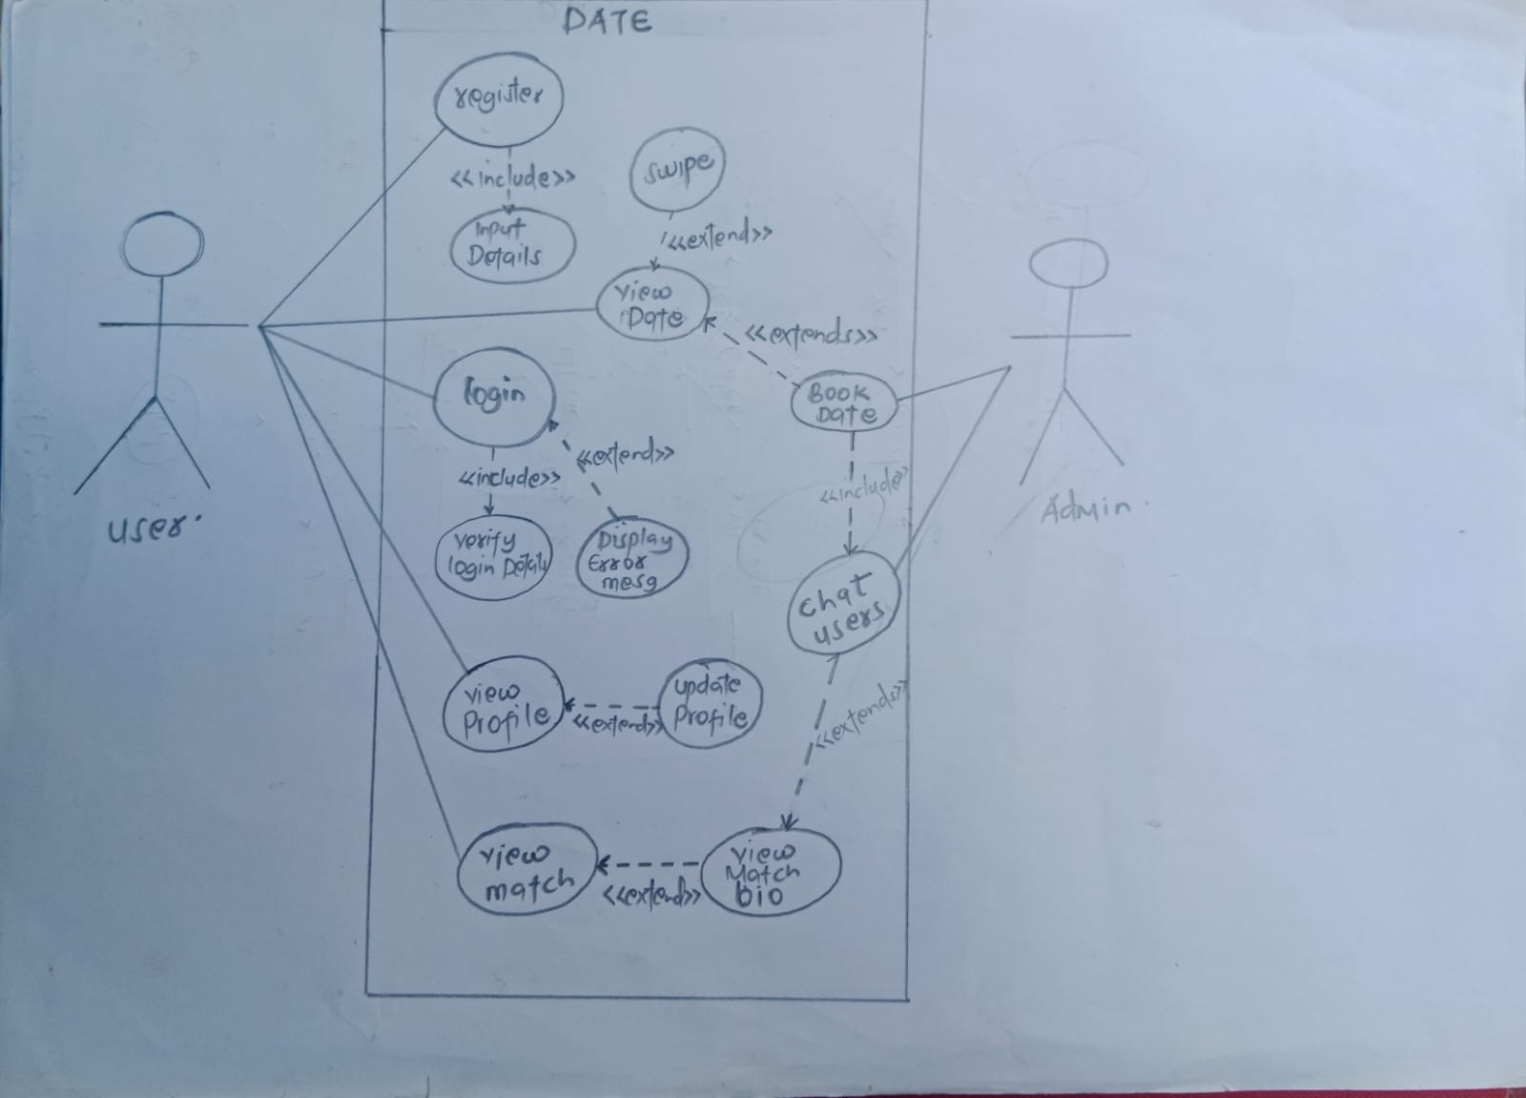
Diagram: 3.1

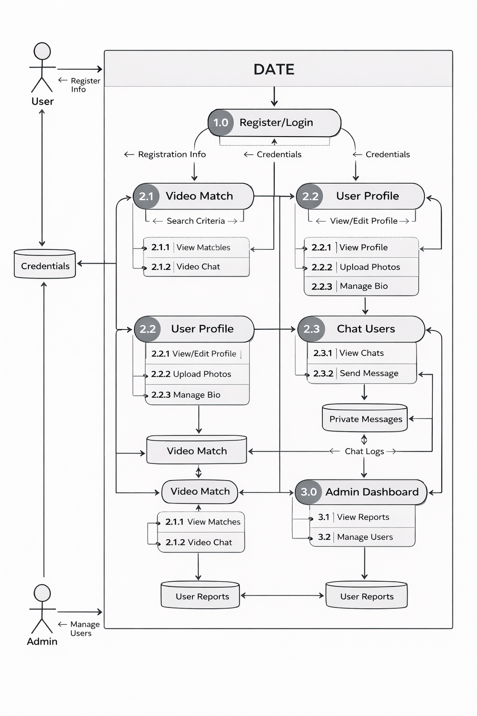
Diagram: 3.2

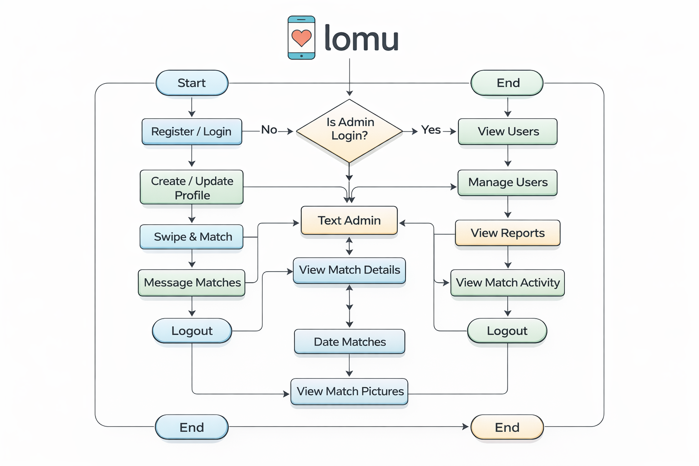
Diagram: 3.3

References
Asch, S.E. (1946) ‘Forming impressions of personality’, Journal of Abnormal and Social Psychology, 41, pp. 258–290.
D’Angelo, J.D. and Toma, C.L. (2016) ‘There are plenty of fish in the sea: The effects of choice overload and reversibility on online daters’ satisfaction with selected partners’, Media Psychology, 20(1), pp. 1–27.
Hancock, J.T. and Toma, C.L. (2009) ‘Putting your best face forward: The accuracy of online dating photographs’, Journal of Communication, 59(2), pp. 367–386.
Heino, R.D., Ellison, N.B. and Gibbs, J.L. (2010) ‘Relationshopping: Investigating the market metaphor in online dating’, Journal of Social and Personal Relationships, 27(4), pp. 427–447.
Lenton, A.P., Fasolo, B. and Todd, P.M. (2008) ‘“Shopping” for a mate: Expected versus experienced preferences in online mate choice’, IEEE Transactions on Professional Communication, 51(2), pp. 169–182.
Ranzini, G. and Lutz, C. (2016) ‘Love at first swipe? Explaining Tinder self-presentation and motives’, Mobile Media & Communication, 5(1), pp. 80–101.
Rosenfeld, M.J., Thomas, R.J. and Hausen, S. (2019) Disintermediating your friends: How online dating in the United States displaces other ways of meeting. Available at: https://osf.io/preprints/socarxiv/f6c4p/ (Accessed: 15 March 2024).
Schüll, N.D. (2014) Addiction by design: Machine gambling in Las Vegas. Princeton: Princeton University Press.
Schwartz, B. (2004) The paradox of choice: Why more is less. New York: Ecco.
Sharabi, L.L. and Timmerman, L. (2020) ‘Social Information Processing Theory’, in Van den Bulck, J. (ed.) The international encyclopedia of media psychology. Hoboken: Wiley Blackwell.
Strubel, J. and Petrie, T.A. (2020) ‘Love me Tinder: Body image and psychosocial functioning among men and women’, Body Image, 34, pp. 259–269.
Timmerman, E. and Courtois, C. (2018) ‘From swiping to casual sex and/or committed relationships: Exploring the experiences of Tinder users’, The Information Society, 34(2), pp. 59–70.
Walther, J.B. (1992) ‘Interpersonal effects in computer-mediated interaction: A relational perspective’, Communication Research, 19(1), pp. 52–90.

