ShopNest Store Power BI Capstone
Sales and Orders Analysis Dashboard

Name: Lonali Ray
Course: Power Bi

1. Introduction
This report presents a Power BI dashboard developed to analyse the ShopNest e-commerce dataset. The dashboard provides insights into sales performance, delivery efficiency, customer payment preferences, product ratings, and regional sales distribution. By visualizing key business metrics, the dashboard helps identify important trends and patterns that support better decision-making and business strategy.

2. Dashboard Overview
The dashboard includes key performance indicators (KPIs) and multiple visualizations that help analyze different aspects of the business.
Key KPIs displayed in the dashboard:
- Total Orders
- Total Sales
- Average Order Value
- Average Product Rating
- Total Products
These KPIs provide a quick overview of overall business performance.

3. Question 1 – Top 10 Product Categories by Sales
Question Statement
Identify and visually represent the top 10 product categories based on total sales.
Visualization
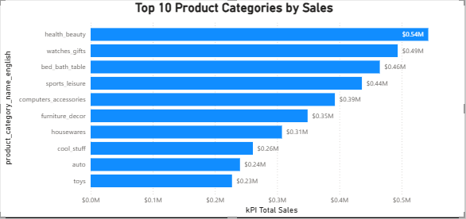
Explanation and Insights
The bar chart shows the top product categories based on total sales revenue. Categories such as health_beauty, watches_gifts, and bed_bath_table generate the highest sales.
Key Insight:
A small number of product categories contribute significantly to the overall revenue.
Business Insight:
The company should focus marketing strategies, promotional campaigns, and inventory planning on high-performing categories to maximize sales.

4. Question 2 – Delayed Orders Analysis
Question Statement
Determine the number of delayed orders in each product category.
Visualization
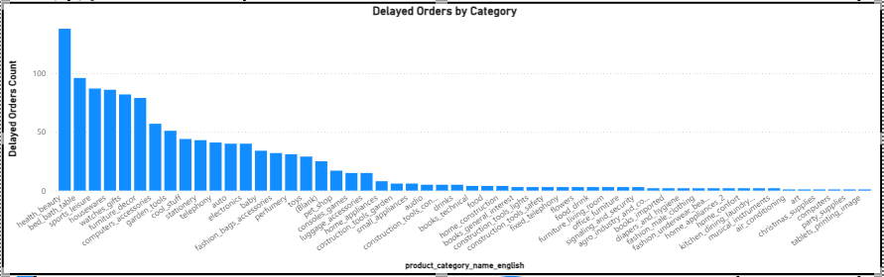
Explanation and Insights
This visualization shows the number of delayed orders across different product categories.
Key Insight:
Certain product categories experience more delayed deliveries than others.
Business Insight:
Improving logistics and supplier coordination for these categories could reduce delivery delays and improve customer satisfaction.

5. Question 3 – Monthly Comparison of On-Time vs Delayed Orders
Question Statement
Compare the number of delayed orders with on-time orders for each month.
Visualization
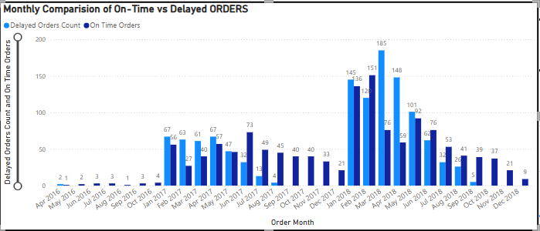Explanation and Insights
The chart compares delayed and on-time orders across different months.
Key Insight:
Some months show a higher number of delayed orders.
Business Insight:
Seasonal demand or operational constraints may cause delivery delays during specific periods. Businesses should allocate additional logistics resources during these months.

6. Question 4 – Payment Method Analysis
Question Statement
Analyze the most frequently used payment methods by customers.
Visualization
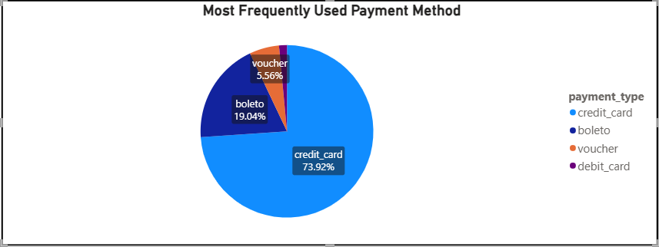Explanation and Insights
The pie chart illustrates the distribution of payment methods used by customers.
Key Insight:
Credit cards represent the majority of transactions compared to other payment methods.
Business Insight:
Businesses should ensure smooth and secure credit card transactions and consider providing promotional offers for digital payments.

7. Question 6 – State-wise Sales Analysis
Question Statement
Identify and visually represent states with high and low sales.
Visualization
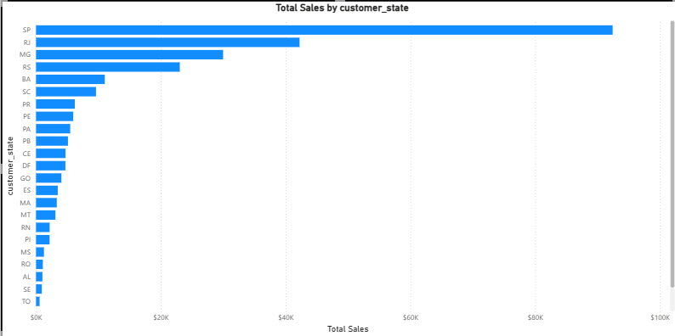
Explanation and Insights
The chart shows the distribution of sales across different states.
Key Insight:
Certain states contribute significantly more to total sales than others.
Business Insight:
High-performing states represent key markets and should be targeted for further marketing efforts and improved distribution networks.

9. Question 7 – Seasonal Sales Patterns
Question Statement
Investigate and visualize seasonal trends in sales over different quarters.
Visualization
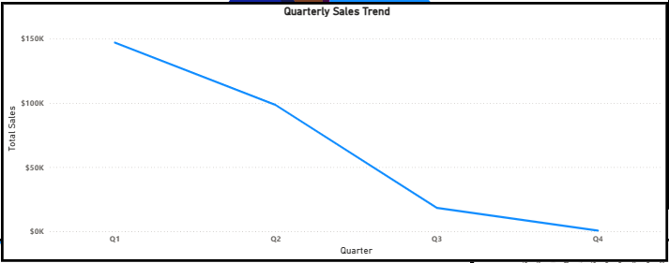Explanation and Insights
The chart shows how sales change across different quarters of the year.
Key Insight:
Some quarters experience higher sales due to seasonal demand.
Business Insight:
Businesses should prepare inventory and marketing campaigns ahead of high-demand seasons.

10. Question 8 – Revenue Analysis
Question Statement
Analyze overall revenue performance.
Visualization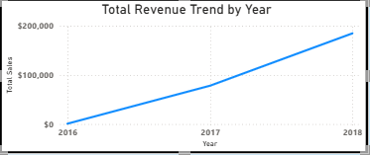
Explanation and Insights
The revenue chart highlights the overall sales trend.
Key Insight:
Revenue trends provide insights into business growth and performance over time.
Business Insight:
Monitoring revenue patterns helps businesses make strategic decisions and improve profitability.

11. Conclusion
The Power BI dashboard provides valuable insights into sales performance, customer behavior, delivery efficiency, and product performance. By analyzing these metrics, businesses can improve operational efficiency, enhance customer satisfaction, and develop more effective marketing strategies.

