# NTiers 2020 – application Slak

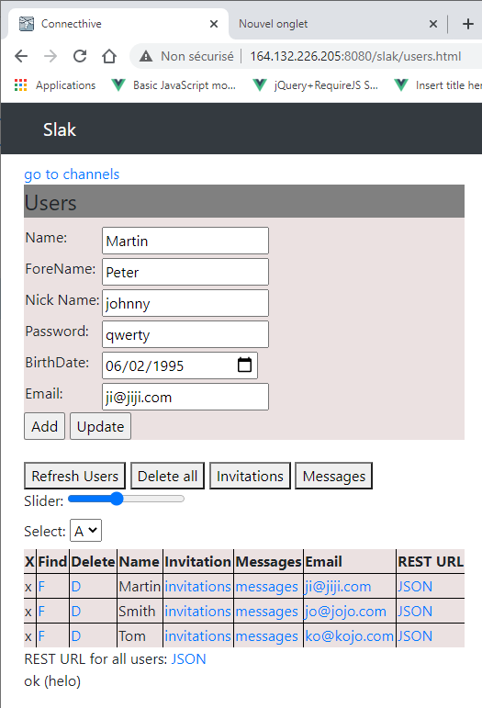

Figure 1: Application déployée sur le VPS  **http://164.132.226.205:8080/slak**

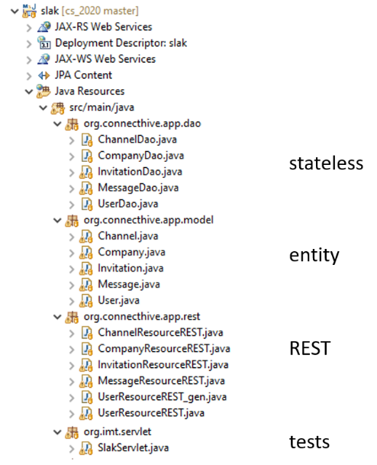

Figure : Backend

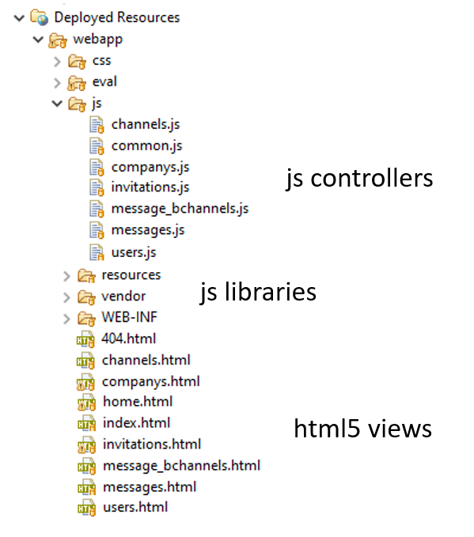

Figure 3: Frontend

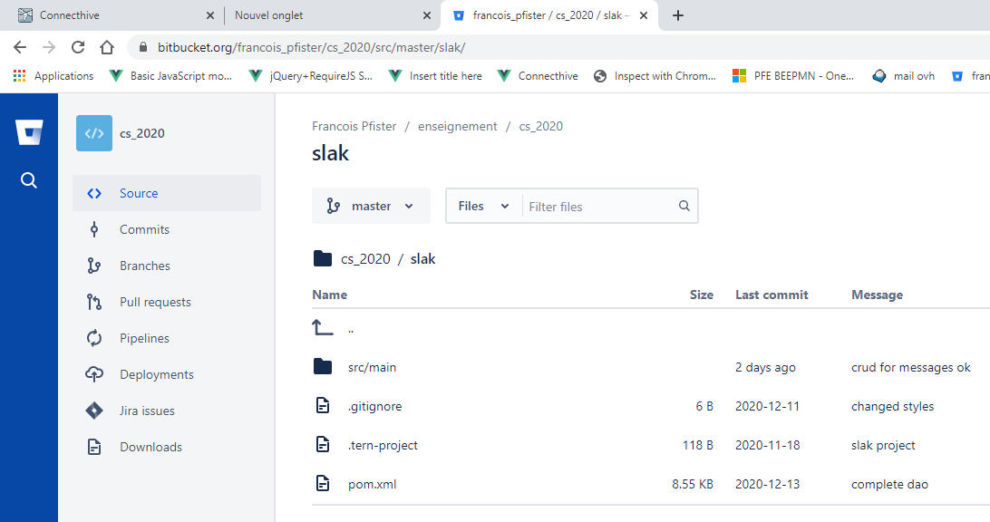

Figure 4: <https://bitbucket.org/francois_pfister/cs_2020/src/master/slak/> mvn clean install