**tl;dr**

I have a script that shows you the size, dimensions and length of movies and photos.

Drop the script into a folder (like “C:\Users\Susan\Pictures\Camera Roll”) and run to get that info for all the captures and still created during testing.

Handy when you have a hundred or more files to peruse.

**Where**

All you need is the script “Get-FileMetaData.ps1” which is here.

There is also sample output from a mixed media directory of mine.

**How**

Copy the “Get-FileMetaData.ps1” file to the directory you want to examine (“Pictures\Camera Roll” for example).

Either open a command or PowerShell window (does not need to be ADMIN) and run from the location OR right-click, “Run with PowerShell” from Explorer.

This is a PowerShell script, so you may need to set script running ON (a one-time operation).

Open an ADMIN PowerShell window and issue this command – “Set-ExecutionPolicy -ExecutionPolicy remotesigned -Force”.

The script will take a little while to run (it’s calling File IO for every file hundreds of times).

It will produce four files.

* MetaData.txt is a list of all the metadata types for the given directory (this can vary according to directory/file system type)
* sample-metadata.txt has each file and the full list of metadata for each.
* sample-metadata.csv has each file with the media data of most interest to us in a spreadsheet format
* sample-metadata.html is the same, but in a html format

If you run the script from a command prompt, you’ll get an interactive viewer to examine the files and sort by data type.

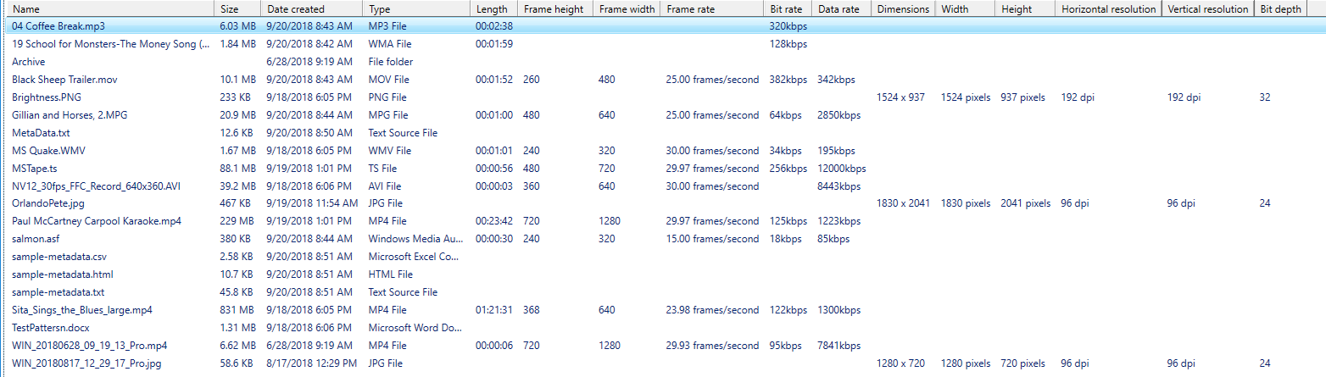

**What**

The file system keeps information like name, size and date, which is displayed in explorer or a command prompt.

There is additional information for files not typically shown.

This additional information is called “metadata”.

Media files, like audio, photo and video, have information that is context sensitive – it varies by type of file.

**Show me**

Here are three sample media files with their complete metadata.

Name              : WIN_20180628_09_19_13_Pro.mp4

Size              : 6.62 MB

Item type         : MP4 File

Date modified     : 6/28/2018 9:19 AM

Date created      : 6/28/2018 9:19 AM

Date accessed     : 6/28/2018 9:19 AM

Attributes        : A

Perceived type    : Video

Owner             : LondonRatcatcherson

Kind              : Video

Rating            : Unrated

Length            : 00:00:06

Bit rate          : 95kbps

Protected         : No

Total size        : 475 GB

Computer          : MININT-GB43O9N (this PC)

File extension    : .mp4

Filename          : WIN_20180628_09_19_13_Pro.mp4

Space free        : 271 GB

Shared            : No

Folder name       : Camera Roll

Folder path       : C:\Users\ LondonRatcatcherson\Pictures\Camera Roll

Folder            : Camera Roll (C:\Users\LondonRatcatcherson\Pictures)

Path              : C:\Users\LondonRatcatcherson\Pictures\Camera Roll\WIN_20180628_09_19_13_Pro.mp4

Type              : MP4 File

Link status       : Unresolved

Media created     : 6/28/2018 9:19 AM

Space used        : 42%

Video compression : {34363248-0000-0010-8000-00AA00389B71}

Data rate         : 7841kbps

Frame height      : 720

Frame rate        : 29.93 frames/second

Frame width       : 1280

Spherical         : No

Stereo            : No

Video orientation : 0

Total bitrate     : 7936kbps

Name                  : WIN_20180817_12_29_17_Pro.jpg

Size                  : 58.6 KB

Item type             : JPG File

Date modified         : 8/17/2018 12:29 PM

Date created          : 8/17/2018 12:29 PM

Date accessed         : 8/17/2018 12:29 PM

Attributes            : A

Perceived type        : Image

Owner                 : LondonRatcatcherson

Kind                  : Picture

Date taken            : 8/17/2018 12:29 PM

Rating                : Unrated

Dimensions            :

Program name          : Windows 10

Total size            : 475 GB

Computer              : MININT-GB43O9N (this PC)

File extension        : .jpg

Filename              : WIN_20180817_12_29_17_Pro.jpg

Space free            : 271 GB

Bit depth             : 24

Horizontal resolution : 96 dpi

Width                 : 1280 pixels

Vertical resolution   : 96 dpi

Height                : 720 pixels

Shared                : No

Folder name           : Camera Roll

Folder path           : C:\Users\ LondonRatcatcherson \Pictures\Camera Roll

Folder                : Camera Roll (C:\Users\ LondonRatcatcherson \Pictures)

Path                  : C:\Users\ LondonRatcatcherson \Pictures\Camera Roll\WIN_20180817_12_29_17_Pro.jpg

Type                  : JPG File

Link status           : Unresolved

Space used            : 42%

Name : 04 Coffee Break.mp3

Size : 6.03 MB

Item type : MP3 File

Date modified : 9/20/2018 8:43 AM

Date created : 9/20/2018 8:43 AM

Date accessed : 9/20/2018 8:43 AM

Attributes : A

Perceived type : Audio

Owner : LondonRatcatcherson

Kind : Music

Contributing artists : Charles Nelson Reilly; Claudette Sutherland

Album : How to Succeed in Business Without Really Trying (Original Broadway Cast Recording)

Year : 1961

Genre : Soundtrack

Rating : Unrated

Authors : Charles Nelson Reilly; Claudette Sutherland

Title : Coffee Break

# : 4

Length : 00:02:38

Bit rate : 320kbps

Protected : No

Total size : 475 GB

Computer : MININT-GB43O9N (this PC)

File extension : .mp3

Filename : 04 Coffee Break.mp3

Space free : 269 GB

Shared : No

Folder name : Camera Roll

Folder path : C:\Users\ LondonRatcatcherson \Pictures\Camera Roll

Folder : Camera Roll (C:\Users\ LondonRatcatcherson \Pictures)

Path : C:\Users\ LondonRatcatcherson \Pictures\Camera Roll\04 Coffee Break.mp3

Type : MP3 File

Link status : Unresolved

Publisher : RCA Victor

Album artist : Soundtrack

Composers : Frank Loesser

Space used : 43%

**How it works**

You can lookup the “Video compression” GUIDs here.

<http://gix.github.io/media-types/>

The script creates a Shell object and uses that to iterate over one file for possible metadata.

Not every position is populated; a few are problematic and need to be filtered out.

The file metadata can also be used in a script to validate media properties, just like in the original Smoke scripts.

*<#*

*This gets the metadata for a single file.*

*Call with the filename and the metadata is returned as an object.*

*#>*

Function **Get-FileMetaDataOne**

{

    Param([string[]] $MediaFile)

    $FileMetaData = **New-Object** PSOBJECT;

    $objShell = (**New-Object** -ComObject Shell.Application).namespace($pwd**.path**);

    foreach ($row in $objShell**.items**())

    {

        if ($row**.Name** -match "$MediaFile")

        {

            for ($a = 0; $a -le 400; $a++)

            {

*# Skip problematic metadata*

                if ($a -eq 291) { continue; }

                if ($a -eq 296) { continue; }

                if ($a -eq 297) { continue; }

                if($objShell**.getDetailsOf**($row, $a))

                {

*<# The -replace filters out '?' characters that sometimes come with the data #>*

                    $hash += @{

$($objShell**.getDetailsOf**($objShell**.items**, $a)) =

                     $($objShell**.getDetailsOf**($row, $a)) -replace([char]8206,"") -replace([char]8207,"") };

                 $FileMetaData | **Add-Member** $hash|**Out-Null**;

                 $hash**.clear**();

}

            }

*# This is the return from function!*

            $FileMetaData;

        }

    }

}