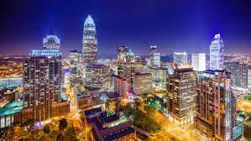

**Comic Connections**

**Local Conventions**