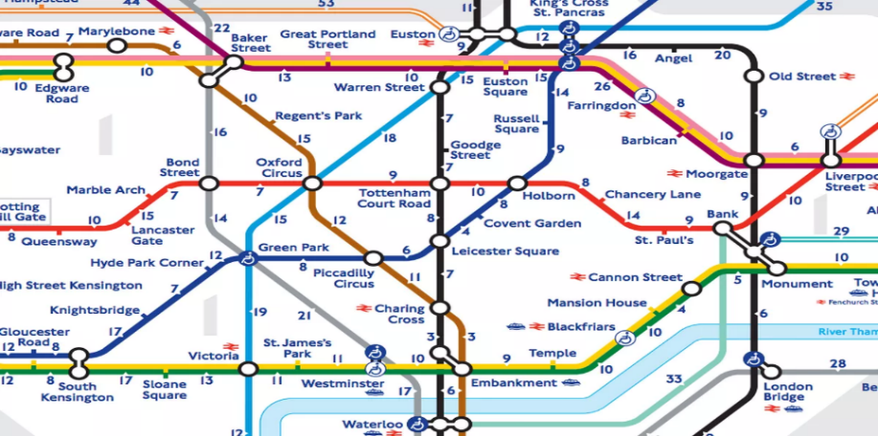

London

Hidden Gems

Boroughs Maps About Us Contact

Explore Central Londons least talked about locations

Located near liverpool street station is a hidden cocktail bar awaits behind a fridge called

Rooftop bar, good views vast landscape towering over london skyline , seabird