EduEdge Tutor System Operation Manual

Introduction

Welcome to the EduEdge Tutor system. This system is designed to help instructors manage their students’ details, grades, tutoring recommendations, and library borrowing.

Table of Contents

1. Instructors

1.1 Viewing Student Details

1.2 Viewing Student Grades

1.3 Viewing Tutoring Recommendations

1.4 Viewing Enrolled Students

1.5 Library Borrowing

2. Students

* 1. View schedule
  2. View enrolled Tutoring session
  3. enroll tutoring session

2.4 View grade

1. Instructors

1.1 Viewing Student Details

To view the details of a student, navigate to the ‘Student List’ tab on the dashboard. Here, you can see a list of all students along with their details.

1.2 Viewing Student Grades

To view the grades of a student, navigate to the ‘Student’s Grade’ tab on the dashboard. Here, you can see a list of all students along with their grades.

1.3 Viewing Tutoring Recommendations

To view the grades that are recommended for tutoring, navigate to the ‘Recommend Tutoring’ tab on the dashboard. Here, you can see a list of all students along with their grades that are recommended for tutoring per subject.

1.4 Viewing Enrolled Students

To view the students who are enrolled in the tutoring, navigate to the ‘Enrolled Students’ tab on the dashboard. Here, you can see a list of all students who are enrolled in the tutoring.

1.5 Library Borrowing

To view and borrow books from the library, navigate to the ‘View Books’ tab on the dashboard. Here, you can see a list of all available books. To borrow a book, click on the ‘Borrow’ button next to the book.

2. Students

2.1 Viewing Tutoring Schedule

To view the schedule of the tutoring session, navigate to the ‘Tutoring Schedule’ tab on the dashboard. Here, you can see the schedule of all tutoring sessions.

2.2 Viewing Tutoring Session Details

To view the details of your own tutoring session, navigate to the ‘My Tutoring Sessions’ tab on the dashboard. Here, you can see the details of all your tutoring sessions.

2.3 Enrolling in Tutoring Sessions

To enroll in a tutoring session, navigate to the ‘Enroll’ tab on the dashboard. Here, you can see a form to be fill out. To enroll in a session, fill in the necessary details and choose a subject in the drop down button and click ‘Enroll’ button to enroll.

2.4 Viewing Grades

To view your own grades, navigate to the ‘My Grades’ tab on the dashboard. Here, you can see a list of all your grades.

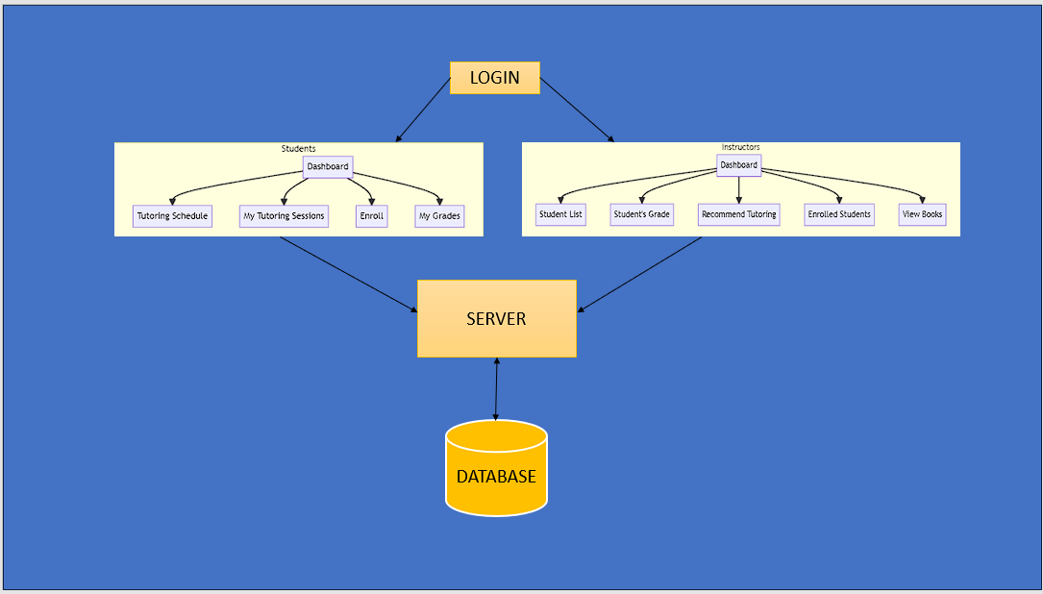

ARCHITECTURAL LAYOUT