**Github Link**

https://github.com/Lonely-DM/SIT305/tree/main/2.1P/2.1P

**Video Link**

<https://youtu.be/s8X77OQEwmY>

**Screenshot**

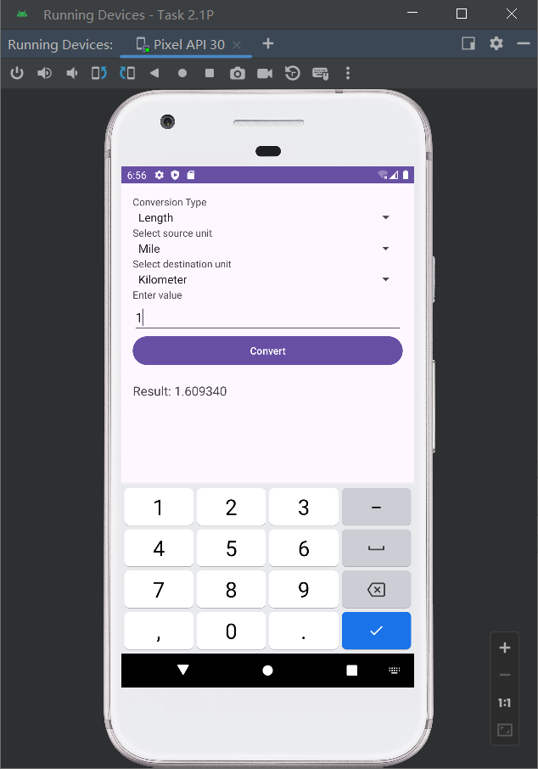

**Research on Llama2**

Llama2, a Large Language Model, revolutionizes mobile applications by enabling intuitive, intelligent interactions and personalized experiences. Its integration across customer support chatbots, content recommendations, real-time translations, adaptive learning tools, and voice-activated personal assistants showcases its vast potential. Llama2 enhances user satisfaction by understanding and responding with unprecedented accuracy, offering tailored content, breaking down language barriers, personalizing educational content, and executing complex voice commands. This advancement opens new possibilities for app development, making technology more accessible, personalized, and user-friendly.