**Github Link**

**Video Link**

<https://youtu.be/PlNn7tIpVPA>

**Screenshot**

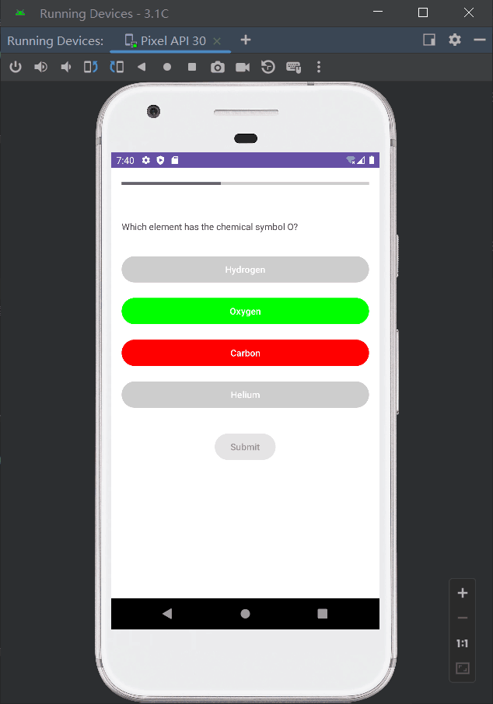

**Task Integration with LLMs**

**Dynamic Question Generation:**

**Task:** Utilize Llama 2 to generate a diverse set of quiz questions dynamically. This can be achieved by defining topics or subjects and letting the LLM create questions based on the difficulty level or other criteria.

**Implementation:** Implement an API call to Llama 2 whenever a new quiz is started, requesting a set of questions based on the user's preferences or past performance.

**Answer Validation and Feedback:**

**Task:** After a user submits an answer, Llama 2 can be used to validate the correctness and provide immediate feedback. For incorrect answers, it could also generate explanations or hints.

**Implementation:** On submission, send the user's answer to Llama 2 for validation. Use the model's response to display feedback and, if necessary, detailed explanations.

**Progress Tracking:**

**Task:** Employ Llama 2 to analyze the user's progress throughout the quiz, offering insights or recommendations on areas for improvement based on their performance.

**Implementation:** Analyze user responses and performance metrics using Llama 2 to identify patterns or areas of difficulty, then provide personalized study recommendations.

**Interactive Learning Experience:**

**Task:** Create an interactive and adaptive learning experience by using Llama 2 to adjust the difficulty level of questions in real-time based on the user's progress and performance.

**Implementation:** Based on the user’s answers, dynamically adjust the complexity of subsequent questions by requesting more appropriate questions from Llama 2.