SIT305

Mobile app development

Learning Summary Report

# Self-Assessment Details

The following checklists provide an overview of my self-assessment for this unit.

|  |  |  |  |  |
| --- | --- | --- | --- | --- |
|  | Pass (P) | Credit (C) | Distinction (D) | High Distinction (HD) |
| Self-Assessment | √ |  |  |  |

Self-Assessment Statement

|  |  |
| --- | --- |
|  | Included |
| Learning Summary Report | √ |
| Pass tasks complete | √ |

Minimum Pass Checklist

|  |  |
| --- | --- |
|  | Included |
| All Credit Tasks are Complete |  |

Minimum Credit Checklist (in addition to Pass Checklist)

|  |  |
| --- | --- |
|  | Included |
| All Distinction tasks are Complete |  |

Minimum Distinction Checklist (in addition to Credit Checklist)

|  |  |
| --- | --- |
| All High Distinction tasks are Complete |  |

Minimum High Distinction Checklist (in addition to Distinction Checklist)

# Declaration

I declare that this portfolio is my individual work. I have not copied from any other student’s work or from any other source except where due acknowledgment is made explicitly in the text, nor has any part of this submission been written for me by another person.

Signature:

**Shujian.Lin**

# Portfolio Overview

This portfolio demonstrates that I have achieved the Unit Learning Outcomes for SIT305 - Mobile Application Development to a **Pass** level.

I have completed all required tasks and have met the basic expectations for this unit. My work reflects an understanding of the fundamental concepts and skills taught in the course.

# Reflection

**Key Learnings:**

A fundamental insight gained from this unit is the basic ability to design, develop, test, and deploy mobile applications using modern frameworks, libraries, and tools. This foundation enables me to produce functional mobile apps that meet basic user needs.

Additionally, the use of open APIs from sources like Google provided me with opportunities to interact with advanced technologies and understand how to integrate them into projects.

**What Helped My Learning:**

Engaging directly in coding exercises and projects was crucial for applying theoretical knowledge to practical scenarios. This hands-on approach helped me understand coding principles and their real-world applications.

The accessibility of online tutorials, forums, and documentation was invaluable for addressing issues and deepening my understanding of specific features or technologies. These resources offered guidance critical for navigating challenges.

**Challenges Encountered:**

Integrating APIs into my projects was challenging as it required learning new coding principles. Each new API required delving into its documentation to grasp the basics and employ it effectively in my tasks.

**Interesting Topics:**

I found UI/UX design and creating visually appealing app layouts captivating, allowing me to explore the creative aspects of mobile app development.

**Areas of Strong Learning:**

I feel comfident with the basic knowledge I have acquired in UI/UX design. Research and exploration allowed me to understand the core concepts and principles, enabling me to create more user-friendly and aesthetically pleasing applications.

**Areas Needing Improvement:**

API usage is an area where I need further improvement. Integrating APIs into my projects often posed challenges, and I recognize the need to devote more time to mastering how to effectively incorporate various APIs into my applications.

**My process in this unit:**

需要修改  
  
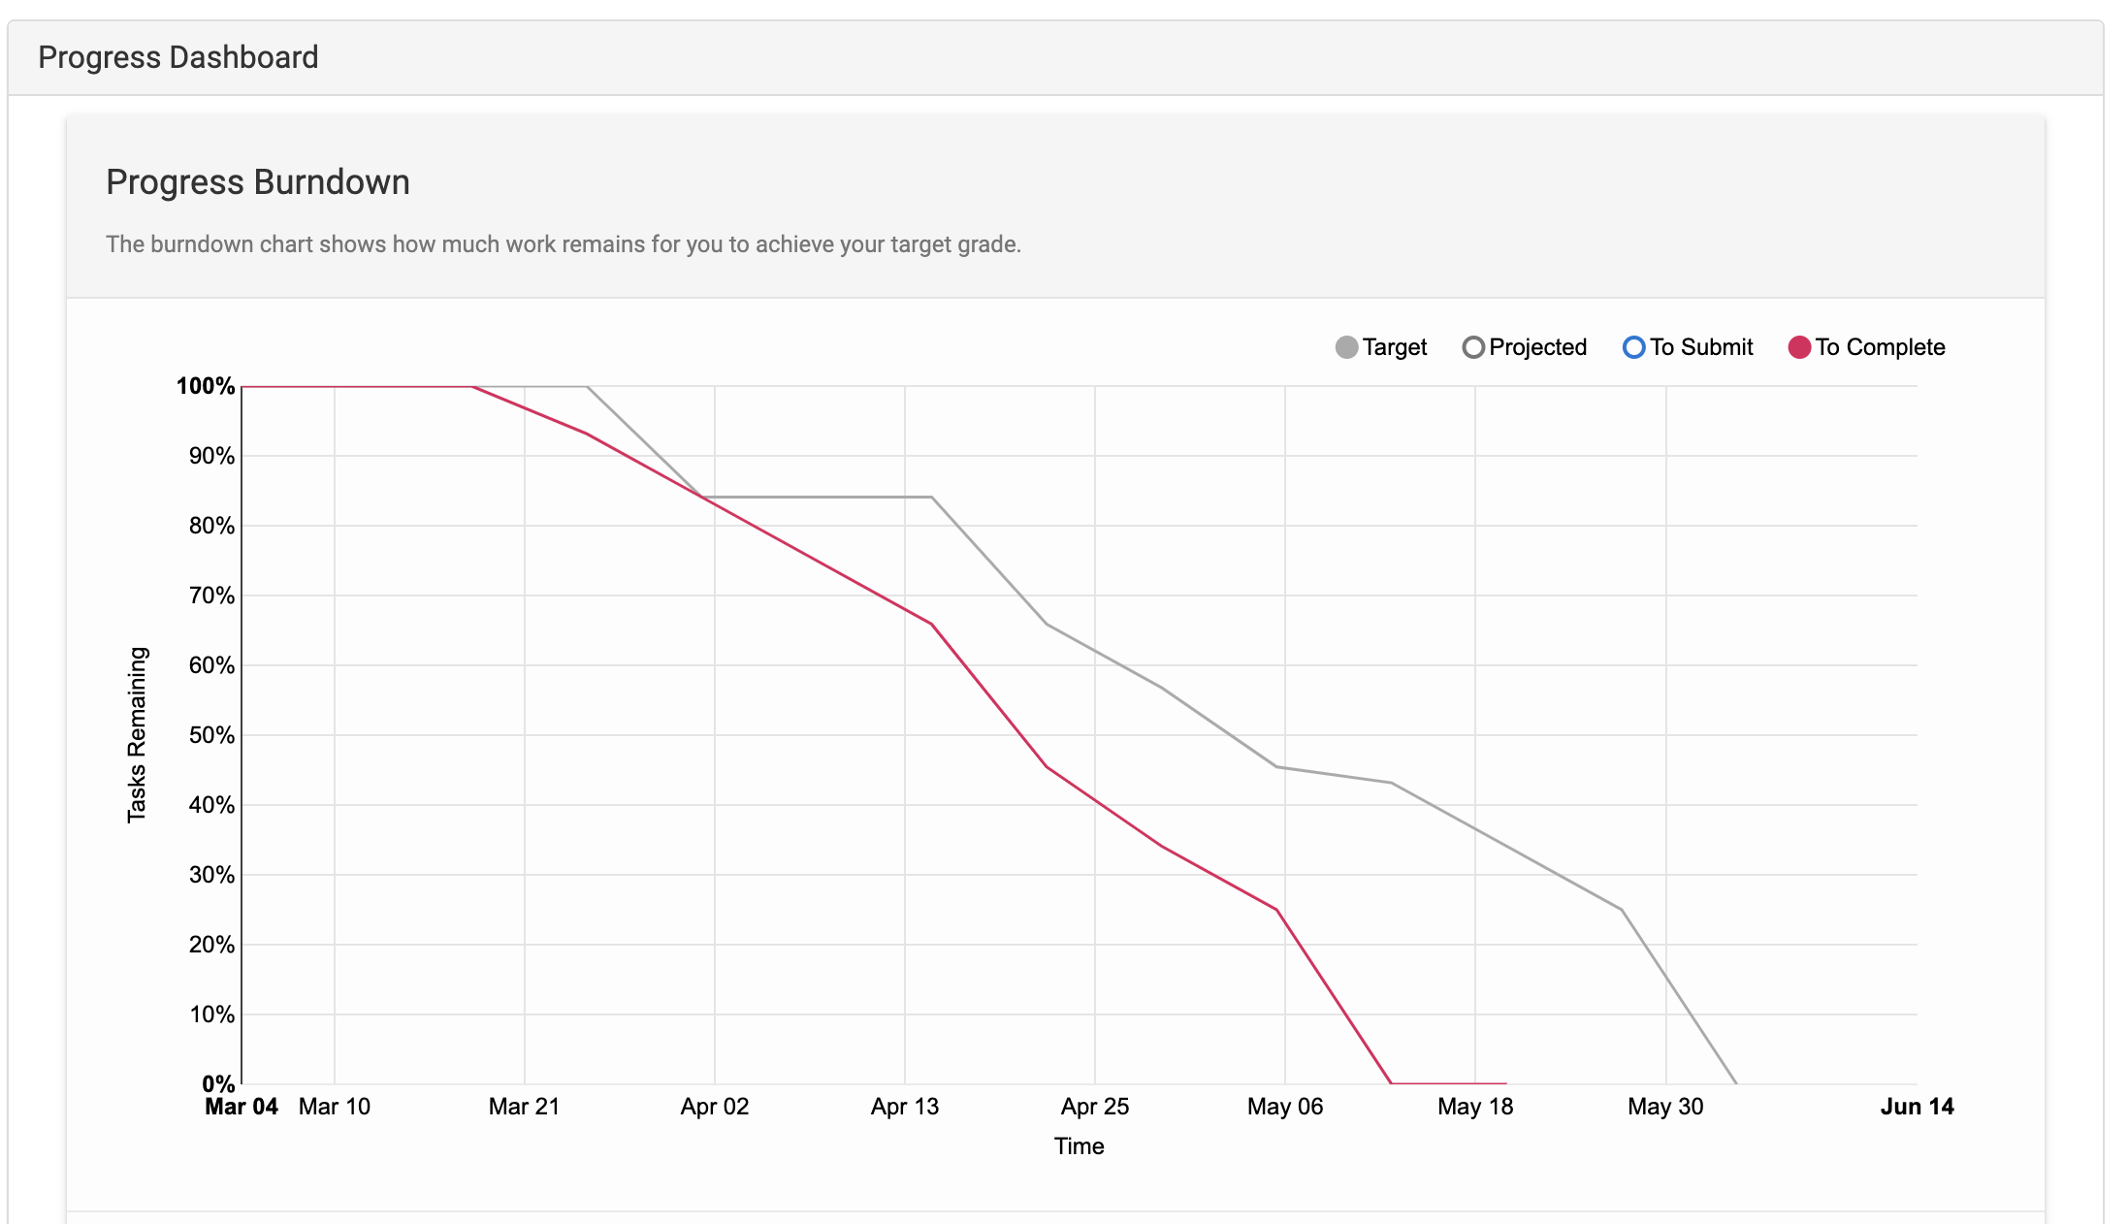

**Future Benefits of This Unit:**

This unit provided me with foundational skills in Android app development, opening up new opportunities for academic advancement and career growth. The knowledge and experience gained here are valuable for future studies and job roles in the IT field.

**Reflections on Improvements:**

If I were to complete this unit again, I would better manage my time to tackle more advanced tasks and achieve a higher level of performance. This improved time management would allow me to delve deeper into complex topics and enhance my overall learning experience.