SIT305

Mobile app development

Learning Summary Report

# Self-Assessment Details

The following checklists provide an overview of my self-assessment for this unit.

|  |  |  |  |  |
| --- | --- | --- | --- | --- |
|  | Pass (P) | Credit (C) | Distinction (D) | High Distinction (HD) |
| Self-Assessment |  |  |  | √ |

Self-Assessment Statement

|  |  |
| --- | --- |
|  | Included |
| Learning Summary Report | √ |
| Pass tasks complete | √ |

Minimum Pass Checklist

|  |  |
| --- | --- |
|  | Included |
| All Credit Tasks are Complete | √ |

Minimum Credit Checklist (in addition to Pass Checklist)

|  |  |
| --- | --- |
|  | Included |
| All Distinction tasks are Complete | √ |

Minimum Distinction Checklist (in addition to Credit Checklist)

|  |  |
| --- | --- |
| All High Distinction tasks are Complete | √ |

Minimum High Distinction Checklist (in addition to Distinction Checklist)

# Declaration

I declare that this portfolio is my individual work. I have not copied from any other student’s work or from any other source except where due acknowledgment is made explicitly in the text, nor has any part of this submission been written for me by another person.

Signature:

**Le Xuan Huy**

# Portfolio Overview

This portfolio includes work that demonstrates that I have achieved all Unit Learning Outcomes for SIT305 - Mobile Application Development to a **High Distinction** level.

I am confident that I have achieved the highest level of performance in this unit, aiming for a High Distinction grade. I have successfully completed all tasks at the Pass, Credit, Distinction, and High Distinction levels. My consistent effort and successful execution throughout the unit warrant recognition and consideration for a HD grade.

# Reflection

**Key Learnings:**

A crucial insight gained from this unit is the comprehensive ability to design, develop, test, and deploy mobile applications using modern frameworks, libraries, and tools. This expertise enables me to produce innovative and functional mobile apps that cater to the needs of contemporary users.

Additionally, the unit highlighted the importance of UI/UX design. Grasping the concepts of effective user interface and user experience design is essential for developing engaging and intuitive applications.

The most important thing that separates the course from some normal App Development tutorial is the use of open API from different source like Google, PayPal, or LLama. This really gave the student opportunities to interact with some of most advanced technologies of the time and how to use them.

**What Helped My Learning:**

Engaging directly in coding exercises and projects was crucial in applying theoretical knowledge to practical scenarios. This hands-on approach deepened my understanding of coding principles and their real-world applications.

The accessibility of online tutorials, forums, and documentation was indispensable for addressing issues and deepening my understanding of specific features or technologies. These resources offered guidance and insights critical for navigating challenges and broadening my expertise.

Also that without the helping hands of my tutor, I will not going to be able to understand and complete all the tasks in time.

Last but not least, I found ChatGPT exceptionally beneficial throughout my programming journey. It clarified various coding principles and served as an excellent troubleshooting resource, significantly enhancing my problem-solving skills. It also capable of giving me a good backbones for my applications.

**Challenges Encountered:**

Integrating APIs into my projects was challenging as it required learning new coding principles. With each new API, I delved into its documentation to grasp the basics and effectively employ it in my tasks. This process involved familiarizing myself with the API's functions, parameters, and methods for smooth integration and optimal results.

I also find design user interfaces a really challenging things to do properly. How to make the app easy to use but still includes all the details is a really hard problems.

**Interesting Topics:**

I was particularly captivated by UI design and the creation of visually appealing app layouts, allowing me to delve into the creative side of mobile app development.

I also found it intriguing to explore various frameworks and libraries for cross-platform development, such as React Native or Flutter, which enable the development of apps for multiple platforms simultaneously.

**Areas of Strong Learning:**

I am proud of the deep knowledge I have acquired in the APIs used in this unit, especially the Machine Learning API. Extensive research and exploration have allowed me to develop a thorough understanding of these APIs’ core concepts and functionalities. My dedicated study has been rewarding, providing me with a solid grasp of how to leverage their features effectively in my projects.

**Areas Needing Improvement:**

I recognize that UI design is an area requiring further attention and improvement. My tutor has frequently pointed out shortcomings in my UI designs. It is clear that I need to devote more time and resources to mastering the fundamental principles of effective UI/UX design, and I am committed to doing so moving forward.

**My process in this unit:**  
  
I am quite proud to be able to complete all the tasks ahead of time. As can be seen in this graph, my “Complete” line is always ahead of the “Target” line. In the end, I managed to finish all the ask 2 weeks before the deadlines, making a lot of times for other subject that need to be done.  
  
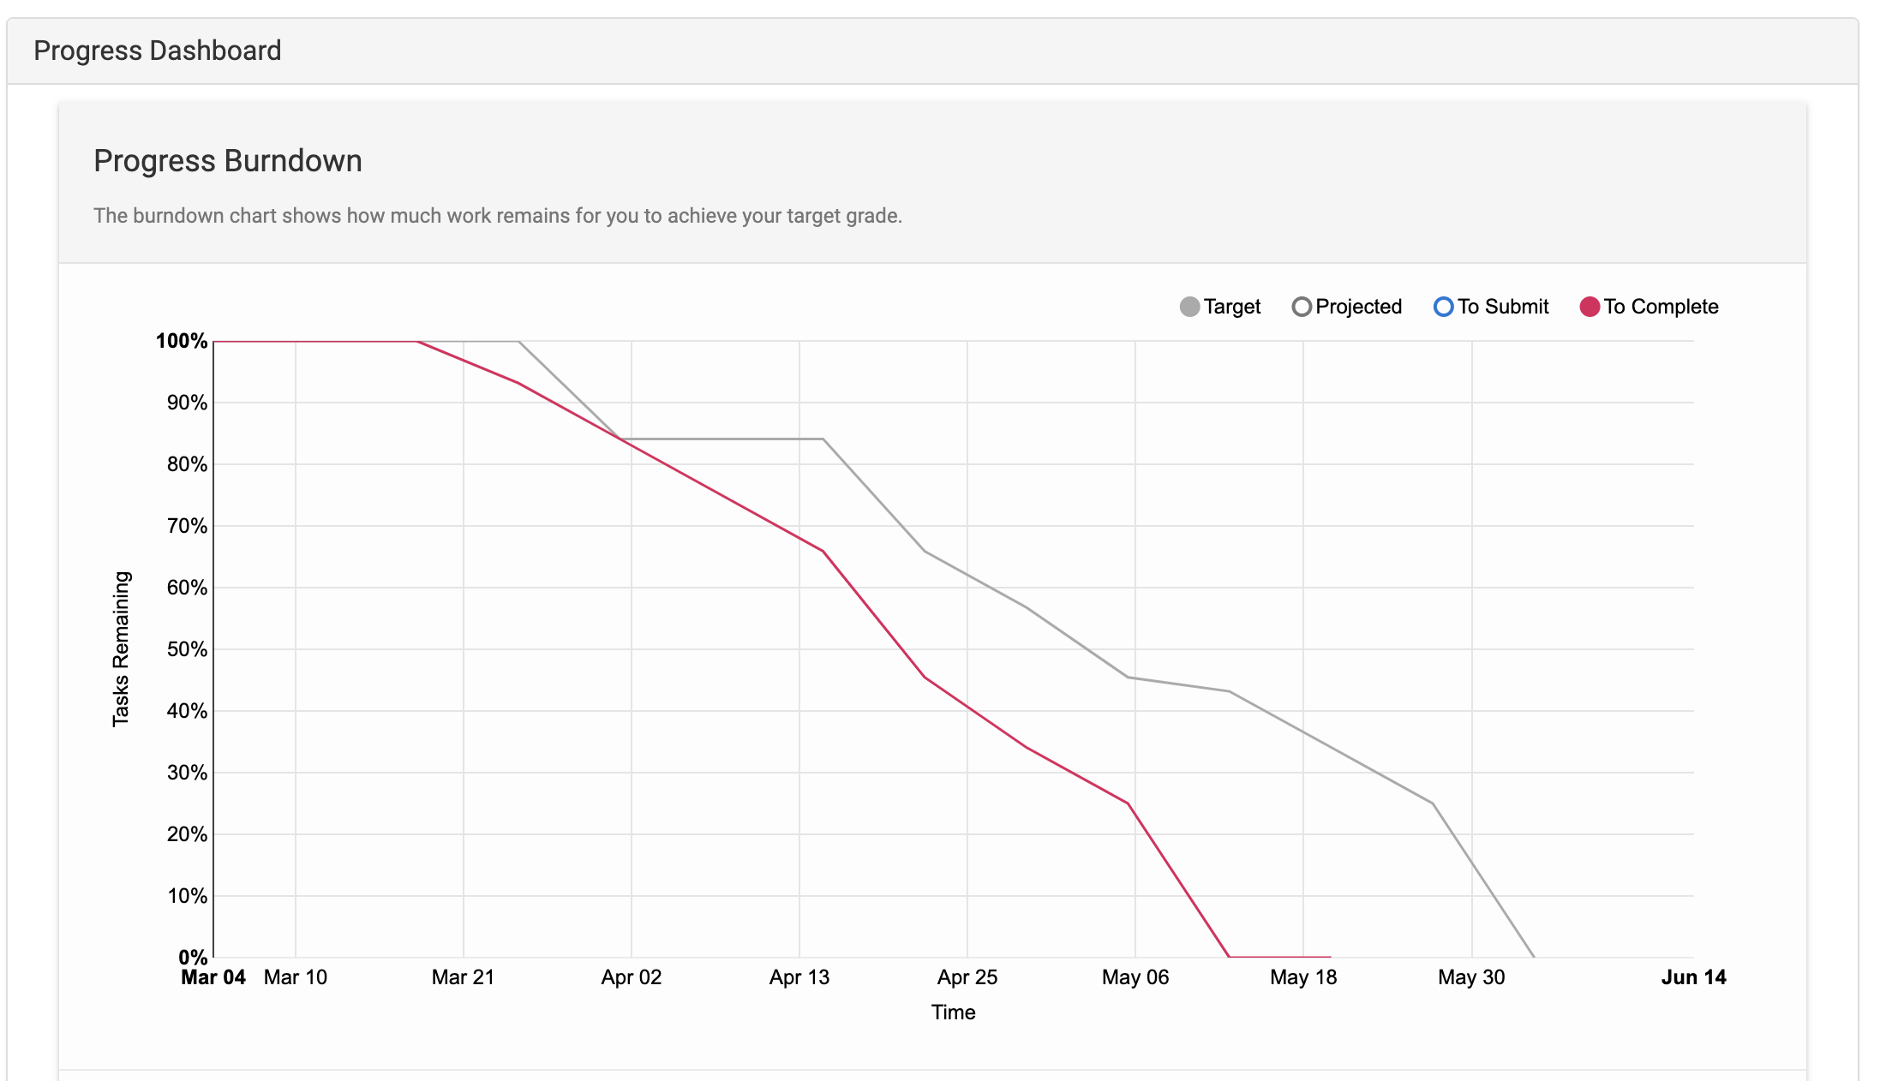

**Future Benefits of This Unit:**

Academic Advancement: Pursuing further studies in IT or a related discipline will significantly benefit from the mobile app development knowledge I've gained. This foundation will be invaluable in numerous future academic endeavors and projects. Also I believe that the knowledge of working with machine learning API is really important for my as it is the main path of my learning.

Career Opportunities: The career outlook for professionals skilled in mobile application development is exceptionally bright in today's technology-driven market. The ubiquitous presence of smartphones and the increasing demand for mobile applications across diverse sectors open vast opportunities for careers in this area. Equipped with the skills from this unit, I am prepared to pursue roles as a mobile app developer, software engineer and even AI engineer

**Reflections on Improvements:**

Upon reflecting on my journey through this unit, I am thoroughly pleased with my achievements and the comprehensive knowledge I've acquired. There are no specific changes I would make if I had the opportunity to complete this unit again, as my overall experience and outcomes were highly satisfactory.