**Performance Analysis**

**Sequential QuickSort**

The sequential version of QuickSort recursively sorts the sub-arrays on a single thread. Its performance relies purely on the processing power of a single CPU core.

**Parallel QuickSort**

The parallel version aims to improve performance by running two recursive calls (left and right sub-arrays) in parallel using multiple threads. However, there are overheads involved in managing threads and recursion.

**Results**

The following results were observed when sorting an array of 10,000,000 random integers

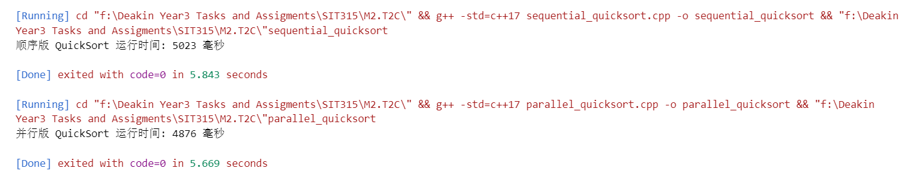

|  |  |
| --- | --- |
| Program Version | Execution Time (ms) |
| Sequential | 5023 |
| Parallel Version | 4876 |

The parallel version of QuickSort achieved only a marginal improvement over the sequential version. This indicates that while the algorithm is well-suited for parallel execution, the gains are heavily dependent on thread management, recursion depth, and hardware resources.

Github Link

<https://github.com/Lonely-DM/SIT315/tree/main/M2.T2C>

Video Link

<https://youtu.be/MSTWFMSvD24>