Activity 1

Code Implementation

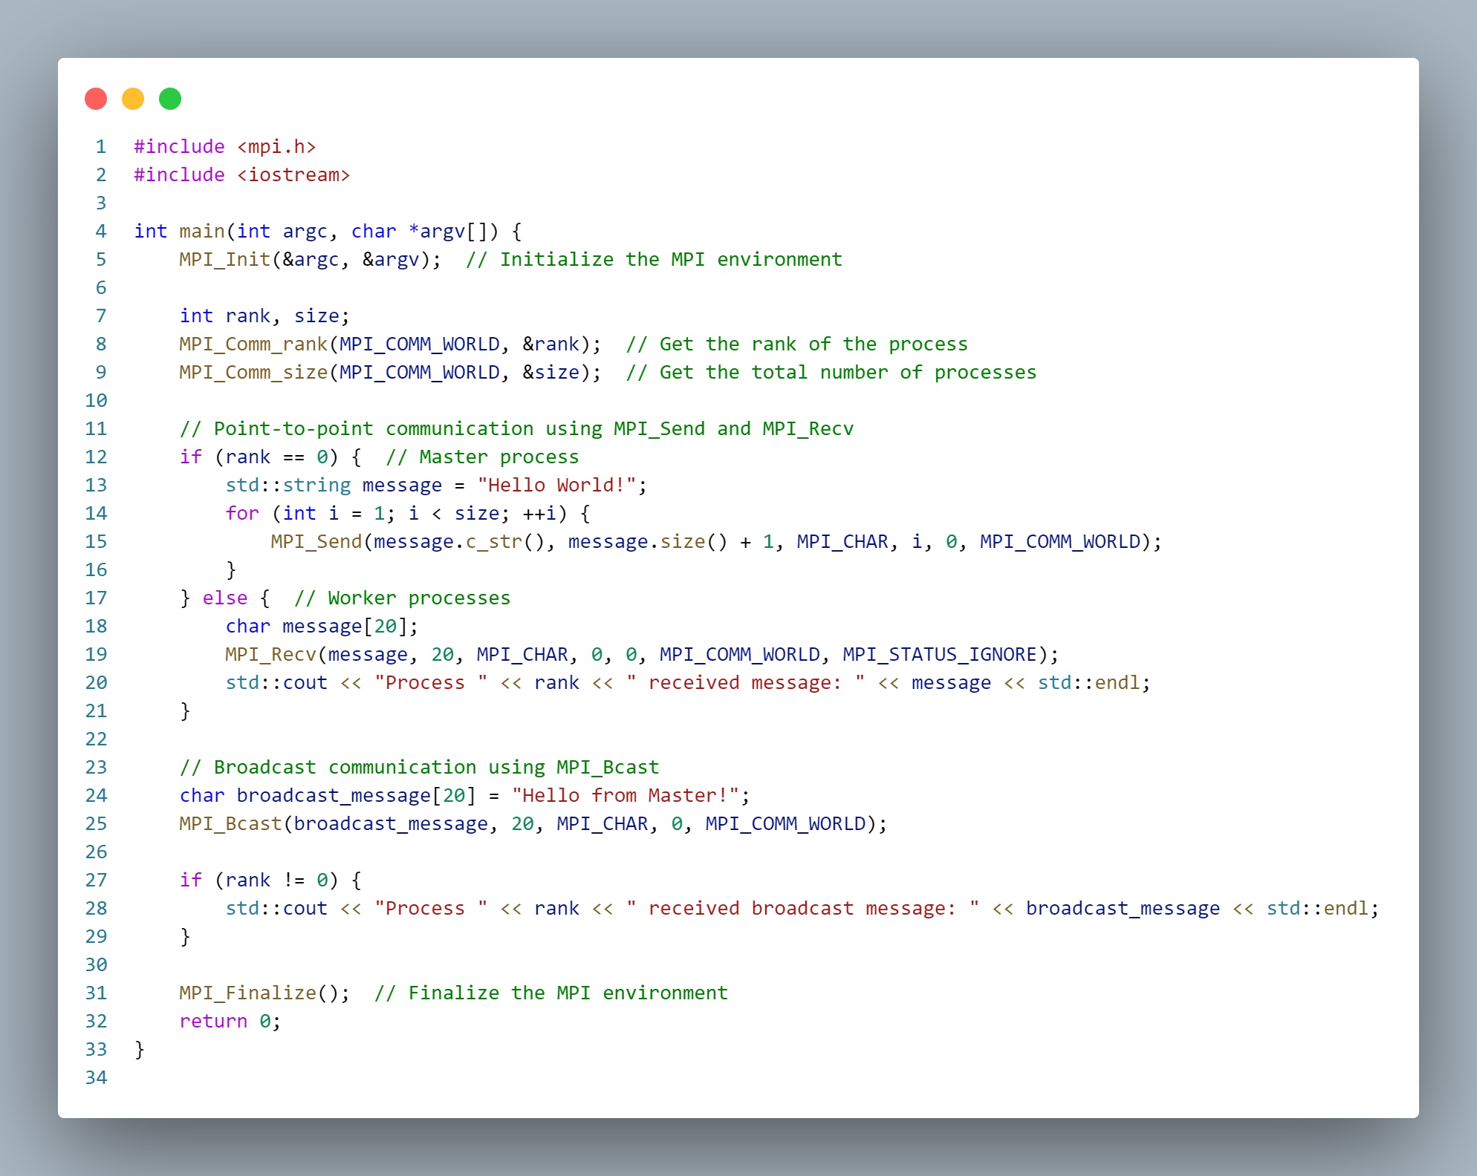

Results

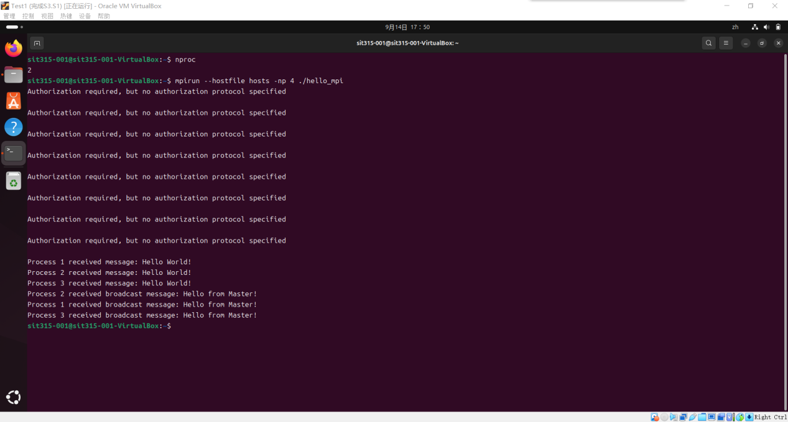

In this activity, I successfully implemented both point-to-point and broadcast communication using MPI. All processes correctly received and printed the messages sent by the master process.

Activity 2

Code Implementation

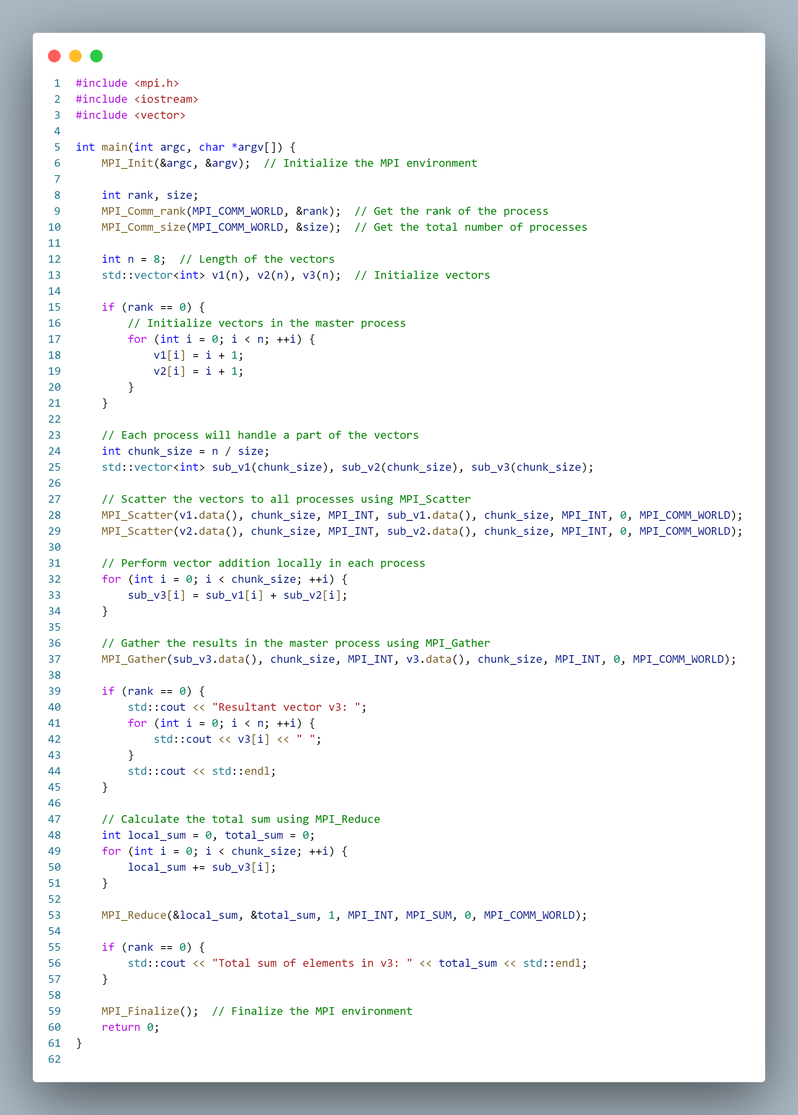

Results

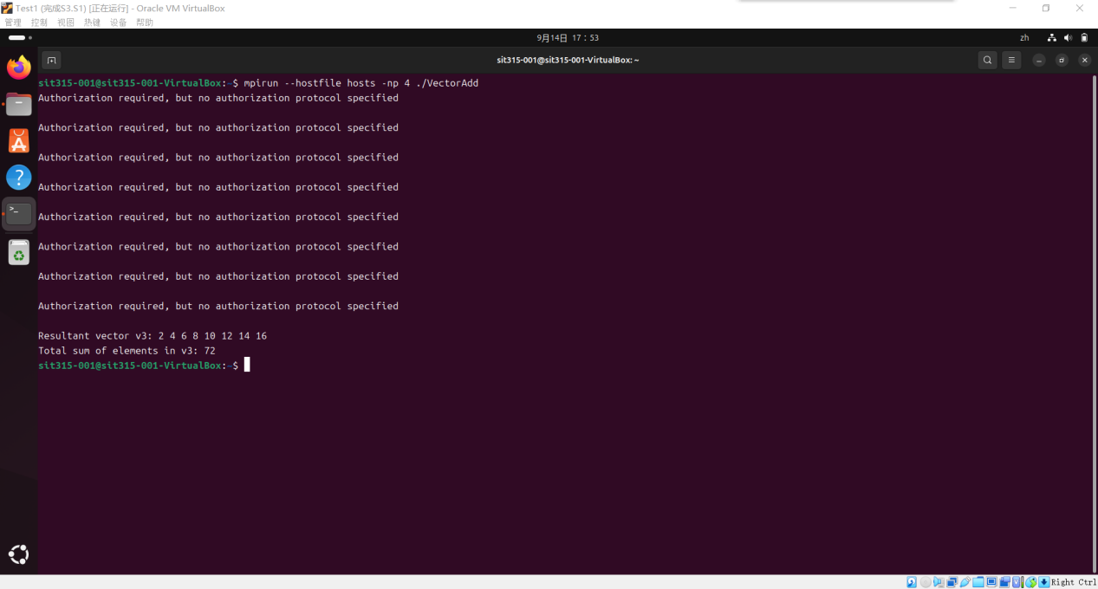

In this activity, I successfully implemented a distributed vector addition program using MPI. The program correctly distributed and computed the vector addition and calculated the total sum of the result vector.