1.

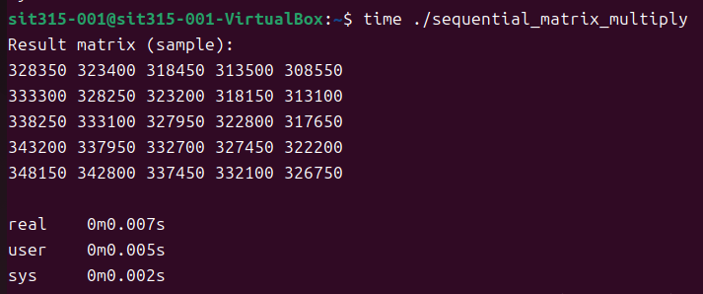

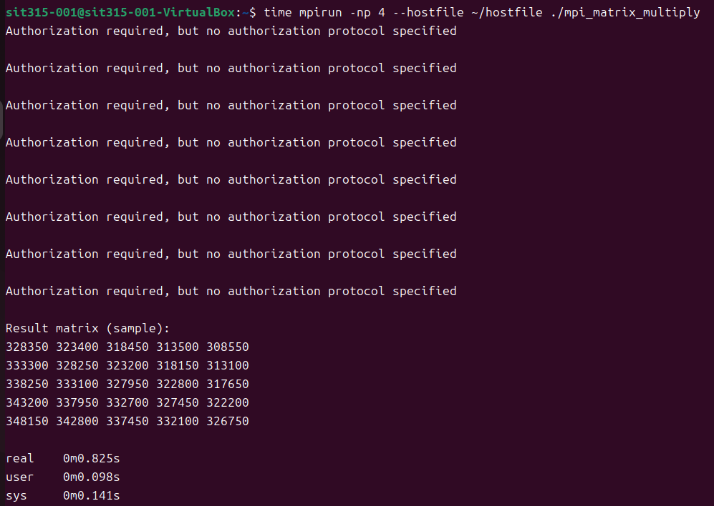

**Time**

1. Sequential Version (sequential_matrix_multiply):

real: 0m0.007s

user: 0m0.005s

sys: 0m0.002s

2. MPI Version (mpi_matrix_multiply):

real: 0m0.825s

user: 0m0.098s

sys: 0m0.141s

**Conclusion**

Sequential Program: The sequential method is fast for small-scale operations due to minimal overhead. However, this method only uses a single CPU core and will not scale efficiently for larger matrices or more complex operations. Its real-time execution is the shortest, but it’s limited to small data sizes and lacks scalability.

MPI Programs: MPI introduces parallelization by distributing tasks across multiple processes, but this comes at the cost of inter-process communication overhead. While it makes sense for distributed systems with large data sizes, the observed real-time execution is much higher than the sequential approach due to this overhead.

2.

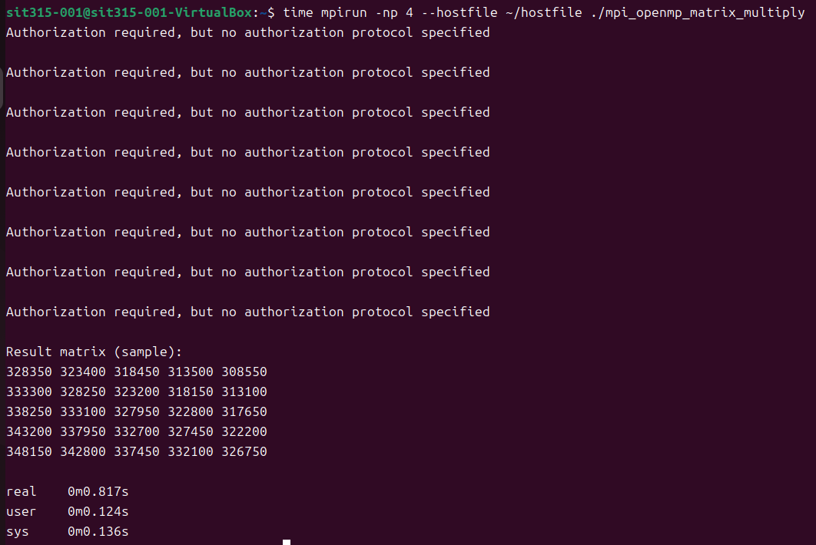

**Time**

3. MPI + OpenMP Version (mpi_openmp_matrix_multiply):

real: 0m0.817s

user: 0m0.124s

sys: 0m0.136s

**Conclusion**

MPI + OpenMP Program: Adds multi-threading but provides minimal additional benefit for small-scale tasks. The overhead from both MPI communication and thread management limits its effectiveness at small sizes, making it no better than MPI alone for smaller problems.

3.

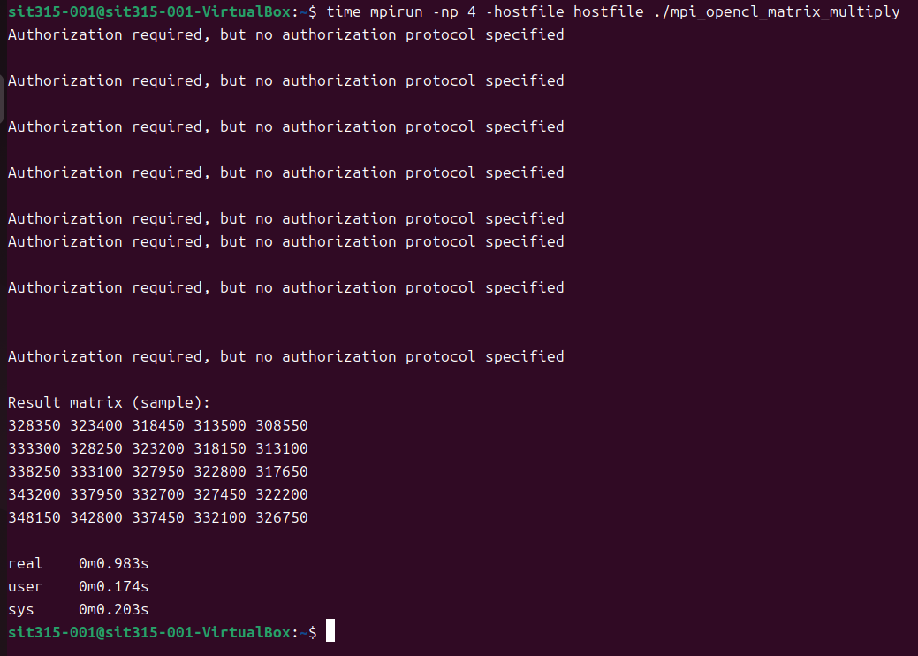

**Time**

real: 0m0.983s

user: 0m0.174s

sys: 0m0.203s

**Conclusion**

The MPI + OpenCL version exhibits a slightly longer execution time compared to the MPI and MPI+OpenMP versions. The extra overhead is likely due to OpenCL kernel initialization, context creation, and data transfer between host and device.

Github Link

<https://github.com/Lonely-DM/SIT315/tree/main/M3.T1P>

Video Link

<https://youtu.be/Jfnb3oZKwIg>