**Speedup Evaluation**

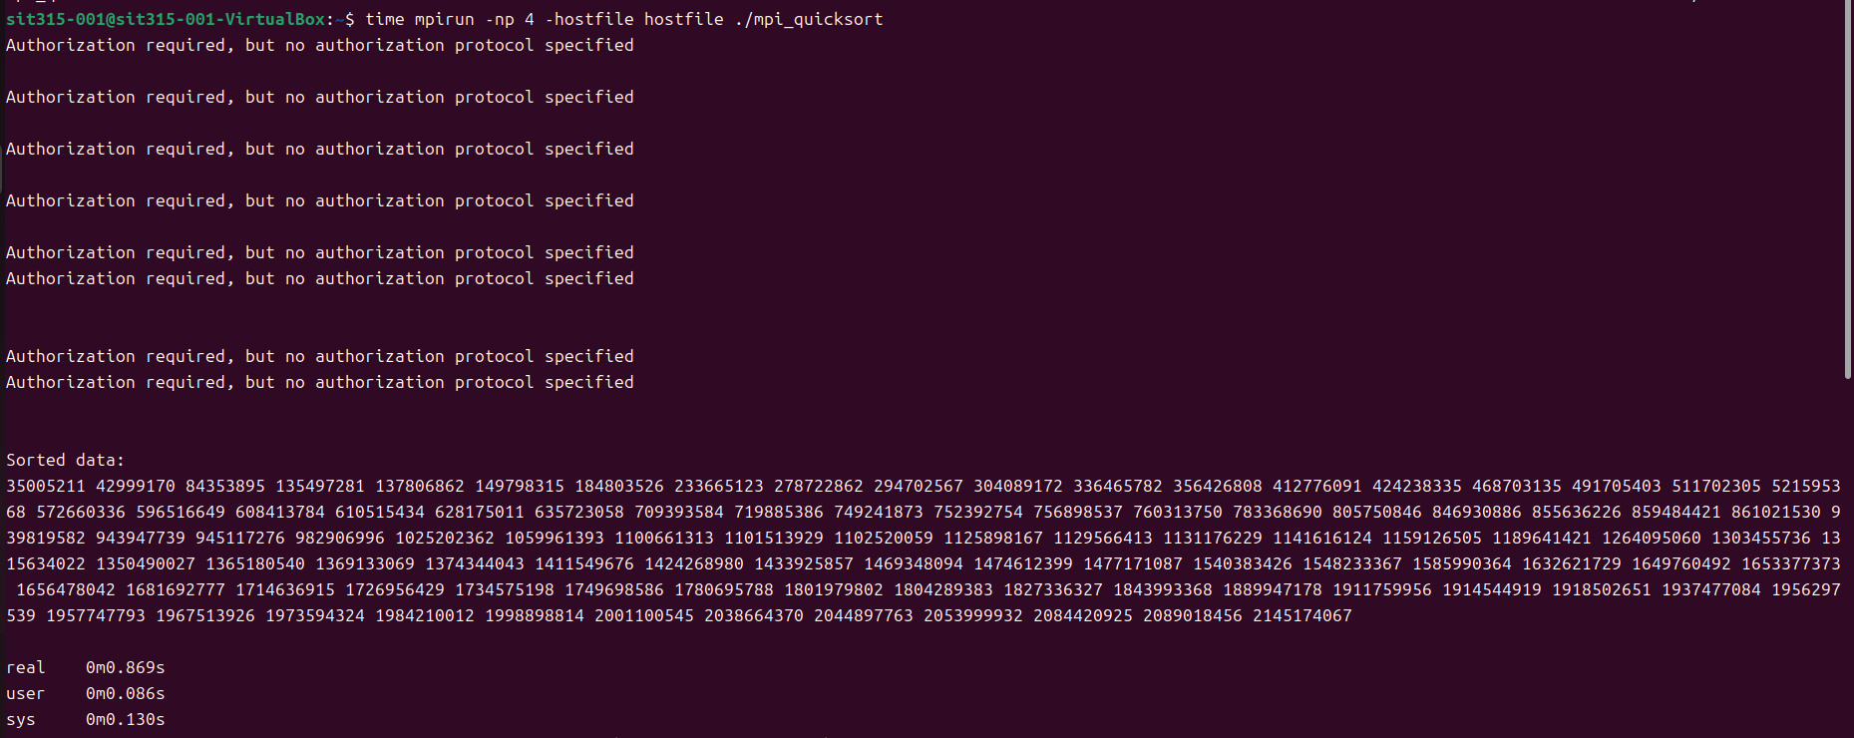

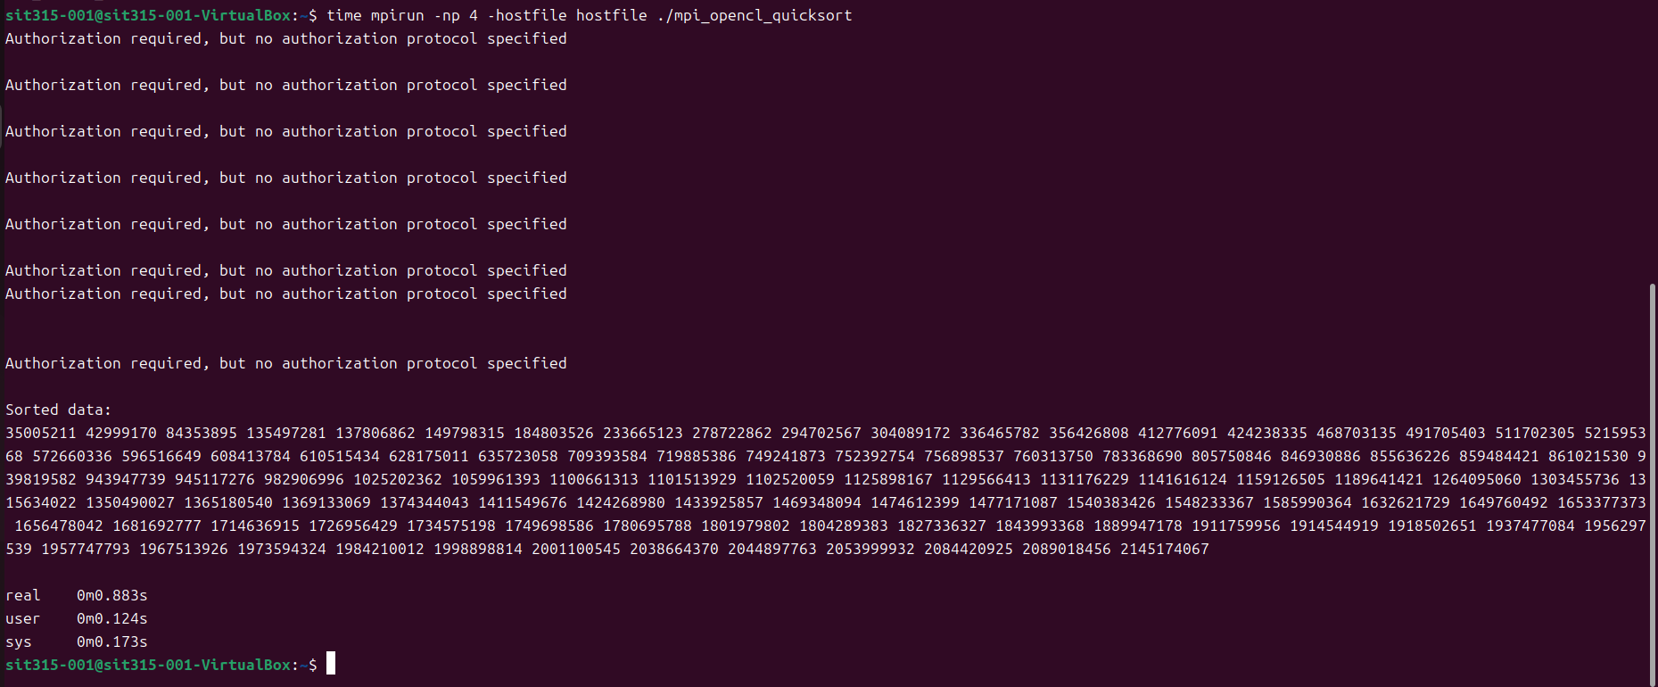

**Time**

MPI Version

real: 0m0.869s

user: 0m0.086s

sys: 0m0.130s

MPI + OpenCL Version

real: 0m0.883s

user: 0m0.124s

sys: 0m0.173s

**Speedup Comparison**

The MPI Version completes the task slightly faster than the MPI + OpenCL Version:

- MPI real time: 0.869 seconds

- MPI + OpenCL real time: 0.883 seconds

This slight difference shows that for the problem size and setup in this case, using OpenCL did not significantly speed up the sorting process. The primary reason for this could be the overhead of setting up OpenCL contexts, memory management, and the fact that the problem size might not be large enough to fully benefit from GPU acceleration.

In smaller workloads or less complex tasks, the initialization and memory transfer costs in OpenCL can outweigh the computational benefits provided by GPU offloading. Therefore, the extra cost of offloading to OpenCL on GPUs resulted in similar or slightly slower performance compared to the MPI-only version.

Github Link

<https://github.com/Lonely-DM/SIT315/tree/main/M3.T2C>

Video Link

<https://youtu.be/oqKfpjWS1ps>