At the beginning of the project, I set up the development environment, created a project directory, and initialized a Node.js project with npm init -y to manage dependencies. Then, I installed the Express framework (npm install express) to efficiently handle [HTTP requests](HTTPrequests).

Next, I implemented the microservice, configured the Express server to listen for requests, and defined API endpoints for addition, subtraction, multiplication, and division. Each operation properly processed inputs and returned the correct result. To improve robustness, I added input validation to ensure valid numeric values and handled errors (e.g., division by zero) by returning appropriate error messages.

Once the backend was complete, I developed the frontend interface, creating an HTML page with input fields, calculation buttons, and a dynamic result display. Then, I optimized CSS styles, designing a modern layout, improving button interactions, and adding visual feedback for input fields.

I implemented JavaScript logic to send requests to the API when a button was clicked, process the responses, and update the result display dynamically. Additionally, I introduced a language toggle feature, allowing users to seamlessly switch between English and Chinese while keeping the core functionality unchanged.

Finally, I launched the Express server and conducted comprehensive testing in the browser, verifying calculation accuracy, language switch responsiveness, and error handling. I also tested edge cases, such as non-numeric inputs and division by zero, to ensure system stability.

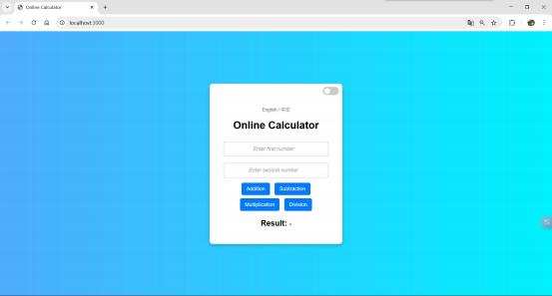

**GitHub Link** <https://github.com/Lonely-DM/SIT323/tree/main/4.1P/sit323-2025-prac4p>