At the beginning of this phase, I expanded the functionality of the calculator microservice by introducing additional arithmetic operations, including exponentiation, square root, and modulo calculations. To begin, I ensured that the development environment was properly set up by verifying the Node.js installation and managing dependencies via npm install express.

Next, I modified the existing Express server configuration to include new API endpoints for the additional operations. I defined routes to handle exponentiation (/power), square root (/sqrt), and modulo (/mod) calculations, ensuring that each endpoint correctly processed user inputs and returned accurate results.

To enhance reliability, I refined the input validation logic to prevent invalid numerical inputs. Specific cases, such as attempting to calculate the square root of a negative number or performing a modulo operation with zero as the divisor, were handled by returning appropriate error messages. Additionally, I ensured that the server consistently responded with meaningful feedback in cases of incorrect usage.

Finally, I verified the correctness of the implementation by conducting manual tests using sample numerical inputs. I tested each API endpoint through a web browser and Postman, confirming that expected results were returned for both valid and invalid inputs.

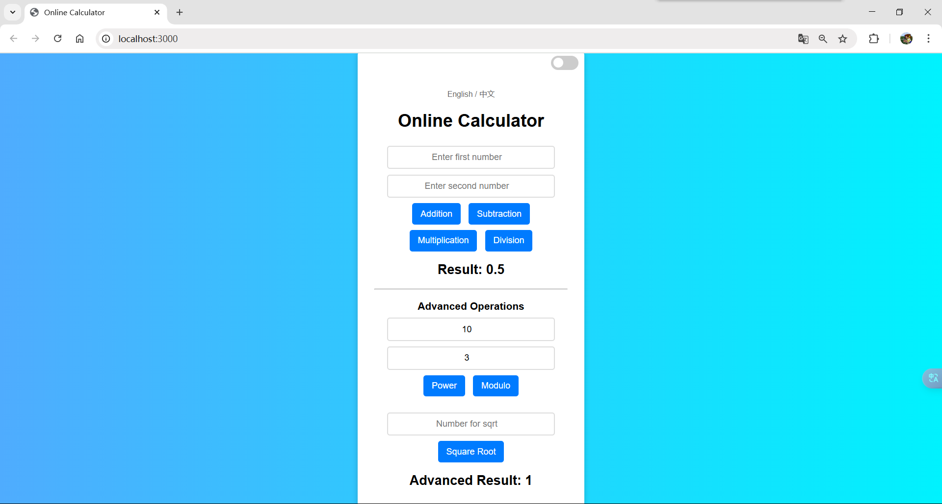

**GitHub Link**