At the beginning of this phase, I containerised the bilingual calculator application using Docker. The application already supported basic arithmetic operations and was developed with Node.js and Express, featuring a bilingual interface implemented in HTML, CSS, and JavaScript.

To begin, I created a Dockerfile that specified the base Node.js image, installed dependencies using npm install, and copied all application files into the image. I then exposed port 3000 and defined the start command using node server.js to ensure the container could run the web service correctly.

Next, I created a docker-compose.yml file to simplify the deployment process. The Compose file defined a single service that built the Docker image, mapped the container port to the host, and mounted the local directory to enable live changes during development.

Once the container was built and running, I accessed the application through http://localhost:3000 and verified that all core functionalities—including both English and Chinese interfaces—were working as intended. I tested the endpoints for addition, subtraction, multiplication, division, exponentiation, square root, and modulo operations.

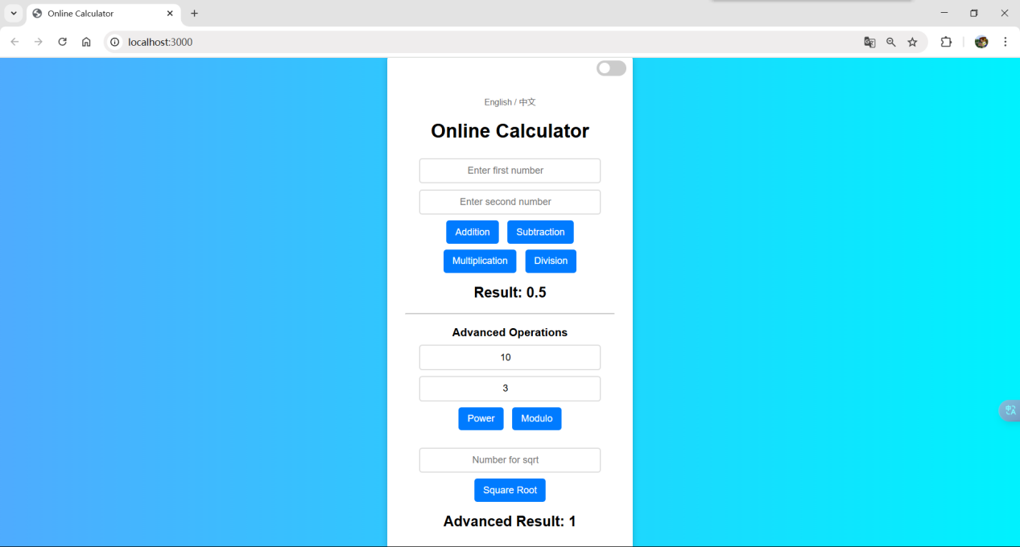

**GitHub Link**