1. **Kubernetes Commands and Interaction Process**

**Step 1: Check Pod Status**

kubectl get pods

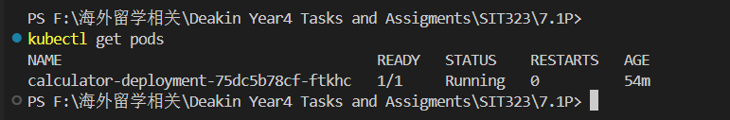

**Step 2: Check Service Status**

kubectl get services

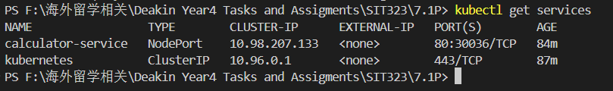

**Step 3: Access the Application Using kubectl port-forward**

kubectl port-forward pod/calculator-deployment-75dc5b78cf-ftkhc 8080:3000



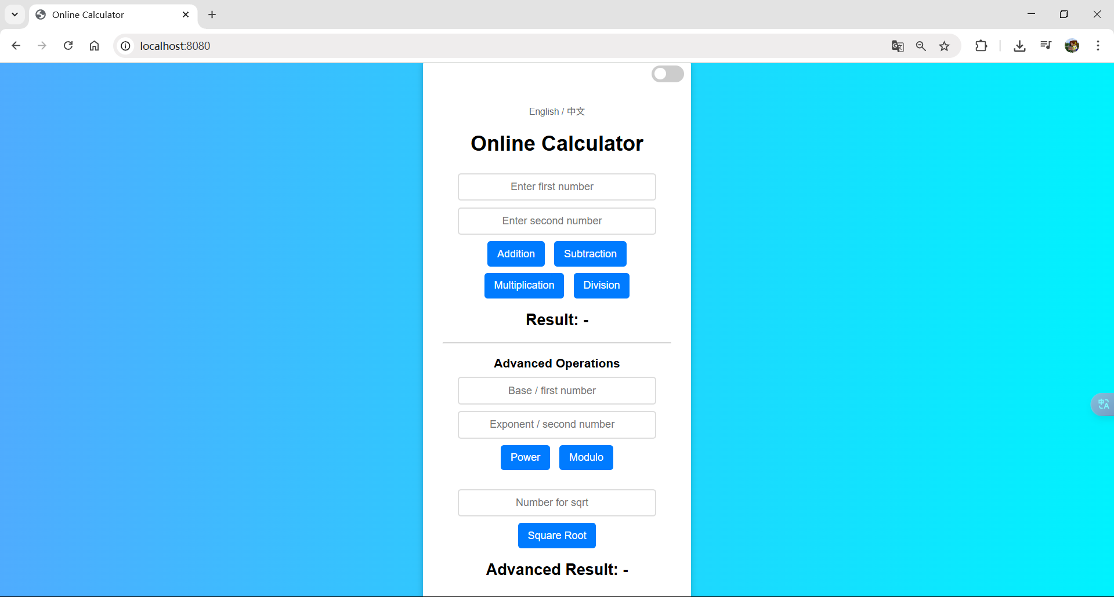

1. **Application Functional Testing**

**Addition**

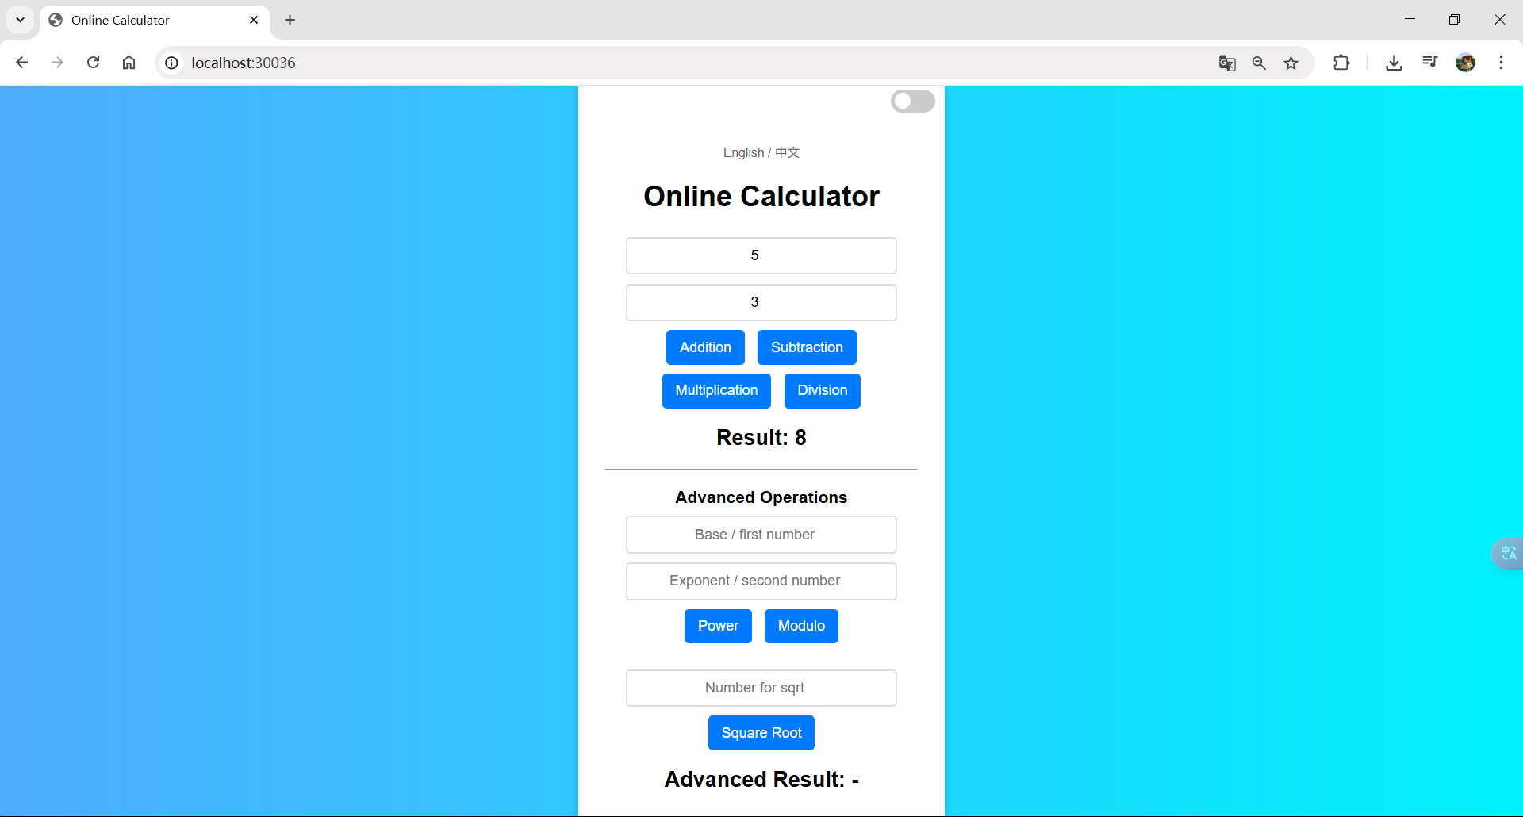

**Subtraction**

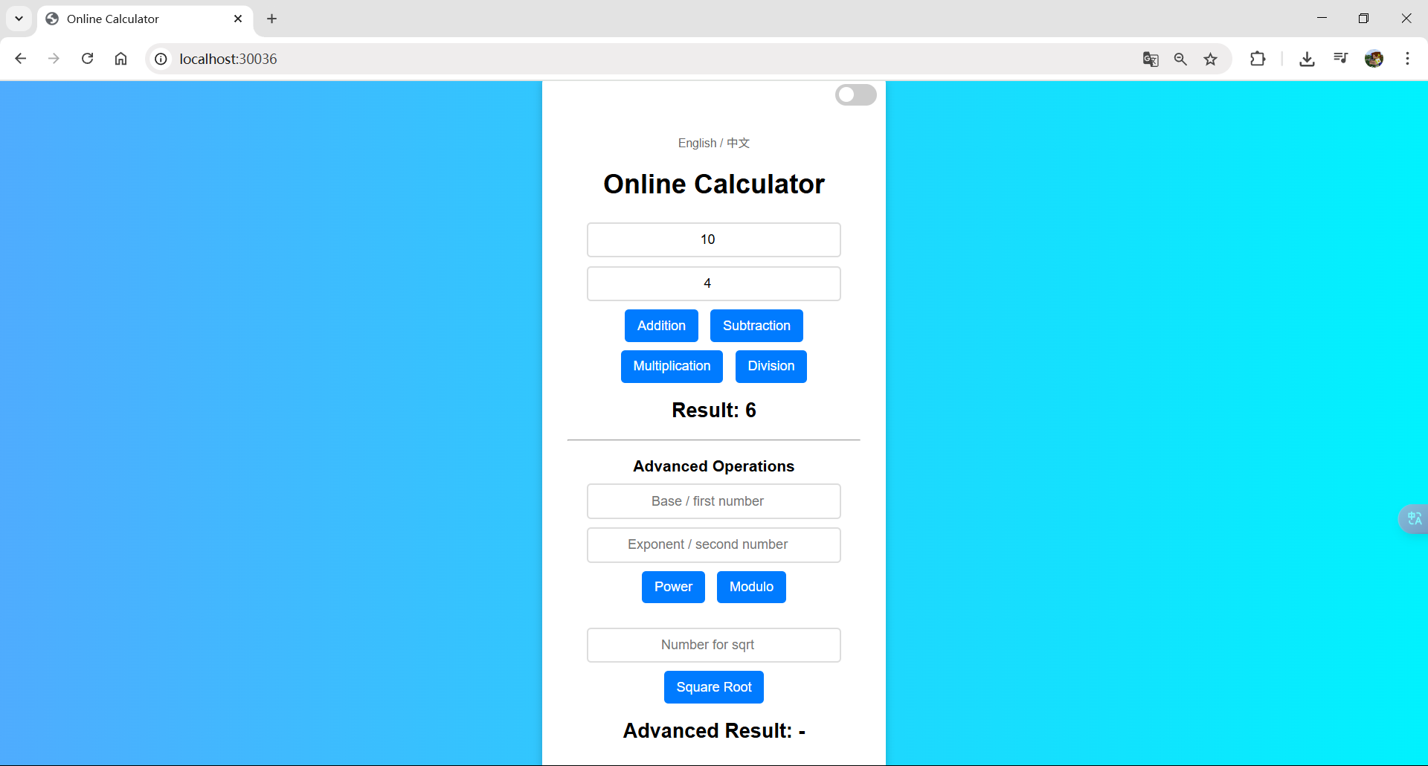

**Multiplication**

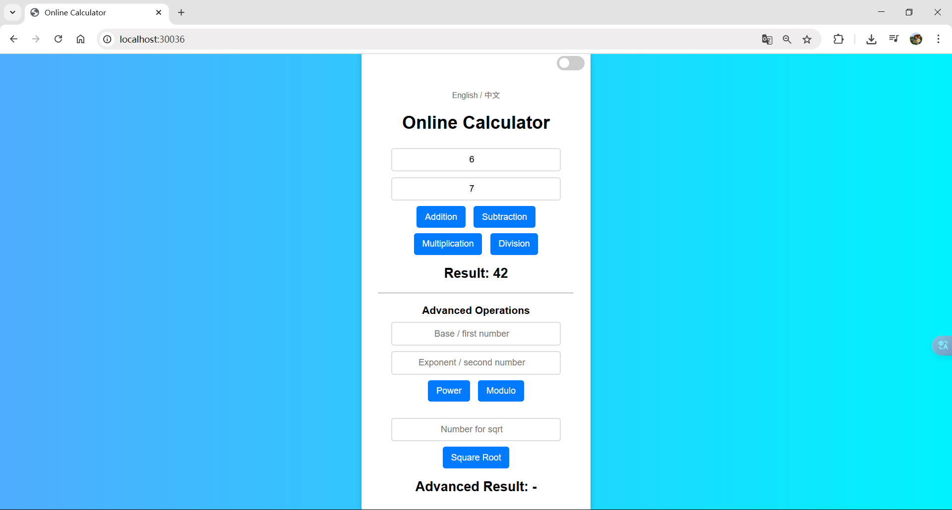

**Division**

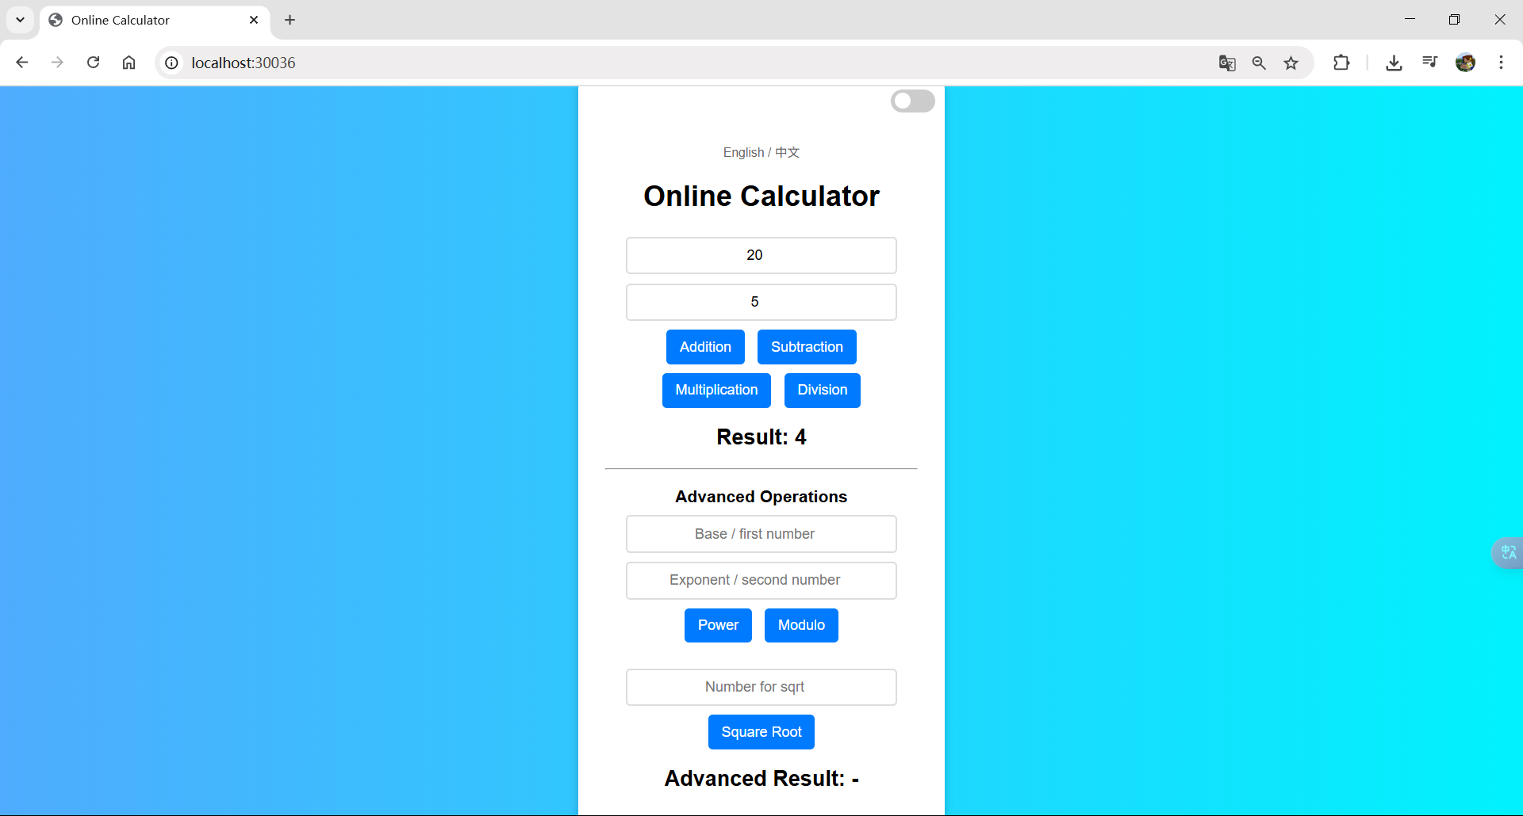

**Power**

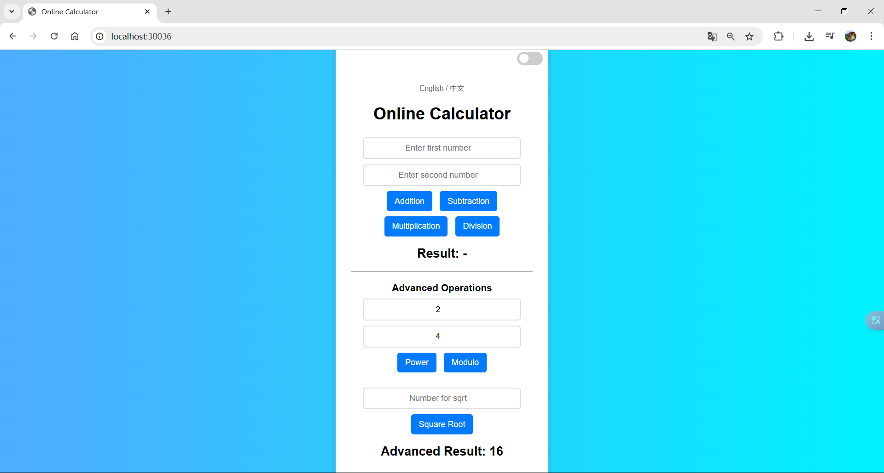

**Modulo**

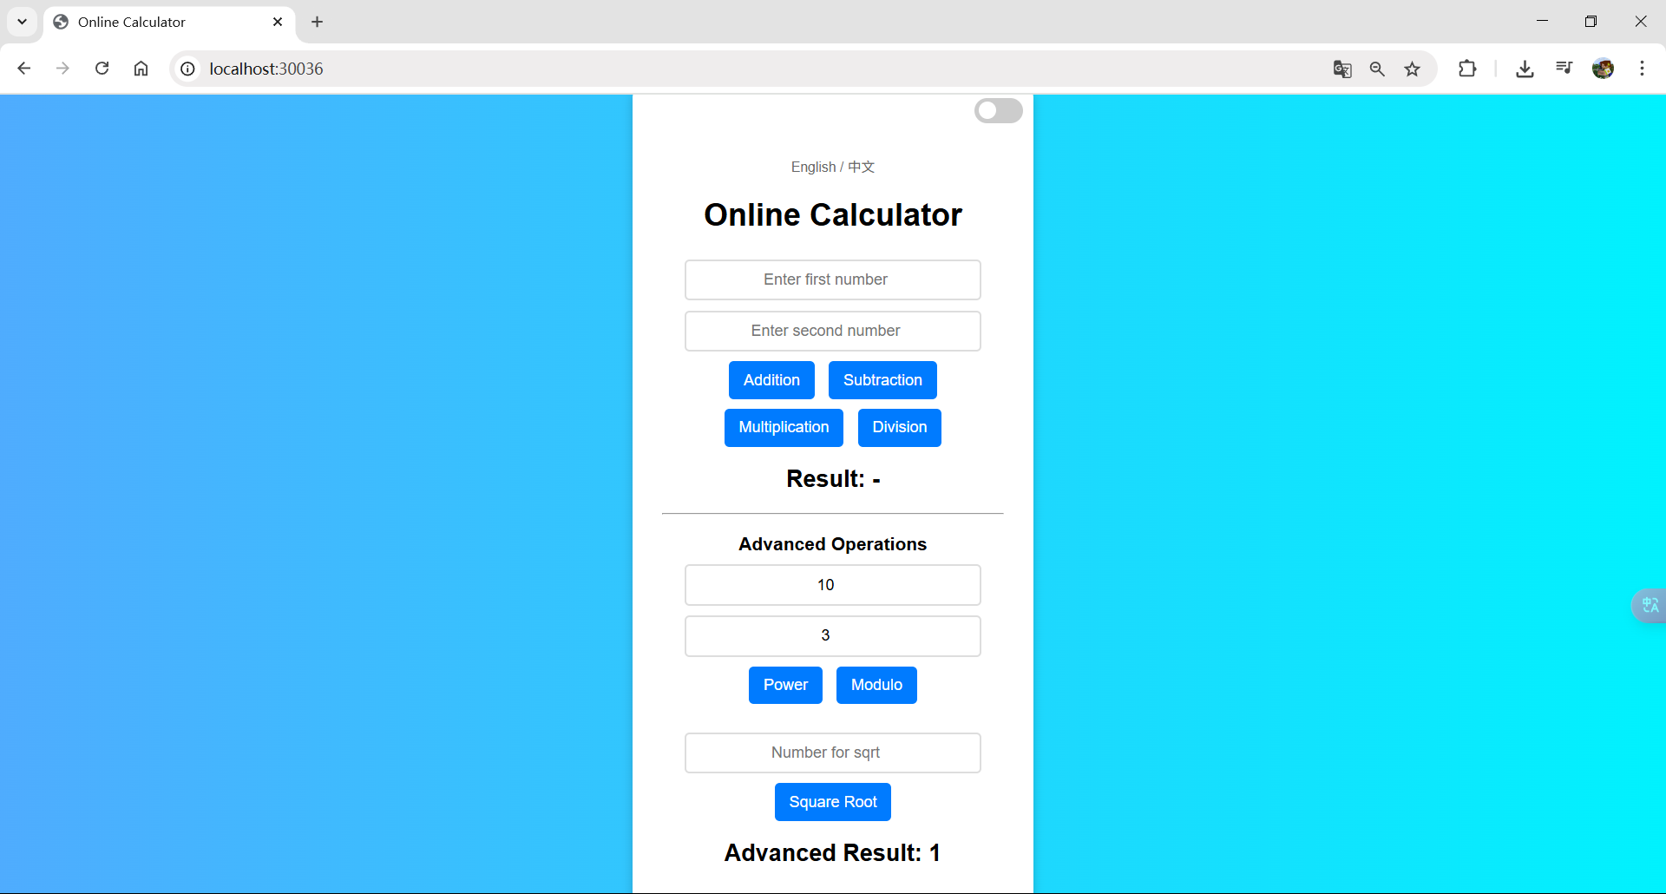

**Square Root**

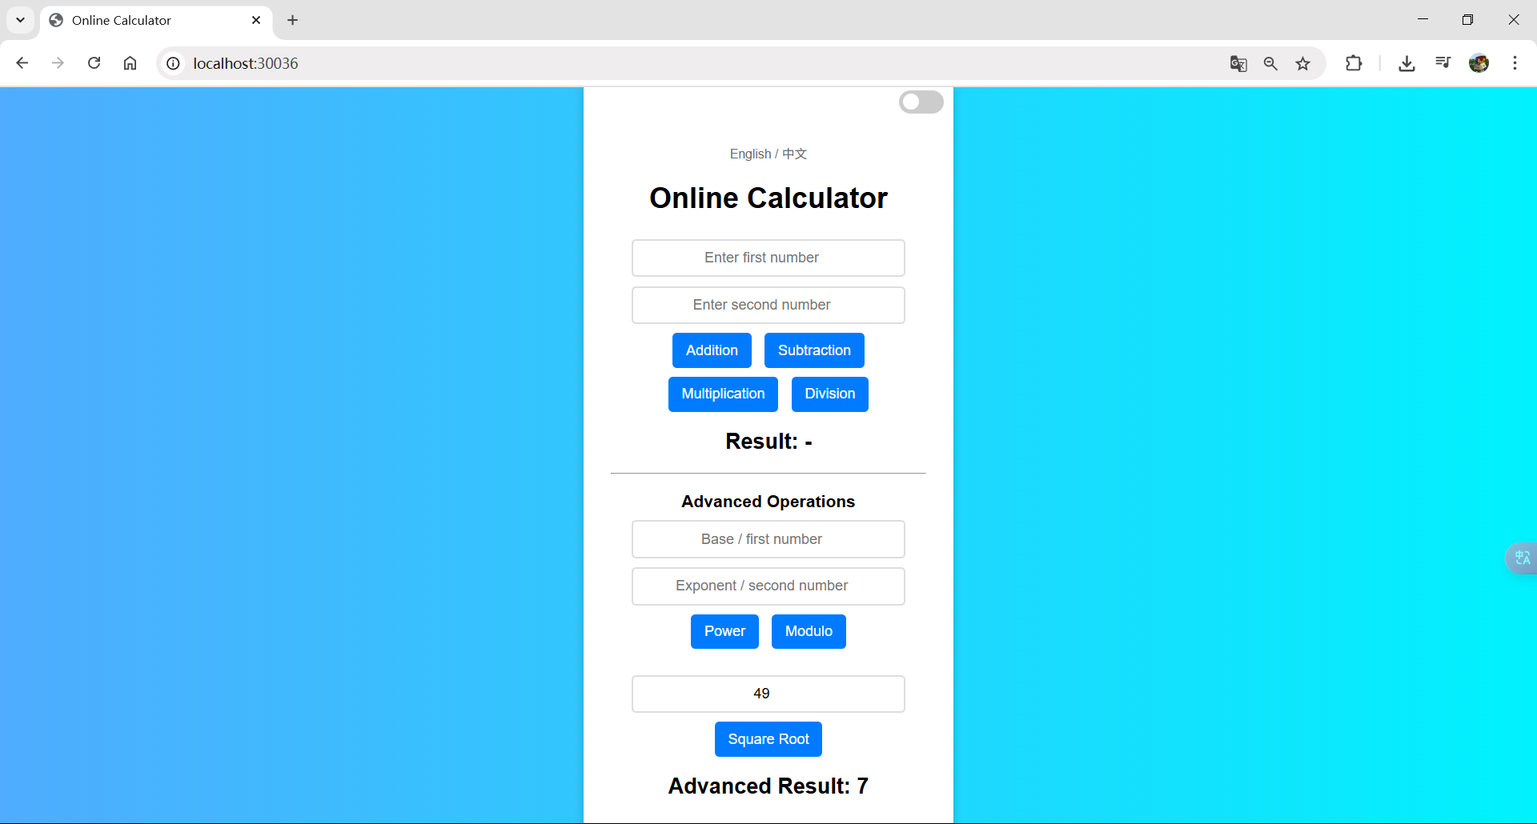

**Github Link:**