1. k和d的影响（rs = 0, transaction = 5000）

|  |  |  |  |  |  |
| --- | --- | --- | --- | --- | --- |
|  | success rate  (mean)  (var) | path  (mean)  (var) | probe  (mean)  (var) | stablization  (random)  (average)  (2/M) data  (2/M) sim | fund  (simulation)  (data) |
| k = 5  d = 4 | 0.87998  4.0084e-05 | 6.5929  0.00088159 | 13.186  0.0035263 | 11632  10434  968148(941)  16554(9) | 26599452935.0  101831454080.0 |
| k = 6  d = 3 | 0.97842  8.6836e-06 | 5.6852 0.00023656 | 11.370  0.00094623 | 29110  27096  1796556(941)  48522(22) | 65491442128.0  101831454080.0 |
| k = 7  d = 3 | 0.95436  6.4944e-06 | 5.6950  0.0010030 | 11.390  0.0040119 | 19451  17752  1602486(941)  31586(15) | 48014167013.0  101831454080.0 |
| k = 8  d = 3 | 0.91284  1.3086e-05 | 5.64149  0.00031467 | 11.283  0.0012587 | 15000  13600  1147204(941)  22432(11) | 34919101256.0  101831454080.0 |
| k = 9  d = 3 | 0.86860  2.5872e-05 | 5.5219  0.00024988 | 11.044  0.00099953 | 13413  12618  897948(941)  17100(8) | 24517601198.0  101831454080.0 |
| k = 10  d = 3 | 0.81444  4.4590e-05 | 5.3678  0.00060560 | 10.736  0.0024224 | 14021  13866  233358(941)  16206(8) | 15513309242.0  101831454080.0 |

1. rs的影响（rs = 0）

|  |  |  |  |
| --- | --- | --- | --- |
|  | success rate  (mean)  (var) | path  (mean)  (var) | probe  (mean)  (var) |
| k = 6, d = 3, r = 0 | 0.97926  4.0884e-06 | 5.6986  0.00070919 | 11.397  0.0028367 |
| k = 6, d = 3, r = 0.005 | 0.98118  1.6116e-05 | 5.6428  0.0012059 | 11.296  0.0049259 |
| k = 6, d = 3, r = 0.01 | 0.97774  1.4248e-05 | 5.6341  0.00052638 | 11.289  0.0025126 |
| k = 6, d = 3, r = 0.05 | 0.97992  9.8496e-06 | 5.4868  0.0018424 | 11.079  0.0064343 |
| k = 6, d = 3, r = 0.1 | 0.98152  6.4416e-06 | 5.2335  0.0018540 | 10.681  0.0081445 |
|  |  |  |  |
| k = 5, d = 4, r = 0 | 0.87924  1.9918e-05 | 6.5999  0.00049718 | 13.200  0.0019887 |
| k = 5, d = 4, r = 0.005 | 0.87880  1.9352e-05 | 6.5646  0.00052023 | 13.134  0.0020463 |
| k = 5, d = 4, r = 0.01 | 0.88112  5.6378e-05 | 6.5673  0.00096817 | 13.142  0.0037837 |
| k = 5, d = 4, r = 0.05 | 0.88620  1.5580e-05 | 6.3863  0.0030891 | 12.817  0.012747 |
| k = 5, d = 4, r = 0.1 | 0.89250  1.0698e-05 | 6.2359  0.00093366 | 12.560  0.0036976 |

1. scalability

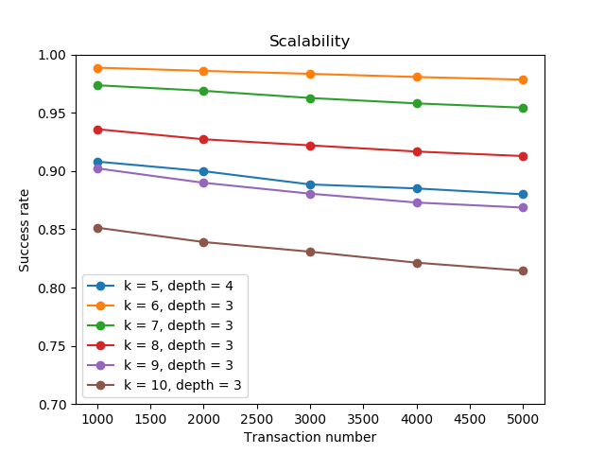

1. 小额交易（rs = 0, transaction = 5000）

|  |  |  |  |
| --- | --- | --- | --- |
|  | success rate  (mean)  (var) | path  (mean)  (var) | probe  (mean)  (var) |
| k = 5  d = 4 | 0.97926  4.0088e-06 | 6.5929  0.00088159 | 13.186  0.0035263 |
| k = 6  d = 3 | 0.97842  8.6836e-06 | 5.6852 0.00023656 | 11.370  0.00094623 |
| k = 7  d = 3 | 0.95436  6.4944e-06 | 5.6950  0.0010030 | 11.390  0.0040119 |
| k = 8  d = 3 | 0.91284  1.3086e-05 | 5.64149  0.00031467 | 11.283  0.0012587 |
| k = 9  d = 3 | 0.86860  2.5872e-05 | 5.5219  0.00024988 | 11.044  0.00099953 |
| k = 10  d = 3 | 0.81444  4.4590e-05 | 5.3678  0.00060560 | 10.736  0.0024224 |