UM-SJTU JOINT INSTITUTE

SINGALS AND SYSTEMS
(VE216)

Laboratory Report

Lab 3

Name: Shengyuan Xu ID:518370910200

Date: July 30, 2020

- Introduction

  - Objectives
- Build an open loop control circuit
- Build a closed loop (feedback) control circuit
- Obtain an understanding over feedback control circuit

  - Open Loop Control system
Figure 1. An example of open loop control system
For an open loop control system, the output only depends on the input. A general result is that a large change in input usually lead to a continuous large change in output.

  - Closed Loop Control system
Figure 2. An example of closed loop control system

For a closed loop control system, which is also called feedback control system, the new output not only depends on the current input but also the past output. Such system can moderate the change of the output. The brake control system of a car is usually designed based on this kind of system.

  - Examples of Feedback Control Systems ---- DC Motor Model
Let us assume that we want to control the shaft position of a DC motor. To help design a controller for this DC motor, we mathematically model the angular position, θ(t) of the shift by the following differential equation
$$\frac{d^{2}θ(t)}{dt^{2}}+\frac{dθ(t)}{dt}=V(t)$$
where V (t) is the voltage applied to the motor. Thus the plant (i.e., the motor) is a LTI system that has the following system transfer function
$$P\left(s\right)=\frac{1}{s(s+1)}$$
This transfer function corresponds to a second-order LTI system with no zeros, and a pair of real poles located at the origin and at -1.

  - Examples of Feedback Control Systems ---- No Controller
Suppose we want the shaft of the motor to rotate by one radian per second by using a unit step as the input, i.e., V (t) = u(t). Then
$$θ\left(s\right)=V\left(s\right)P\left(s\right)=\frac{1}{s}\frac{1}{s\left(s+1\right)}= -\frac{1}{s}+\frac{1}{s^{2}}+\frac{1}{s+1}$$
where the right-most side is obtained by a partial fraction expansion. Consequently,
$$θ\left(t\right)=\left(t-1+e^{-t}\right)u\left(t\right)$$
which is clearly not going to achieve the desired rotation by one radian per second!

- Experimental Setup
  - Open Loop Control ---- Plant
Figure 3: Plant Circuit

    - Construct the plant circuit according to Figure 1. Where R₀ = 10k$Ω$, C₁ = 100$μ$F, C₂ = 0.22$μ$F.
    - Impulse response: A=1V, width=0.1s, f=1Hz. (1 Picture)
    - Step Response: A=1V, f=1Hz. (1 Picture)

Note 1: Do not destroy your plant circuit after you get the image, you are going to use it in the next part.
Note 2: Do not forget to supply all the op-amps with DC voltage (Pin 4(-12V) and 7(12V))
Note 3: If a capacitor is labeled\474", its capacitance is 47 * 10⁴ pF; “224" is 22 * 10⁴ pF
Figure 4: Op-amp
  - Feedback Control
Figure 5: Feedback Control Circuit

    - Add the feedback control circuit to the plant according to Figure 4. Where R₁ = R₃ = 150k$Ω$, R₂ = 3k$Ω$, C₃ = 0.47$μ$F.
    - Impulse response: A=1V, width=0.1s, f=1Hz. (1 Picture)
    - Step Response: A=1V, f=1Hz.(1 Picture)

- Results and Calculations
  - Experiment Circuit

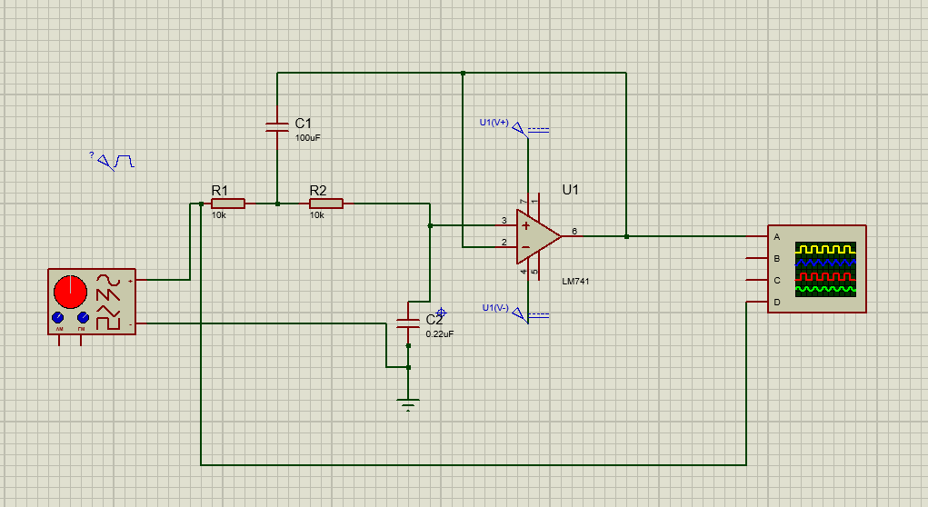
Figure 6. Experimental circuit for open loop control system

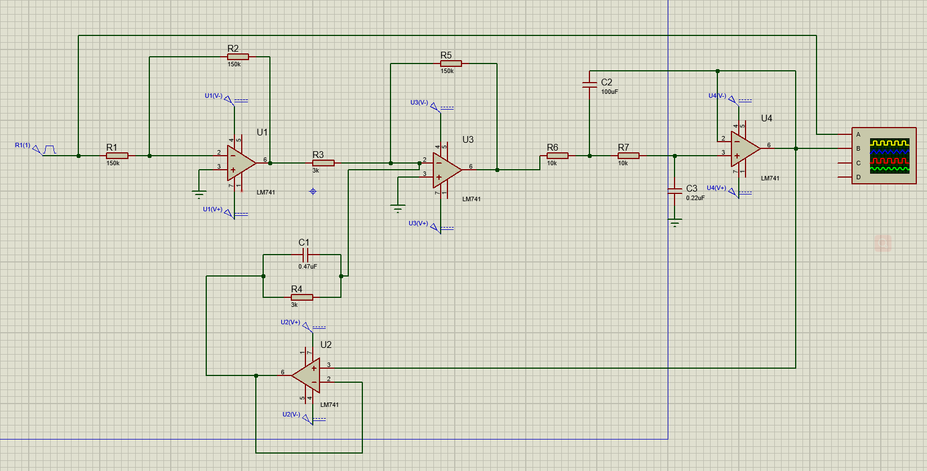
Figure 7. Experimental circuit for closed loop control system

    - Open Loop Control system
    - Raw Data
The raw data of this part is as follows,
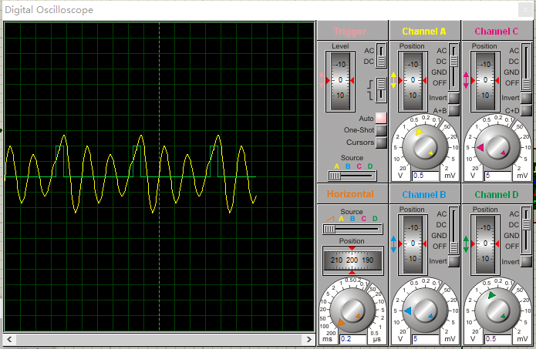
Figure 8. Measured result for o pen loop control system impulse input

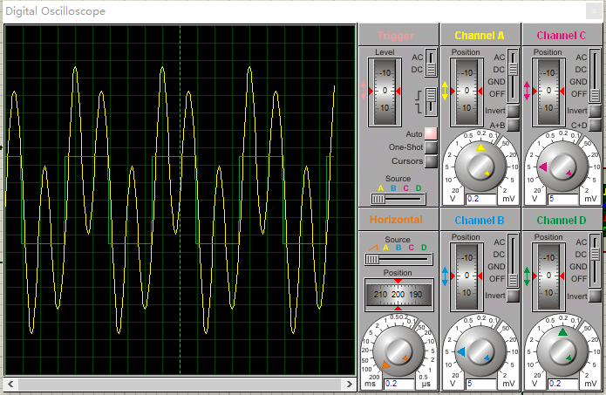
Figure 9. Measured result for o pen loop control system square input

  - Open Loop Control system
    - Raw Data
The raw data of this part is as follows,

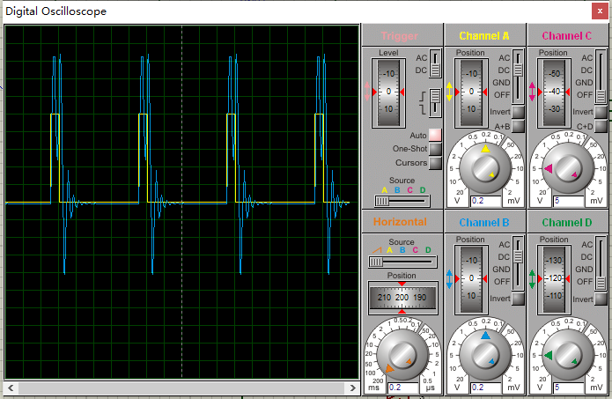
Figure 10. Measured result for closed loop control system impulse input

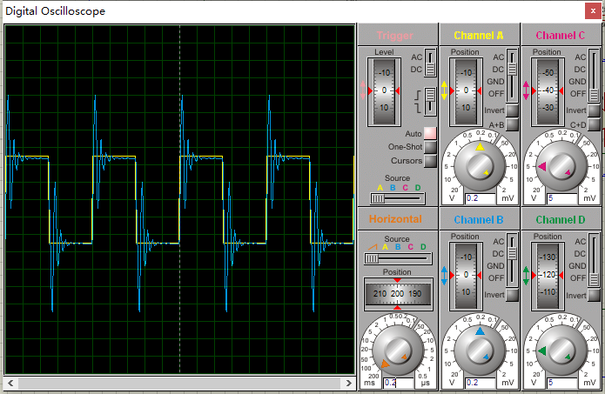
Figure 11. Measured result for closed loop control system square input

- Error analysis and Discussion
As the experiment was carried out on software, the main reason for the error in the last section was the reading of oscilloscope. By increasing the scale, we can measure the figure more accurately.
If we take a close look at the measurement, it’s the significant that may account for the error.
The shape, however, is what we expected.
- Conclusion and Discussion
In this lab:
- We successfully build an open loop control circuit
- We successfully build a closed loop (feedback) control circuit
- We successfully obtain an understanding over feedback control circuit

