**Ve270 Introduction to Logic Design Homework 3**

**Assigned: October 8, 2019**

**Due: October 15, 2019, 4:00pm.**

**The homework should be submitted in hard copies.**

1. Problem 2.57 (15 points)
2. Problem 2.58 (15 points)
3. Problem 2.59 (15 points)
4. Problem 2.74 (15 points)
5. Show how four 2-to-1 and one 4-to-1 MUXs could be connected to form an 8-to-1 MUX. (5 points)
6. Show how to make a 6-to-1 MUX using an 8-to-1 MUX. (5 points)
7. Use one 4-to-1 MUX and one inverter to implement a digital circuit for following truth table. (5 points)

|  |  |  |  |
| --- | --- | --- | --- |
| a | b | c | F |
| 0 | 0 | 0 | 1 |
| 0 | 0 | 1 | 0 |
| 0 | 1 | 0 | 1 |
| 0 | 1 | 1 | 1 |
| 1 | 0 | 0 | 1 |
| 1 | 0 | 1 | 0 |
| 1 | 1 | 0 | 1 |
| 1 | 1 | 1 | 0 |

1. Use one 3-by-8 decoder and other components to implement a digital circuit for above truth table. (10 points)
2. Design an 8-bit ALU described in the following functional table. Use building blocks. (10 points)

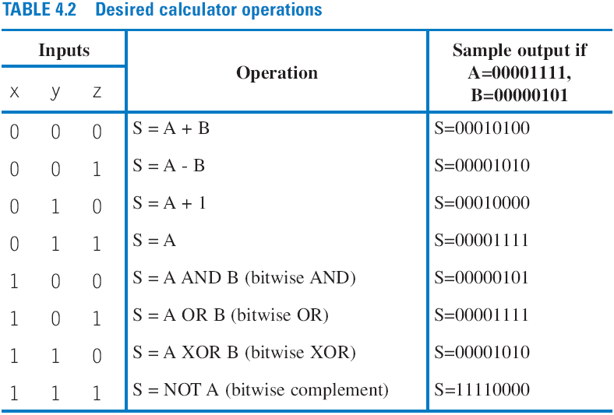

1. Highlight the critical paths of the following circuit. Assume that each gate (including the individual inverters and XOR gates) has a delay of 1 ns and each wire has a delay of 0.5 ns. (5 points)

c