______________________________________________________________

UM-SJTU JOINT INSTITUTE

INTRO TO COMPUTER ORGANIZATION

(VE 370)

______________________________________________________________

INDIVIDUAL PROJECT REPORT

PROJECT 2

|  |  |  |
| --- | --- | --- |
| Name: **Weikai Zhou** | ID: **518021911039** |  |
| Date: 12 Nov 2020 |  |  |

1. **Objective**

In the individual part of this project, we are going to implement the single cycle processor in Verilog so that it can support memory-reference instructions load word (lw) and store word (sw), arithmetic-logical instructions add, addi, sub, and, andi, or, and slt, jumping instructions branch equal (beq), branch not equal (bne), and jump (j).

1. **Architecture of single cycle processor**

The figure below shows the architecture of single cycle processor (Figure 1).

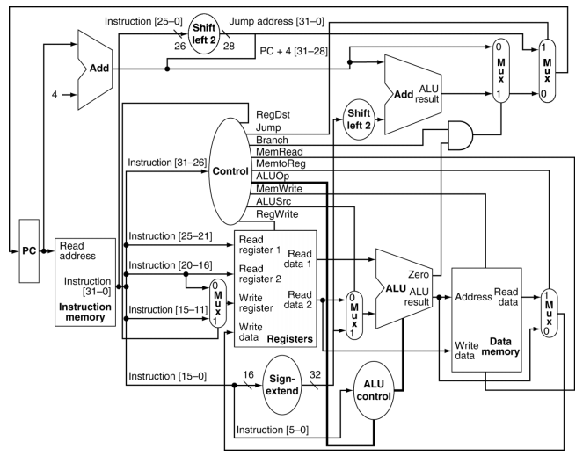

Figure 1. Architecture of single cycle processor

From the figure, we know that we can divide the processor into PC, Instruction Memory, Registers, Control Unit, Sign-Extend, ALU Control, ALU and Data Memory parts and connect them with wires. The detailed sourced code is in appendix.

1. **Simulation result**

Since single cycle processor conducts one instruction in one clock time, there is no hazard we need to solve. Based on the “InstructionMem_for_P2_Demo.txt” provided by TAs, I write my own instructions, which is in appendix.

* 1. **addi**

The figure below shows the result of “addi $t0, $zero, 0x20 (LOOP3)” (Figure 2).

$$\left[\$t0\right]=\left[\$0\right]+0x20=0x20$$

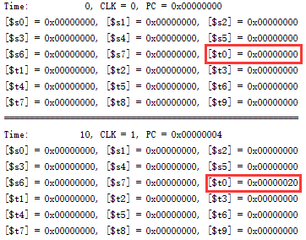

Figure 2. Result of addi

* 1. **and**

The figure below shows the result of “and $s0, $t0, $t1” (Figure 3).

$$\left[\$s0\right]=\left[\$t0\right] \& \left[\$t1\right]=0x20 \& 0x37=0x20$$

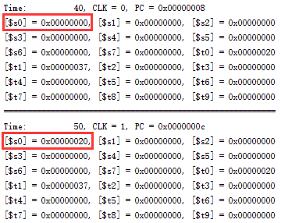

Figure 3. Result of and

* 1. **or**

The figure below shows the result of “or $s0, $t0, $t1” (Figure 4).

$$\left[\$s0\right]=\left[\$t0\right] \left| \left[\$t1\right]=0x20 \right| 0x37=0x37$$

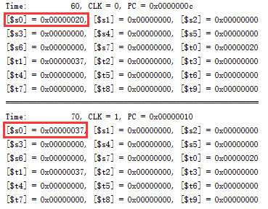

Figure 4. Result of or

* 1. **sw & lw**

For sw and lw, we use the following instructions.

sw $s0, 4($zero)

lw $s1, 4($zero)

Therefore, we can know that after running the code, the value in $s1 should be the same as the value in $s0. The figure below shows the result (Figure 5).

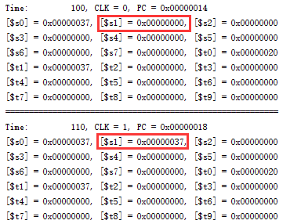

Figure 5. Result of sw & lw

* 1. **add**

The figure below shows the result of “add $t3, $t1, $t0” (Figure 6).

$$\left[\$t3\right]=\left[\$t1\right]+\left[\$t0\right]=0x37+0x20=0x57$$

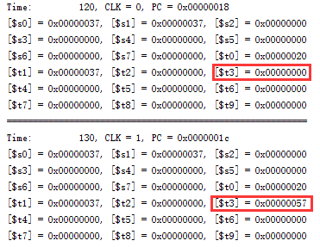

Figure 6. Result of add

* 1. **sub**

The figure below shows the result of “sub $t3, $t1, $t0” (Figure 7).

$$\left[\$t3\right]=\left[\$t1\right]-\left[\$t0\right]=0x37-0x20=0x17$$

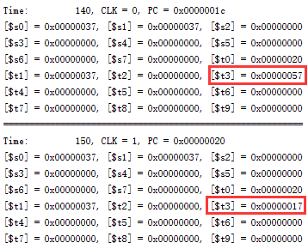

Figure 7. Result of sub

* 1. **andi**

The figure below shows the result of “andi $t3, $t0, 0x37” (Figure 8).

$$\left[\$t3\right]=\left[\$t0\right] \& 0x37=0x20 \& 0x37=0x20$$

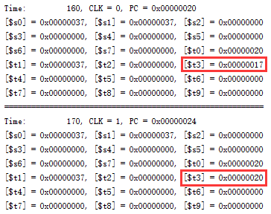

Figure 8. Result of andi

* 1. **slt**

The figure below shows the result of “slt $t3, $t0, $t1” (Figure 9).

$$\left[\$t3\right]=\left(\left[\$t0\right]<\left[\$t1\right]\right) ? 1:0=1$$

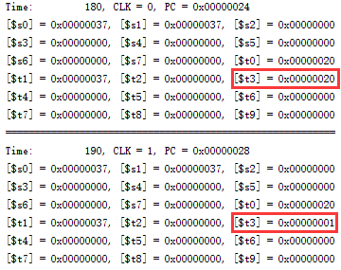

Figure 9. Result of slt

* 1. **beq**

The figure below shows the result of “beq $t0, $t0, LOOP1” (Figure 10). The PC jumps to where LOOP1 locates.

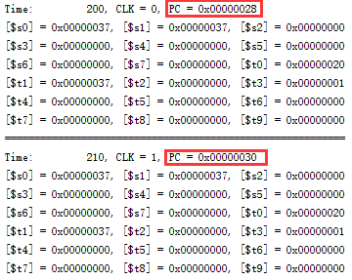

Figure 10. Result of beq

* 1. **bne**

The figure below shows the result of “bne $t0, $t1, LOOP2 (LOOP1)” (Figure 11). The PC jumps to where LOOP2 locates.

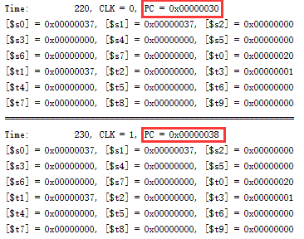

Figure 11. Result of bne

* 1. **j**

The figure below shows the result of “j LOOP3 (LOOP2)” (Figure 12). The PC jumps to where LOOP3 locates.

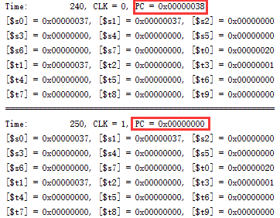

Figure 11. Result of j

Therefore, we know that all the instructions required has been achieved successfully.

1. **Conclusion**

In the individual part of this project, we have implemented the single cycle processor in Verilog so that it can support memory-reference instructions load word (lw) and store word (sw), arithmetic-logical instructions add, addi, sub, and, andi, or, and slt, jumping instructions branch equal (beq), branch not equal (bne), and jump (j).

From this project, we know that designing the processor from a larger perspective is important because the wire used to connect different components can be annoying.

1. **Peer Evaluation**

|  |  |  |
| --- | --- | --- |
| Name | Level of contribution | Description of contribution |
| Weikai Zhou (myself) | 5 | Writing pipelined processor (excluding forwarding, hazard detection), final debugging, writing report |
| Shengyuan Xu | 5 | Writing report |
| Yiwei Yang | 5 | Writing forwarding, hazard detection and report |
| Yuxuan Zhang | 5 | Writing code that connects pipelined processor with the FPGA, writing report |

1. **Appendix**
   1. **Test instructions**

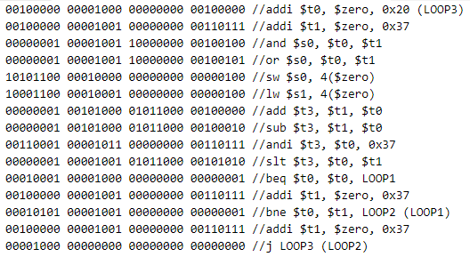

* 1. **Single cycle**

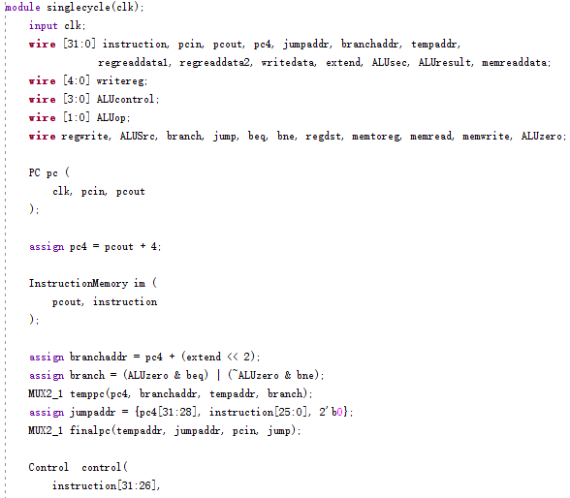

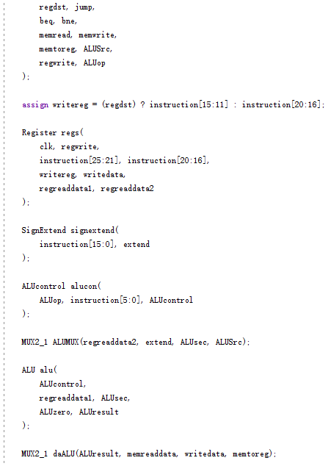

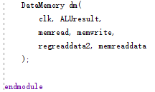

* 1. **ALU**

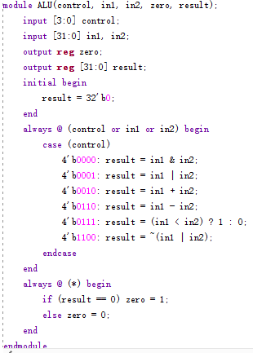

* 1. **ALUControl**

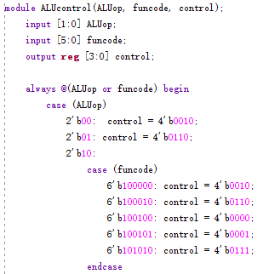

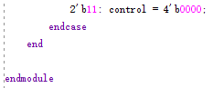

* 1. **Register**

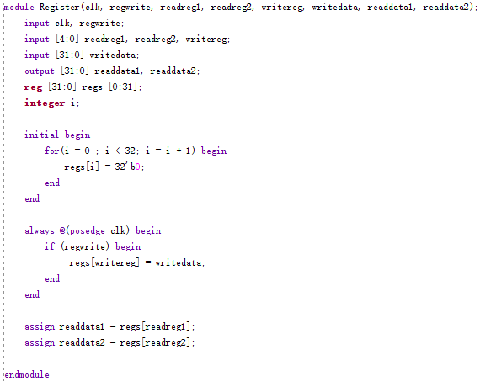

* 1. **Control**

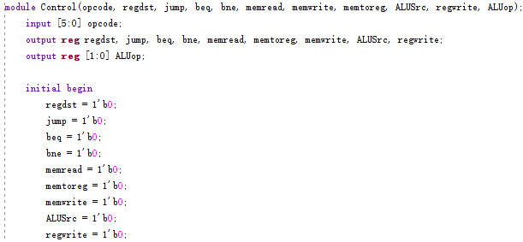

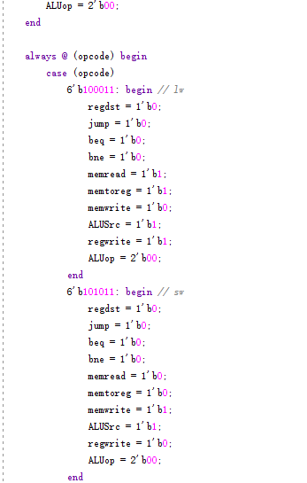

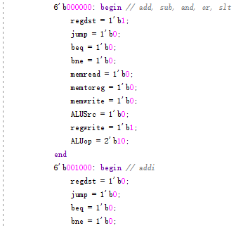

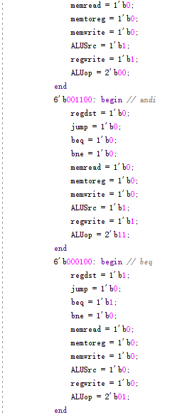

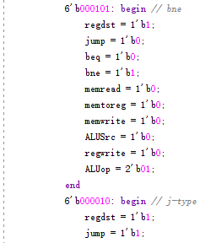

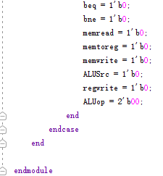

* 1. **InstructionMemory**

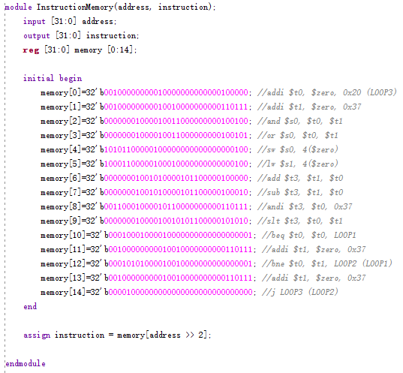

* 1. **PC**

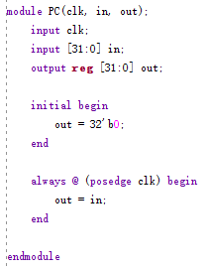

* 1. **DataMemory**

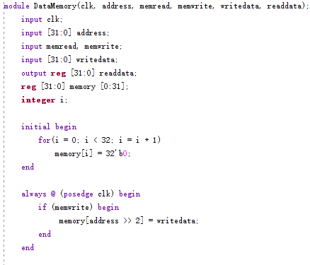

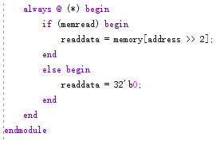

* 1. **SignExtend**

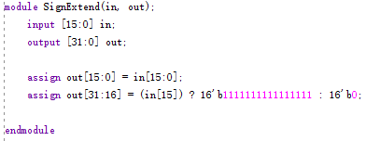

* 1. **MUX2_1**

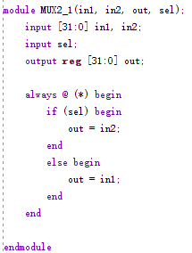

* 1. **Testbench**

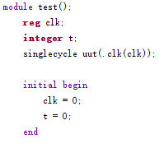

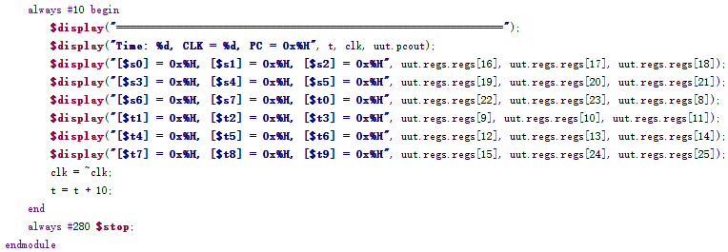

* 1. **Simulation result**

=========================================================

Time: 0, CLK = 0, PC = 0x00000000

[$s0] = 0x00000000, [$s1] = 0x00000000, [$s2] = 0x00000000

[$s3] = 0x00000000, [$s4] = 0x00000000, [$s5] = 0x00000000

[$s6] = 0x00000000, [$s7] = 0x00000000, [$t0] = 0x00000000

[$t1] = 0x00000000, [$t2] = 0x00000000, [$t3] = 0x00000000

[$t4] = 0x00000000, [$t5] = 0x00000000, [$t6] = 0x00000000

[$t7] = 0x00000000, [$t8] = 0x00000000, [$t9] = 0x00000000

=========================================================

Time: 10, CLK = 1, PC = 0x00000004

[$s0] = 0x00000000, [$s1] = 0x00000000, [$s2] = 0x00000000

[$s3] = 0x00000000, [$s4] = 0x00000000, [$s5] = 0x00000000

[$s6] = 0x00000000, [$s7] = 0x00000000, [$t0] = 0x00000020

[$t1] = 0x00000000, [$t2] = 0x00000000, [$t3] = 0x00000000

[$t4] = 0x00000000, [$t5] = 0x00000000, [$t6] = 0x00000000

[$t7] = 0x00000000, [$t8] = 0x00000000, [$t9] = 0x00000000

=========================================================

Time: 20, CLK = 0, PC = 0x00000004

[$s0] = 0x00000000, [$s1] = 0x00000000, [$s2] = 0x00000000

[$s3] = 0x00000000, [$s4] = 0x00000000, [$s5] = 0x00000000

[$s6] = 0x00000000, [$s7] = 0x00000000, [$t0] = 0x00000020

[$t1] = 0x00000000, [$t2] = 0x00000000, [$t3] = 0x00000000

[$t4] = 0x00000000, [$t5] = 0x00000000, [$t6] = 0x00000000

[$t7] = 0x00000000, [$t8] = 0x00000000, [$t9] = 0x00000000

=========================================================

Time: 30, CLK = 1, PC = 0x00000008

[$s0] = 0x00000000, [$s1] = 0x00000000, [$s2] = 0x00000000

[$s3] = 0x00000000, [$s4] = 0x00000000, [$s5] = 0x00000000

[$s6] = 0x00000000, [$s7] = 0x00000000, [$t0] = 0x00000020

[$t1] = 0x00000037, [$t2] = 0x00000000, [$t3] = 0x00000000

[$t4] = 0x00000000, [$t5] = 0x00000000, [$t6] = 0x00000000

[$t7] = 0x00000000, [$t8] = 0x00000000, [$t9] = 0x00000000

=========================================================

Time: 40, CLK = 0, PC = 0x00000008

[$s0] = 0x00000000, [$s1] = 0x00000000, [$s2] = 0x00000000

[$s3] = 0x00000000, [$s4] = 0x00000000, [$s5] = 0x00000000

[$s6] = 0x00000000, [$s7] = 0x00000000, [$t0] = 0x00000020

[$t1] = 0x00000037, [$t2] = 0x00000000, [$t3] = 0x00000000

[$t4] = 0x00000000, [$t5] = 0x00000000, [$t6] = 0x00000000

[$t7] = 0x00000000, [$t8] = 0x00000000, [$t9] = 0x00000000

=========================================================

Time: 50, CLK = 1, PC = 0x0000000c

[$s0] = 0x00000020, [$s1] = 0x00000000, [$s2] = 0x00000000

[$s3] = 0x00000000, [$s4] = 0x00000000, [$s5] = 0x00000000

[$s6] = 0x00000000, [$s7] = 0x00000000, [$t0] = 0x00000020

[$t1] = 0x00000037, [$t2] = 0x00000000, [$t3] = 0x00000000

[$t4] = 0x00000000, [$t5] = 0x00000000, [$t6] = 0x00000000

[$t7] = 0x00000000, [$t8] = 0x00000000, [$t9] = 0x00000000

=========================================================

Time: 60, CLK = 0, PC = 0x0000000c

[$s0] = 0x00000020, [$s1] = 0x00000000, [$s2] = 0x00000000

[$s3] = 0x00000000, [$s4] = 0x00000000, [$s5] = 0x00000000

[$s6] = 0x00000000, [$s7] = 0x00000000, [$t0] = 0x00000020

[$t1] = 0x00000037, [$t2] = 0x00000000, [$t3] = 0x00000000

[$t4] = 0x00000000, [$t5] = 0x00000000, [$t6] = 0x00000000

[$t7] = 0x00000000, [$t8] = 0x00000000, [$t9] = 0x00000000

=========================================================

Time: 70, CLK = 1, PC = 0x00000010

[$s0] = 0x00000037, [$s1] = 0x00000000, [$s2] = 0x00000000

[$s3] = 0x00000000, [$s4] = 0x00000000, [$s5] = 0x00000000

[$s6] = 0x00000000, [$s7] = 0x00000000, [$t0] = 0x00000020

[$t1] = 0x00000037, [$t2] = 0x00000000, [$t3] = 0x00000000

[$t4] = 0x00000000, [$t5] = 0x00000000, [$t6] = 0x00000000

[$t7] = 0x00000000, [$t8] = 0x00000000, [$t9] = 0x00000000

=========================================================

Time: 80, CLK = 0, PC = 0x00000010

[$s0] = 0x00000037, [$s1] = 0x00000000, [$s2] = 0x00000000

[$s3] = 0x00000000, [$s4] = 0x00000000, [$s5] = 0x00000000

[$s6] = 0x00000000, [$s7] = 0x00000000, [$t0] = 0x00000020

[$t1] = 0x00000037, [$t2] = 0x00000000, [$t3] = 0x00000000

[$t4] = 0x00000000, [$t5] = 0x00000000, [$t6] = 0x00000000

[$t7] = 0x00000000, [$t8] = 0x00000000, [$t9] = 0x00000000

=========================================================

Time: 90, CLK = 1, PC = 0x00000014

[$s0] = 0x00000037, [$s1] = 0x00000000, [$s2] = 0x00000000

[$s3] = 0x00000000, [$s4] = 0x00000000, [$s5] = 0x00000000

[$s6] = 0x00000000, [$s7] = 0x00000000, [$t0] = 0x00000020

[$t1] = 0x00000037, [$t2] = 0x00000000, [$t3] = 0x00000000

[$t4] = 0x00000000, [$t5] = 0x00000000, [$t6] = 0x00000000

[$t7] = 0x00000000, [$t8] = 0x00000000, [$t9] = 0x00000000

=========================================================

Time: 100, CLK = 0, PC = 0x00000014

[$s0] = 0x00000037, [$s1] = 0x00000000, [$s2] = 0x00000000

[$s3] = 0x00000000, [$s4] = 0x00000000, [$s5] = 0x00000000

[$s6] = 0x00000000, [$s7] = 0x00000000, [$t0] = 0x00000020

[$t1] = 0x00000037, [$t2] = 0x00000000, [$t3] = 0x00000000

[$t4] = 0x00000000, [$t5] = 0x00000000, [$t6] = 0x00000000

[$t7] = 0x00000000, [$t8] = 0x00000000, [$t9] = 0x00000000

=========================================================

Time: 110, CLK = 1, PC = 0x00000018

[$s0] = 0x00000037, [$s1] = 0x00000037, [$s2] = 0x00000000

[$s3] = 0x00000000, [$s4] = 0x00000000, [$s5] = 0x00000000

[$s6] = 0x00000000, [$s7] = 0x00000000, [$t0] = 0x00000020

[$t1] = 0x00000037, [$t2] = 0x00000000, [$t3] = 0x00000000

[$t4] = 0x00000000, [$t5] = 0x00000000, [$t6] = 0x00000000

[$t7] = 0x00000000, [$t8] = 0x00000000, [$t9] = 0x00000000

=========================================================

Time: 120, CLK = 0, PC = 0x00000018

[$s0] = 0x00000037, [$s1] = 0x00000037, [$s2] = 0x00000000

[$s3] = 0x00000000, [$s4] = 0x00000000, [$s5] = 0x00000000

[$s6] = 0x00000000, [$s7] = 0x00000000, [$t0] = 0x00000020

[$t1] = 0x00000037, [$t2] = 0x00000000, [$t3] = 0x00000000

[$t4] = 0x00000000, [$t5] = 0x00000000, [$t6] = 0x00000000

[$t7] = 0x00000000, [$t8] = 0x00000000, [$t9] = 0x00000000

=========================================================

Time: 130, CLK = 1, PC = 0x0000001c

[$s0] = 0x00000037, [$s1] = 0x00000037, [$s2] = 0x00000000

[$s3] = 0x00000000, [$s4] = 0x00000000, [$s5] = 0x00000000

[$s6] = 0x00000000, [$s7] = 0x00000000, [$t0] = 0x00000020

[$t1] = 0x00000037, [$t2] = 0x00000000, [$t3] = 0x00000057

[$t4] = 0x00000000, [$t5] = 0x00000000, [$t6] = 0x00000000

[$t7] = 0x00000000, [$t8] = 0x00000000, [$t9] = 0x00000000

=========================================================

Time: 140, CLK = 0, PC = 0x0000001c

[$s0] = 0x00000037, [$s1] = 0x00000037, [$s2] = 0x00000000

[$s3] = 0x00000000, [$s4] = 0x00000000, [$s5] = 0x00000000

[$s6] = 0x00000000, [$s7] = 0x00000000, [$t0] = 0x00000020

[$t1] = 0x00000037, [$t2] = 0x00000000, [$t3] = 0x00000057

[$t4] = 0x00000000, [$t5] = 0x00000000, [$t6] = 0x00000000

[$t7] = 0x00000000, [$t8] = 0x00000000, [$t9] = 0x00000000

=========================================================

Time: 150, CLK = 1, PC = 0x00000020

[$s0] = 0x00000037, [$s1] = 0x00000037, [$s2] = 0x00000000

[$s3] = 0x00000000, [$s4] = 0x00000000, [$s5] = 0x00000000

[$s6] = 0x00000000, [$s7] = 0x00000000, [$t0] = 0x00000020

[$t1] = 0x00000037, [$t2] = 0x00000000, [$t3] = 0x00000017

[$t4] = 0x00000000, [$t5] = 0x00000000, [$t6] = 0x00000000

[$t7] = 0x00000000, [$t8] = 0x00000000, [$t9] = 0x00000000

=========================================================

Time: 160, CLK = 0, PC = 0x00000020

[$s0] = 0x00000037, [$s1] = 0x00000037, [$s2] = 0x00000000

[$s3] = 0x00000000, [$s4] = 0x00000000, [$s5] = 0x00000000

[$s6] = 0x00000000, [$s7] = 0x00000000, [$t0] = 0x00000020

[$t1] = 0x00000037, [$t2] = 0x00000000, [$t3] = 0x00000017

[$t4] = 0x00000000, [$t5] = 0x00000000, [$t6] = 0x00000000

[$t7] = 0x00000000, [$t8] = 0x00000000, [$t9] = 0x00000000

=========================================================

Time: 170, CLK = 1, PC = 0x00000024

[$s0] = 0x00000037, [$s1] = 0x00000037, [$s2] = 0x00000000

[$s3] = 0x00000000, [$s4] = 0x00000000, [$s5] = 0x00000000

[$s6] = 0x00000000, [$s7] = 0x00000000, [$t0] = 0x00000020

[$t1] = 0x00000037, [$t2] = 0x00000000, [$t3] = 0x00000020

[$t4] = 0x00000000, [$t5] = 0x00000000, [$t6] = 0x00000000

[$t7] = 0x00000000, [$t8] = 0x00000000, [$t9] = 0x00000000

=========================================================

Time: 180, CLK = 0, PC = 0x00000024

[$s0] = 0x00000037, [$s1] = 0x00000037, [$s2] = 0x00000000

[$s3] = 0x00000000, [$s4] = 0x00000000, [$s5] = 0x00000000

[$s6] = 0x00000000, [$s7] = 0x00000000, [$t0] = 0x00000020

[$t1] = 0x00000037, [$t2] = 0x00000000, [$t3] = 0x00000020

[$t4] = 0x00000000, [$t5] = 0x00000000, [$t6] = 0x00000000

[$t7] = 0x00000000, [$t8] = 0x00000000, [$t9] = 0x00000000

=========================================================

Time: 190, CLK = 1, PC = 0x00000028

[$s0] = 0x00000037, [$s1] = 0x00000037, [$s2] = 0x00000000

[$s3] = 0x00000000, [$s4] = 0x00000000, [$s5] = 0x00000000

[$s6] = 0x00000000, [$s7] = 0x00000000, [$t0] = 0x00000020

[$t1] = 0x00000037, [$t2] = 0x00000000, [$t3] = 0x00000001

[$t4] = 0x00000000, [$t5] = 0x00000000, [$t6] = 0x00000000

[$t7] = 0x00000000, [$t8] = 0x00000000, [$t9] = 0x00000000

=========================================================

Time: 200, CLK = 0, PC = 0x00000028

[$s0] = 0x00000037, [$s1] = 0x00000037, [$s2] = 0x00000000

[$s3] = 0x00000000, [$s4] = 0x00000000, [$s5] = 0x00000000

[$s6] = 0x00000000, [$s7] = 0x00000000, [$t0] = 0x00000020

[$t1] = 0x00000037, [$t2] = 0x00000000, [$t3] = 0x00000001

[$t4] = 0x00000000, [$t5] = 0x00000000, [$t6] = 0x00000000

[$t7] = 0x00000000, [$t8] = 0x00000000, [$t9] = 0x00000000

=========================================================

Time: 210, CLK = 1, PC = 0x00000030

[$s0] = 0x00000037, [$s1] = 0x00000037, [$s2] = 0x00000000

[$s3] = 0x00000000, [$s4] = 0x00000000, [$s5] = 0x00000000

[$s6] = 0x00000000, [$s7] = 0x00000000, [$t0] = 0x00000020

[$t1] = 0x00000037, [$t2] = 0x00000000, [$t3] = 0x00000001

[$t4] = 0x00000000, [$t5] = 0x00000000, [$t6] = 0x00000000

[$t7] = 0x00000000, [$t8] = 0x00000000, [$t9] = 0x00000000

=========================================================

Time: 220, CLK = 0, PC = 0x00000030

[$s0] = 0x00000037, [$s1] = 0x00000037, [$s2] = 0x00000000

[$s3] = 0x00000000, [$s4] = 0x00000000, [$s5] = 0x00000000

[$s6] = 0x00000000, [$s7] = 0x00000000, [$t0] = 0x00000020

[$t1] = 0x00000037, [$t2] = 0x00000000, [$t3] = 0x00000001

[$t4] = 0x00000000, [$t5] = 0x00000000, [$t6] = 0x00000000

[$t7] = 0x00000000, [$t8] = 0x00000000, [$t9] = 0x00000000

=========================================================

Time: 230, CLK = 1, PC = 0x00000038

[$s0] = 0x00000037, [$s1] = 0x00000037, [$s2] = 0x00000000

[$s3] = 0x00000000, [$s4] = 0x00000000, [$s5] = 0x00000000

[$s6] = 0x00000000, [$s7] = 0x00000000, [$t0] = 0x00000020

[$t1] = 0x00000037, [$t2] = 0x00000000, [$t3] = 0x00000001

[$t4] = 0x00000000, [$t5] = 0x00000000, [$t6] = 0x00000000

[$t7] = 0x00000000, [$t8] = 0x00000000, [$t9] = 0x00000000

=========================================================

Time: 240, CLK = 0, PC = 0x00000038

[$s0] = 0x00000037, [$s1] = 0x00000037, [$s2] = 0x00000000

[$s3] = 0x00000000, [$s4] = 0x00000000, [$s5] = 0x00000000

[$s6] = 0x00000000, [$s7] = 0x00000000, [$t0] = 0x00000020

[$t1] = 0x00000037, [$t2] = 0x00000000, [$t3] = 0x00000001

[$t4] = 0x00000000, [$t5] = 0x00000000, [$t6] = 0x00000000

[$t7] = 0x00000000, [$t8] = 0x00000000, [$t9] = 0x00000000

=========================================================

Time: 250, CLK = 1, PC = 0x00000000

[$s0] = 0x00000037, [$s1] = 0x00000037, [$s2] = 0x00000000

[$s3] = 0x00000000, [$s4] = 0x00000000, [$s5] = 0x00000000

[$s6] = 0x00000000, [$s7] = 0x00000000, [$t0] = 0x00000020

[$t1] = 0x00000037, [$t2] = 0x00000000, [$t3] = 0x00000001

[$t4] = 0x00000000, [$t5] = 0x00000000, [$t6] = 0x00000000

[$t7] = 0x00000000, [$t8] = 0x00000000, [$t9] = 0x00000000

=========================================================

Time: 260, CLK = 0, PC = 0x00000000

[$s0] = 0x00000037, [$s1] = 0x00000037, [$s2] = 0x00000000

[$s3] = 0x00000000, [$s4] = 0x00000000, [$s5] = 0x00000000

[$s6] = 0x00000000, [$s7] = 0x00000000, [$t0] = 0x00000020

[$t1] = 0x00000037, [$t2] = 0x00000000, [$t3] = 0x00000001

[$t4] = 0x00000000, [$t5] = 0x00000000, [$t6] = 0x00000000

[$t7] = 0x00000000, [$t8] = 0x00000000, [$t9] = 0x00000000