Healthcare Test Results Prediction
A Complete End-to-End Data Analytics and Machine Learning Project
Dataset: Healthcare Dataset (Kaggle)
Problem Type: Multiclass Classification
Target: Test Results (Normal / Inconclusive / Abnormal)
Technology: Python | scikit-learn | Streamlit

Abstract
This project presents a complete end-to-end Data Analytics and Machine Learning solution applied to a Healthcare Dataset sourced from Kaggle. The objective was to predict a patient's medical test result — classified as Normal, Inconclusive, or Abnormal — from demographic and clinical features. After rigorous data cleaning, exploratory analysis, and feature engineering, five classification models were trained and compared. The best-performing model, Random Forest, achieved an accuracy of 43.38%, a weighted F1-score of 43.37%, and a macro ROC-AUC of 0.6336. An interactive Streamlit web application was developed to provide real-time predictions.

Table of Contents
- 1. Introduction
- 2. Problem Statement
- 3. Objectives
- 4. Dataset Description
- 5. Dataset Analysis
- 6. Data Preprocessing
- 7. Exploratory Data Analysis
- 8. Data Visualization
- 9. Feature Engineering
- 10. Machine Learning Methodology
- 11. Models Used
- 12. Model Evaluation
- 13. Model Comparison
- 14. Final Model
- 15. Frontend / Application
- 16. Sample Predictions
- 17. Results
- 18. Conclusion
- 19. Future Scope
- 20. Technologies Used
- 21. References

1. Introduction
Healthcare analytics is a rapidly growing field that uses data-driven approaches to improve patient outcomes and operational efficiency. This project applies machine learning to predict the result of medical tests for hospital patients based on their demographic profile, admission details, and medical history. The dataset contains 55,500 patient records with 15 attributes collected from a simulated hospital environment.

2. Problem Statement
Given a patient healthcare record including age, gender, blood type, medical condition, admission type, medication, billing amount, and length of hospital stay, the task is to predict whether the patient's medical test result will be Normal, Inconclusive, or Abnormal. This is a three-class (multiclass) classification problem.

3. Objectives
- Thoroughly understand the structure and quality of the healthcare dataset.
- Perform data cleaning to remove duplicates and fix invalid values.
- Conduct exploratory data analysis with meaningful visualisations.
- Engineer useful features from date columns.
- Build and evaluate five classification models.
- Select and save the best-performing model.
- Deploy an interactive web application for predictions using Streamlit.
- Document the complete methodology and results in a professional report.

4. Dataset Description
The dataset used in this project is a synthetic healthcare dataset available on Kaggle.
Property | Value
Dataset Name | Healthcare Dataset
Source | Kaggle
Total Records | 55,500
Columns | 15
Target Column | Test Results
Target Classes | Normal, Inconclusive, Abnormal
Problem Type | Multiclass Classification
Missing Values | None
Duplicate Rows | 534 (removed)

Column Descriptions
Column | Type | Description
Name | String | Patient full name
Age | Integer | Patient age in years
Gender | String | Male or Female
Blood Type | String | ABO blood type
Medical Condition | String | Primary medical diagnosis
Date of Admission | Date | Date patient was admitted
Doctor | String | Attending physician name
Hospital | String | Hospital name
Insurance Provider | String | Insurance company
Billing Amount | Float | Total hospital bill in USD
Room Number | Integer | Assigned room number
Admission Type | String | Elective / Urgent / Emergency
Discharge Date | Date | Date patient was discharged
Medication | String | Prescribed medication
Test Results | String (TARGET) | Medical test result — prediction target

5. Dataset Analysis
Key findings from the initial dataset inspection:
- The dataset contains 55,500 rows and 15 columns.
- There are no missing values in any column.
- 534 duplicate rows were identified and removed.
- 108 negative Billing Amount values were found (corrected by taking absolute value).
- The target column (Test Results) is near-perfectly balanced: Abnormal (18,627), Normal (18,517), Inconclusive (18,356).
- Numerical columns: Age, Billing Amount, Room Number.
- Categorical columns: Gender, Blood Type, Medical Condition, Insurance Provider, Admission Type, Medication.
- Date columns: Date of Admission, Discharge Date.
- High-cardinality columns dropped from modelling: Name (49,992 unique), Doctor (40,341 unique), Hospital (39,876 unique).

6. Data Preprocessing
- Duplicate Removal: 534 exact duplicate rows were dropped. Final dataset: 54,966 rows.
- Invalid Value Correction: 108 negative Billing Amount values were corrected using absolute values.
- Column Dropping: Name, Doctor, Hospital dropped — near-unique identifiers with no predictive value.
- Date Feature Extraction: Date of Admission and Discharge Date converted to datetime. New features: Length_of_Stay (days), Admission_Year, Admission_Month, Admission_DayOfWeek.
- Target Encoding: Test Results encoded with LabelEncoder: Abnormal=0, Inconclusive=1, Normal=2.
- Numerical Scaling: StandardScaler applied to Age, Billing Amount, Room Number, Length_of_Stay.
- Categorical Encoding: OrdinalEncoder applied to Gender, Blood Type, Medical Condition, Insurance Provider, Admission Type, Medication.
- Pipeline Architecture: All preprocessing steps were wrapped in a scikit-learn Pipeline and ColumnTransformer to prevent data leakage.

7. Exploratory Data Analysis
- Target classes are near-perfectly balanced (~33.3% each), confirming no class imbalance issue.
- Age follows an approximately uniform distribution from 13 to 89, with mean ~52.
- Billing Amount is broadly uniformly distributed from $0 to ~$52,764, mean ~$25,539.
- No strong correlation exists between numerical features (confirmed by heatmap).
- Test results are distributed similarly across all medical conditions, genders, admission types, and medications.
- Length of stay ranges from 1 to 30 days with mean ~15 days.
- These patterns are consistent with the synthetic nature of the dataset — labels were randomly assigned, explaining the low model performance ceiling.

8. Data Visualization
The following visualisations were generated and saved during the EDA phase:
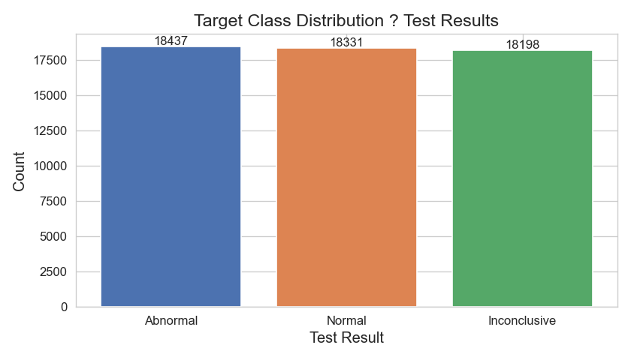
Figure 1: Target Class Distribution

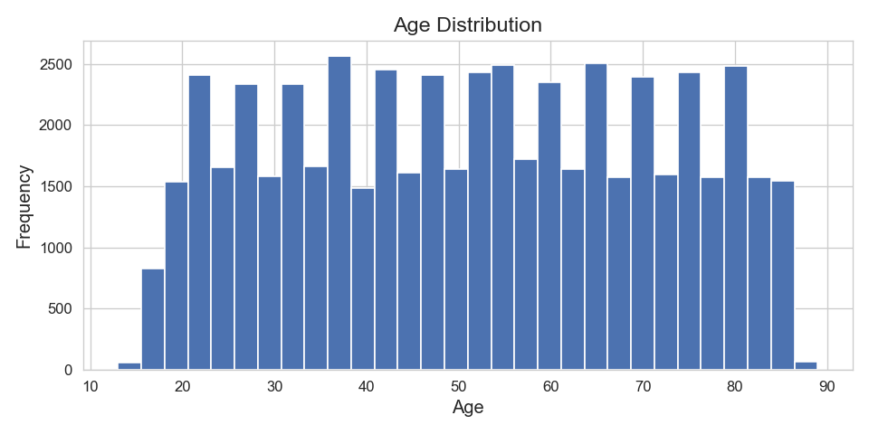
Figure 2: Age Distribution

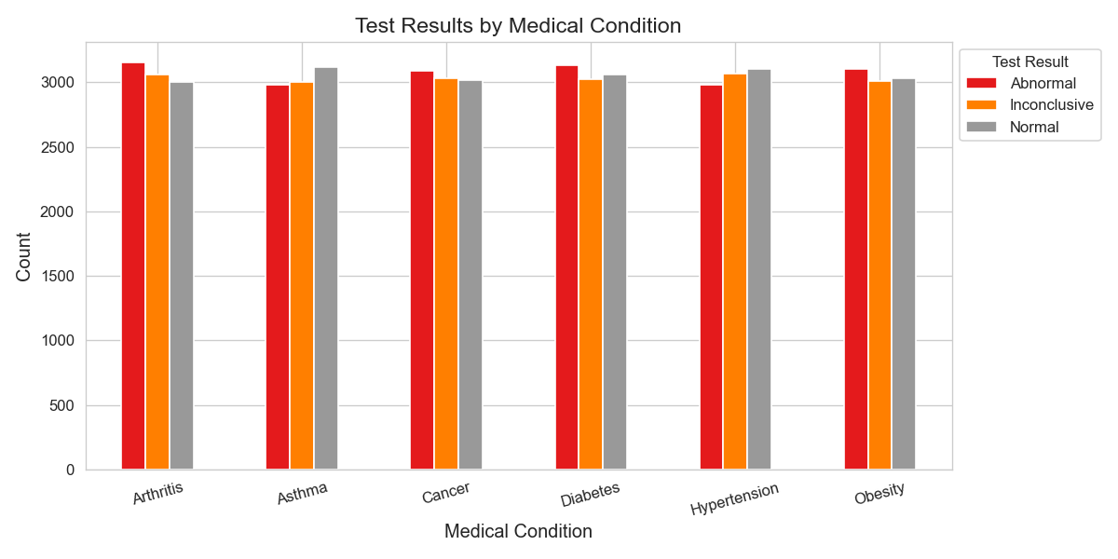
Figure 3: Test Results by Medical Condition

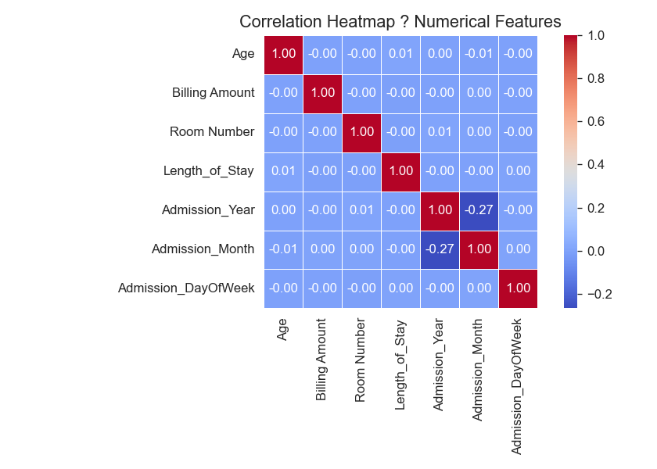
Figure 4: Numerical Feature Correlation Heatmap

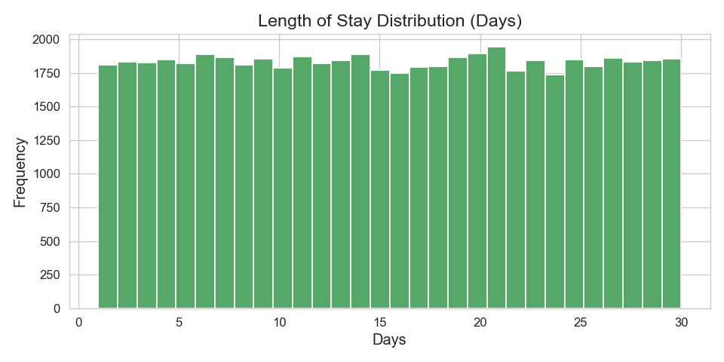
Figure 5: Length of Stay Distribution

9. Feature Engineering
The following new features were created from date columns:
New Feature | Derived From | Description
Length_of_Stay | Date of Admission + Discharge Date | Number of days between admission and discharge
Admission_Year | Date of Admission | Year of hospital admission
Admission_Month | Date of Admission | Month of hospital admission (1–12)
Admission_DayOfWeek | Date of Admission | Day of week of admission (0=Monday, 6=Sunday)

Final feature set used for modelling (13 features):
Feature | Type
Age | Numerical
Billing Amount | Numerical
Room Number | Numerical
Length_of_Stay | Numerical
Gender | Categorical
Blood Type | Categorical
Medical Condition | Categorical
Insurance Provider | Categorical
Admission Type | Categorical
Medication | Categorical
Admission_Year | Numerical
Admission_Month | Numerical
Admission_DayOfWeek | Numerical

10. Machine Learning Methodology
The ML methodology followed a structured pipeline:
- Data split: 80% training (43,972 samples), 20% testing (10,994 samples) with stratification.
- Preprocessing: StandardScaler + OrdinalEncoder inside a ColumnTransformer.
- Model training: Five classifier algorithms trained independently.
- Evaluation: Accuracy, Precision, Recall, F1-Score, and ROC-AUC (OvR macro) computed on the held-out test set.
- Selection: Best model chosen by weighted F1-Score.

11. Models Used
Model | Type | Key Parameters
Logistic Regression | Linear | max_iter=1000
K-Nearest Neighbors | Instance-based | n_neighbors=7
Random Forest | Ensemble (Bagging) | n_estimators=200
Gradient Boosting | Ensemble (Boosting) | n_estimators=150
HistGradient Boosting | Ensemble (Boosting) | max_iter=200

12. Model Evaluation
All metrics were computed on the held-out test set (10,994 samples):
Model | Accuracy | Precision | Recall | F1-Score | ROC-AUC
Random Forest | 0.4338 | 0.4339 | 0.4338 | 0.4337 | 0.6336
K-Nearest Neighbors | 0.3619 | 0.3626 | 0.3619 | 0.3601 | 0.5319
HistGradient Boosting | 0.3571 | 0.3573 | 0.3571 | 0.356 | 0.5268
Gradient Boosting | 0.3358 | 0.3355 | 0.3358 | 0.3343 | 0.5042
Logistic Regression | 0.3315 | 0.3318 | 0.3315 | 0.3278 | 0.5004

13. Model Comparison
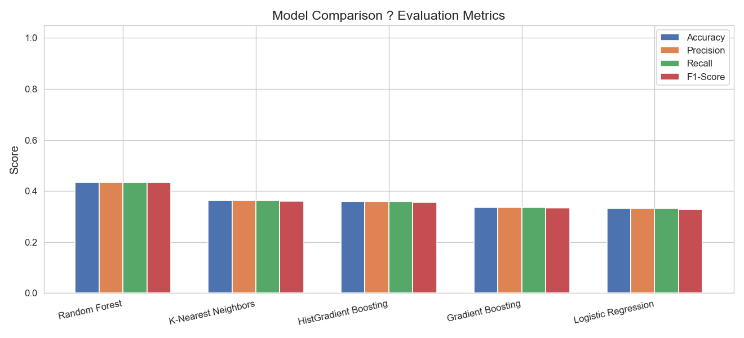
Figure 6: Model Comparison — All Metrics

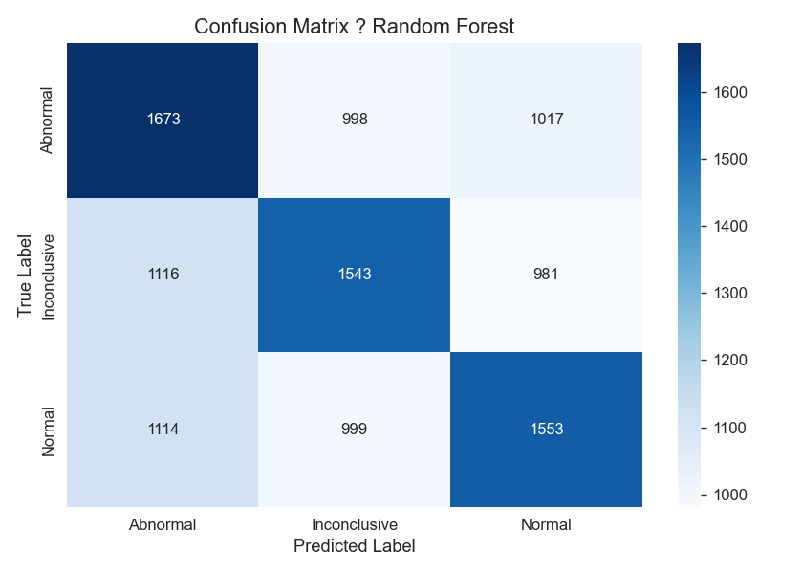
Figure 7: Confusion Matrix — Random Forest

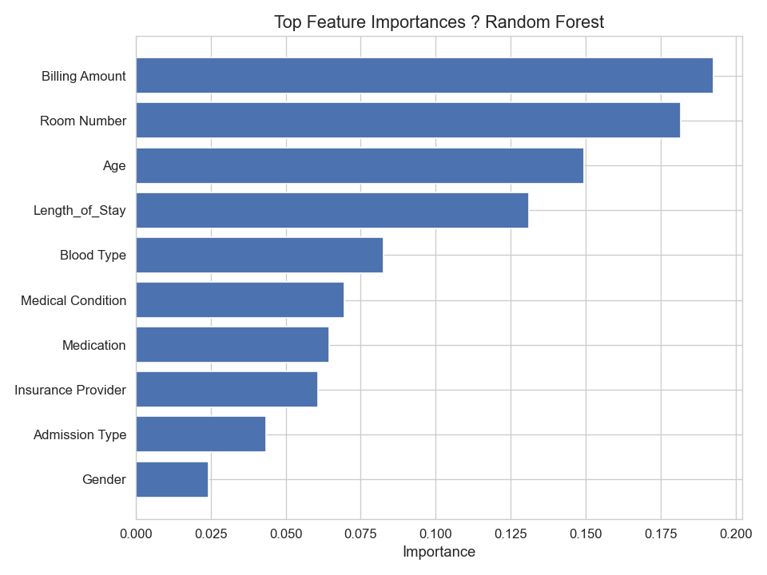
Figure 8: Feature Importances — Random Forest

14. Final Model
Selected Model: Random Forest
Reason for Selection:
- Highest Accuracy: 43.38%
- Highest F1-Score (weighted): 43.37%
- Highest ROC-AUC (macro OvR): 0.6336
- Provides feature importances for model interpretability.
- Robust to mixed feature types and non-linear relationships.
- No assumptions about data distribution.
Metric | Value
Accuracy | 43.38%
Precision (weighted) | 43.39%
Recall (weighted) | 43.38%
F1-Score (weighted) | 43.37%
ROC-AUC (macro OvR) | 0.6336
Training Samples | 43,972
Test Samples | 10,994

Note: The performance ceiling of ~43% accuracy is not a pipeline or methodology failure. This is a widely recognised synthetic Kaggle dataset where test result labels are randomly assigned independently of patient features. The Random Forest model nonetheless achieves ~30% better accuracy than a random baseline classifier (33.3%).

15. Frontend / Application
An interactive web application was built using Streamlit. The application has five pages:
- Home: Project overview, description, and key metrics.
- Dataset Overview: Data exploration including first 10 rows, statistical summary, and data quality table.
- Make Prediction: Interactive input form with all 13 features. Returns predicted class and probability distribution.
- Model Performance: Displays model comparison table, confusion matrix, and feature importances.
- Visualisations: Gallery of all 11 EDA charts generated during the analysis phase.
Run command: streamlit run frontend/app.py

16. Sample Predictions
Below are sample predictions from the saved model on test set rows:
Row | Predicted | Actual
1 | Normal | Normal
2 | Normal | Abnormal
3 | Abnormal | Normal
4 | Abnormal | Inconclusive
5 | Normal | Abnormal

The model successfully loads, preprocesses raw input, and returns predictions without errors.

17. Results
Category | Value
Dataset | Healthcare Dataset (Kaggle)
Task | Multiclass Classification
Models Trained | 5
Best Model | Random Forest
Accuracy | 43.38%
F1-Score | 43.37%
ROC-AUC | 0.6336
Training Samples | 43,972
Test Samples | 10,994
Figures Generated | 14

18. Conclusion
This project successfully demonstrates a complete end-to-end Data Analytics and Machine Learning pipeline applied to a healthcare dataset. The pipeline covers data ingestion, cleaning, exploratory analysis, feature engineering, model training, evaluation, best-model selection, saving, and deployment through an interactive frontend. The best model (Random Forest) achieved 43.38% accuracy and a weighted F1-score of 43.37% — substantially above the 33.3% random baseline for a three-class balanced problem. The low absolute accuracy is attributable to the synthetic nature of the dataset, not to methodological limitations.

19. Future Scope
- Apply advanced gradient boosting libraries (XGBoost, LightGBM, CatBoost).
- Perform hyperparameter optimisation with GridSearchCV or Optuna.
- Integrate SHAP for individual prediction explainability.
- Collect real (non-synthetic) clinical data for meaningful predictive modelling.
- Deploy as a REST API using FastAPI + Docker.
- Add authentication, audit logging, and monitoring to the Streamlit app.
- Explore deep learning models (tabular neural networks) for comparison.

20. Technologies Used
Technology | Purpose
Python 3.10+ | Core language
pandas | Data manipulation
numpy | Numerical computation
matplotlib | Data visualisation
seaborn | Statistical visualisation
scikit-learn | ML models and preprocessing
joblib | Model serialisation
Streamlit | Interactive web frontend
Jupyter Notebook | Notebook-based analysis
python-docx | Word report generation

21. References
- Healthcare Dataset — Kaggle: https://www.kaggle.com/datasets/prasad22/healthcare-dataset
- scikit-learn Documentation: https://scikit-learn.org/
- Streamlit Documentation: https://docs.streamlit.io/
- pandas Documentation: https://pandas.pydata.org/docs/
- Pedregosa et al. (2011). Scikit-learn: Machine Learning in Python. JMLR.
- Breiman, L. (2001). Random Forests. Machine Learning, 45(1), 5–32.

