# DWA_03.4 Knowledge Check_DWA3.1

______________________________________________________________________________________

1. Please show how you applied a Markdown File to a piece of your code.

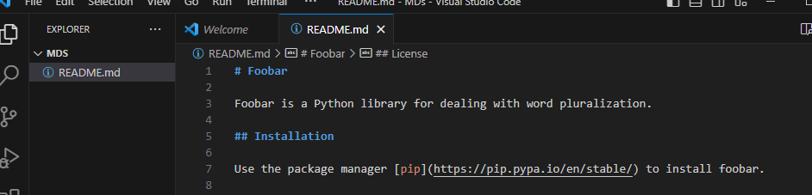

______________________________________________________________________________________

2. Please show how you applied JSDoc Comments to a piece of your code.

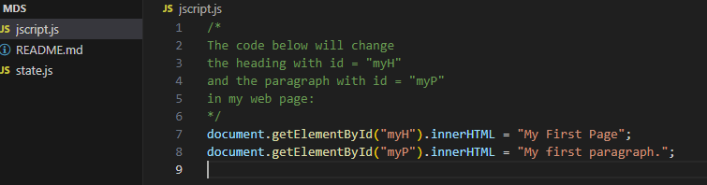

______________________________________________________________________________________

3. Please show how you applied the @ts-check annotation to a piece of your code.

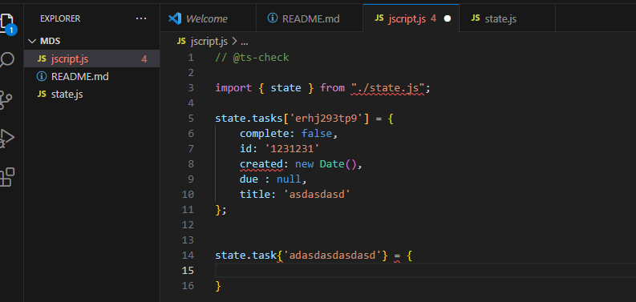

______________________________________________________________________________________

4. As a BONUS, please show how you applied any other concept covered in the 'Documentation' module.



