

**S.I.E.S College of Arts, Science and Commerce**

**Sion(W), Mumbai – 400 022.**

**CERTIFICATE**

This is to certify that Mr. / ~~Miss~~. **Nadar Kabilan Rethinaswamy**

Roll No. **SCS2223105** has successfully completed the necessary course of

experiments in the subject of **Core Java** during the academic year **2022 – 2023**

complying with the requirements of **University of Mumbai**, for the course of **S.Y.**

**BSc. Computer Science [Semester-3]**

Prof. In-Charge

**Prof. Shivani Deopa**

**(Core Java)**

Examination Date:

Examiner’s Signature & Date:

Head of the Department

**Prof. Manoj Singh**

College Seal

And

Date

**Name: Kabilan Nadar**

**Roll Call: SCS2223105**

CORE JAVA JOURNAL

|  |  |  |  |
| --- | --- | --- | --- |
| PRACTICALS INDEX | | | |
| **NO** | **AIM** | **PAGE** | **SIGN** |
| 1 | Accept integer values for a, b, and c which are coefficients of quadratic equation. Find the solution of quadratic equation. | 3 |  |
| 2 | Accept two n * m matrices. Write a Java program to find addition of these matrices. | 5 |  |
| 3 | Accept n strings. Sort names in ascending order. | 8 |  |
| 4 | Create a package: Animals. In package animals create interface Animal with suitable behaviors. Implement the interface Animal in the same package Animals. | 10 |  |
| 5 | Demonstrate Java inheritance using extends keyword. | 11 |  |
| 6 | Demonstrate method overloading and method overriding in Java. | 13 |  |
| 7 | Demonstrate creating your own exception in Java. | 16 |  |
| 8 | Using various AWT components design Java application to accept a student’s resume. (Design form) | 18 |  |
| 9 | Write a Java List example and demonstrate methods of Java List interface. | 21 |  |
| 10 | Design simple calculator GUI application using AWT components. | 23 |  |

Practical 1:

Code:

import java.util.Scanner;

public class Practical1

{

public static void main(String[] Strings)

{

Scanner input=new Scanner(System.in);

System.out.print("Input a: ");

double a=input.nextDouble();

System.out.print("Input b: ");

double b=input.nextDouble();

System.out.print("Input c: ");

double c=input.nextDouble();

double result=b*b-4.0*a*c;

if(result>0.0)

{

double r1=(-b+Math.pow(result,0.5))/(2.0*a);

double r2=(-b-Math.pow(result,0.5))/(2.0*a);

System.out.print("The first root is" +r1+" and the second root is " +r2);

}

else if (result==0.0)

{

double r3=-b/(2.0*a);

System.out.print("The root is" +r3);

}

else

{

System.out.println("The roots are not real");

}

}

}

Output:

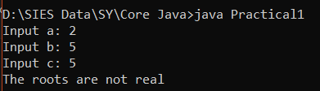

Practical 2

Code:

class Matrixadd

{

public static void main(String args[])

{

int m,n,i,j,k=2;

m=Integer.parseInt(args[0]);

n=Integer.parseInt(args[1]);

int a[][]=new int[m][n];

int b[][]=new int[m][n];

int c[][]=new int[m][n];

for(i=0;i<m;i++)

{

for(j=0;j<n;j++)

{

a[i][j]=Integer.parseInt(args[k]);

k++;

}}

for(i=0;i<m;i++)

{

for(j=0;j<n;j++)

{

b[i][j]=Integer.parseInt(args[k]);

k++;

}}

for(i=0;i<m;i++)

{

for(j=0;j<n;j++)

{

c[i][j]=a[i][j]+b[i][j];

}}

System.out.println("First matrix");

for(i=0;i<m;i++)

{

for(j=0;j<n;j++)

{

System.out.print(a[i][j]+" ");

}

System.out.println();

}

System.out.println("Second Matrix");

for(i=0;i<m;i++)

{

for(j=0;j<n;j++)

{

System.out.print(b[i][j]+" ");

}

System.out.println();

}

System.out.println("Result MAtrix AFter Addition");

for(i=0;i<m;i++)

{

for(j=0;j<n;j++)

{

System.out.print(c[i][j]+ " ");

}

System.out.println();

}

}

}

Output:

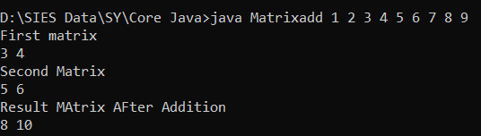

Practical 3

Code:

import java.io.*;

import java.util.Scanner;

class Practical3{

public static void main(String[] args)

{

Scanner sc=new Scanner(System.in);

System.out.println("Enter the array size:");

int n=sc.nextInt();

String names[]=new String[n];

System.out.println("Enter the names:");

for(int i=0;i<n;i++)

{

names[i]=sc.next();

}

String temp;

for (int i=0;i<n;i++){

for(int j=i+1;j<n;j++){

if (names[i].compareTo(names[j])>0)

{

temp=names[i];

names[i]=names[j];

names[j]=temp;

}

}

}

System.out.println("Sorted List:");

for(int i=0;i<n;i++){

System.out.println(names[i]);

}

}}

Output:

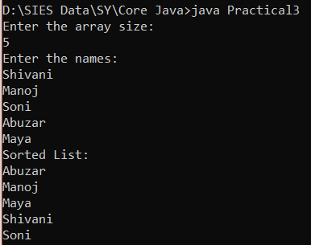

Practical 4

Code:

package Animal;

public interface Behaviour

{

public void eat();

public void type();

}

import Animal.*;

public class Dolphin implements Behaviour

{

public void eat()

{

System.out.println("Dolphin eats small fishes and weeds");

}

public void type()

{

System.out.println("Dolphin are omnivorous");

}

public static void main(String args[])

{

Dolphin e=new Dolphin();

e.eat();

e.type();

}

}

Output:

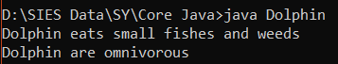

Practical 5

Code:

import java.util.*;

class AddSub

{

public void Add(int a,int b)

{

int c = a+b;

System.out.println("The Addition is : "+c);

}

public void Sub(int a,int b)

{

int c = a-b;

System.out.println("The Subtraction is : "+c);

}

}

class MulDiv extends AddSub

{

public void Mul(int a,int b)

{

int c = a*b;

System.out.println("The Multiplication is : "+c);

}

public void Div(int a,int b)

{

int c = a/b;

System.out.println("The Division is : "+c);

}

}

class Inheritance

{

public static void main(String args[])

{

Scanner sc = new Scanner(System.in);

System.out.println("Enter number1: ");

int a = sc.nextInt();

System.out.println("Enter number2: ");

int b = sc.nextInt();

MulDiv md=new MulDiv();

md.Add(a,b);

md.Sub(a,b);

md.Mul(a,b);

md.Div(a,b);

}

}

Output:

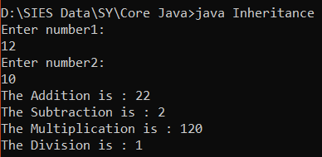

Practical 6

Overloading Code:

import java.io.*;

class Overloading{

public static void main(String[] args) {

Geometry obj = new Geometry();

obj.Area(2.5);

obj.Area(2);

obj.Area(2,4);

}

}

class Geometry {

double PI = 3.14;

void Area(double r){

double A = PI * r * r;

System.out.println("Area of the circle is : " + A);

}

void Area(int s){

double A = s* s;

System.out.println("Area of the square is : " + A);

}void Area(double l, double b){

double A = l * b;

System.out.println("Area of the rectangle is : " + A);

}

}

Overriding Code:

import java.util.*;

class Vehicle

{

void VehicleName()

{

System.out.println("Aeroplane");

}

void VehicleModel()

{

System.out.println("A504");

}

}

class Car extends Vehicle

{

void VehicleName()

{

System.out.println("Audi");

}

void VehicleModel()

{

System.out.println("X500");

}

}

class Bike extends Vehicle

{

void VehicleName()

{

System.out.println("Passion");

}

void VehicleModel()

{

System.out.println("RS200");

}

}

class Overriding

{

public static void main(String[] args)

{

Vehicle v = new Vehicle();

Car c = new Car();

Bike b = new Bike();

v.VehicleName();

v.VehicleModel();

c.VehicleName();

c.VehicleModel();

b.VehicleName();

b.VehicleModel();

}

}

Output:

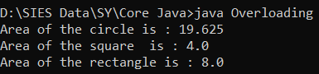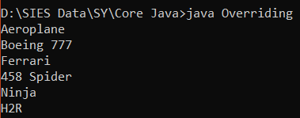

Practical 7

Code:

import java.util.Scanner;

class NotProperNameException extends RuntimeException

{

NotProperNameException(String msg){

super(msg);

}

}

public class CustomCheckedException{

String name;

int age;

public static boolean containAlphabet(String name){

for (int i = 0; i < name.length();i++){

char ch = name.charAt(i);

if (!(ch >= 'a' && ch <= 'z')){

return false;

}

}

return true;

}

public CustomCheckedException(String name, int age){

if(!containAlphabet(name) && name!=null){

String msg = "Improper name (Should contain only characters between a to z (all small))";

NotProperNameException exName = new NotProperNameException(msg);

throw exName;

}

this.name = name;

this.age = age;

}

public void display(){

System.out.println("Name of the Student: "+this.name);

System.out.println("Age of the Student: "+this.age);

}

public static void main(String args[]){

Scanner sc = new Scanner(System.in);

System.out.println("Enter the name of the person: ");

String name = sc.next();

System.out.println("Enter the age of the person: ");

int age = sc.nextInt();

CustomCheckedException obj = new CustomCheckedException(name,age);

obj.display();

}

}

Output:

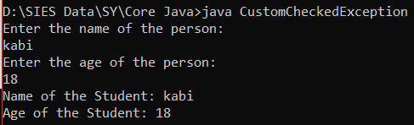

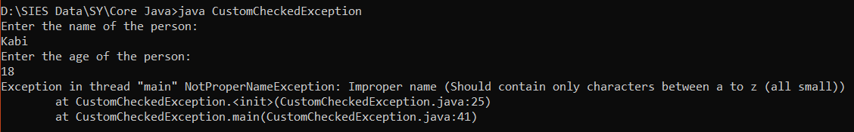

Practical 8

Code:

import java.awt.*;

public class Practical8 extends Frame{

TextField txtName, txtAge, txtPhone;

Checkbox chkMale, chkFemale;

Checkbox chkQ1, chkQ2, chkQ3;

CheckboxGroup cbgGender;

Button btnSubmit;

TextArea txaAddress;

public Practical8(){

txtName = new TextField(20);

txtAge = new TextField(20);

txtPhone = new TextField(20);

cbgGender = new CheckboxGroup();

chkMale = new Checkbox("Male", false, cbgGender);

chkFemale = new Checkbox("Female", false, cbgGender);

chkQ1 = new Checkbox("Msc CS");

chkQ2 = new Checkbox("Msc IT");

chkQ3 = new Checkbox("Msc BT");

txaAddress = new TextArea(5, 20);

btnSubmit = new Button("Submit");

add(new Label("Name"));

add(txtName);

add(new Label("Age"));

add(txtAge);

add(new Label("Phone"));

add(txtPhone);

add(new Label("Gender"));

add(chkMale);

add(chkFemale);

add(new Label("Qualification"));

add(chkQ1);

add(chkQ2);

add(chkQ3);

add(new Label("Address"));

add(txaAddress);

add(btnSubmit);

}

public static void main(String[] args) {

Practical8 practical8 = new Practical8();

practical8.setLayout(new FlowLayout());

practical8.setSize(200,500);

practical8.setVisible(true);

}

}

Output:

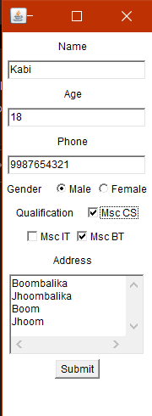

Practical 9

Code:

import java.util.*;

class SortArrayList{

public static void main(String args[]){

List <String> list1=new ArrayList<String>();

list1.add("Mango");

list1.add("Apple");

list1.add("Banana");

list1.add("Grapes");

System.out.println("Returning element: "+list1.get(1));

list1.set(1,"Dates");

Collections.sort(list1);

for(String fruit:list1)

System.out.println(fruit);

System.out.println("Sorting numbers...");

List<Integer> list2=new ArrayList<Integer>();

list2.add(21);

list2.add(11);

list2.add(51);

list2.add(1);

Collections.sort(list2);

for(Integer number:list2)

System.out.println(number);

}

}

Output:

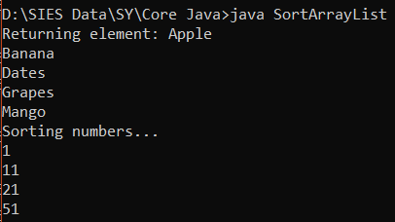

Practical 10

Code:

import java.awt.*;

import java.awt.event.*;

class Calculator implements ActionListener

{

Frame f = new Frame();

Label l1 = new Label("Enter first Number");

Label l2 = new Label("Enter second Number");

Label l3 =new Label("Result");

TextField t1 = new TextField();

TextField t2 = new TextField();

TextField t3 = new TextField();

Button b1 = new Button("Add");

Button b2 = new Button("Sub");

Button b3 = new Button("Mul");

Button b4 = new Button("Div");

Calculator(){

l1.setBounds(50,100,150,20);

l2.setBounds(50,150,150,20);

l3.setBounds(50,200,150,20);

t1.setBounds(250,100,100,20);

t2.setBounds(250,150,100,20);

t3.setBounds(250,200,100,20);

b1.setBounds(50,250,50,20);

b2.setBounds(110,250,50,20);

b3.setBounds(170,250,50,20);

b4.setBounds(230,250,50,20);

f.add(l1);

f.add(l2);

f.add(l3);

f.add(t1);

f.add(t2);

f.add(t3);

f.add(b1);

f.add(b2);

f.add(b3);

f.add(b4);

b1.addActionListener(this);

b2.addActionListener(this);

b3.addActionListener(this);

b4.addActionListener(this);

f.setLayout(null);

f.setVisible(true);

f.setSize(500,500);

}

public void actionPerformed(ActionEvent e){

int i = Integer.parseInt(t1.getText());

int j = Integer.parseInt(t2.getText());

if(e.getSource()==b1){

t3.setText(String.valueOf(i+j));

}

if(e.getSource()==b2){

t3.setText(String.valueOf(i-j));

}

if(e.getSource()==b3){

t3.setText(String.valueOf(i*j));

}

if(e.getSource()==b4){

t3.setText(String.valueOf(i/j));

}

}

public static void main(String args[]){

new Calculator();

}

}

Output:

