**Career objective :**

Willing to work in a dynamic and stable workplace that offers me a positive atmosphere where I can utilize my professional skills for the growth of the organization.

**Educational Qualifications :**

|  |  |  |  |  |
| --- | --- | --- | --- | --- |
| S No | Qualification | Institution | Year of Passing | score |
| 1. | BTech (CSE) | Andhra University,  Visakhapatnam | 2023 | 8.43(GPA) |
| 2. | Intermediate | Sri Chaitanya Junior college, Anakapalli | 2019 | 97.9%  10.0(GPA) |
| 3. | SSC | Ravindra Bharathi School, Anakapalli | 2017 | 10.0(GPA) |

**Certifications and workshops :**

* Certification in Python for Data Science, Verzeo – March 6, 2022
* Certification in Web Development, Oasis Infobyte – August 2, 2022
* Certification in Full Stack Web Development, Business Web

Solutions ( BWS ) – August 6, 2022

**Interpersonal skills :**

* Collaborative
* Responsible
* Emotional intelligence

**Special skills:**

Good knowledge on basics of

* Python Programming, Basics of Java Programming
* React JS, JavaScript, Spring Boot
* HTML, CSS, MySQL

Place :

Date :

adarsht.2k01@gmail.com +919154948993

https://www.linkedin.com/in/adarsh-teeparthi-380980233

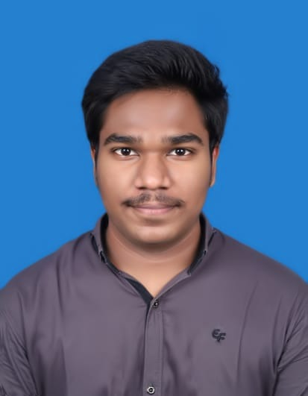

**Strengths :**

* Flexibility, Focused
* Time Management

**Projects :**

* Home Surveillance System using OpenCV and Python
* Movie Review Project using React & Spring Boot

**Personal Profile**

**Name**: T.Adarsh

**Father’s Name:** T.Brahmaji Rao

**Mother’s Name:** T.B.Manga Devi

**DOB:** 6th October,2001

**Gender**: Male

**Languages Known:** English, Telugu, Hindi