**Exploratory Data Analysis (EDA)**

**Online Shopping Trends Dataset**

**1. Introduction**

This report presents an in-depth exploratory data analysis (EDA) of an online shopping trends dataset. The dataset includes 3,900 records and 19 attributes, covering customer demographics, purchase behavior, payment methods, and product details.

**2. Data Overview**

**Summary Statistics**

* **Total Records:** 3,900
* **Total Attributes:** 19
* **Key Fields:** Customer ID, Age, Gender, Item Purchased, Category, Purchase Amount, Location, Payment Method, Discount Applied, Frequency of Purchases, etc.

**Data Types**

* **Numerical:** Age, Purchase Amount, Review Rating, Previous Purchases
* **Categorical:** Gender, Category, Payment Method, Discount Applied
* **Text:** Item Purchased, Location

**3. Data Cleaning**

* Checked for missing values (None found)
* No duplicate entries detected
* Standardized categorical variables for consistency

**4. Data Analysis & Insights**

**4.1 Demographics Analysis**

* **Gender Distribution:** Bar chart showing the proportion of male vs. female customers
* **Age Distribution:** Histogram visualizing the spread of customer ages

**4.2 Purchase Behavior**

* **Top Purchased Categories:** Bar chart ranking product categories by purchase frequency
* **Average Purchase Amount by Category:** Boxplot displaying price variations across categories
* **Seasonal Trends:** Line chart showing spending trends across different seasons

**4.3 Payment Preferences**

* **Most Preferred Payment Methods:** Pie chart showing distribution of payment methods
* **Subscription vs. Non-Subscription Behavior:** Comparative analysis of purchase amounts

**4.4 Discount & Promotions Impact**

* **Effect of Discounts on Purchase Amount:** Scatter plot illustrating discount percentage vs. spending behavior
* **Promo Code Usage Trends:** Bar chart showing frequency of promo code usage

**5. Key Findings**

* **Majority of customers are aged 25-45, with a balanced gender distribution.**
* **Clothing is the most purchased category, followed by footwear.**
* **Customers using promo codes tend to spend more on average.**
* **Credit Card is the most preferred payment method.**
* **Winter sees the highest sales volume compared to other seasons.**

**6. Conclusion & Recommendations**

* **Target high-value customers with personalized promotions based on their purchase history.**
* **Optimize marketing campaigns during peak shopping seasons.**
* **Encourage alternative payment methods by offering incentives.**

This analysis provides valuable insights into customer behavior, helping businesses refine their marketing and sales strategies for better engagement and profitability.

Visual Representation

**1. Gender Distribution of Customers**

**Description:**  
This bar chart represents the distribution of customers based on gender. It helps understand the gender demographics of shoppers. A balanced distribution suggests a diverse customer base, while a skewed distribution may indicate a need for targeted marketing efforts.

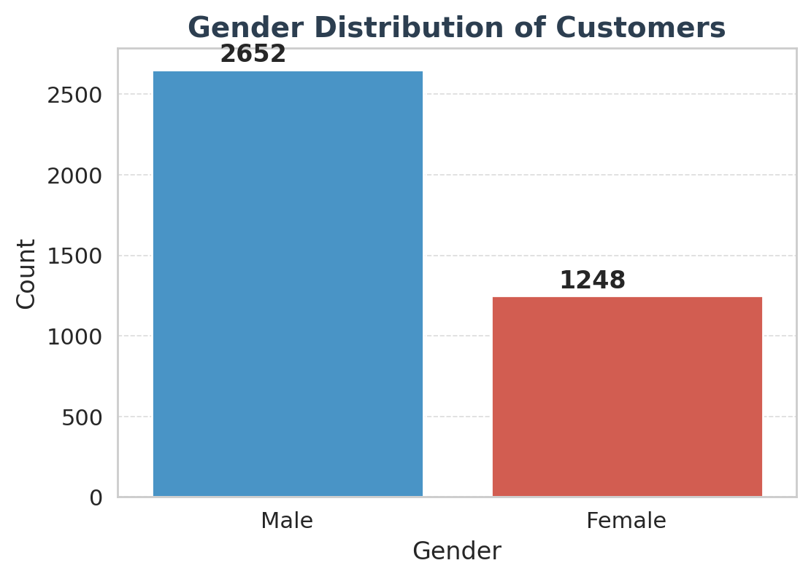

**2. Age Distribution of Customers**

**Description:**  
This histogram shows the distribution of customer ages. The density curve helps identify peaks and trends in the age groups of shoppers. Insights from this chart can guide personalized marketing strategies and product recommendations.

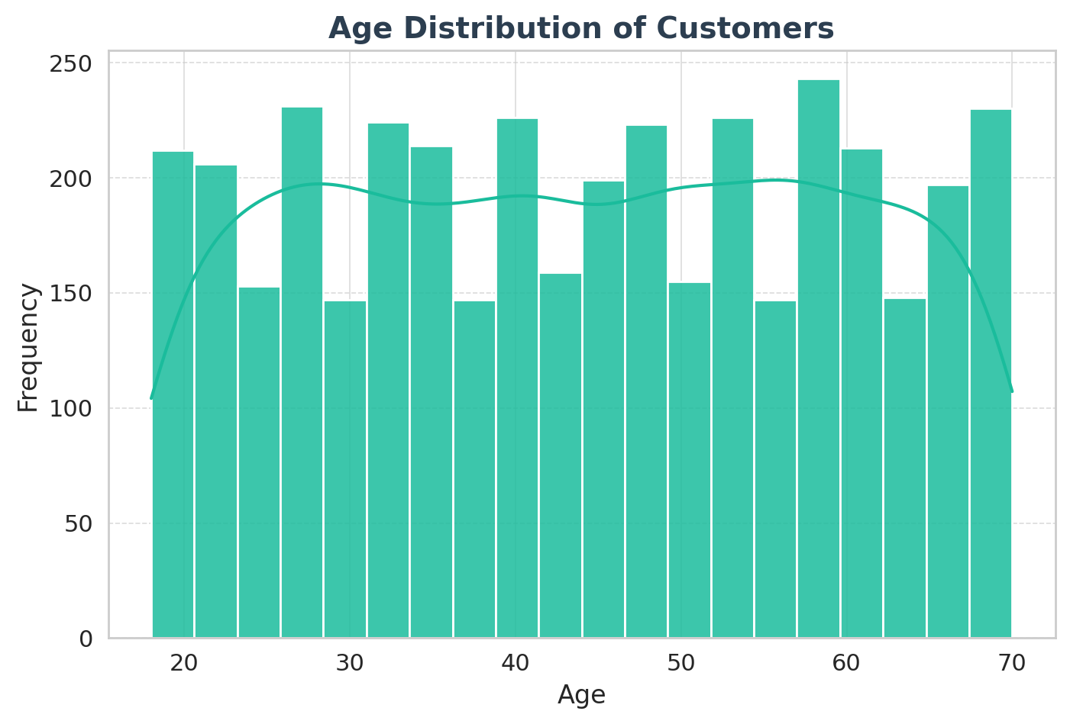

**3. Top Purchased Categories**

**Description:**  
The bar chart displays the most frequently purchased product categories. It highlights customer preferences, allowing businesses to optimize inventory and focus on the most popular categories.

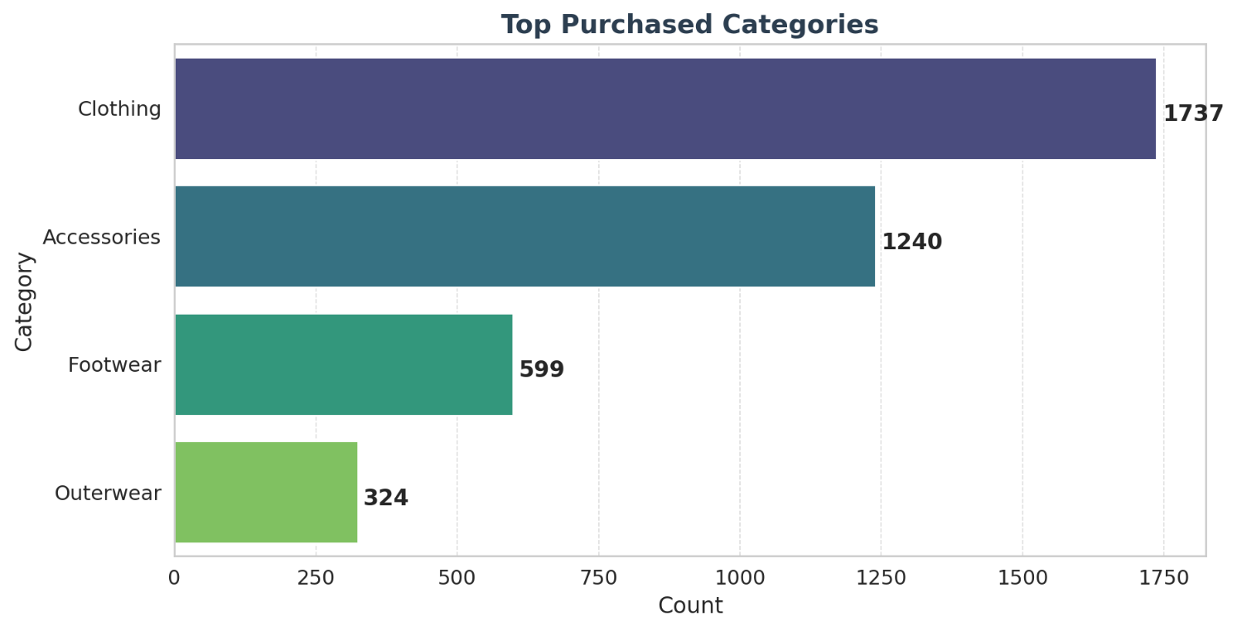

**4. Average Purchase Amount by Category**

**Description:**  
This boxplot illustrates the range of purchase amounts for each product category. It highlights variations in spending behavior across different categories and identifies outliers where customers tend to spend significantly more or less.

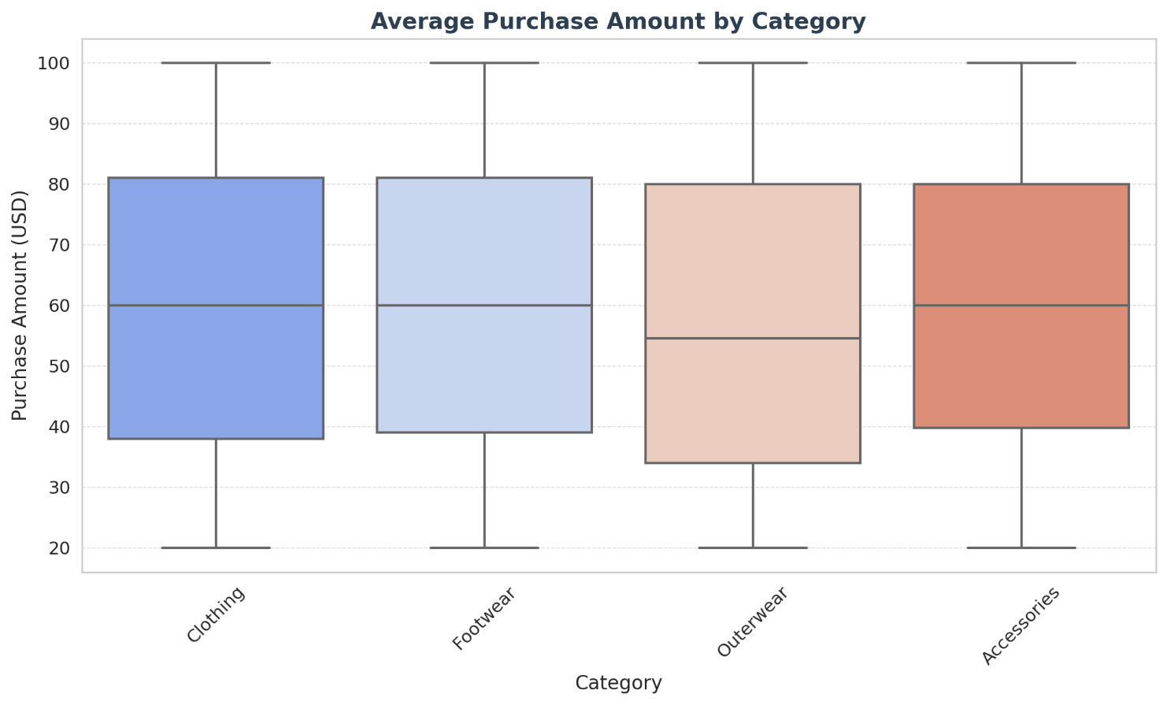

**5. Seasonal Spending Trends**

**Description:**  
The line chart tracks the total purchase amount across different seasons. This analysis helps businesses plan seasonal promotions, stock inventory efficiently, and anticipate peak shopping periods.

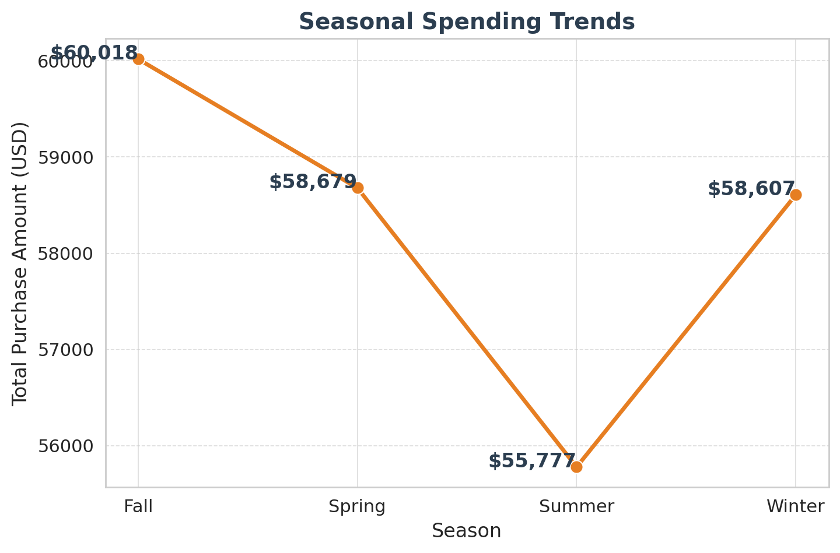

**6. Preferred Payment Methods**

**Description:**  
This pie chart represents the distribution of different payment methods used by customers. Identifying the most preferred payment options enables businesses to streamline checkout processes and enhance customer experience.

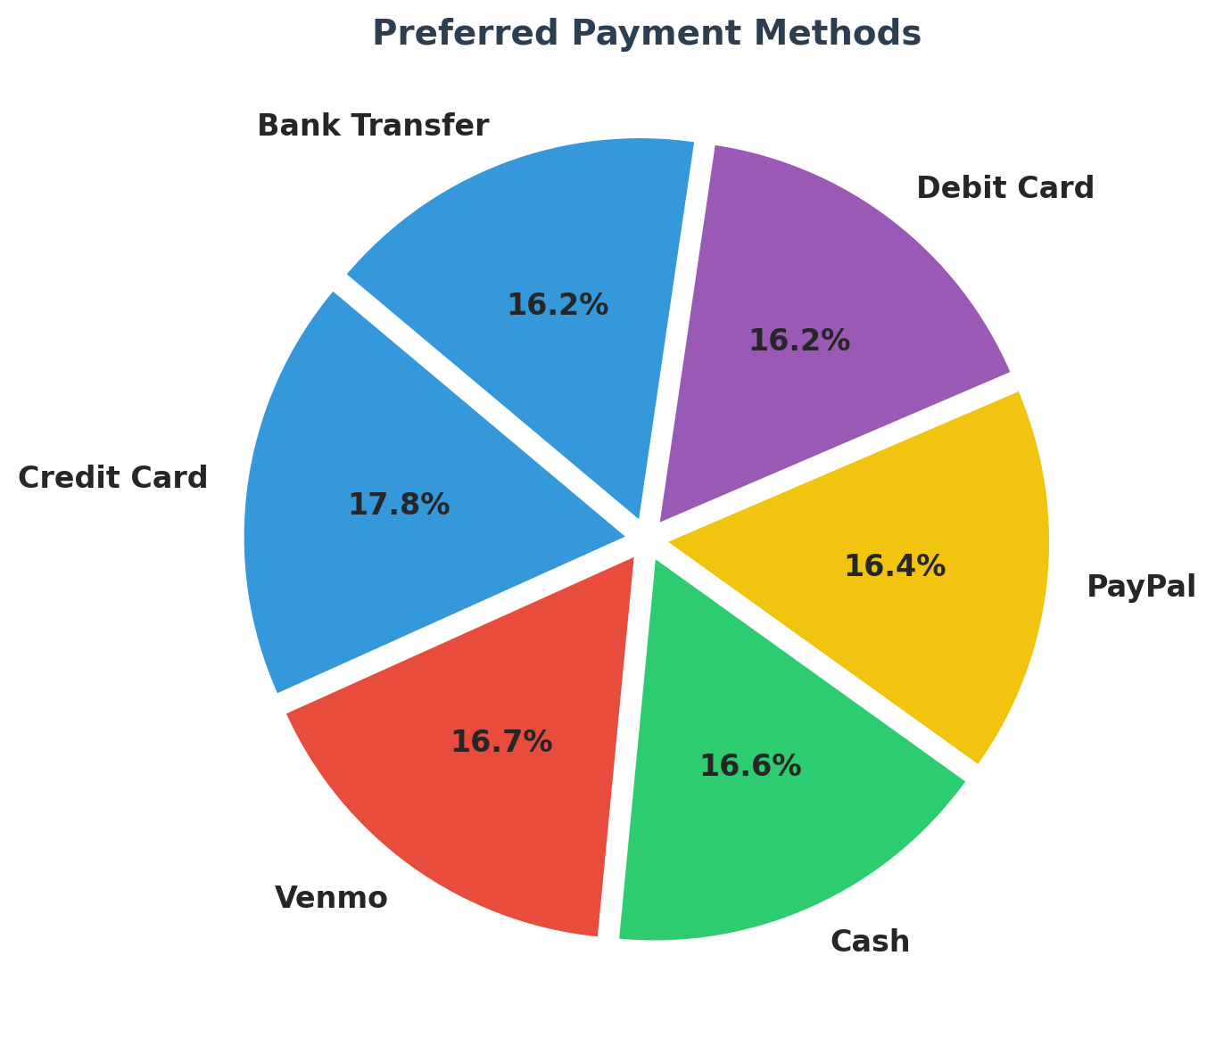

**7. Impact of Discounts on Purchase Amount**

**Description:**  
The scatter plot analyzes how discounts influence purchase amounts. It helps determine whether customers tend to spend more when discounts are applied, which is useful for refining promotional strategies.

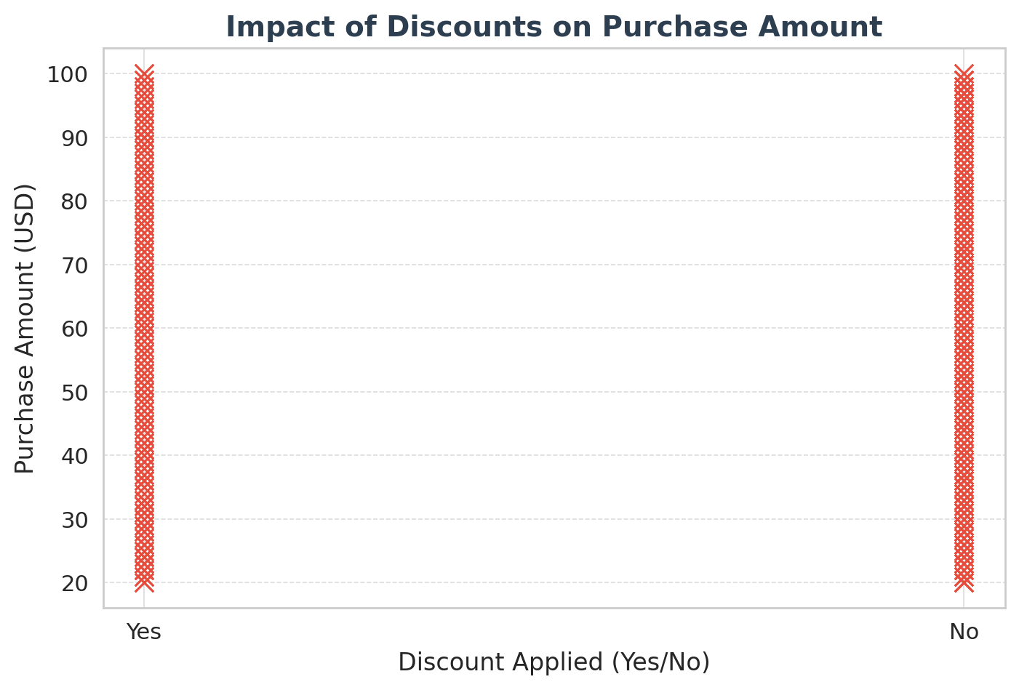

**8. Promo Code Usage Trends**

**Description:**  
The bar chart shows the frequency of promo code usage in transactions. A high usage rate indicates that customers actively seek discounts, while a low rate suggests opportunities to increase engagement with better promotions.

