ASP.NET Assessment

Jackie Ye

18/11/2022

GIT: https://github.com/Long-Tian-Jackie-Ye/BootCamp.NetProject

Home Page

Attempted Table join code in data folder

Owners Page

Owner Creation Form

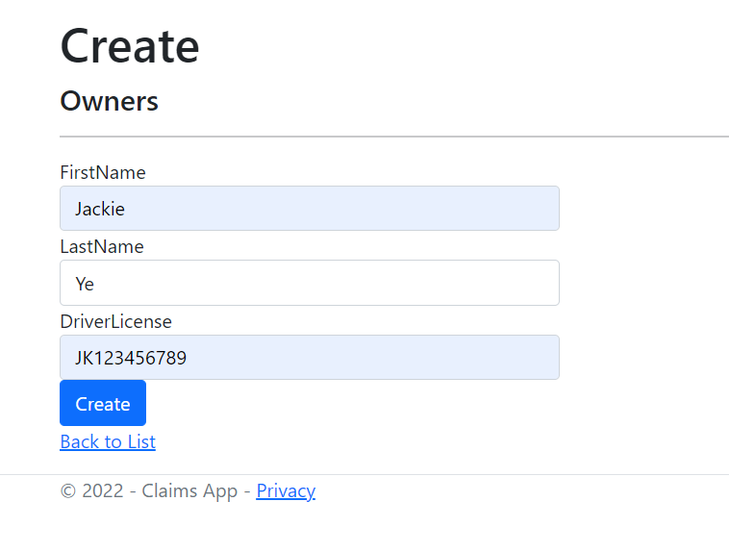

Updated Owners Table Display

Updated Owners in SQL

Claims Page

Claims Creation Form

Updated Claims Table Display

Updated Claims in SQL

Vehicles Page

Vehicles Creation Form

Updated Vehicles Table Display

Updated Vehicles in SQL

Edit Vehicles



Updated Vehicles Table Display



Updated Vehicles in SQL

Delete Vehicles

Updated Vehicles Table Display

Updated Vehicles in SQL

