Name: Nguyễn Thanh Long

ID: ITITIU18012

**Lab 05**

**5.1)**

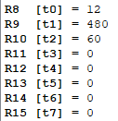

**5.2)**

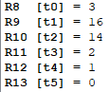



**If x = -4:**

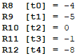



**5.3)**

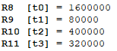

**Result is 320000**

**5.4) Fill the table by inspection:**

