NGUYEN THANH LONG

ITITRG18012

LAB 01

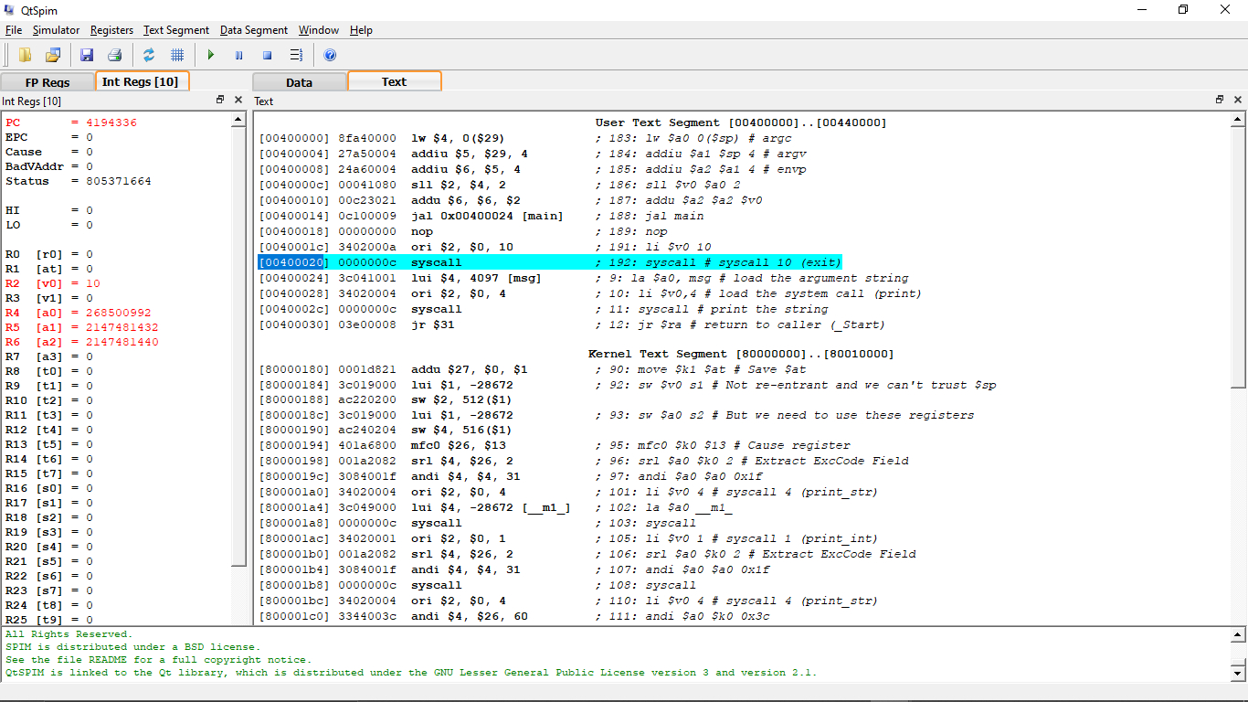

3.1/ The memory address : From [00400000] to [00400030]

3.2/ This instruction shows the next instruction. By looking at the register and the instructor so I know that.

3.3

**User data segment [10000000]..[10040000]**

[10000000]..[1000ffff]  00000000  
[10010000]    6c6c6548  4d202c6f  0a535049  00000000    H e l l o ,   M I P S . . . . .   
[10010010]..[1003ffff]  00000000

3.4/

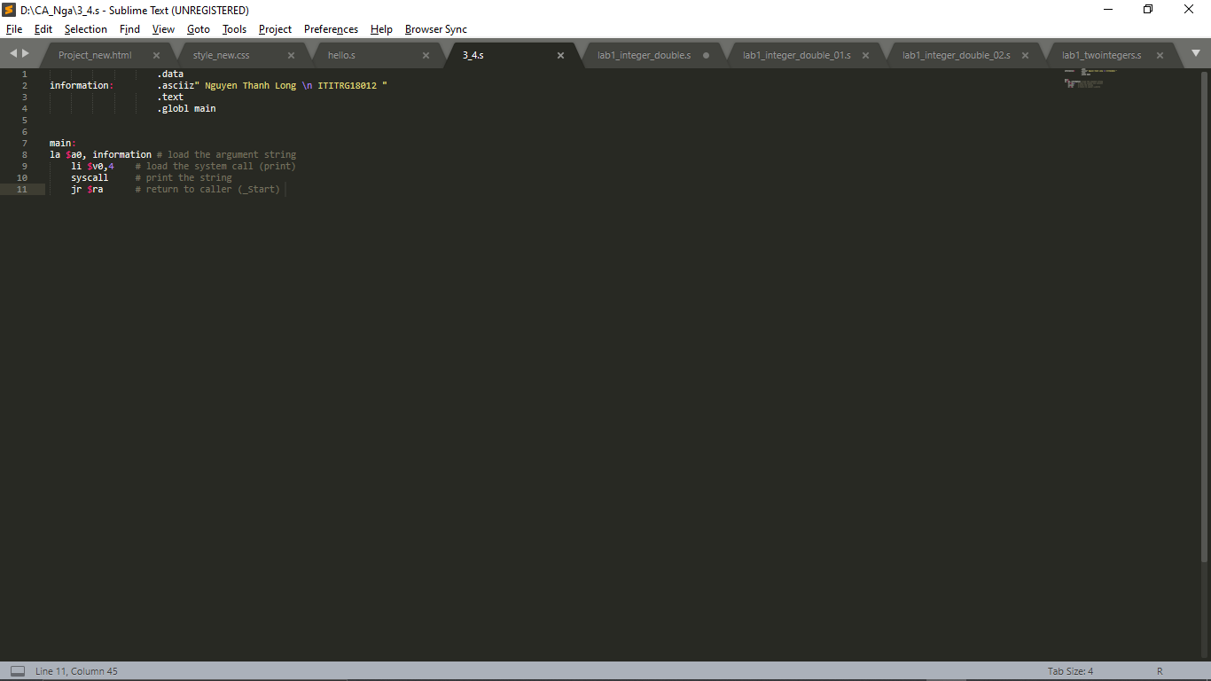

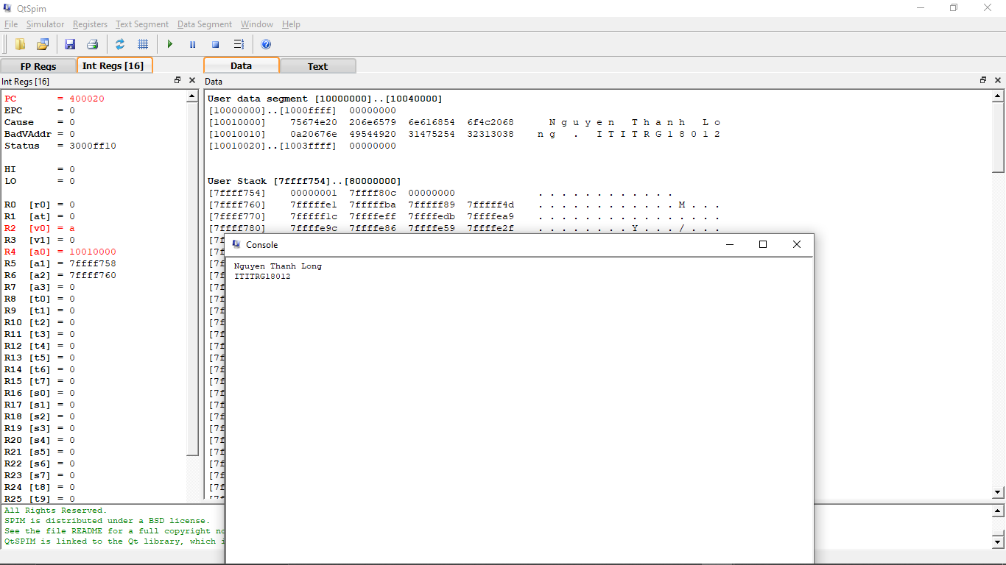

**4.1)**



Due to overflow problem, the answer is wrong.

**4.2)**

Maximum is 1073741823 (230 -1)

Minimum is -1073741824 (-230)

4.3/

**Console Result**

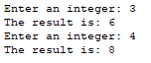

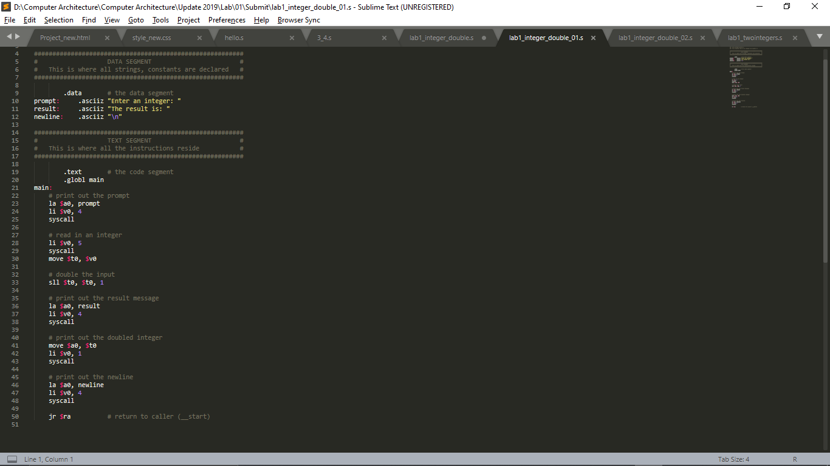

4.4

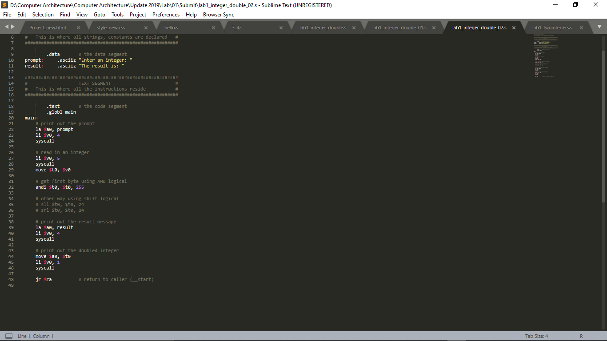

**Console Result**



5.

.data # the data segment

prompt_1: .asciiz "Enter first integer: "

prompt_2: .asciiz "Enter second integer: "

addresult: .asciiz "The addition is: "

subresult: .asciiz "\nThe subtract is: "

newline: .asciiz "\n"

.text # the code segment

.globl main

main:

# print out the prompt

la $a0, prompt_1

li $v0, 4

syscall

# read in an integer

li $v0, 5

syscall

move $t0, $v0

# print out the prompt

la $a0, prompt_2

li $v0, 4

syscall

# read in an integer

li $v0, 5

syscall

move $t1, $v0

# calculate

add $t3, $t0, $t1

sub $t4, $t0, $t1

# print out the result message

la $a0, addresult

li $v0, 4

syscall

# print out the add result

move $a0, $t3

li $v0, 1

syscall

# print out the result message

la $a0, subresult

li $v0, 4

syscall

# print out the add result

move $a0, $t4

li $v0, 1

syscall

# print out the newline

la $a0, newline

li $v0, 4

syscall

jr $ra # return to caller (__start)

**Console Result**



II/

Flash/FRAM usage is 110 bytes. RAM usage is 80 bytes