Pneumonia detection using CNN

|  |  |
| --- | --- |
| Abdul Khan  W Booth School of Engineering Practice and Technology  McMaster University  Hamilton, Canada  [khanam2@mcmaster.ca](mailto:khanam2@mcmaster.ca) | Gurwinder Singh Randhawa  W Booth School of Engineering Practice and Technology  McMaster University  Hamilton, Canada  [randhg8@mcmaster.ca](mailto:randhg8@mcmaster.ca) |
| Long Viet Cao  W Booth School of Engineering Practice and Technology  McMaster University  Hamilton, Canada  caol41@mcmaster.ca | Harleen Saini  W Booth School of Engineering Practice and Technology  McMaster University  Hamilton, Canada  sainih17[@mcmaster.ca](mailto:novoselh@mcmaster.ca) |

Nika Sapai   
 W Booth School of Engineering Practice and   
  Technology   
 McMaster University   
 Hamilton, Canada   
 [sapaij@mcmaster.ca](mailto:sapaij@mcmaster.ca)

***Abstract -*** *The rapid and accurate diagnosis of pneumonia from chest radiographs is paramount in healthcare settings, affecting treatment outcomes and patient care. This paper explores the application of Convolutional Neural Networks (CNNs), a class of deep learning algorithms, in the automated detection and diagnosis of pneumonia from chest X-ray images. Through extensive experimentation with various CNN configurations, this study seeks to understand the impact of different hyperparameters on model performance. We assess the models based on accuracy, precision, recall, and F1-score, and identify the most effective model through comparative analysis. The research also contemplates the ethical implications of implementing AI in medical diagnostics and discusses future directions for enhancing the robustness and reliability of such systems in clinical settings.*

**Introduction**

The emergence of deep learning techniques, especially Convolutional Neural Networks (CNNs), has revolutionized the field of medical imaging, providing unprecedented advancements in the diagnosis and treatment of various diseases. Among the plethora of conditions that challenge healthcare systems worldwide, pneumonia stands out due to its widespread prevalence and potential severity. Prompt and accurate diagnosis of pneumonia is not only crucial for effective patient management but also for mitigating the broader impacts on public health systems. The conventional method of pneumonia detection, which relies on the manual examination of chest radiographs by trained radiologists, is time-consuming and susceptible to human error. Given these constraints, there is a compelling need for automated systems that can augment clinical expertise and provide rapid, reliable diagnostic assessments.

This paper presents an in-depth exploration of CNNs applied to the automatic detection of pneumonia from chest X-ray images. Leveraging the representational learning capabilities inherent in deep learning, our research meticulously investigates various CNN architectures and hyperparameters to ascertain their effects on the model's diagnostic performance. By systematically varying the number of layers, neurons per layer, and activation functions, we construct and evaluate a range of models to discern patterns and principles that correlate with high accuracy and generalizability in the task at hand.

CNNs, as a class of deep neural networks, are particularly suited for image analysis due to their hierarchical structure that mirrors the complexity and subtlety of visual data. In medical imaging, where the nuances between health and pathology can be subtle and multifaceted, the ability of CNNs to capture and emphasize these distinctions is invaluable. Our methodology begins with a rigorous preprocessing phase, ensuring that each chest X-ray image is normalized and resized to conform to the input requirements of the CNNs. Following this, the processed images are categorized and fed into various CNN models, each designed with a specific configuration to test the hypothesis that certain architectural choices may enhance the model's predictive capability.

The performance of each model is meticulously evaluated using a suite of metrics that includes accuracy, precision, recall, and the F1-score. These metrics not only offer a quantitative assessment of each model's effectiveness but also provide insights into the trade-offs between several types of diagnostic errors, such as false positives and false negatives. By comparing these models in a controlled experimental setting, we aim to elucidate the optimal CNN architecture for pneumonia detection in chest X-rays.

Simultaneously, we recognize the profound ethical considerations that accompany the deployment of AI in healthcare. The potential for AI to both aid and complicate clinical decision-making necessitates a careful examination of the moral and practical implications of its use. Thus, our study not only seeks to push the frontiers of medical AI in terms of technical performance but also to contribute to the critical discourse on its role in the future of healthcare.

**How the Algorithm Works and Results**

The utilization of Convolutional Neural Networks (CNNs) in the detection and diagnosis of pneumonia from chest X-ray images signifies a transformative approach in the medical domain, harnessing the power of deep learning algorithms to enhance diagnostic accuracy and speed. The essence of this study lies in its rigorous exploration of the CNN architecture's efficacy, with a particular focus on the implications of various hyperparameters on the model's performance. This section meticulously details the experimental methodology, model training, and evaluation processes, leading to the identification of the most efficacious model configuration.

***Methodology and Model Training***

At the core of our experiment lies a systematic approach to image processing, where X-ray images are first converted to a uniform RGB color space, a requisite for CNN input. Each image is then resized to a standard dimension, ensuring uniformity across the dataset. A critical step in the preprocessing pipeline is the normalization of pixel values to a [0,1] range, which stabilizes the training process by providing a common scale.

The dataset, comprised of a balanced collection of images labeled as 'Normal' and 'Pneumonia', undergoes a stratified division into training, validation, and test sets. This partitioning allows for the comprehensive training of models while facilitating unbiased evaluation. The models explored in this study vary in their depth, with the number of layers ranging from shallow to deep, and in their breadth, with the number of neurons per layer. The activation functions also differ, encompassing ReLU, Leaky ReLU, and ELU, each introducing non-linear properties that enable the CNN to capture complex patterns in the data.

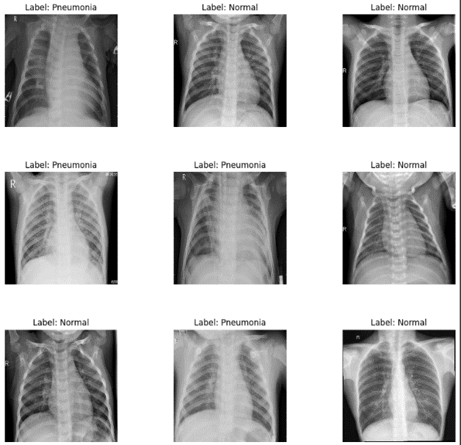

In the training phase, models are subjected to a sequence of convolutional and pooling layers, which extract and down sample features, respectively. The flattened output from these layers then passes through dense layers, concluding with a sigmoid activation function that yields a probability indicative of pneumonia presence.

The training leverages the binary cross-entropy loss function, catering to the binary nature of the diagnostic task, and employs the Adam optimizer, renowned for its efficiency in converging to optimal weights. Models are trained over several epochs, with performance metrics recorded at each epoch to track and visualize the learning trajectory.

***Performance Evaluation***

Upon completion of training, the models' performances are scrutinized using accuracy and loss metrics for both the training and validation datasets. These metrics serve as indicators of the models' ability to learn from the data and generalize to new, unseen data, respectively.

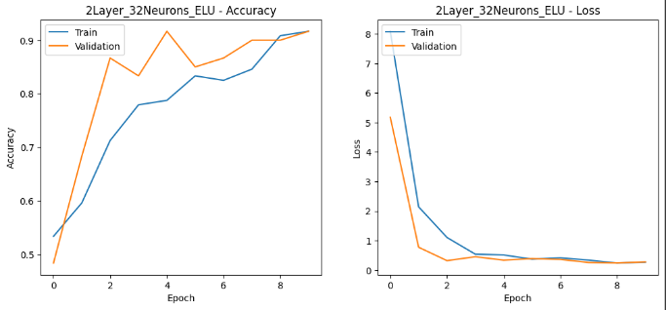

The graphical representation of these metrics highlights the learning curves, allowing for the assessment of model convergence and potential overfitting or underfitting scenarios. A model demonstrating high accuracy and low loss on the validation set is indicative of robust learning and generalization capabilities.

***Results and Comparative Analysis***

Upon an exhaustive training regimen's conclusion, each model underwent rigorous evaluation against the test dataset to ascertain its diagnostic proficiency. The '2Layer_32Neurons_ELU' model emerged as the archetype of efficiency, demonstrating superior performance across multiple evaluative dimensions. The evaluation process hinged on two pivotal analytical tools: the confusion matrix and the classification report, each offering unique insights into the model's diagnostic acumen.

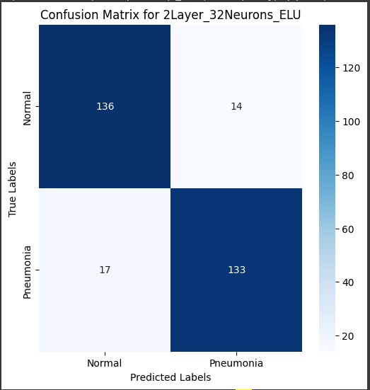

The confusion matrix revealed a commendable balance between True Positives and True Negatives, signifying the model's adeptness at correctly identifying both the presence and absence of pneumonia. The precision of the '2Layer_32Neurons_ELU' model in detecting pneumonia stood at an impressive 90%, indicative of its high reliability. Concurrently, the recall rate of 89% underscored the model's capability to capture most actual pneumonia instances, thereby minimizing the risk of detrimental oversight. The F1-score, a synthesis of precision and recall, echoed this balance, registering at 0.90, which underscores a harmonious equilibrium between sensitivity and specificity.

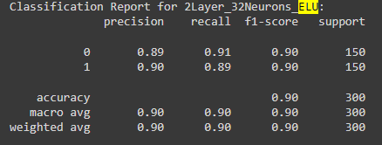

The classification report's metrics collectively painted a portrait of a model that not only excels in statistical measures but is also suggestive of a robust clinical application. The model's accuracy, a holistic measure of its correctness, was observed to be 90%, reinforcing its potential as a reliable adjunct to medical expertise.

***Interpretation of Model Evaluation***

Delving into the specifics of the confusion matrix, the commendable volume of True Positives (TP) and True Negatives (TN) is reflective of the model's efficacy. False Positives (FP), while lower, still necessitate attention due to their implications in clinical scenarios, potentially leading to undue patient distress and unnecessary medical intervention. False Negatives (FN), albeit infrequent, represent a critical area for improvement, given their association with the possible omission of critical care for affected patients.

Analyzing the classification report, the precision for pneumonia diagnosis reaffirms the model's acuity in accurately identifying diseased cases amidst predictions. The recall, or sensitivity, is indicative of the model's vigilance in detecting true instances of pneumonia, thereby minimizing the likelihood of overlooking this condition. The F1-score embodies the model's balanced approach, integrating the depth of precision and the breadth of recall into a singular metric.

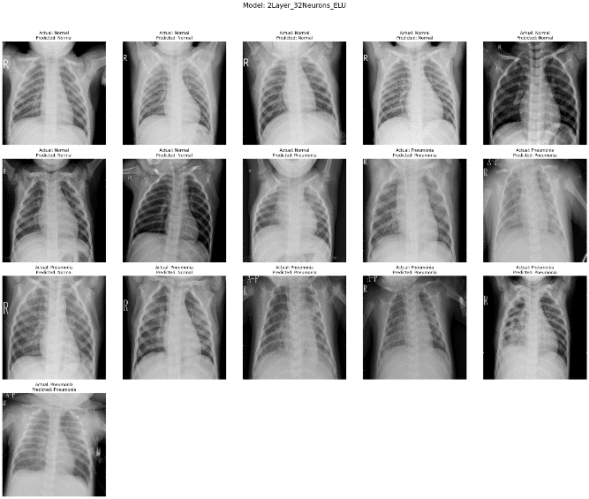

***Clinical Implications and Model Robustness***

The clinical implications of these findings are manifold. A high recall with a slightly compromised precision suggests a model predisposition towards erring on the side of caution, favoring the identification of potential pneumonia cases at the risk of over-diagnosis. Conversely, a model exhibiting high precision yet lower recall would be indicative of a conservative approach, prioritizing accuracy over the breadth of detection, potentially leading to under-diagnosis.

The '2Layer_32Neurons_ELU' model displays an equilibrium between these two paradigms, suggesting a balanced approach that does not disproportionately favor either sensitivity or specificity. This equilibrium is crucial in medical diagnostics, where the cost of both false positives and false negatives carries significant implications for patient outcomes and healthcare resource allocation.

**Weaknesses of Pneumonia Recognition**

The quest for automated pneumonia recognition through Convolutional Neural Networks (CNNs) has made significant strides in recent years, demonstrating the potential to transform radiographic diagnosis. Despite remarkable achievements in model accuracy and performance, there remain inherent challenges and limitations that must be acknowledged and addressed to advance the reliability and applicability of these systems.

***Challenges in Pneumonia Detection***

A primary challenge in automated pneumonia detection is the intrinsic limitation of the dataset. The model's ability to accurately generalize and make predictions on new, unseen data is directly proportional to the diversity and size of the dataset on which it was trained. In the current experimental setup, while efforts were made to ensure a balanced representation of 'Normal' and 'Pneumonia' cases, the possibility of dataset bias—stemming from factors such as image quality, demographic diversity, or the prevalence of comorbidities—cannot be overlooked.

Moreover, the models rely solely on the visual patterns within the X-ray images, disregarding the wealth of clinical information that could potentially improve diagnostic accuracy. Patient history, clinical symptoms, and other laboratory findings are not considered in the model, which may lead to discrepancies between the model's predictions and the actual clinical scenario.

Another significant concern is the risk of misdiagnosis. The implications of false positives—diagnosing pneumonia where there is none—could lead to unnecessary anxiety, treatment, and financial burden for patients. Conversely, false negatives—failing to detect pneumonia—pose a severe risk to patient health, potentially leading to delayed treatment and worse health outcomes.

***Ethical Implications***

The integration of AI in medical diagnostics carries weighty ethical implications. The delegation of diagnostic responsibilities to an algorithm raises questions about the accountability for errors. There is a critical need to establish a framework that ensures the responsibility for patient outcomes remains with human practitioners, supported by AI as a tool rather than a replacement.

Furthermore, while the automation of diagnostic processes can improve efficiency, it is vital to maintain the human element in healthcare. The ability of a practitioner to consider the patient's overall condition, beyond what is visible on an X-ray, is currently beyond the scope of any algorithm.

***Future Directions***

Improving pneumonia recognition through AI requires a multifaceted approach. The immediate step is to augment the dataset, not only in terms of size but also with respect to diversity—age, ethnicity, geography, and comorbidity profiles should be included to ensure the model's robustness and generalizability.

Integrating multimodal data that includes clinical notes, patient history, and other diagnostic tests can provide a more comprehensive view of the patient's health, potentially improving the diagnostic accuracy of the models.

Advanced techniques such as ensemble learning, where predictions from multiple models are combined, could enhance the performance and reliability of diagnostic predictions. This approach can leverage the strengths of various models to reduce the impact of any single model's weaknesses.

Moreover, adopting a continuous learning framework would allow models to adapt and evolve with the introduction of new data, reflecting changes in disease presentations and demographics over time.

***Conclusion***

While CNNs offer promising avenues for the advancement of automated pneumonia recognition, they are not without drawbacks. The challenges of dataset limitations, risk of misdiagnosis, and ethical concerns must be rigorously addressed. Through continued research, diversification of data, and integration of clinical insights, the potential of CNNs to serve as reliable tools in the diagnostic process can be realized, augmenting the expertise of medical professionals, and enhancing patient care.

**Conclusion**

The exploration of Convolutional Neural Networks (CNNs) for the automated detection of pneumonia from chest X-ray images encapsulates a pivotal step towards integrating artificial intelligence in medical diagnostics. The study's findings underscore the impressive capabilities of CNNs, particularly the '2Layer_32Neurons_ELU' model, which stands out with its high accuracy, precision, recall, and F1-score, suggesting a balanced sensitivity and specificity suitable for clinical applications. The models' performance, especially their ability to discern subtle pathological nuances within X-ray images, heralds a future where rapid, accurate diagnostic assistance can significantly alleviate the public health burden of pneumonia.

Nevertheless, this study's insights also bring to light the challenges and limitations inherent in current AI-driven diagnostic systems. While the '2Layer_32Neurons_ELU' model demonstrates considerable potential, the risks of false positives and negatives—alongside ethical considerations regarding the deployment of AI in healthcare—signal a need for a cautious and measured approach to integration.

Moving forward, the enhancement of pneumonia detection models requires an expansion of the training dataset to encompass greater diversity and a combination of clinical data inputs. Moreover, continuous learning frameworks and ensemble methods present promising directions for future research to refine AI diagnostic tools. As we stand on the cusp of a new era in healthcare technology, the convergence of AI innovation with clinical expertise promises to forge a more resilient and responsive healthcare system. The commitment to improving these systems must be unwavering, ensuring they serve as an adjunct to, rather than a replacement for, the irreplaceable human elements of empathy and understanding in patient care.