1. 修改esp8266.c下的wifi账号及密码



1. 修改onenet.c下的PROID、ACCESS_KEY_key和DEVICE_NAME

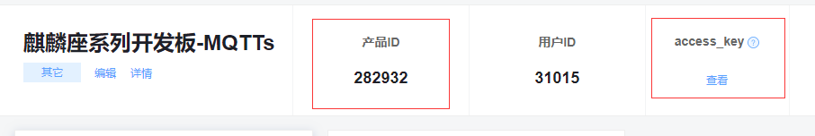

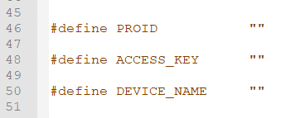

其中DEVICE_NAME为自定义参数

# 主要参考视频：

# B站：

# 世界不大我姓张：基于STM32的DHT11温湿度模块代码详解

# <https://www.bilibili.com/video/BV1We4y197pc/?spm_id_from=333.880.my_history.page.click&vd_source=b567447237dcfa732a3045ea99c6ec3d>

# 画卿师兄：【挽救小白第一季】STM32+8266+小程序智能家居毕设实战

# <https://www.bilibili.com/video/BV1ae411W7yD/?p=9&spm_id_from=333.880.my_history.page.click&vd_source=b567447237dcfa732a3045ea99c6ec3d>

# 王铭东：Micropython+ESP32+HomeAssistant 智能家居系 源码+教程

# <https://www.bilibili.com/video/BV1gM411v7u7/?p=12&spm_id_from=333.880.my_history.page.click&vd_source=b567447237dcfa732a3045ea99c6ec3d>

# 壹知半解：小白物联网智能家居毕设参考STM32+ESP8266/MQTT+OneNet+UniApp

# https://www.bilibili.com/video/BV1HH4y1o7EN/?p=13&spm_id_from=333.880.my_history.page.click&vd_source=b567447237dcfa732a3045ea99c6ec3d