Group 6:

Nguyễn Đình Long 18110027

Thiều Quang Khánh 18110022

Topic: Health daily checking app

Practice 1: explore and design user case

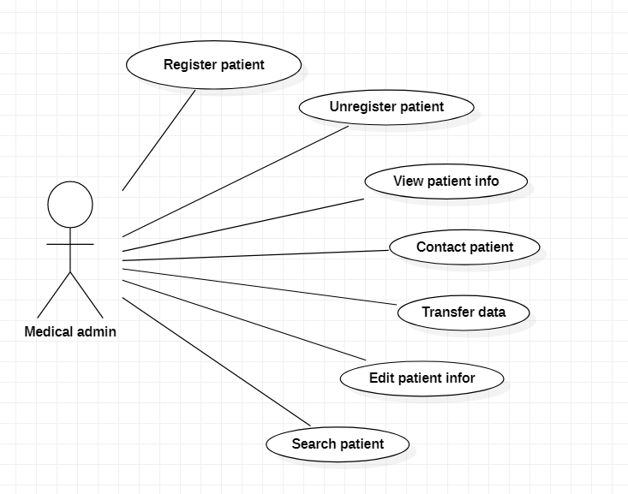

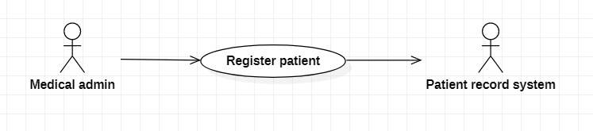

|  |  |
| --- | --- |
| **MHC-PMS: Register patient** | |
| Actors | Medical admin, Patient record system |
| Description | Admin may register patient to information system. It will be let patient to login to application |
| Data | Patient’s username, password |
| Stimulus | User command issued by medical admin |
| Response | Confirmation that PRS has been updated |
| Comments | The receptionist must have appropriate security permissions to access the patient information and the PRS. |

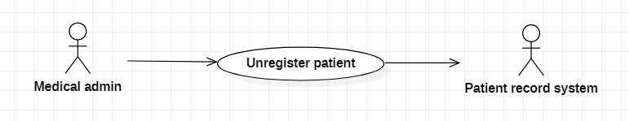

|  |  |
| --- | --- |
| **MHC-PMS: Unregister patient** | |
| Actors | Medical admin, Patient record system |
| Description | Admin may delete user’s account from PRS. That command will delete user’s account forever in PRS. |
| Data | Patient’s account |
| Stimulus | User command issued by medical admin |
| Response | Confirmation that PRS has been updated |
| Comments | The receptionist must have appropriate security permissions to access the patient information and the PRS. |

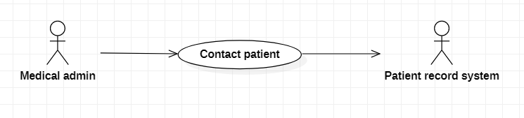

|  |  |
| --- | --- |
| **MHC-PMS: Contact patient** | |
| Actors | Medical admin, Patient record system |
| Description | Admin may contact patient to notify the information |
| Data | Patient’s contact |
| Stimulus | PRS may store content of communication |
| Response | Show contact of user |
| Comments | The receptionist must have appropriate security permissions to protect information of users |

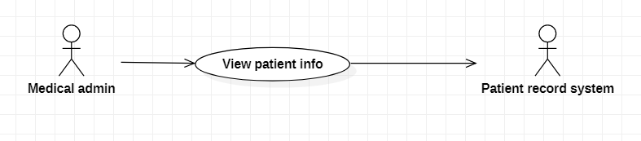

|  |  |
| --- | --- |
| **MHC-PMS: View patient info** | |
| Actors | Medical admin, Patient record system |
| Description | Medical admin may view patient info from PRS to manage user |
| Data | Patient’s personal information |
| Stimulus |  |
| Response | PRS show info of patient |
| Comments | The receptionist must have good security system to protect user’s info |

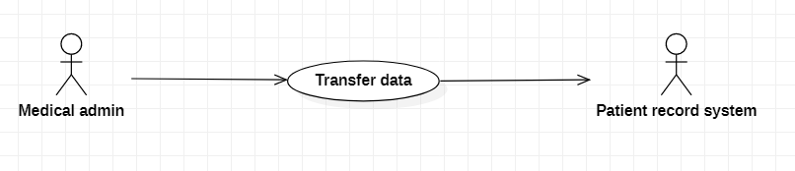

|  |  |
| --- | --- |
| **MHC-PMS: Transfer data** | |
| Actors | Medical admin, Patient record system |
| Description | A receptionist may transfer data from the mentcase system to general patient record database that is maintained by a health authority. The information transferred may either be updated personal information(address, phone number, etc.) or a summary of the patient’s diagnosis and treatment. |
| Data | Patient’s personal information, treatment summary |
| Stimulus | User command issued by medical admin |
| Response | Confirmation that PRS has been updated |
| Comments | The receptionist must have appropriate security permissions to access the patient information and the PRS. |

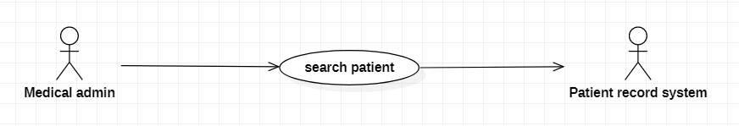

|  |  |
| --- | --- |
| **MHC-PMS: Search patient** | |
| Actors | Medical admin, Patient record system |
| Description | A receptionist may search user to manage and make decision (contact, delete, etc.) |
| Data | Patient’s personal information |
| Stimulus | admin command |
| Response | Show the searched patient |
| Comments | The receptionist must have appropriate security permissions to access the patient information and the PRS. |

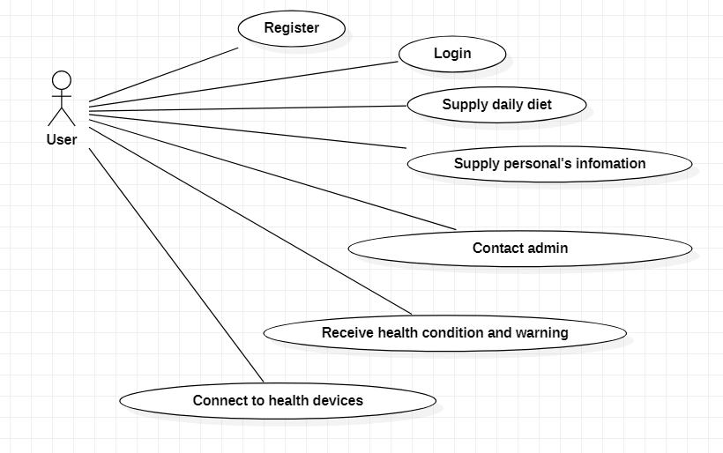

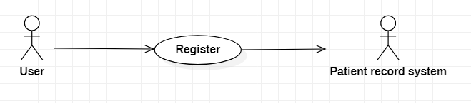

|  |  |
| --- | --- |
| **MHC-PMS: Register** | |
| Actors | User, Patient record system |
| Description | Patient may register account to login health application |
| Data | Patient’s username and password |
| Stimulus | Upgrade security system |
| Response | Confirmation that the account has been created |
| Comments | The receptionist must have appropriate security permissions to access to PRS. |

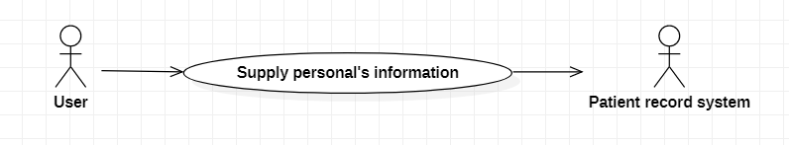

|  |  |
| --- | --- |
| **MHC-PMS: Supply personal’s info** | |
| Actors | User, Patient record system |
| Description | A patient must supply personal’s health information to patient record system. System may execute user’s information and show health condition. |
| Data | Patient’s personal information |
| Stimulus | Update daily to receive notify about health |
| Response | Confirmation that that information be recorded |
| Comments | The receptionist must have good security system to protect user’s info |

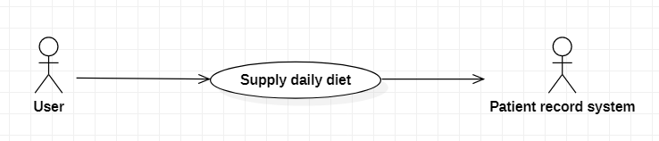

|  |  |
| --- | --- |
| **MHC-PMS: Supply daily diet** | |
| Actors | User, Patient record system |
| Description | A patient must supply personal’s daily diet to patient record system. System may execute user’s information and show health condition. |
| Data | Patient’s daily diet |
| Stimulus | Update daily to receive notify about diet |
| Response | Confirmation that that information be recorded |
| Comments | The receptionist must have good security system to protect user’s info |

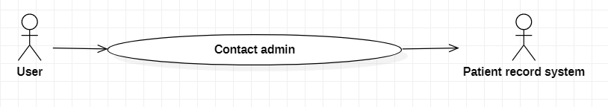

|  |  |
| --- | --- |
| **MHC-PMS: Contact admin** | |
| Actors | User, Patient record system |
| Description | A patient may contact admin to have questions about system and his health. |
| Data | Admin’s contact |
| Stimulus | The receptionist may operate message system to contact between user and admin. |
| Response | Confirmation to make a contact with admin |
| Comments | The receptionist must have good security system to protect user’s info |

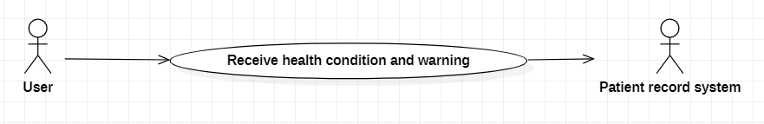

|  |  |
| --- | --- |
| **MHC-PMS: Receive health condition and warning** | |
| Actors | User, Patient record system |
| Description | A patient may receive her health condition and warning when bad signal about her health |
| Data | System’s notification |
| Stimulus | Notifications may show daily |
| Response | Show healthy condition and warning |
| Comments | The receptionist must have good security system to protect user’s information |

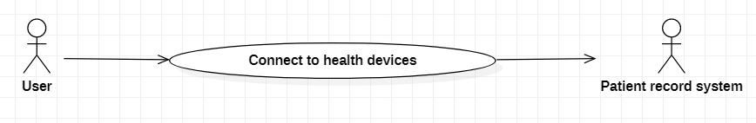

|  |  |
| --- | --- |
| **MHC-PMS: Connect health device** | |
| Actors | User, Patient record system |
| Description | A patient may connect to health device to system. RPS will record that information of user to execute health condition and notify to users |
| Data | Patient’s information |
| Stimulus | Refresh the connection |
| Response | Confirmation that this device has been connected |
| Comments | The receptionist must have good security system to protect user’s information |

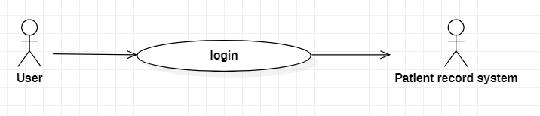

|  |  |
| --- | --- |
| **MHC-PMS: Login** | |
| Actors | User, Patient record system |
| Description | A patient may login to her account to edit personal information, enter health condition, contact admin, etc. |
| Data | Patient’s username and password |
| Stimulus | Update password monthly |
| Response | Confirmation that the user has been logged in |
| Comments | The receptionist must have good security system to protect user’s info |