**Texture**

**I. Introduction.**

Texture playa an important role in many machine vision tasks auch as surface inspection, acene classification, and surface orientation and shape determi- nation. For example, surface texture features are used in the inspection of semiconductor wafers, gray-level distribution features of homogeneous Ges- tured regions are used in the classibcation of aerial imagery, and variations in texture patternB due to per8pective projection are used to determine three- dimensional ahapea of objects.

* Texture is a feature used to partition images into regions of interest and to classify those regions.
* Texture provides information in the spatial arrangement of colours or intensities in an image.
* Texture is characterized by the spatial distribution of intensity levels in a neighborhood.
* Texture is a repeating pattern of local variations in image intensity:

Texture cannot be defined for a point.

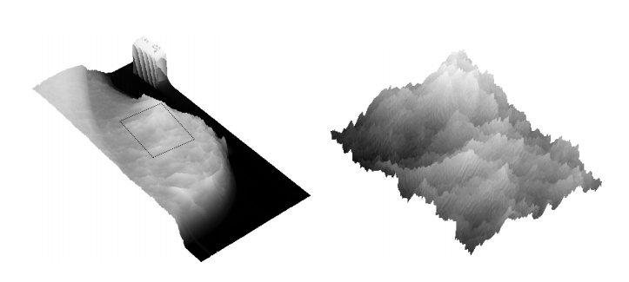

Figure1

**II. Types of texture.**

1. **Texture Analysis:**

There are two primary issues in texture analysis:

* texture classification : is concerned with automatically determining the boundaries between various texture regions in an image.
* texture segmentation: is concerned with identifying a given textured region from a given set of texture classes.

There are three approaches to defining exactly what texture is:

* :Structural: texture is a set of primitive texels in some regular or repeated relationship.
* Statistical: texture is a quantitative measure of the arrangement of intensities in a region. This set of measurements is called a feature vector.
* Fouriee approach:

**\*Defining texture:**

Statistical methods are particularly useful when the texture primitives are small, resulting in microtextures. • When the size of the texture primitive is large, first determine the shape and properties of the basic primitive and the rules which govern the placement of these primitives, forming macrotextures.

**\*Simple Analysis of Texture**

**Range:**

One of the simplest of the texture operators is the range or difference between maximum and minimum intensity values in a neighborhood. – The range operator converts the original image to one in which brightness represents texture.

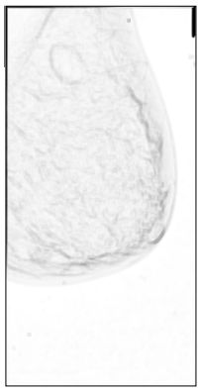

Figure2

**Variance:**

Another estimator of texture is the variance in neighborhood regions. – This is the sum of the squares of the differences between the intensity of the central pixel and its neighbours.

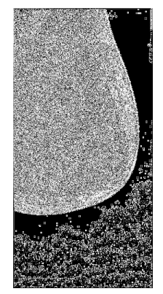

Figure3

**Quantitative Texture Measures:**

• Numeric quantities or statistics that describe a texture can be calculated from the intensities (or colours) themselves.

**Grey Level Co-occurrence :**

• The statistical measures described so far are easy to calculate, but do not provide any information about the repeating nature of texture.

• A gray level co-occurrence matrix (GLCM) contains information about the positions of pixels having similar gray level values.

**Graylevel Difference Statistics:**

Grey-level differences are based on absoute differences between pairs of grey-levels.

• The grey-level differences are contained in a 256-element vector, and are computed by taking the absolute differences of all possible pairs of grey levels distance d apart at angle θ, and counting the number of times the difference is 0,1,…,255

**Mean:**

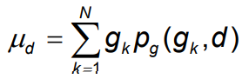

Small mean values µd indicate coarse texture having a grain size equal to or larger than the magnitude of the displacement vector.

**Entropy:**

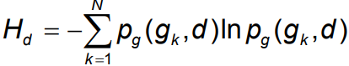

– This is a measure of the homogeneity of the histogram. It is maximised for uniform histograms.

**Variance:**

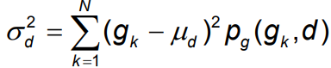

The variance is a measure of the dispersion of the gray-level differences at a certain distance, **d**.

**Contrast:**

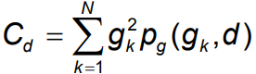

**Mean Standard Deviation Entropy Contrast**

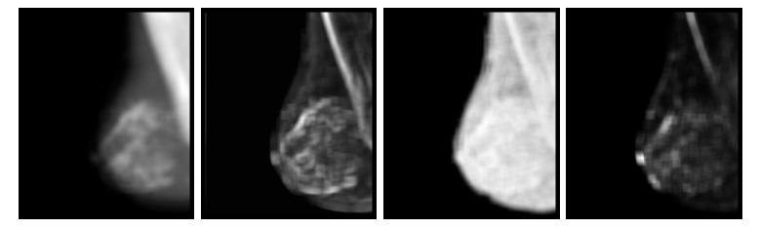

Figure4

**Edges and Texture:**

It should be possible to locate the edges that result from the intensity transitions along the boundary of the texture.

– Since a texture will have large numbers of texels, there should be a property of the edge pixels that can be used to characterise the texture.

• a set of common directions

• a measure of the locadensity of the edge pixels

• Compute the co-occurrence matrix of an edgeenhanced image

**Original Sobel-Enhanced Contrast**

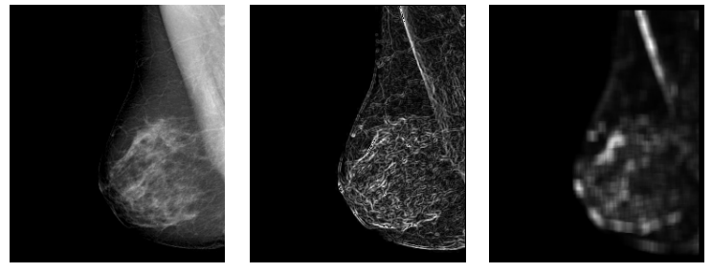

Figure5

**Laws:**

* A set of convolution kernels are used to compute texture energy.
* The kernels are computed from the following vectors:

L5 = [ 1 4 6 4 1]

E5 = [-1 -2 0 2 1]

S5 = [-1 0 2 0 -1]

R5 = [1 -4 6 -4 1]

W5 = [-1 2 0 -2 -1]

* The **L5** (level) vector gives a centre-weighted local average. The **E5** (edge) vector detects edges, the **S5** (spot) vector detects spots, the **R5** (ripple) vector detects ripples, and the **W5** (wave) vector detects waves.

Eg. **E5L5**  is computed as the product of **E5** and **L5** as follows:

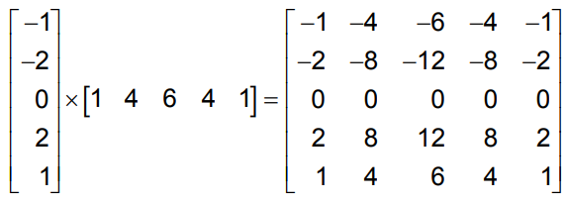

This results **in 25 5×5** kernels**, 24** of the kernels are zero-sum, the **L5L5** is not.

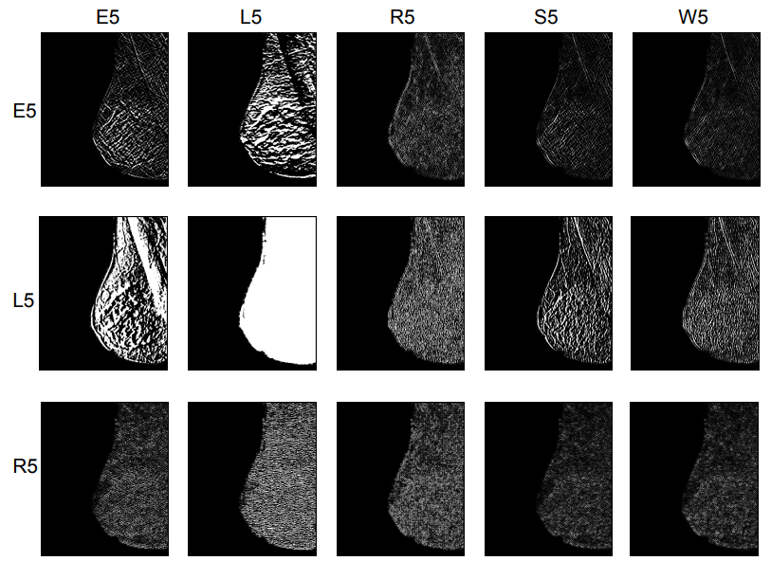

Figure6

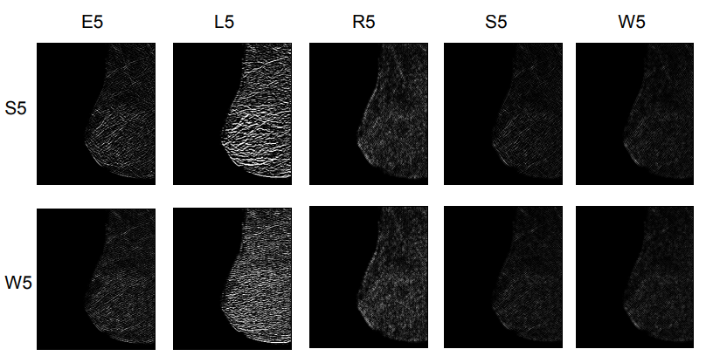

Figure7

* Bias from the “directionality” of textures can be removed by combining symmetric pairs of features, making them rotationally invariant.

e.g. S5L5(H) + L5S5(V) = L5S5R

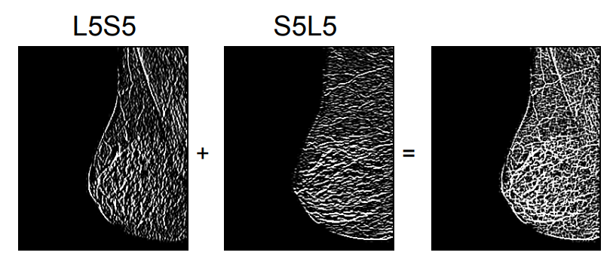

Figure8

**Hurst:**

* Within each group, the largest difference in intensity is found, this is the same as subtracting the minimum value from the maximum value.
* The central pixel is ignored, and a straight line is fitted to the Log of the maximum difference (ycoord), and the Log og the distance from the central pixel (x-coord).
* The slope of this line is the Hurst coefficient, and replaces the pixel at the centre of the region.

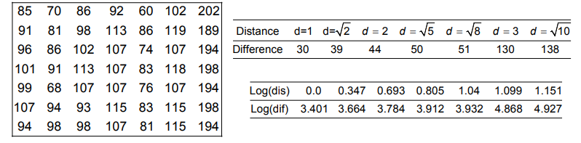

**Y=1.145x+3.229**

* The slope of the line, m=1.145 is the Hurst coefficient

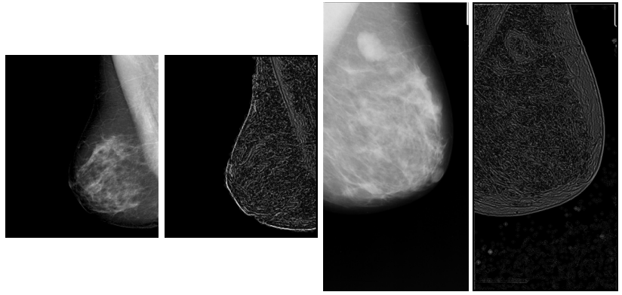

Figure9

**2. Texture Synthesis.**

Texture Systhesis is a technique of generating arbitrarily large textures from small real-world samples. The idea is that we get the input image of some texture and we want to get other images that look like that same texture. So the assumption here is that somewhere out there, in the real world there exists true infinite texture and the input image is just a small sample may be like a little deep hole that you are looking at there at the grand big texture and we want to get just some more samples of that texture. There are several assumptions here and one of them is input image is somehow large enough to capture the essence of this texture.

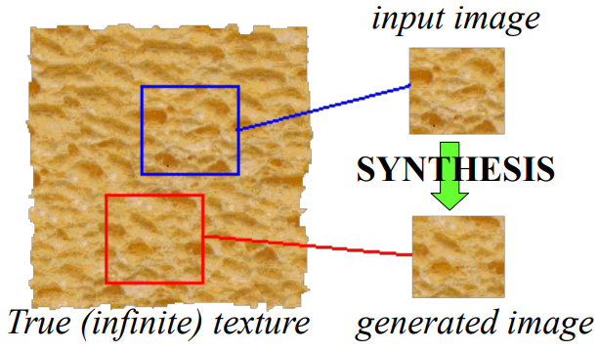

Figure10

* Goal of Texture Synthesis: create new samples of a given texture
* Many applications: virtual environments, holefilling, texturing surfaces

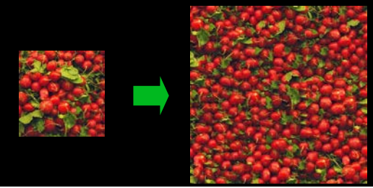

Figure11

**How texture systhesis work ?**

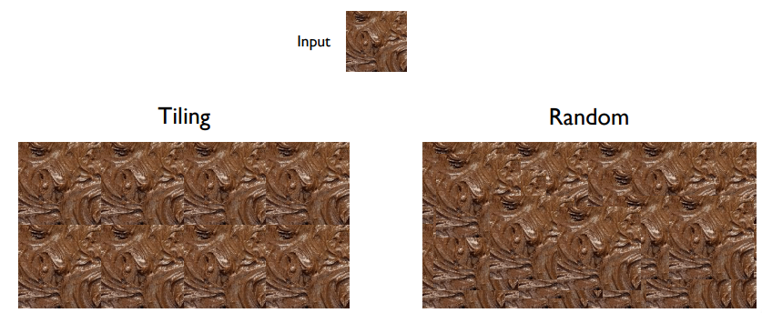

**Systhesis Results**

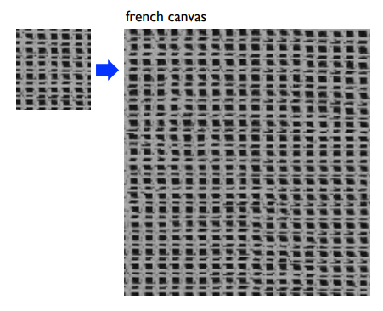

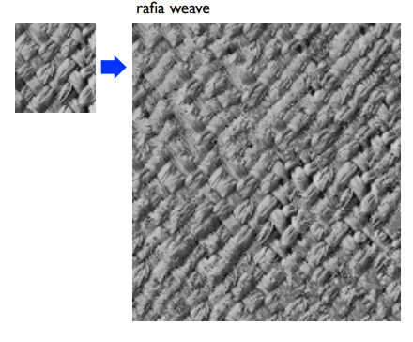

**Potential Applications of Texture synthesis**

Other than large surface creations, there are many other areas where texture synthesis can be applied as a solution. Like hole-filling, Image-video compression, foreground removal etc. Some of these applications are presented here.

1. **Occlusion Fill-in or image extrapolation**

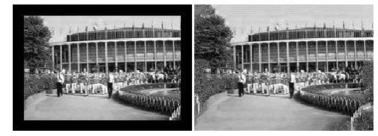

Figure12

1. **Foreground Removal**

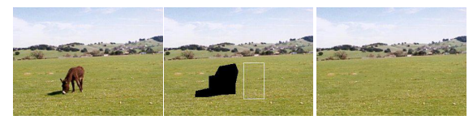

1. **Surfacing objects or texture transfer**

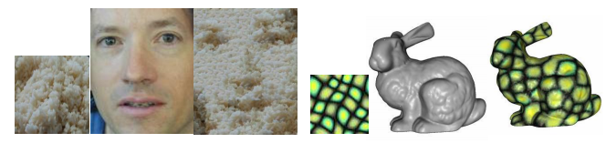

**Texture Transfer**

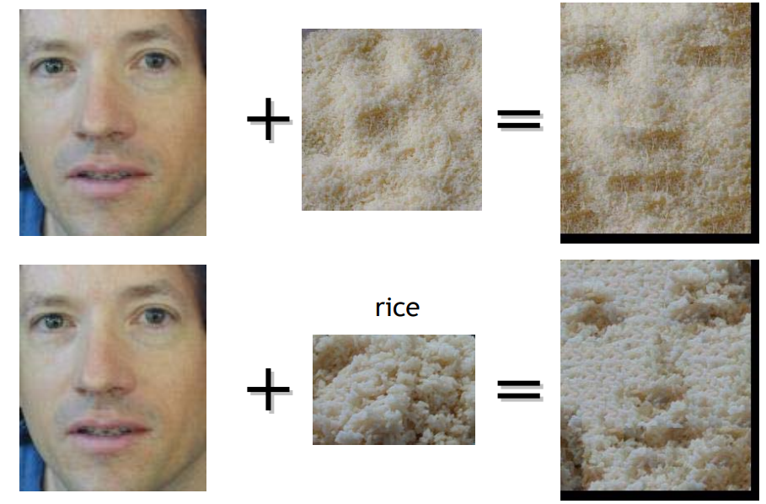

**Image analogies (filter by example)**

A to A’ like B to B’

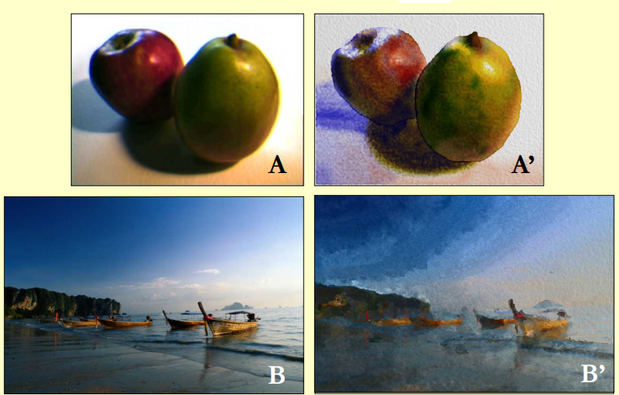

**III. Conclusion.**

In this report, a review on different groups of texture methods which and an application in biomedical image analysis and CAD systems waspresented. Texture analysis is an active research area of study and manyresearchers in different felds (including the medical image analysis)work on this topic. This paper tried to summarize some of the originalmethods which have been proposed in computer vision and imageprocessing community for texture analysis and some of theirbiomedical applications have been considered.