0）先写清：你跑的是哪个分支
PR 链接 + head branch 名称（PR页面显示的那个分支名）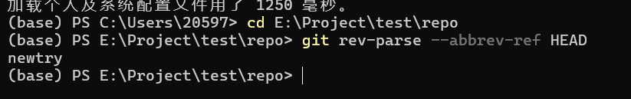
你在仓库里执行的命令截图/文本：
git rev-parse --abbrev-ref HEAD
git log -1 --oneline
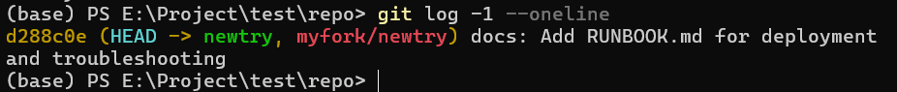
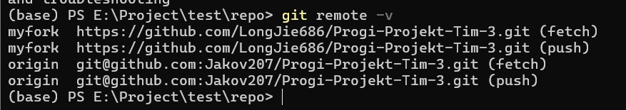
1）Docker Compose 运行证据（必须）
docker compose up -d --build 的输出（截图或复制文本）
(base) PS E:\Project\test\repo> docker compose up -d --build
time="2026-04-02T19:01:25+08:00" level=warning msg="The \"VITE_STRIPE_PUBLIC_KEY\" variable is not set. Defaulting to a blank string."
[+] Building 6.6s (38/38) FINISHED
=> [internal] load local bake definitions 0.0s
=> => reading from stdin 668B 0.0s
=> [backend internal] load build definition from Dockerfile 0.0s
=> => transferring dockerfile: 998B 0.0s
=> [frontend internal] load build definition from Dockerfile 0.0s
=> => transferring dockerfile: 522B 0.0s
=> [frontend internal] load metadata for docker.io/library/nginx:alp 0.1s
=> [backend internal] load metadata for docker.io/library/node:20-al 0.1s
=> [backend internal] load .dockerignore 0.0s
=> => transferring context: 127B 0.0s
=> [frontend internal] load .dockerignore 0.0s
=> => transferring context: 94B 0.0s
=> [frontend builder 1/9] FROM docker.io/library/node:20-alpine@sha2 0.1s
=> => resolve docker.io/library/node:20-alpine@sha256:f598378b524022 0.1s
=> [backend internal] load build context 0.0s
=> => transferring context: 5.53kB 0.0s
=> [frontend internal] load build context 0.1s
=> => transferring context: 9.21kB 0.0s
=> [frontend runner 1/3] FROM docker.io/library/nginx:alpine@sha256: 0.1s
=> => resolve docker.io/library/nginx:alpine@sha256:e7257f1ef28ba17c 0.1s
=> CACHED [backend builder 2/9] WORKDIR /app 0.0s
=> CACHED [frontend builder 3/6] COPY package*.json ./ 0.0s
=> CACHED [frontend builder 4/6] RUN npm ci 0.0s
=> CACHED [frontend builder 5/6] COPY . . 0.0s
=> CACHED [frontend builder 6/6] RUN npm run build 0.0s
=> CACHED [frontend runner 2/3] COPY --from=builder /app/dist /usr/s 0.0s
=> CACHED [frontend runner 3/3] COPY nginx.conf /etc/nginx/conf.d/de 0.0s
=> [frontend] exporting to image 0.4s
=> => exporting layers 0.0s
=> => exporting manifest sha256:e64230060a569e41c7ef4e8fd2b87a51dd47 0.0s
=> => exporting config sha256:85260d64d1cc851ec851af2d721afec2212f8c 0.0s
=> => exporting attestation manifest sha256:b0e54342cc4c2423ed6f8df1 0.1s
=> => exporting manifest list sha256:f4cd77f8cb9e3e6c1e959540be4471a 0.0s
=> => naming to docker.io/library/repo-frontend:latest 0.0s
=> => unpacking to docker.io/library/repo-frontend:latest 0.1s
=> CACHED [backend runner 2/10] RUN apk add --no-cache curl 0.0s
=> CACHED [backend runner 3/10] WORKDIR /app 0.0s
=> CACHED [backend runner 4/10] COPY package*.json ./ 0.0s
=> CACHED [backend runner 5/10] RUN npm ci 0.0s
=> CACHED [backend runner 6/10] COPY prisma ./prisma/ 0.0s
=> CACHED [backend runner 7/10] COPY prisma.config.ts ./ 0.0s
=> CACHED [backend runner 8/10] RUN npx prisma generate 0.0s
=> CACHED [backend runner 9/10] COPY src ./src 0.0s
=> CACHED [backend builder 3/9] COPY package*.json ./ 0.0s
=> CACHED [backend builder 4/9] RUN npm ci 0.0s
=> CACHED [backend builder 5/9] COPY prisma ./prisma/ 0.0s
=> CACHED [backend builder 6/9] COPY prisma.config.ts ./ 0.0s
=> CACHED [backend builder 7/9] RUN npx prisma generate 0.0s
=> CACHED [backend builder 8/9] COPY . . 0.0s
=> CACHED [backend builder 9/9] RUN npm run build 0.0s
=> CACHED [backend runner 10/10] COPY --from=builder /app/dist ./dis 0.0s
=> [backend] exporting to image 5.3s
=> => exporting layers 0.0s
=> => exporting manifest sha256:460a71c1b180565e45e8dc398660730290d5 0.0s
=> => exporting config sha256:29ca42e845494026b9dd3fd20ce87df8738265 0.0s
=> => exporting attestation manifest sha256:661e93552e4db0e8404afdab 0.1s
=> => exporting manifest list sha256:ec7a987e192f8ae3392f9e55e3df7ed 0.0s
=> => naming to docker.io/library/repo-backend:latest 0.0s
=> => unpacking to docker.io/library/repo-backend:latest 5.1s
=> [frontend] resolving provenance for metadata file 0.0s
=> [backend] resolving provenance for metadata file 0.0s
[+] Running 11/11
✔ backend Built 0.0s
✔ frontend Built 0.0s
✔ Network repo_stemtutor_network Created 0.1s
✔ Volume "repo_minio_data" Creat... 0.0s
✔ Volume "repo_postgres_data" Cr... 0.0s
✔ Volume "repo_redis_data" Creat... 0.0s
✔ Container stemtutor_redis Heal... 12.1s
✔ Container stemtutor_minio Star... 2.6s
✔ Container stemtutor_postgres H... 12.1s
✔ Container stemtutor_backend He... 15.7s
✔ Container stemtutor_frontend S... 16.0s

docker compose ps（完整输出，必须能看到所有容器状态与端口映射）
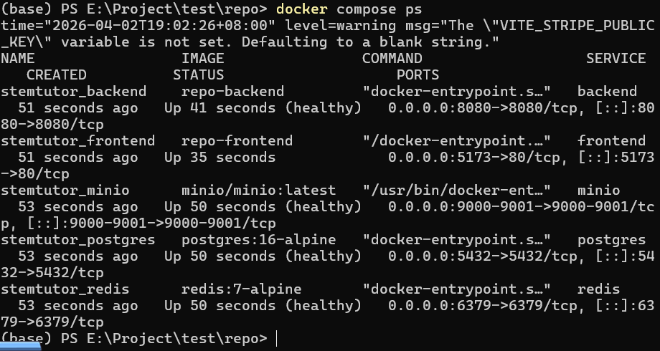
docker compose config（强烈建议，加分项，但我建议你要求必须交，最防“跑错文件”）
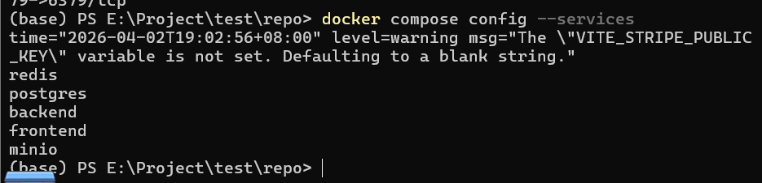
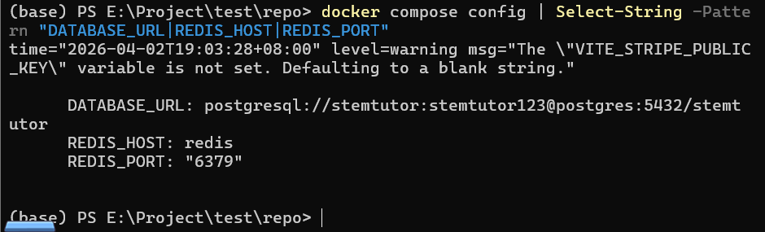
2）API/页面可用证据（必须）
curl -s http://localhost:8080/api-docs/ | head -20
必须能看到 swagger html 头（title/link/css等）
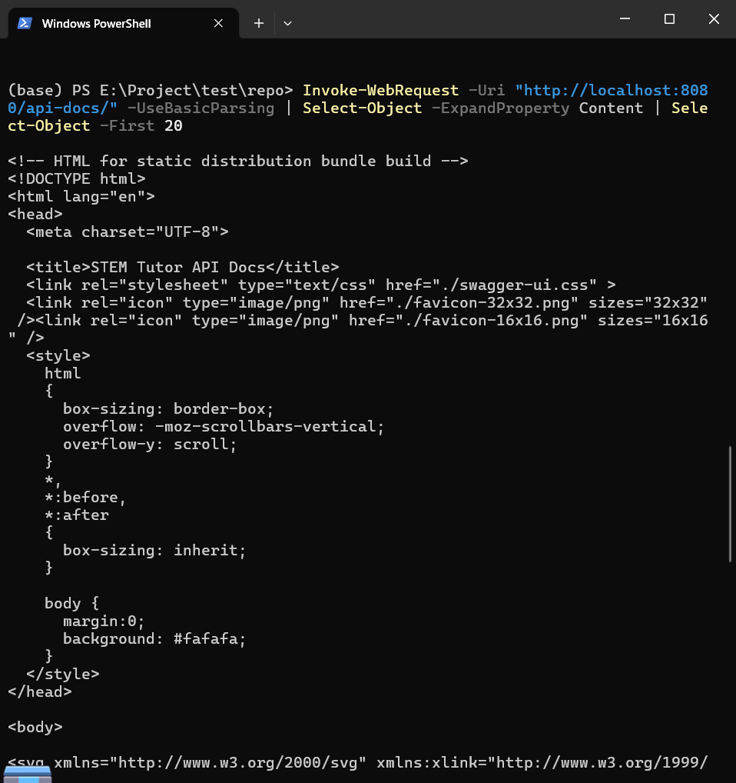
curl -s http://localhost:8080/api/tutors（或项目 README 里指定的任一业务 API）
必须返回 JSON（空数据也行）
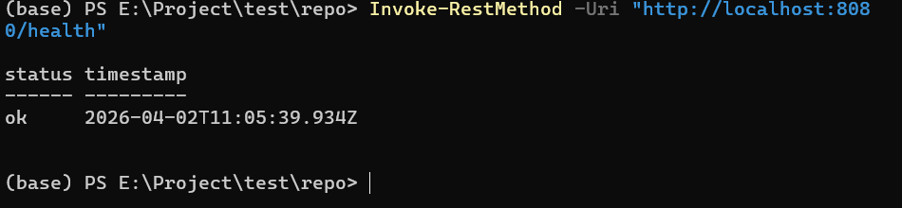
如果是服务器上跑：把 localhost 换成服务器 IP，但要写清“访问口径”。

3）日志证据（必须）
docker logs stem-tutor-server --tail 80
我重点看：started / api-docs available / connected to redis / db ready 等关键行
（可选）docker logs stem-tutor-client --tail 50
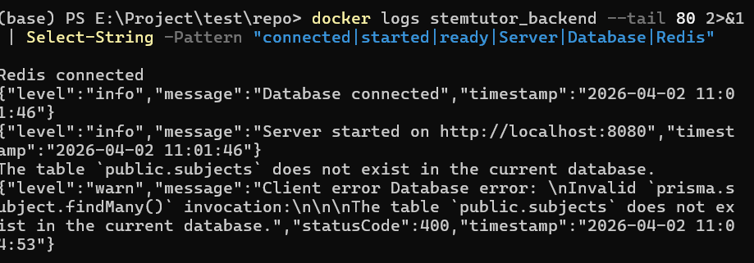
4）故障注入与恢复（必须，最能验真）

任选一个依赖做（Redis 或 Postgres）：

方案A（推荐 Postgres）
- docker stop stem-tutor-postgres
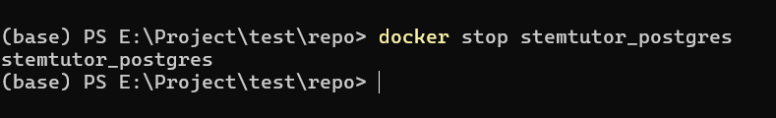
- 再 curl 一次业务接口：curl -s http://localhost:8080/api/tutors（看变化）
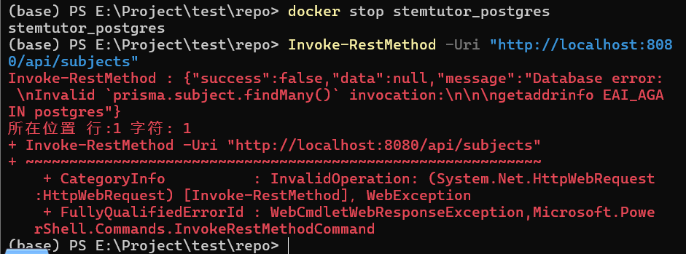
- docker start stem-tutor-postgres
11) 再 curl 一次同接口（恢复成功）
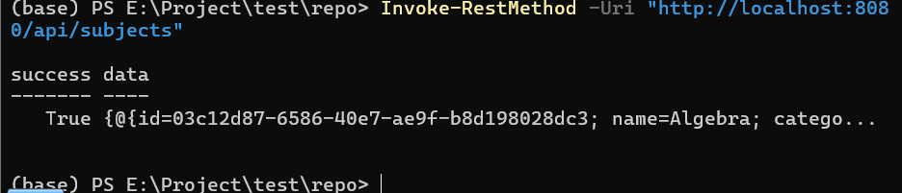
方案B（Redis）
同理 stop/start stem-tutor-redis，观察 server logs 的 reconnect 行为。

三句话复盘（必须）：
现象（停了什么后发生了什么）
证据（哪一行日志/哪个返回证明）
修复（做了什么让它恢复，如何验证恢复）
5）最终交付物（必须，可复现）
RUNBOOK.md 或 README_RUN.md（一页以内，但必须可复现）包含：
从0开始的命令（clone→checkout→compose up）
访问口径（8080/api-docs、5173前端、minio端口等）
3条验证命令（compose ps、api-docs curl、业务接口 curl）
常见故障三板斧（ps→logs→curl）
回滚/清理（compose down -v）

