MarketLink — Screen Gallery & Functional Flows by Role
Part I (Sections 1–5): Core SRS Screens Required by Brief | Part II (Sections 6–8): Extended Bonus Value-Add Features Placed at the End
1. Guest & Public Marketplace Discovery (01-guest/)
Core SRS 1.6 — Landing Page, Browse/Filter Produce, Interactive Market Map, Farmer Profiles, About & Contact
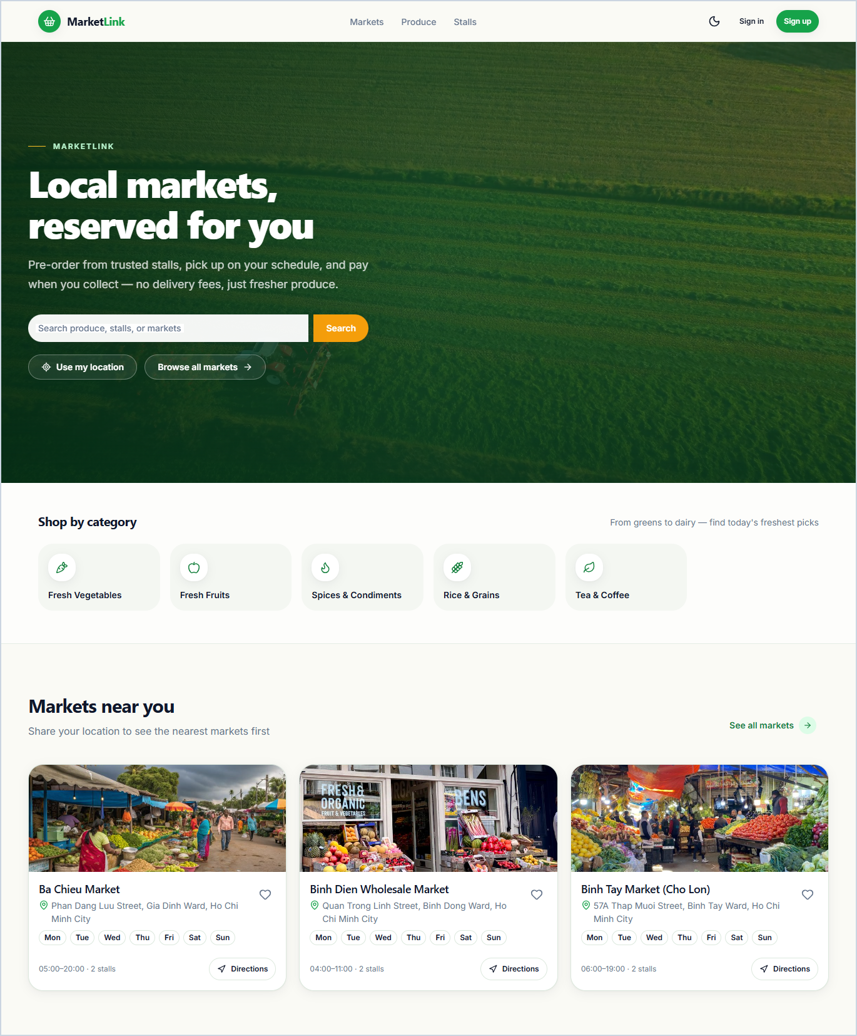  1.1A Home (Part 1) — Hero Search, Categories & Markets Near You  Introduces MarketLink's value proposition with a unified keyword search bar, GPS 'Use my location' button, quick produce category shortcuts, and nearby farmers markets showing operating days and map directions. | 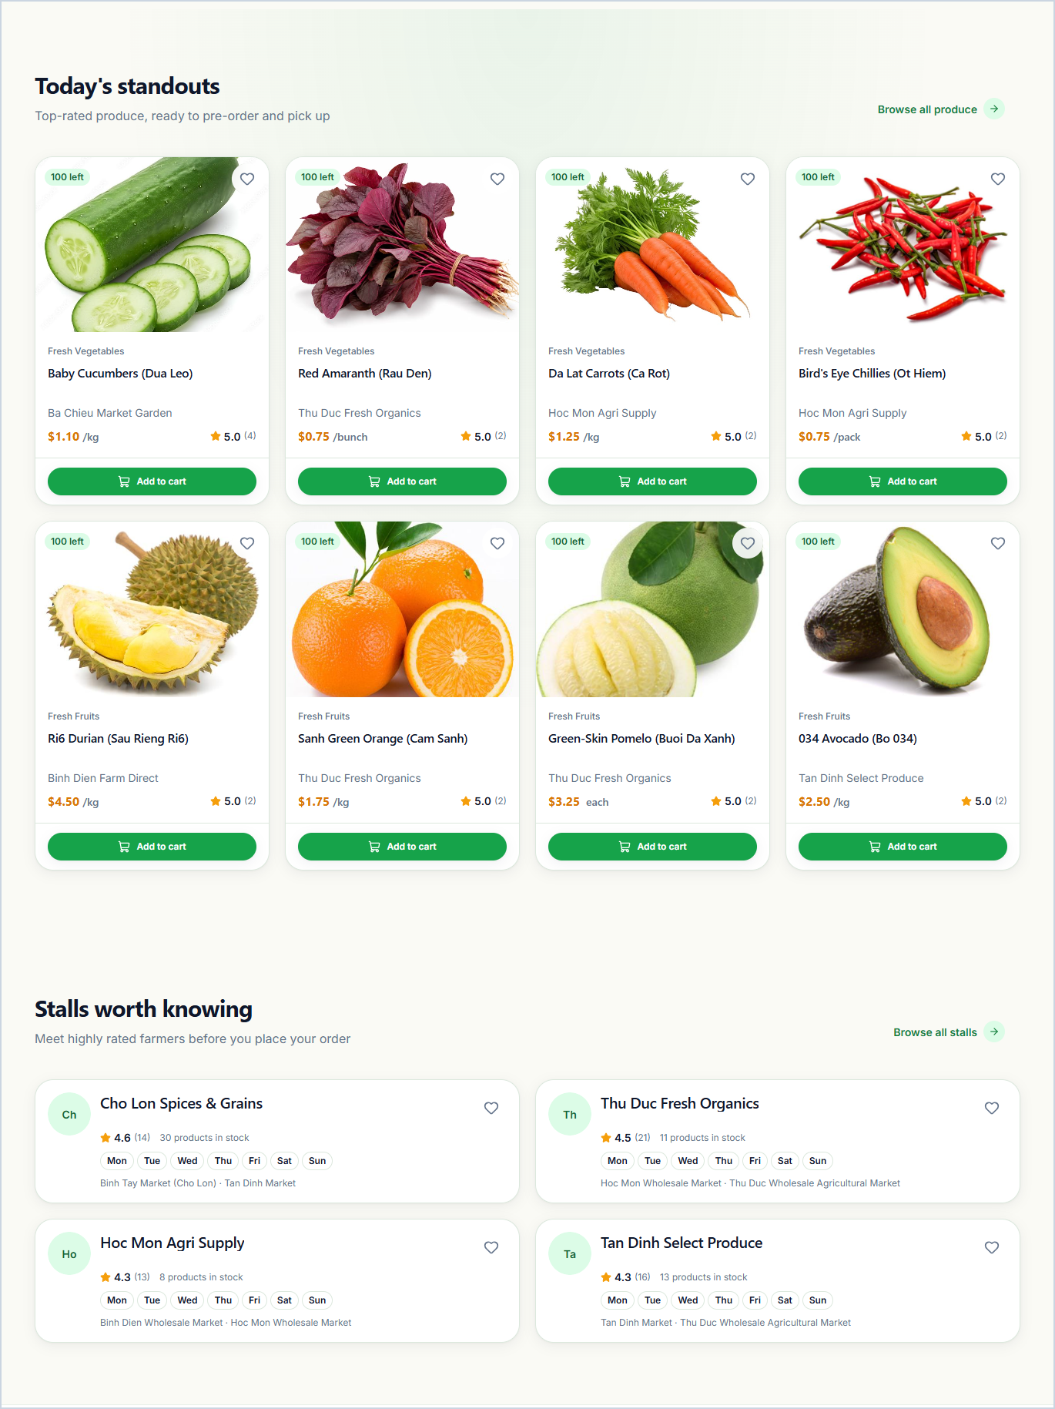  1.1B Home (Part 2) — Today's Standout Produce & Featured Stalls  Showcases top-rated seasonal produce cards with live remaining stock badges, unit prices, stall attribution, and quick 'Add to cart' buttons, followed by featured high-rating farmer stalls.
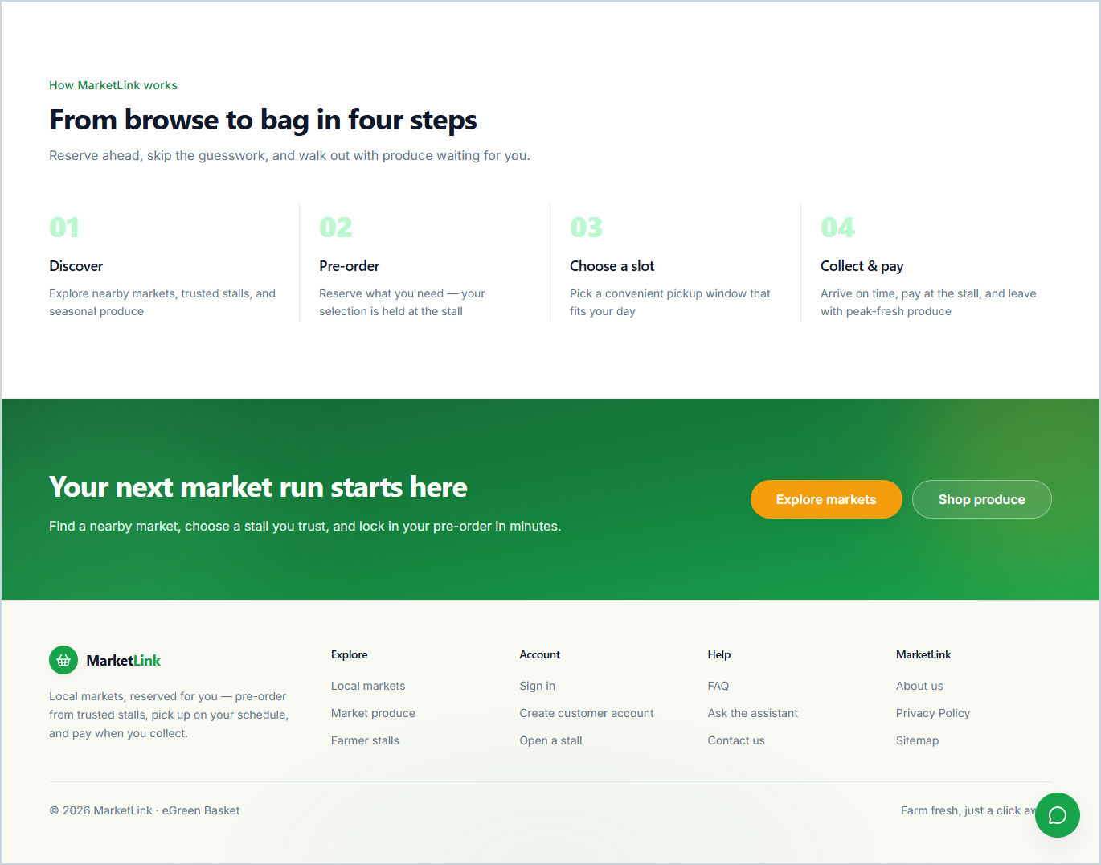  1.1C Home (Part 3) — 4-Step Pre-Order Guide, Call-to-Action & Footer  Explains the 4-step market pickup workflow (01 Discover, 02 Pre-order, 03 Choose a slot, 04 Collect & pay), conversion call-to-action buttons, footer links, and the floating AI Assistant launcher. | 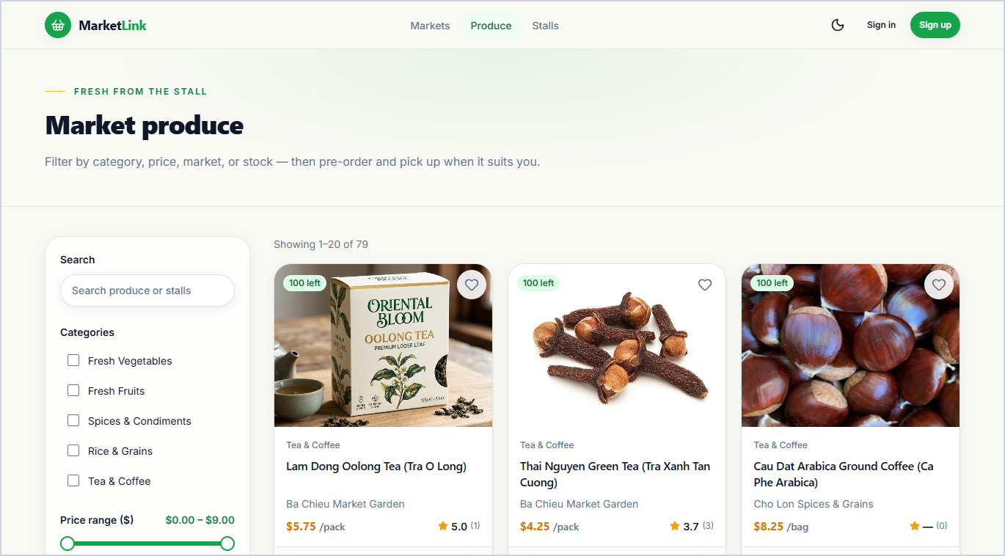  1.2 Browse, Search & Filter Produce Catalog  Workflow: Enter keyword or select Category, Price Range, Market & Day filters -> Sort catalog results -> Click 'Add to cart' or open Product Detail.
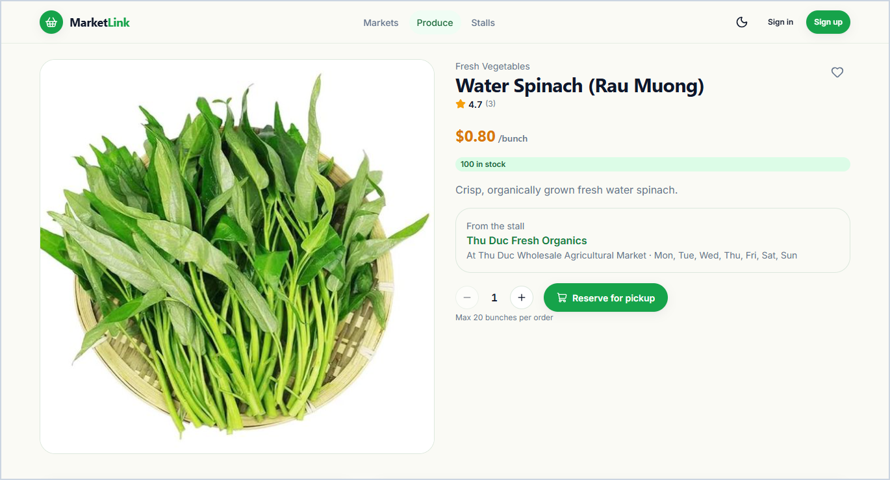  1.3 Product Detail & Pickup Availability  Workflow: Inspect unit price, live stock, stall info, pickup markets & buyer reviews -> Select quantity within allowed limits -> Click 'Add to cart' or Favorite. | 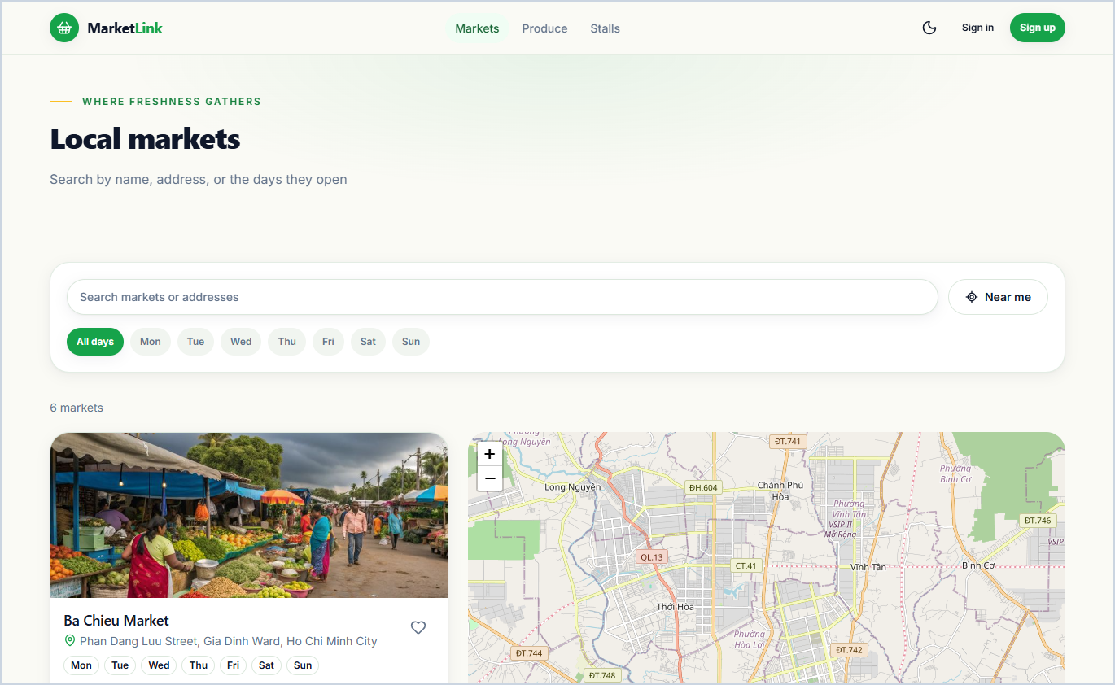  1.4 Browse Local Markets & Interactive Map  Workflow: Filter by opening day or click 'Near me' GPS sort -> Select market pin on interactive map -> Click 'Directions' or open Market Detail.
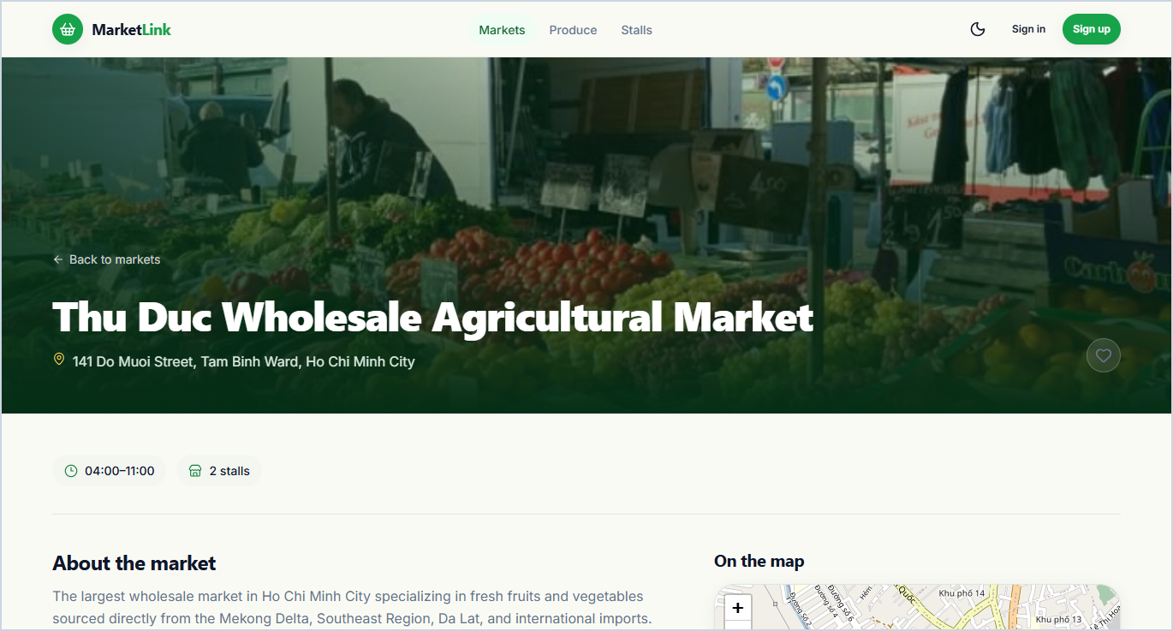  1.5 Market Detail & Participating Stalls  Displays a market's address, operating days and hours, interactive map pin for pickup navigation, and the list of approved farmer stalls trading at that location. | 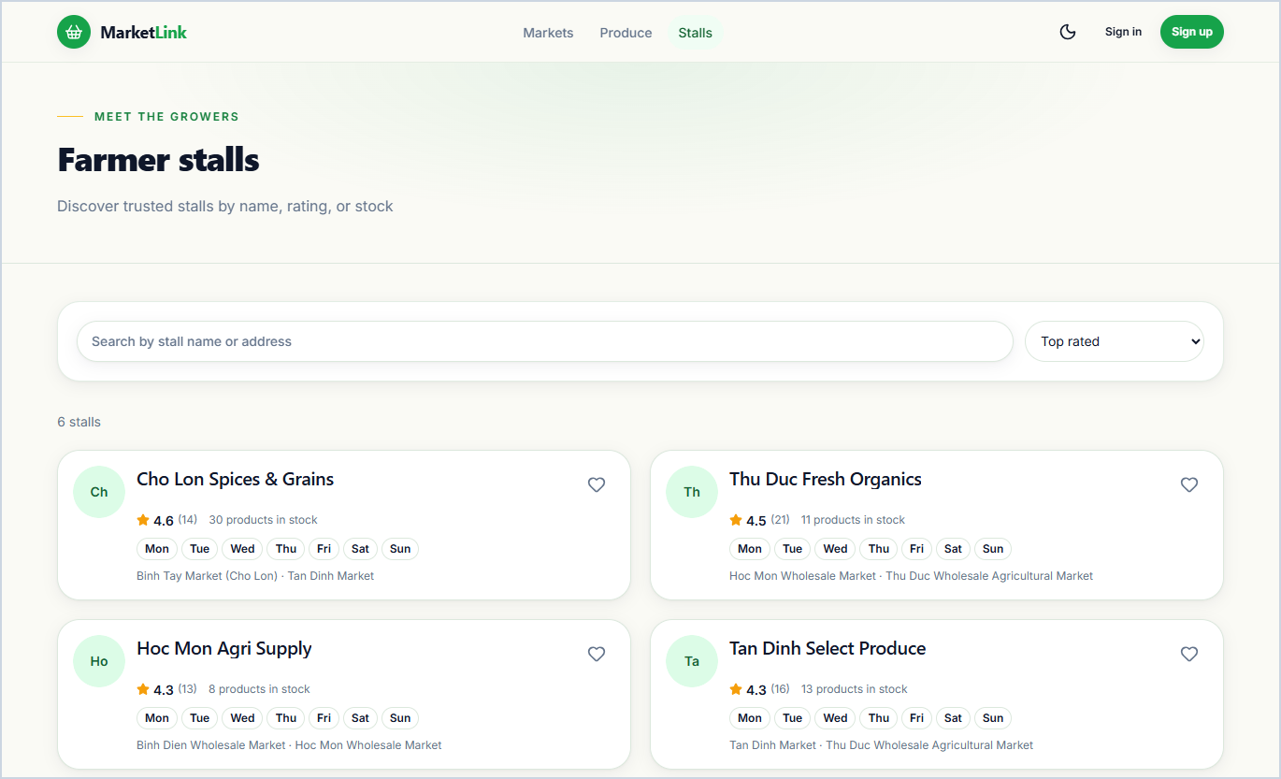  1.6 Farmer Stalls Directory  Workflow: Search stall name or filter by Market, Operating Day & Distance -> Compare stall ratings & active product counts -> Select stall card to view profile.
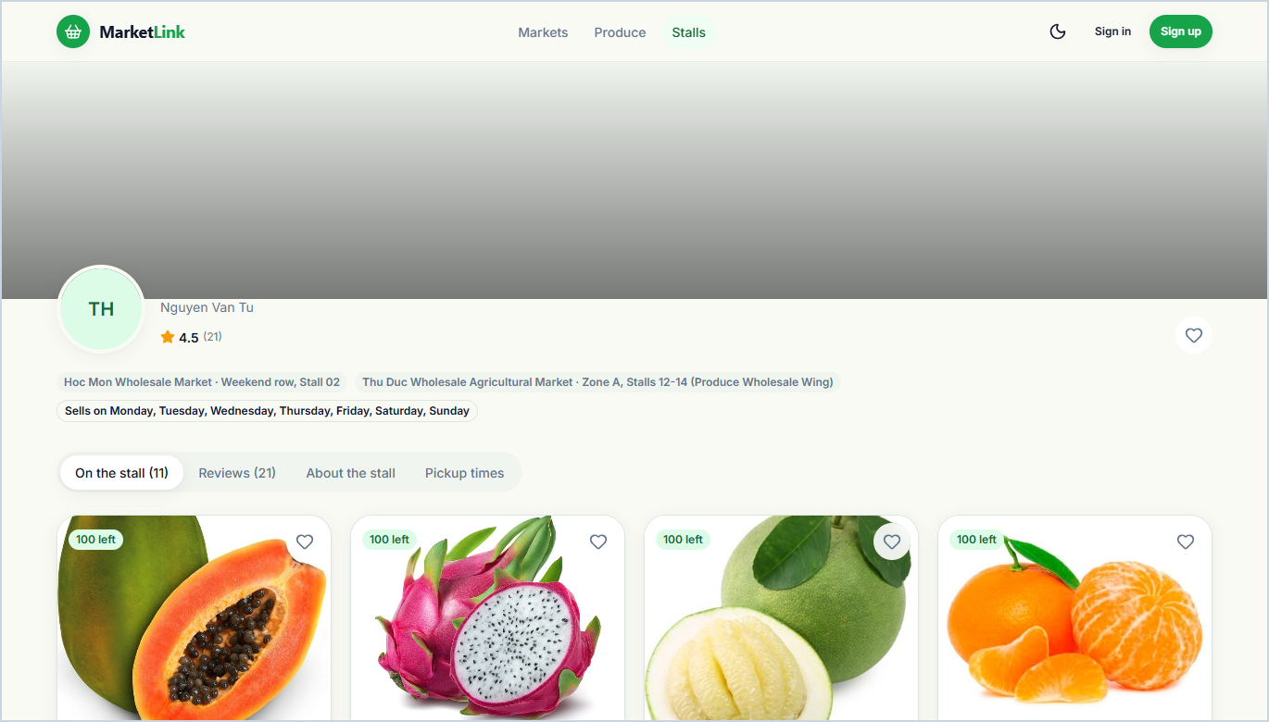  1.7 Farmer Stall Public Profile & Weekly Stock  Public stall storefront presenting farmer bio, operating days, pickup map location, current weekly produce stock available for pre-order, and customer reviews. | 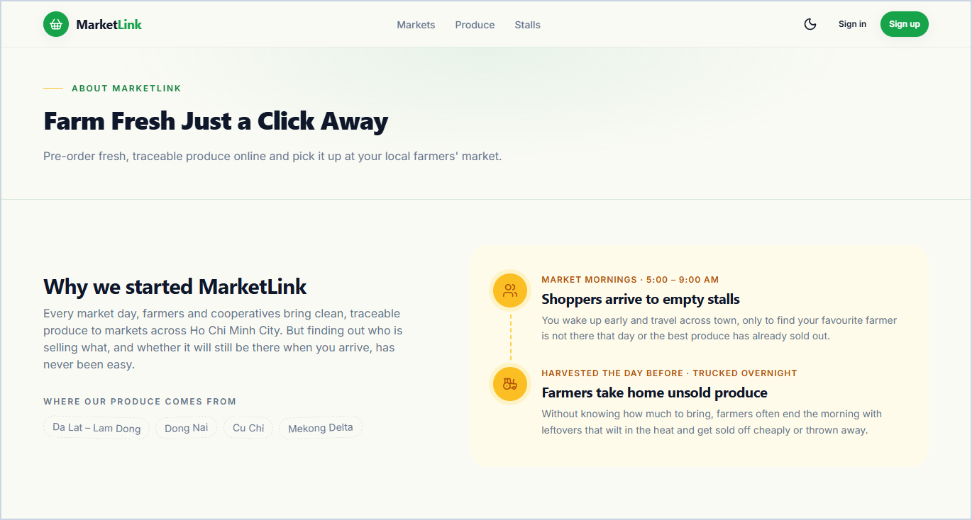  1.8 About Us & Platform FAQ  Presents the MarketLink mission, community impact metrics, development team profiles, and an interactive FAQ accordion answering common pre-order questions.
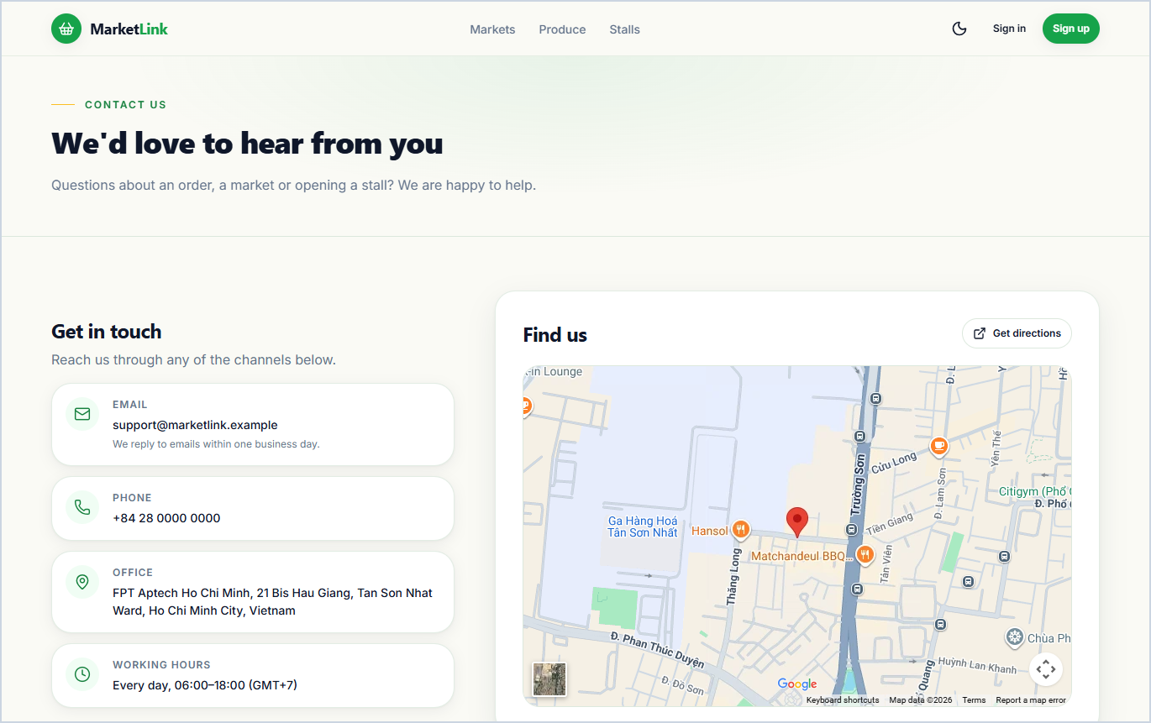
1.9 Contact Us & Team Map Location
Workflow: View static team contact info & embedded headquarters map -> Fill Name, Email, Subject & Message -> Submit inquiry to receive confirmation.

2. Authentication & Role-Based Registration (02-auth/)
Core SRS 1.6 — Customer & Farmer Sign-In, Customer Sign-Up, Farmer Stall Application & Dedicated Admin Portal
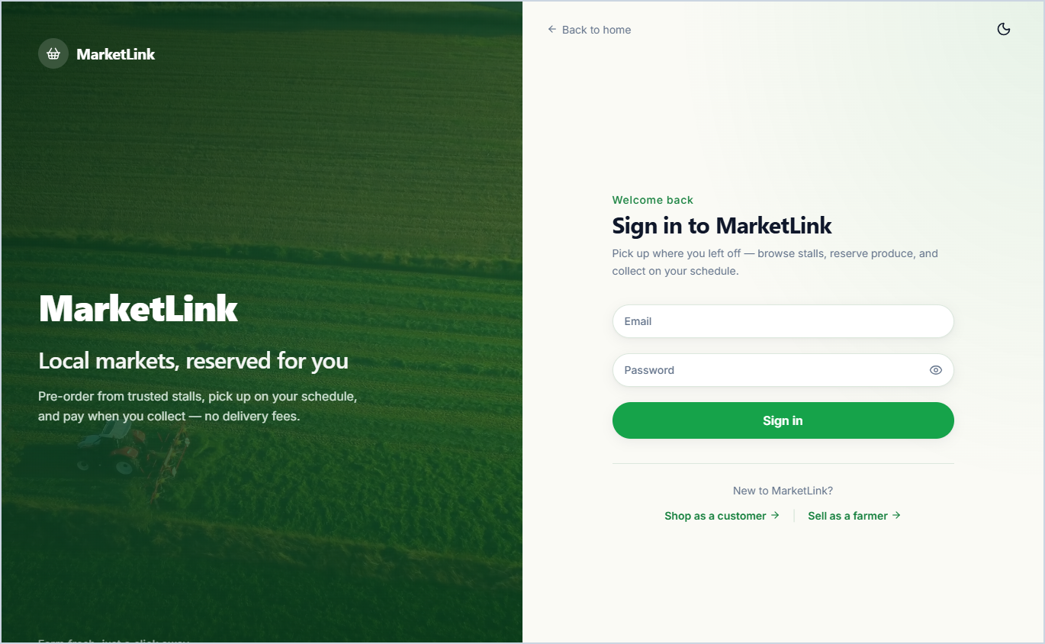  2.1 Customer & Farmer Sign In  Workflow: Enter registered email & password -> Submit sign-in form -> Authenticate credentials & role -> Redirect to Customer or Farmer Dashboard. | 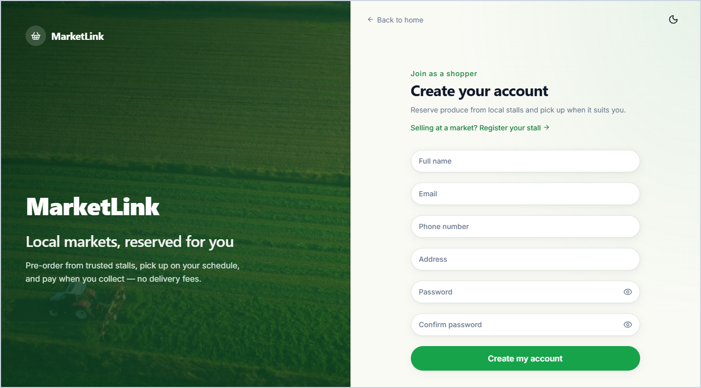  2.2 Customer Account Registration  Workflow: Enter Full Name, Contact Number, Email, Address & Password -> Submit registration -> Create active account -> Redirect to Customer Dashboard.
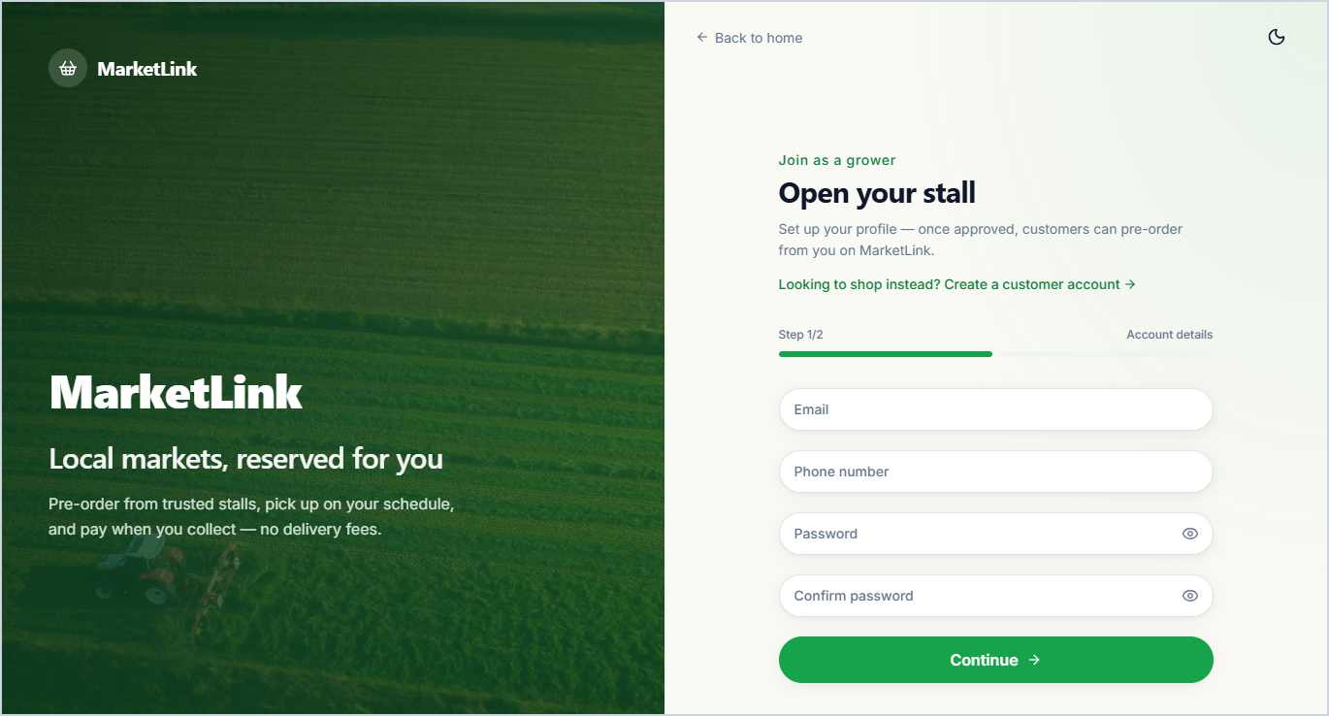  2.3 Farmer Stall Registration  Workflow: Fill Stall Name, Contact Person, Phone, Email, Address & Operating Days -> Pin stall location on map -> Submit application -> Enter pending admin approval. | 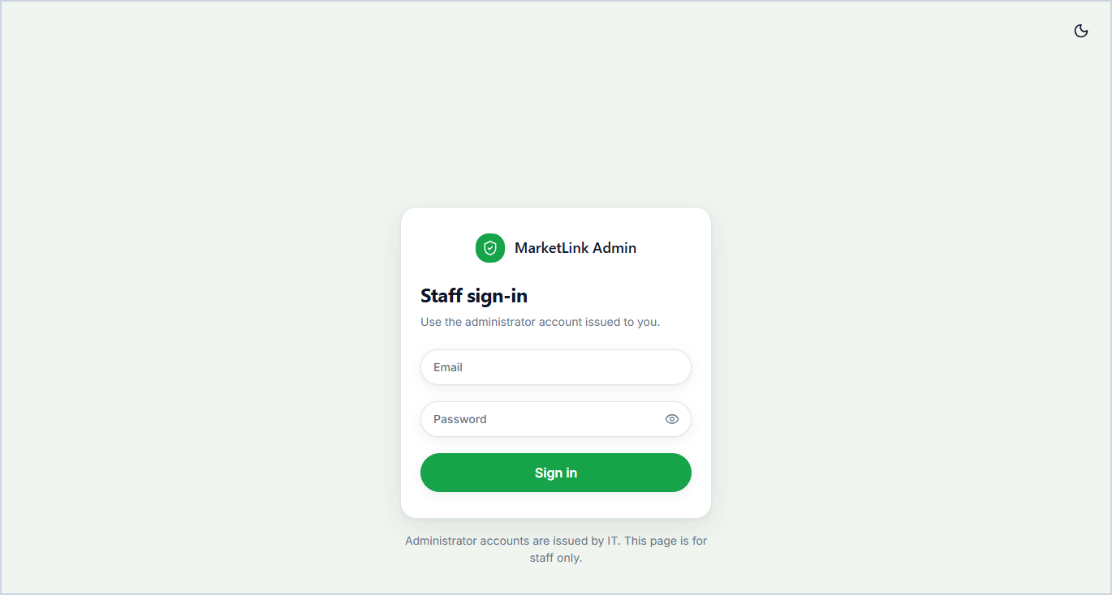  2.4 Dedicated Administrator Sign In  Workflow: Open isolated /admin/login portal -> Enter administrator credentials -> Verify elevated role -> Redirect to Admin Control Dashboard.

3. Customer Portal — Core Screens (03-customer/)
Core SRS 1.6 — Dashboard, Pre-Order Cart & Pickup Slot Checkout, Order Management, Reviews, Favorites & Alerts
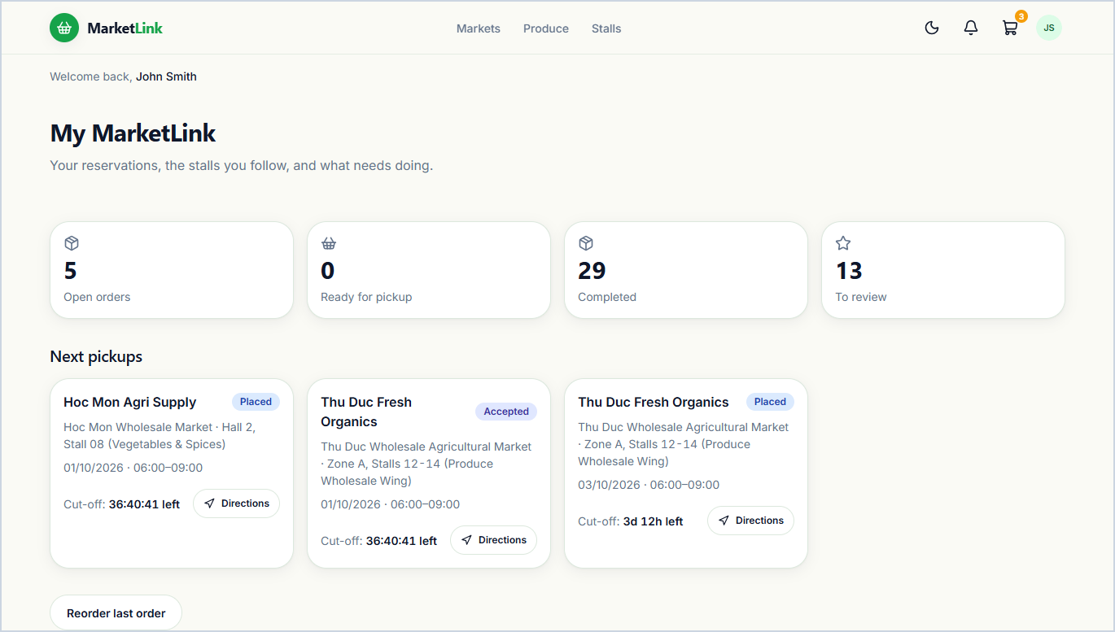  3.1 Customer Dashboard & Quick Reorder  Personal shopper hub summarizing upcoming market pickups, active order counters, one-click 'Order Again' items from past purchases, saved favorites, and recent notifications. | 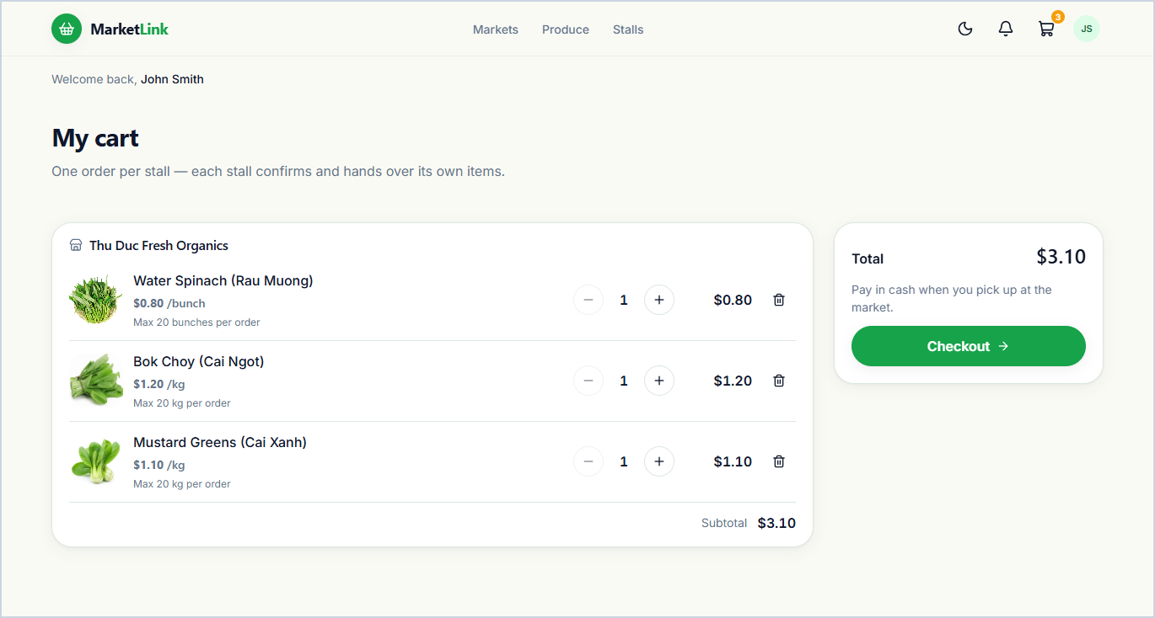  3.2 Pre-Order Shopping Cart  Workflow: Review items grouped by farmer stall -> Adjust quantities within live stock & per-order limits -> Verify stall subtotals -> Click 'Proceed to checkout'.
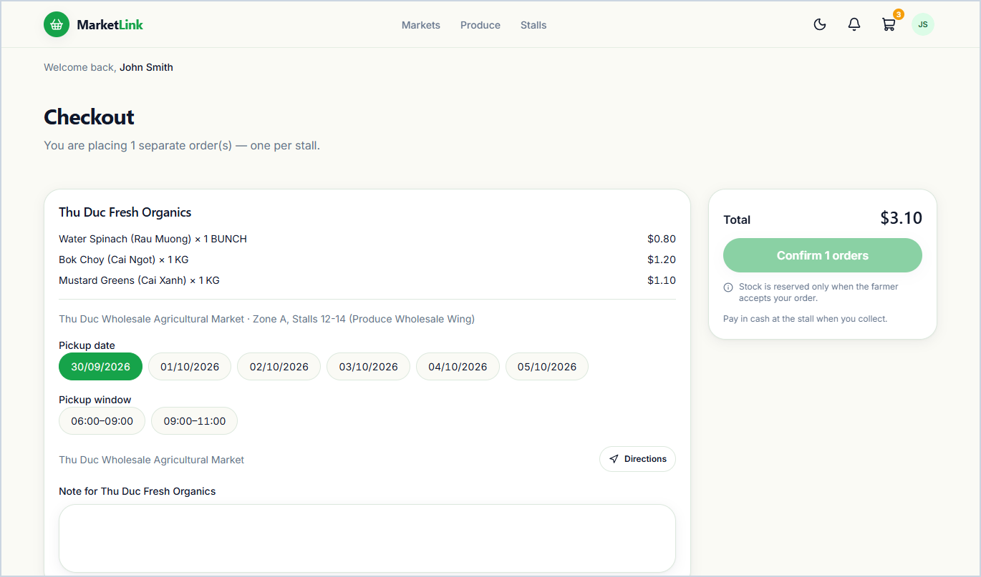  3.3 Pre-Order Checkout & Pickup Slot Selection  Workflow: Select pickup market, date & farmer time window for each stall -> Add optional note -> Confirm cash-at-pickup pre-order -> Reserve stock & notify farmer. | 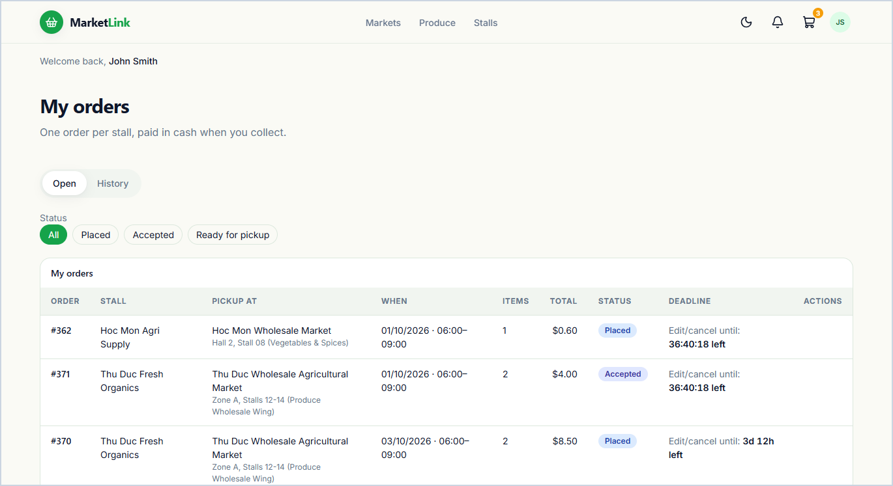  3.4 My Orders & Order History  Displays all current and past pre-orders organized by status tabs (Placed, Accepted, Ready for Pickup, Completed, Cancelled) with quick reorder shortcuts.
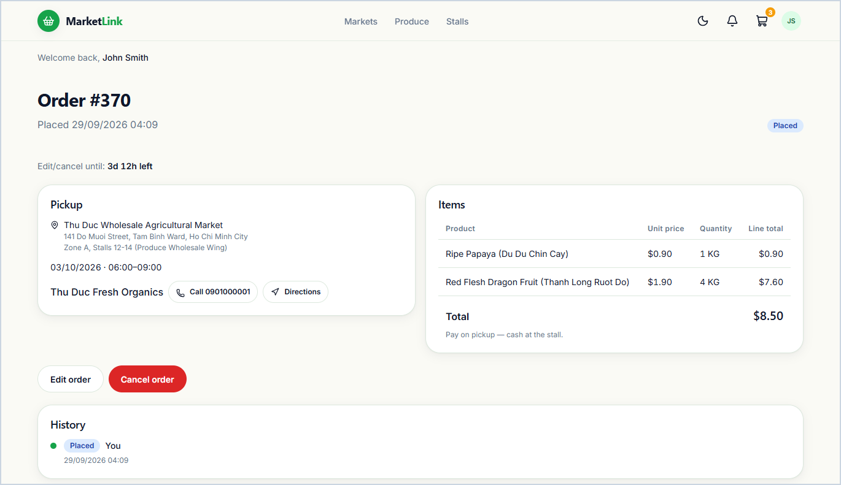  3.5 Customer Order Detail & Pickup Route  Shows full order status history, reserved items, stall pickup coordinates with route directions, cut-off countdown, and allowed edit/cancel actions. | 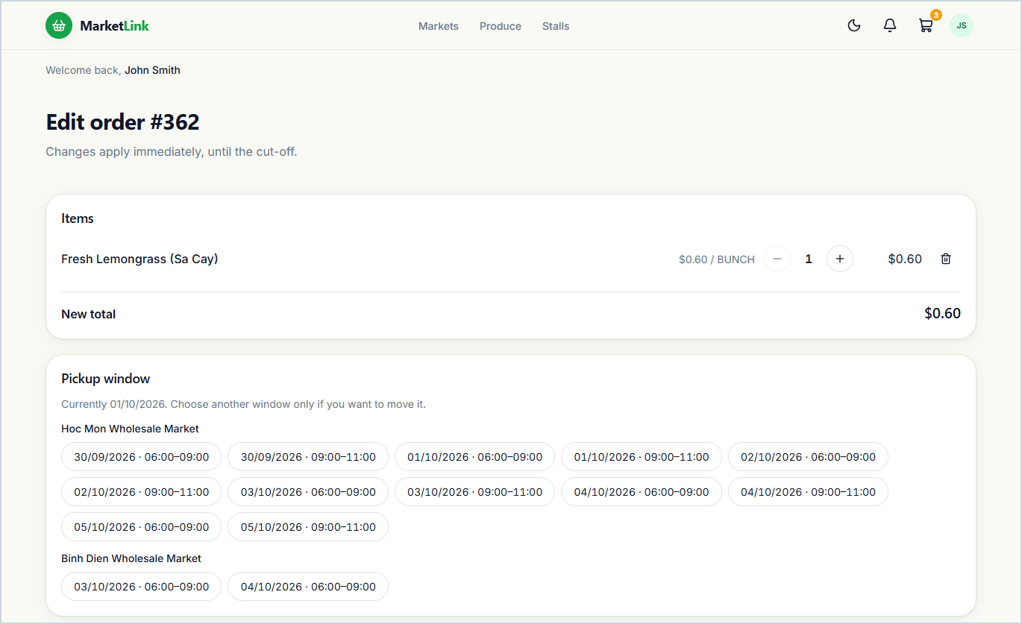  3.6 Modify Pre-Order Before Cut-Off  Workflow: Adjust item quantities, pickup slot, or note before cut-off -> Submit changes -> Apply immediately (if Placed) or send change request to farmer (if Accepted).
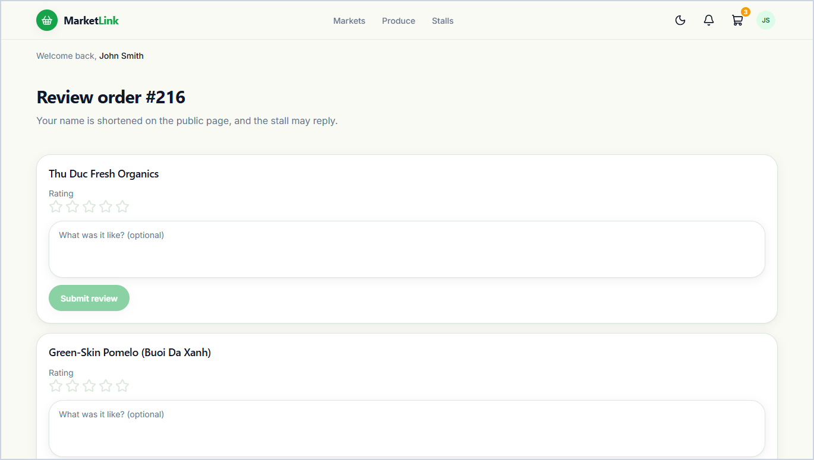  3.7 Rate & Review Completed Order  Workflow: Open completed order -> Assign 1–5 star ratings & written comments for the stall and individual products -> Submit review -> Publish on public storefront. | 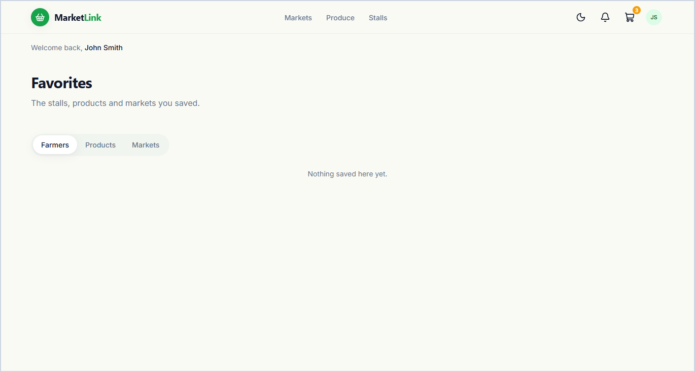  3.8 Saved Favorites & Restock Watchlist  Workflow: Switch between saved Products, Stalls & Markets tabs -> Add available items to cart or remove bookmarks -> Receive automatic alerts when restocked.
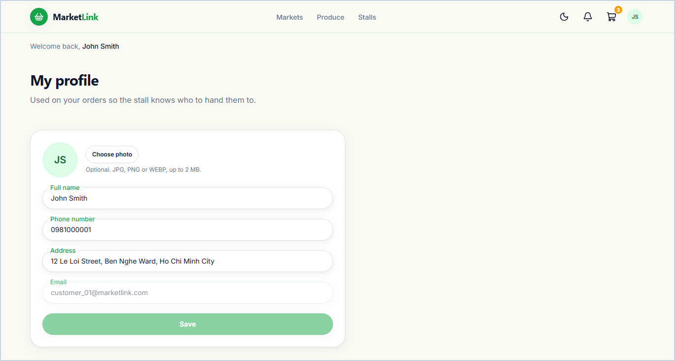  3.9 Customer Profile Management  Workflow: Edit full name, contact phone, default address, or avatar photo -> Click 'Save changes' -> Update profile & nearby market location defaults. | 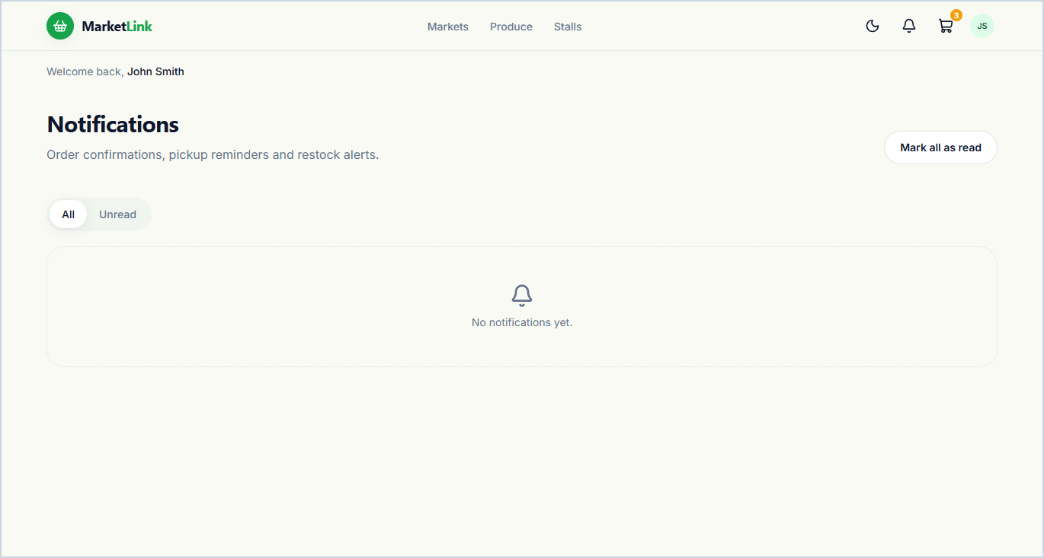  3.10 Customer In-App Notification Center  Real-time alert inbox notifying customers when orders are confirmed, marked ready for pickup, modified, or when favorite produce is back in stock.

4. Farmer Portal — Core Screens (04-farmer/)
Core SRS 1.6 — Stall Overview, Pre-Order Fulfillment, Weekly Stock Template, Pickup Windows, Reviews & Sales Insights
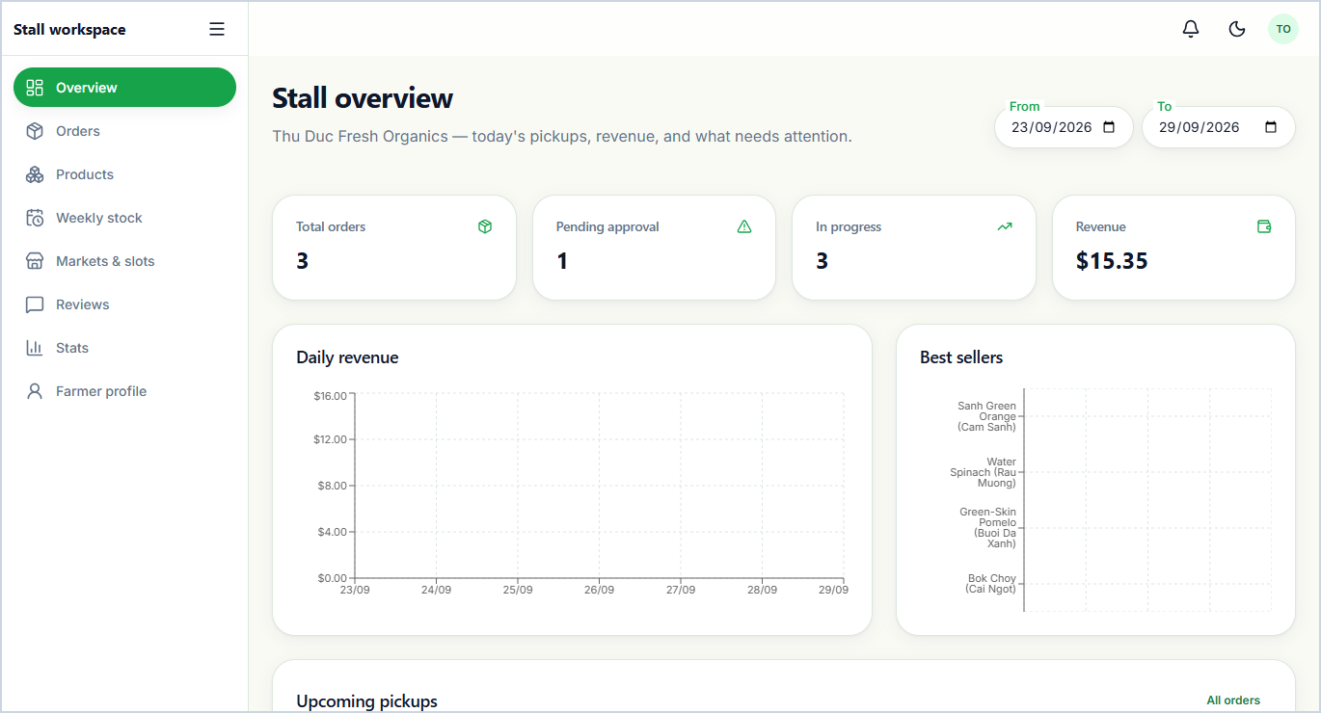  4.1 Farmer Stall Overview & KPI Summary  Operational dashboard displaying Total Orders, Pending Orders, In-Progress Orders, and Revenue Summary, alongside daily sales trends, best sellers, and upcoming pickups. | 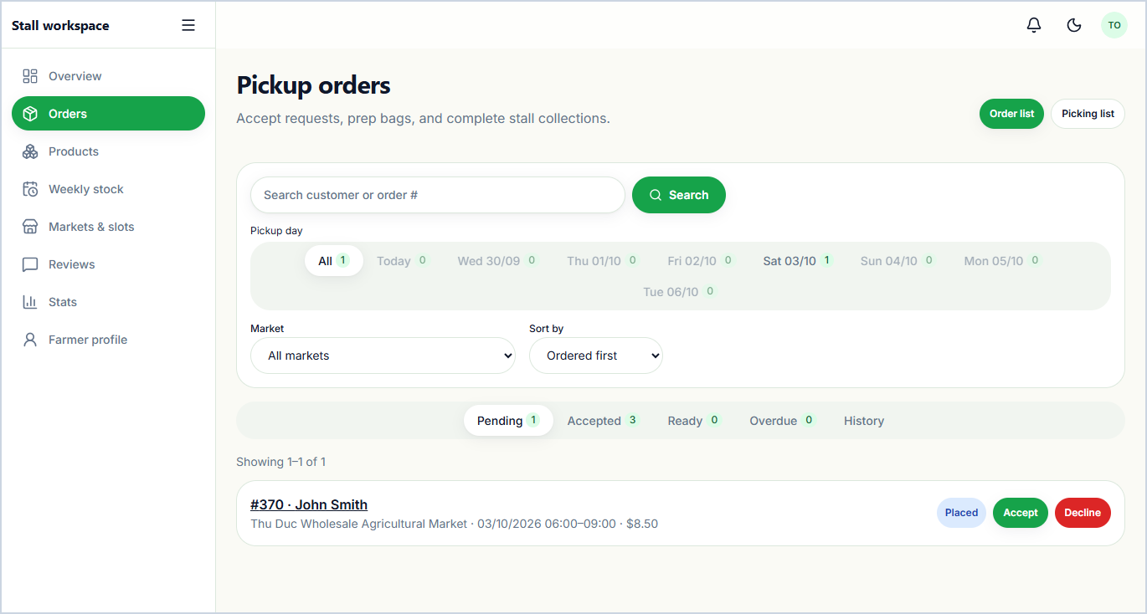  4.2 Manage Incoming Pre-Orders & Picking List  Workflow: Open 'New' tab -> Accept or Decline incoming pre-order -> Pack items using aggregated Picking List -> Mark 'Ready for Pickup' -> Mark 'Completed' at pickup.
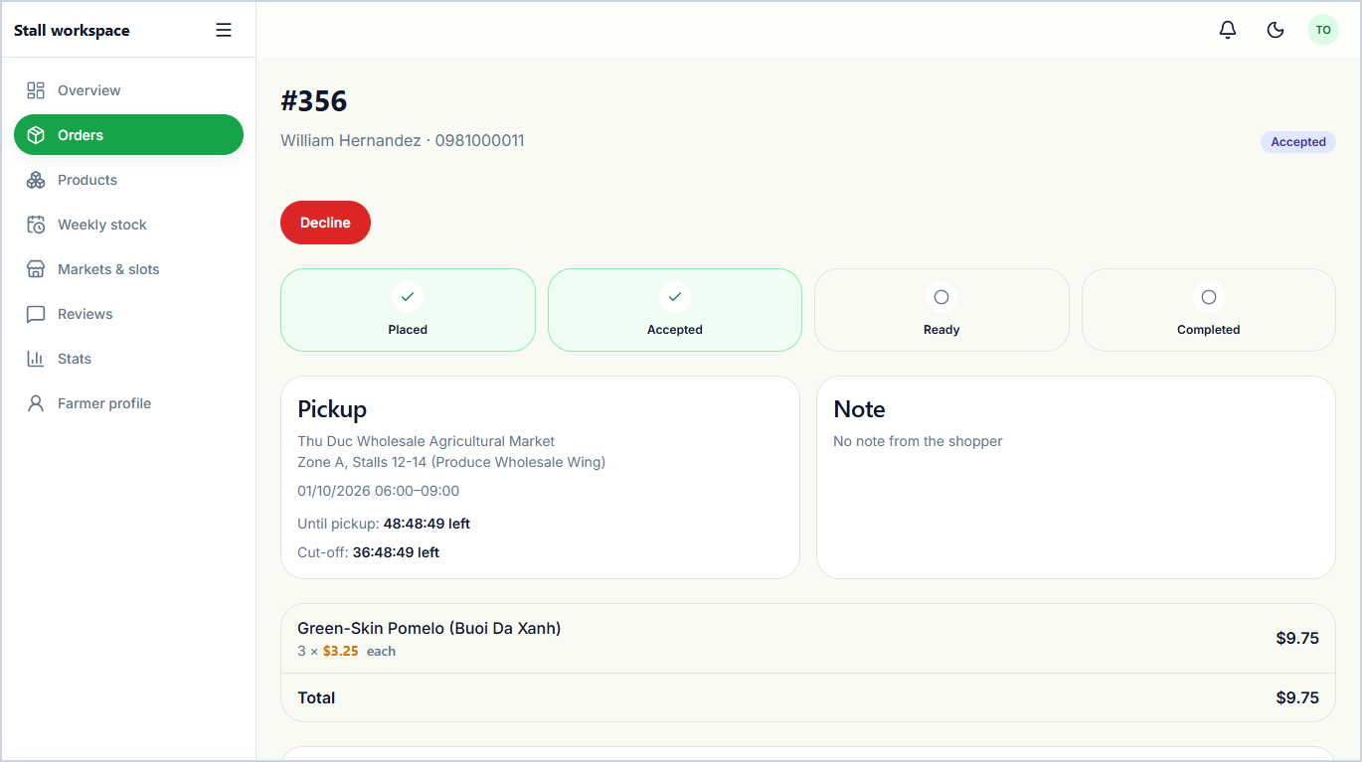  4.3 Farmer Pre-Order Detail & Change Approval  Workflow: Inspect customer details, reserved items & pickup slot -> Approve or reject pending customer change request -> Advance order status & notify shopper. | 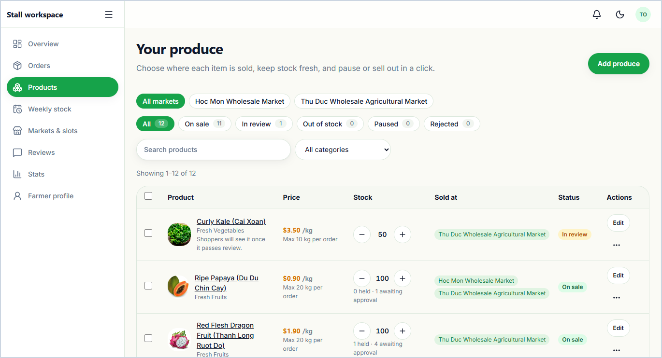  4.4 Manage Stall Products & Availability  Workflow: Filter inventory by market or status -> Toggle 'Sold Out' / 'Pause' or run bulk actions -> Click 'Edit' or 'Add product' to update catalog.
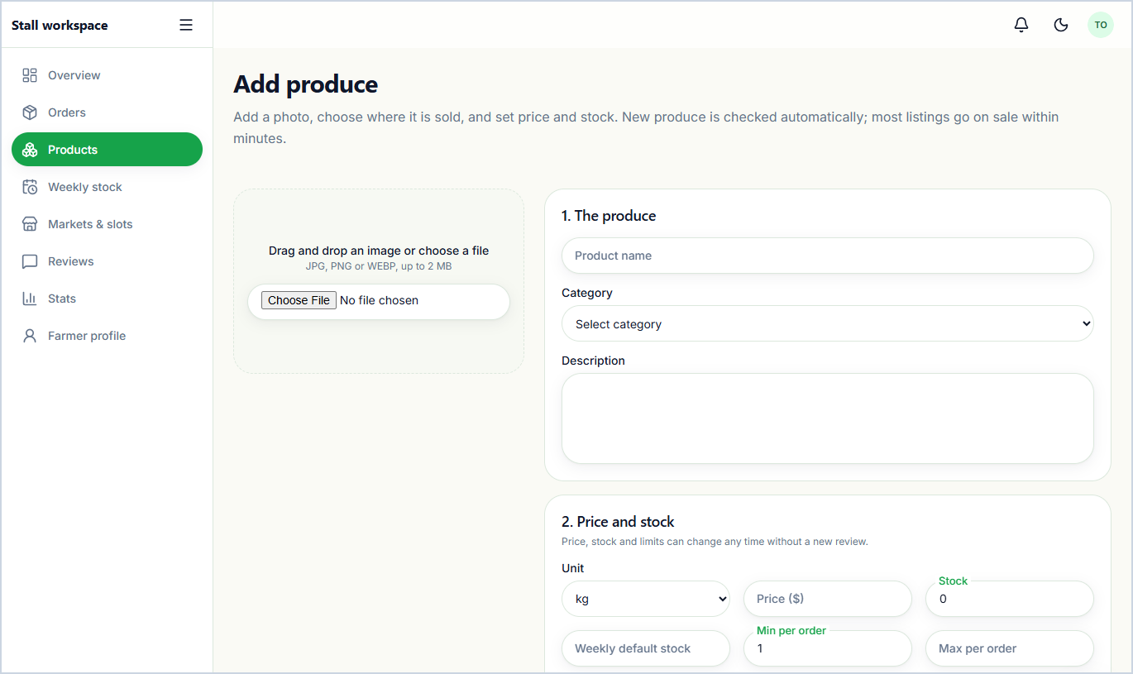  4.5 Add New Product Listing  Workflow: Enter Name, Category, Price, Unit, Stock & Description -> Upload product photo & select selling markets -> Submit listing -> Pass moderation & publish. | 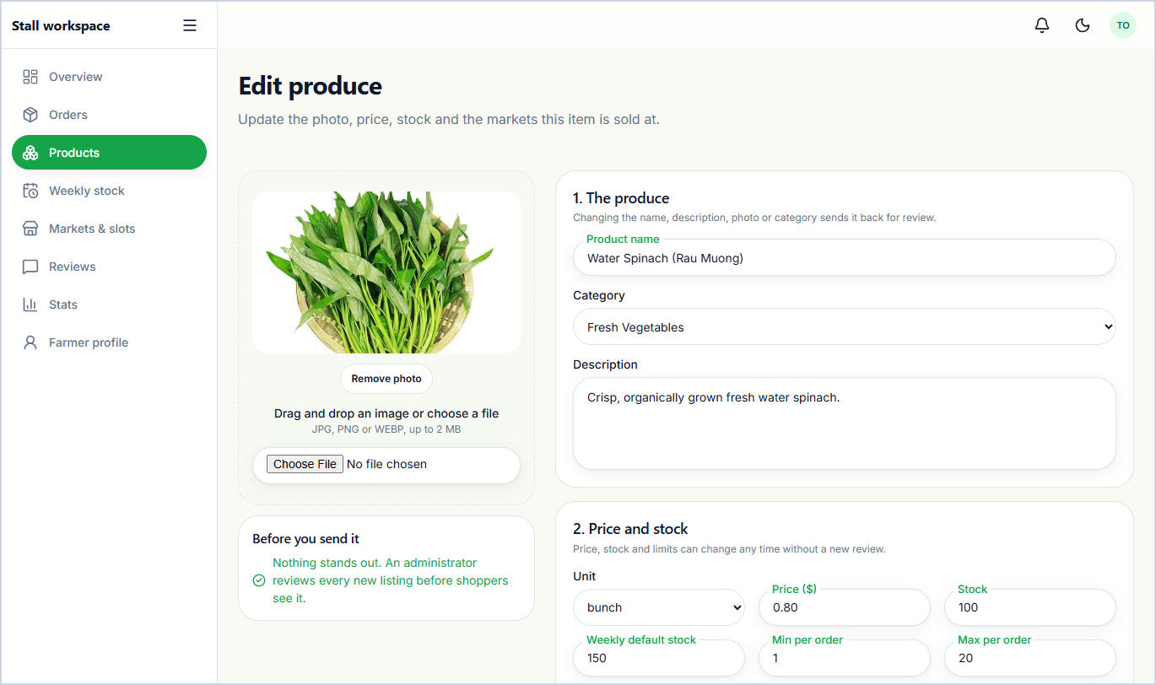  4.6 Edit Existing Product Listing  Workflow: Modify product price, available quantity, description, markets, or photo -> Click 'Save changes' -> Update live storefront inventory.
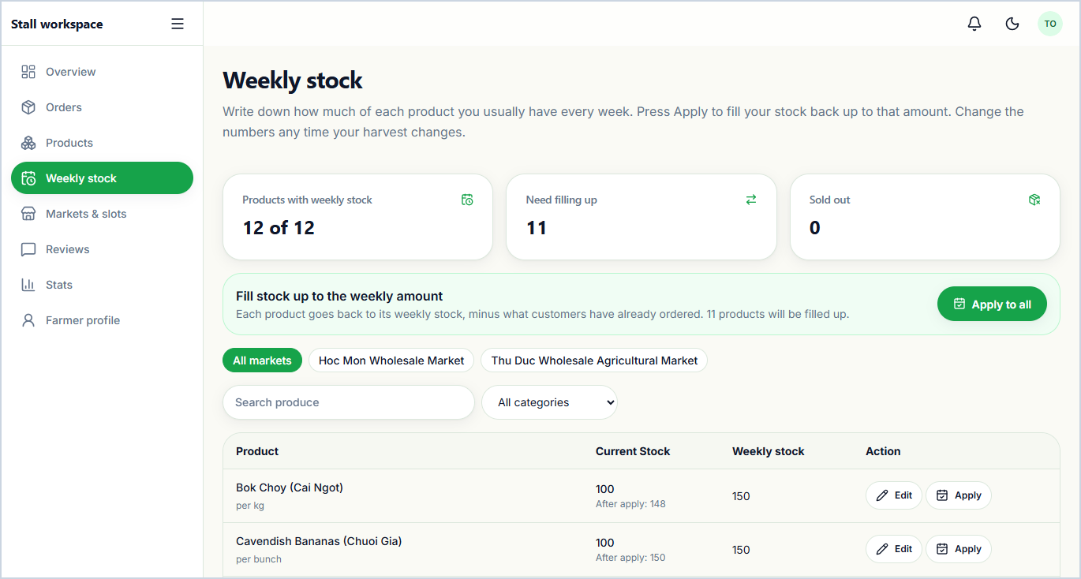  4.7 Recurring Weekly Stock Template  Workflow: Set default weekly harvest quantities per product -> Adjust for seasonal changes -> Click 'Apply to stock' (single, filtered, or all) to reset weekly stock. | 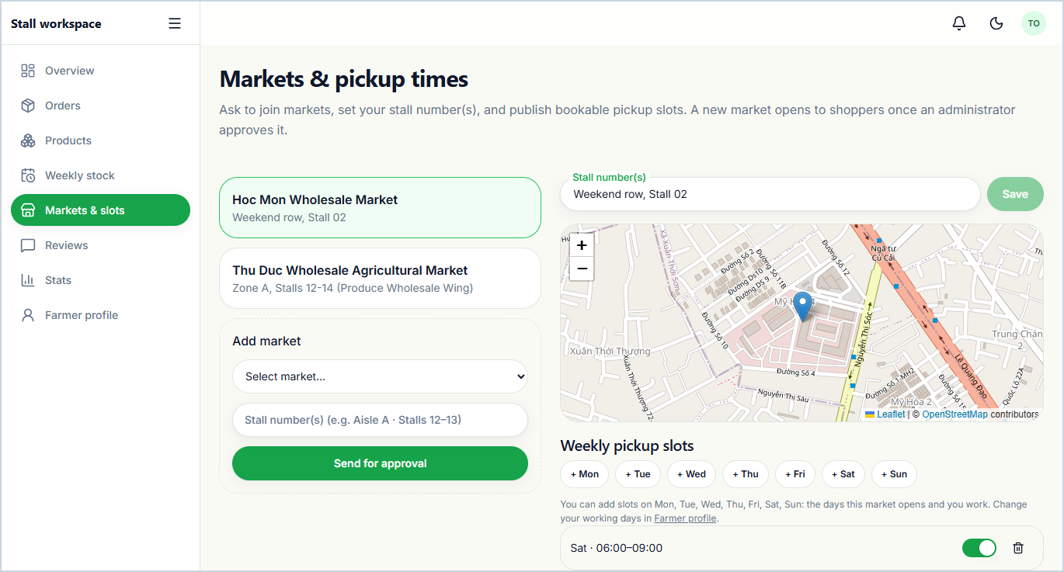  4.8 Manage Markets, Cut-Offs & Pickup Slots  Workflow: Select approved market -> Configure bookable pickup time windows & slot capacities -> Request to join additional market -> Save schedule.
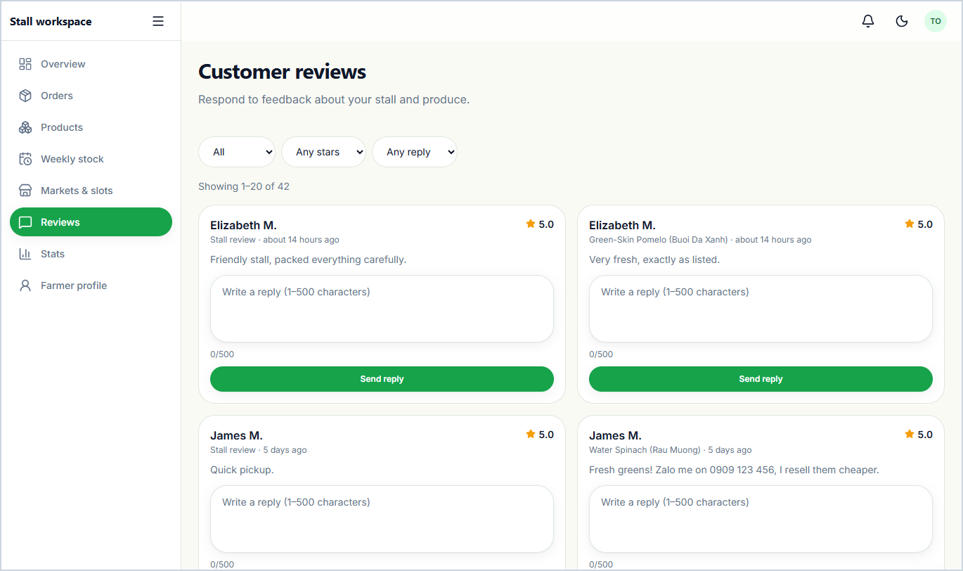  4.9 Customer Reviews & Farmer Responses  Workflow: Filter reviews by star rating or product -> Read verified buyer comment -> Write & submit official stall reply -> Display response publicly. | 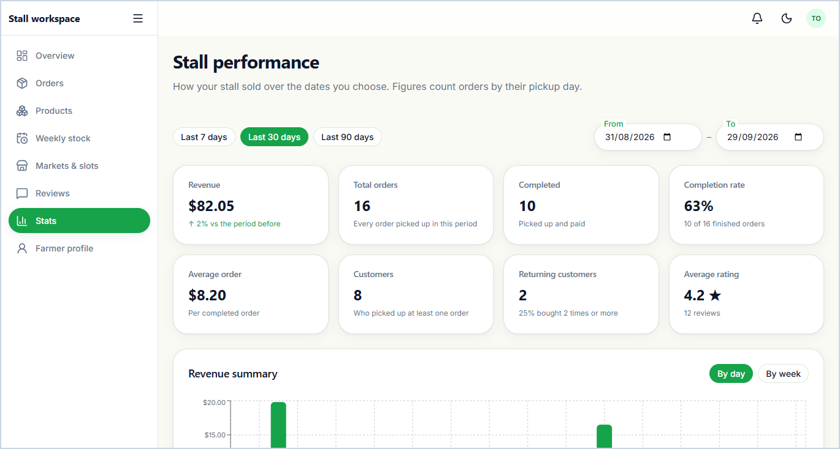  4.10 Farmer Sales History & Performance Insights  Analytics dashboard showing period-over-period revenue comparisons, order completion rates, busiest pickup days, sales by market, and best-selling produce.
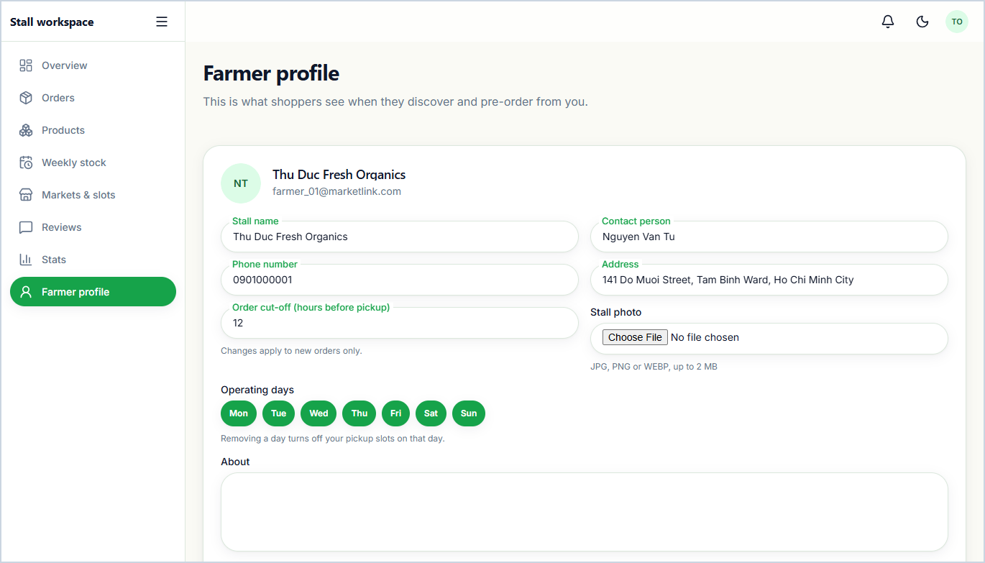
4.11 Farmer Stall Profile & Geolocation Setup
Workflow: Update stall name, contact info, operating days & cut-off lead hours -> Drag map pin to set exact latitude/longitude -> Save profile.

5. Administrator Portal — Core Screens (06-admin/)
Core SRS 1.6 — Admin Dashboard, Manage Farmers/Customers, Manage Markets, Content Moderation, Reports & System Config
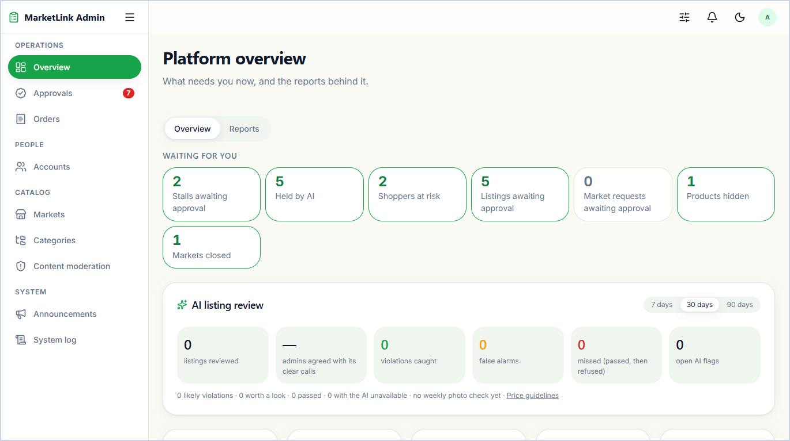  5.1 Administrator Overview Dashboard  Summarizes key platform metrics (Total Farmers, Total Customers, Total Markets, Total Orders, Gross Revenue) alongside urgent approval and moderation queues. | 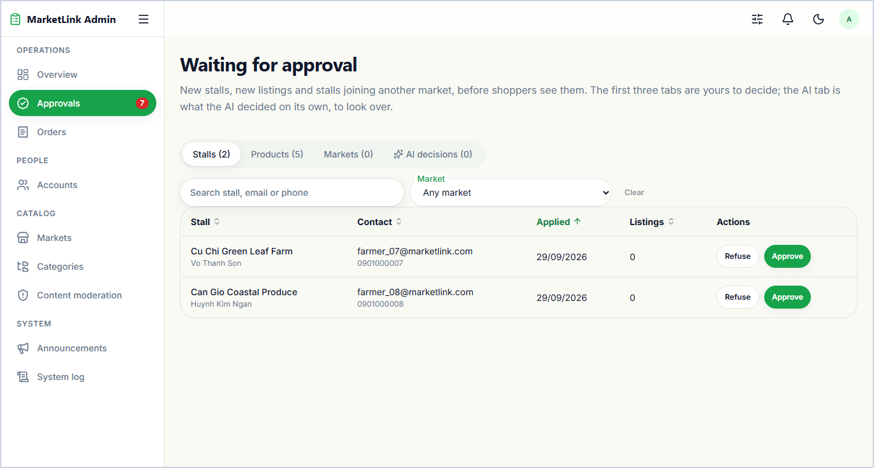  5.2 Pending Approvals Queue (Stalls, Markets & Listings)  Workflow: Select Stalls, Market Requests, or Listings tab -> Inspect applicant details -> Click 'Approve' or 'Reject' with reason -> Notify farmer & log action.
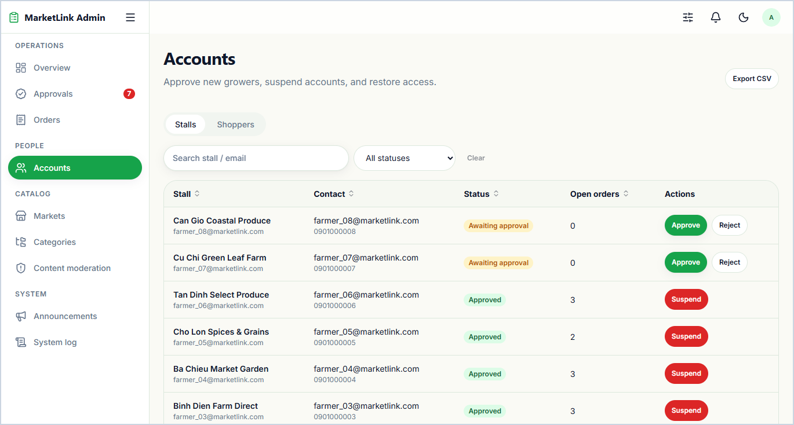  5.3 Manage Farmers (Stalls) Directory  Workflow: Search or filter farmer accounts by status (Approved, Pending, Suspended) -> Click 'Approve', 'Suspend', or 'Reinstate' -> Enforce storefront access. | 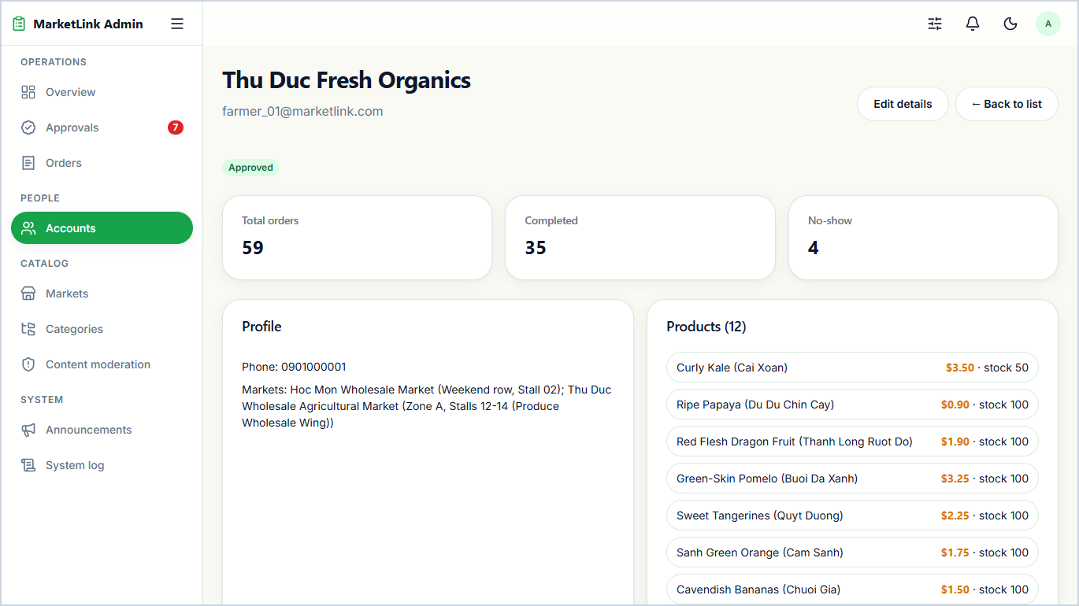  5.4 Administrator Farmer Stall Detail  Detailed inspection view of a farmer's profile, assigned markets, product listings, order fulfillment metrics, and administrative status history.
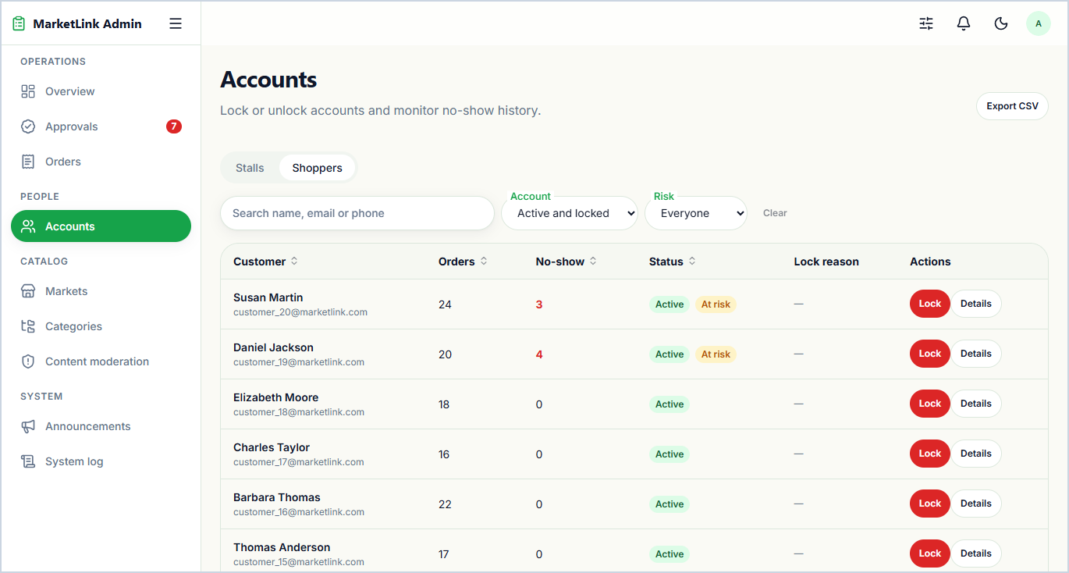  5.5 Manage Customers Directory  Workflow: Search customer list or filter by account status -> Identify policy violations or repeated missed pickups -> Click 'Deactivate' or 'Activate' account. | 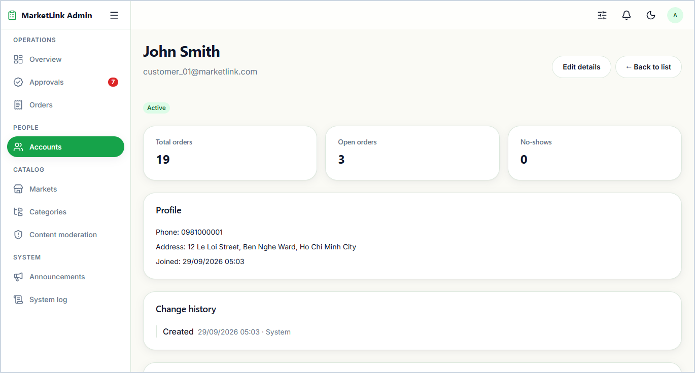  5.6 Administrator Customer Detail  Displays a customer's contact details, complete pre-order history, missed-pickup strike counter, and account activation/deactivation controls.
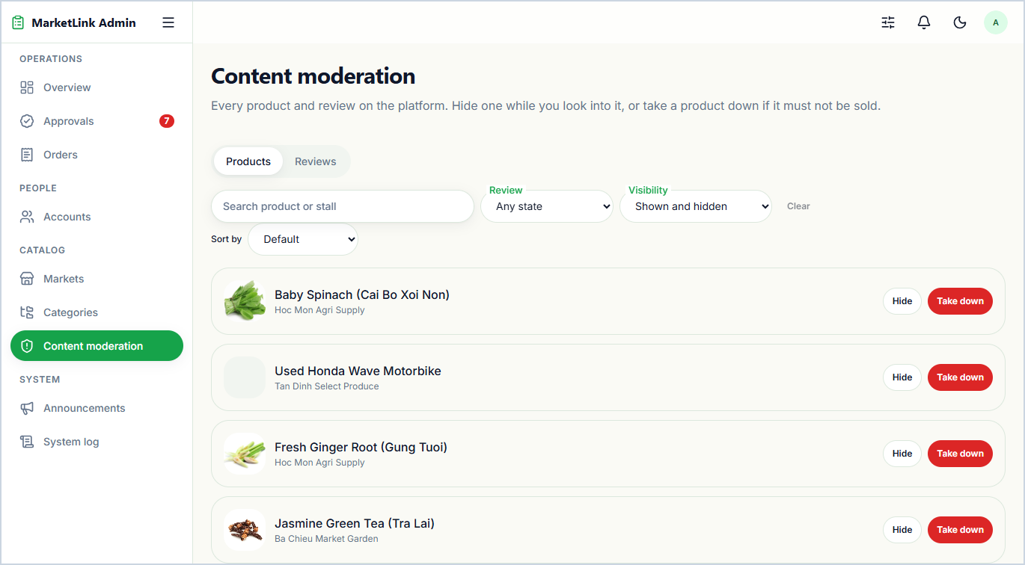  5.7 Content Moderation (Products & Reviews)  Workflow: Switch between Products and Reviews tabs -> Filter flagged content -> Click 'Hide', 'Restore', or 'Take Down' with reason -> Remove violating item. | 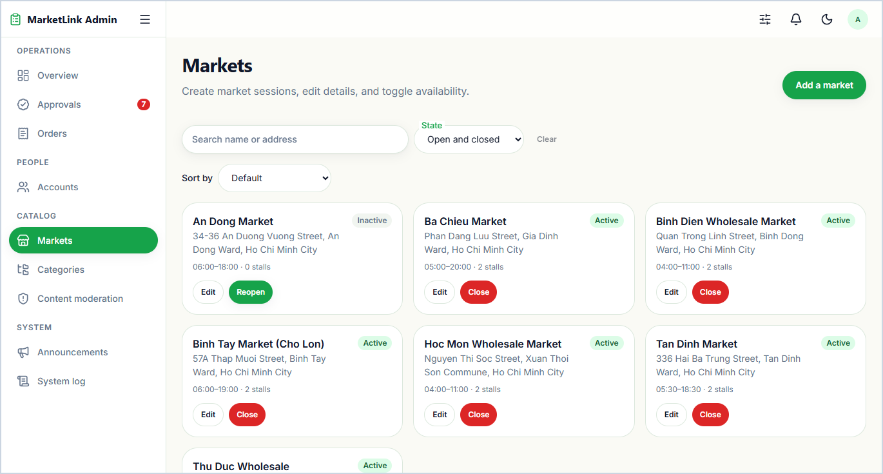  5.8 Manage Farmers Markets Directory  Workflow: Browse or search markets list -> Click 'Add market', 'Edit', or toggle active status -> Update public market directory.
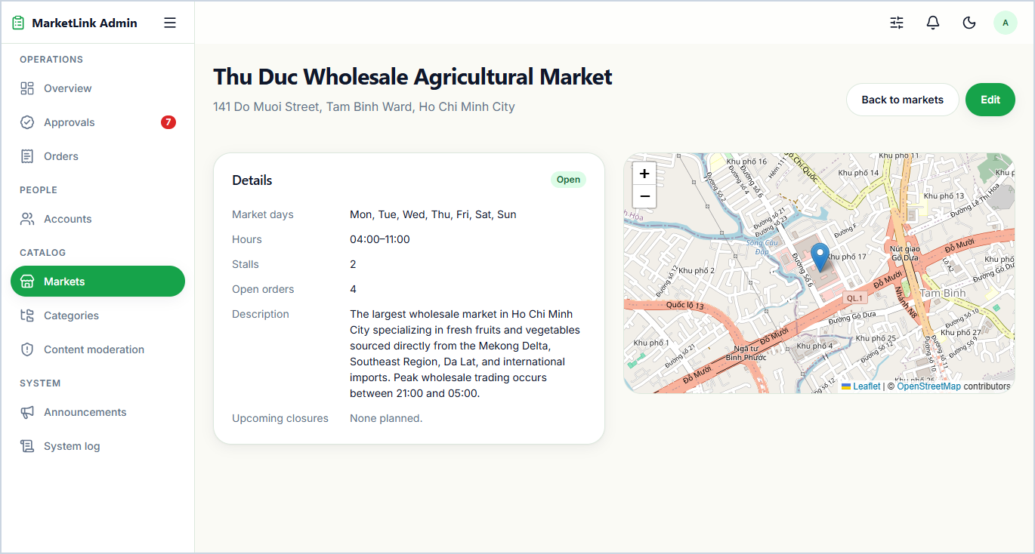  5.9 Administrator Market Detail & Stall Roster  Shows a market's operating schedule, GPS coordinates, embedded map preview, and the roster of farmer stalls approved or requesting to trade there. | 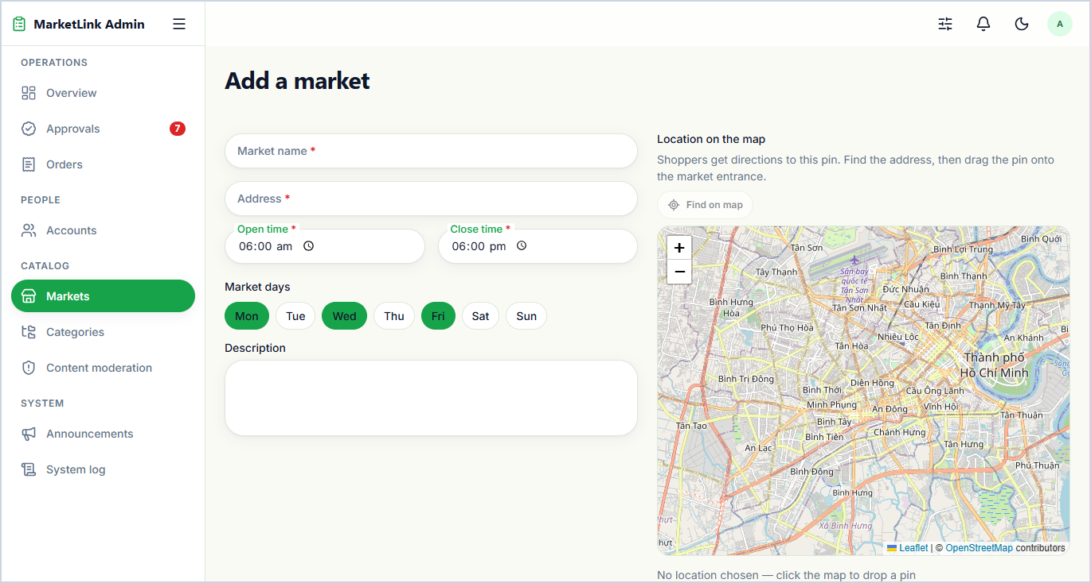  5.10 Add New Farmers Market  Workflow: Enter Market Name, Address, Operating Days & Timings -> Click map to set latitude/longitude coordinates -> Submit form to publish market.
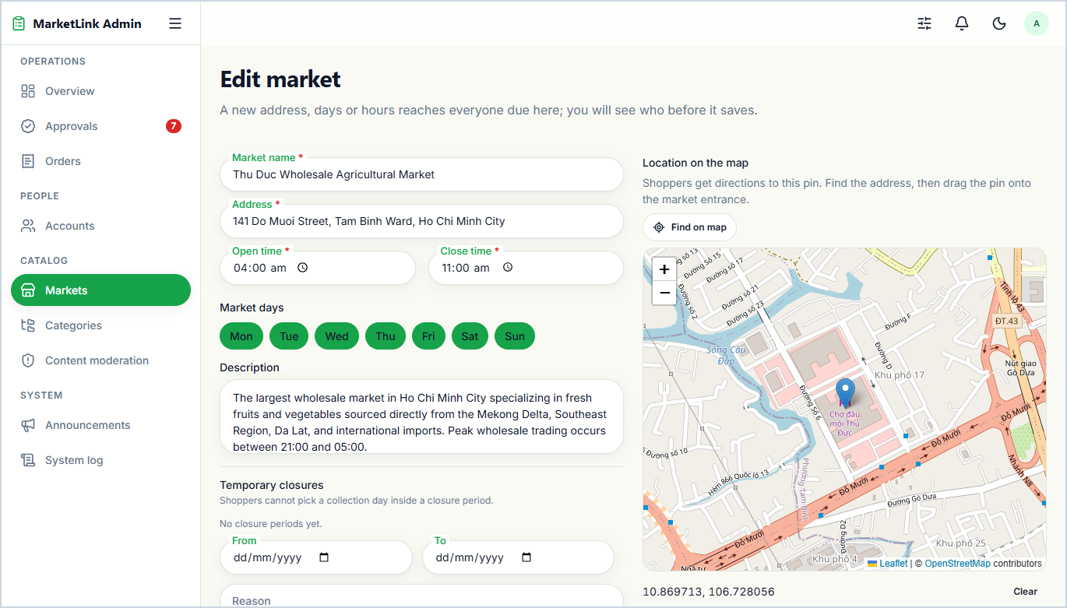  5.11 Edit Existing Farmers Market  Workflow: Update market timings, operating days, address, photo, or map pin coordinates -> Click 'Save changes' -> Synchronize across platform. | 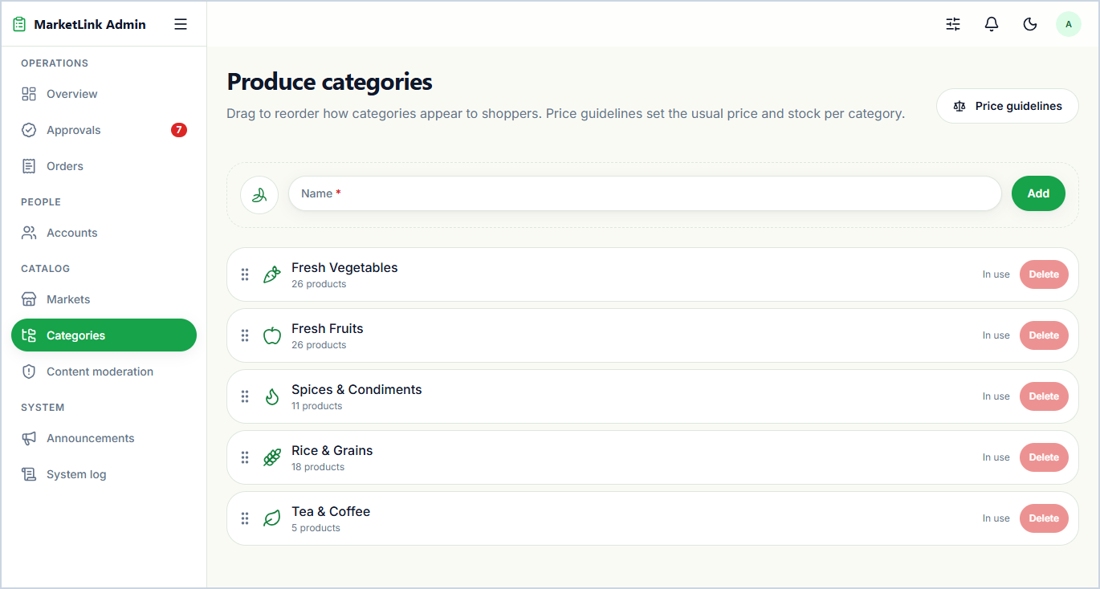  5.12 System Configuration: Produce Categories  Workflow: Review produce category master list -> Add new category or edit name, icon & display order -> Save configuration to update catalog filters.
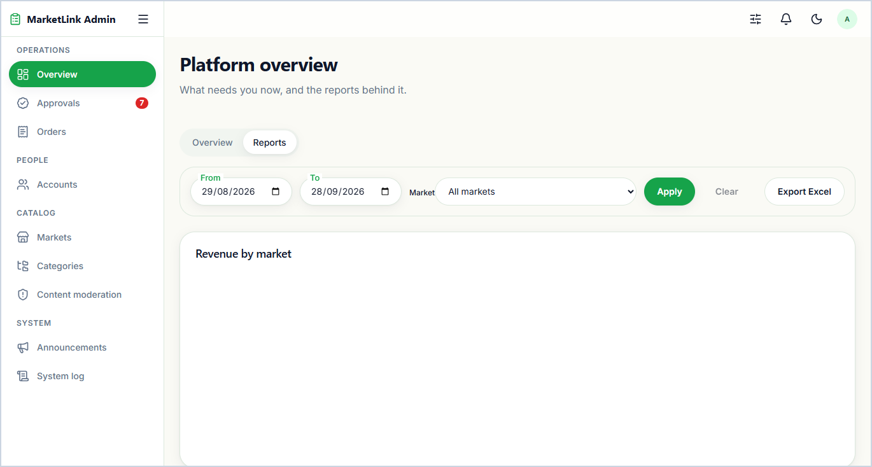  5.13 Platform-Wide Reports & Analytics  Analytical reports covering platform-wide total orders, revenue summary across markets, order status breakdown, and most active farmers. | 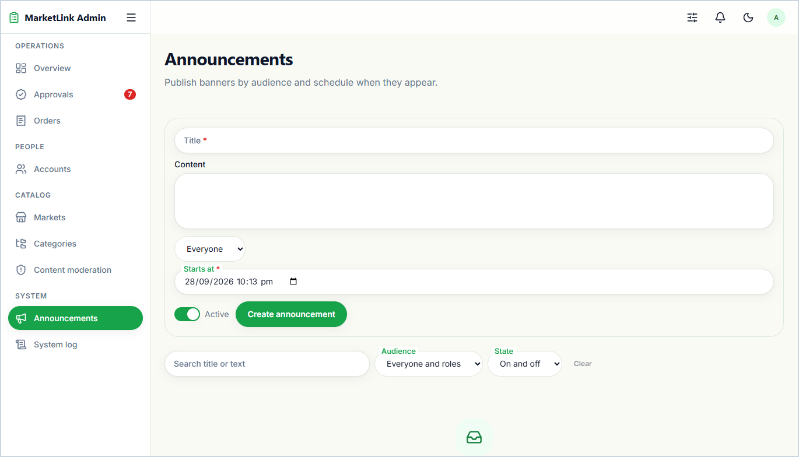  5.14 System Configuration: Platform Announcements  Workflow: Compose announcement title, message & target audience (Customers, Farmers, or All) -> Click 'Publish' -> Broadcast real-time in-app notification.

PART II — EXTENDED & BONUS VALUE-ADD FEATURES (BEYOND BASELINE SRS)
6. Extended Bonus — AI Governance, Price Guidelines & Platform Safeguards (06-admin/)
Value-Add Features Beyond SRS — Hybrid Gemini AI Listing Moderation, Anomaly Detection, Anti-Abuse Limits & Audit Trail
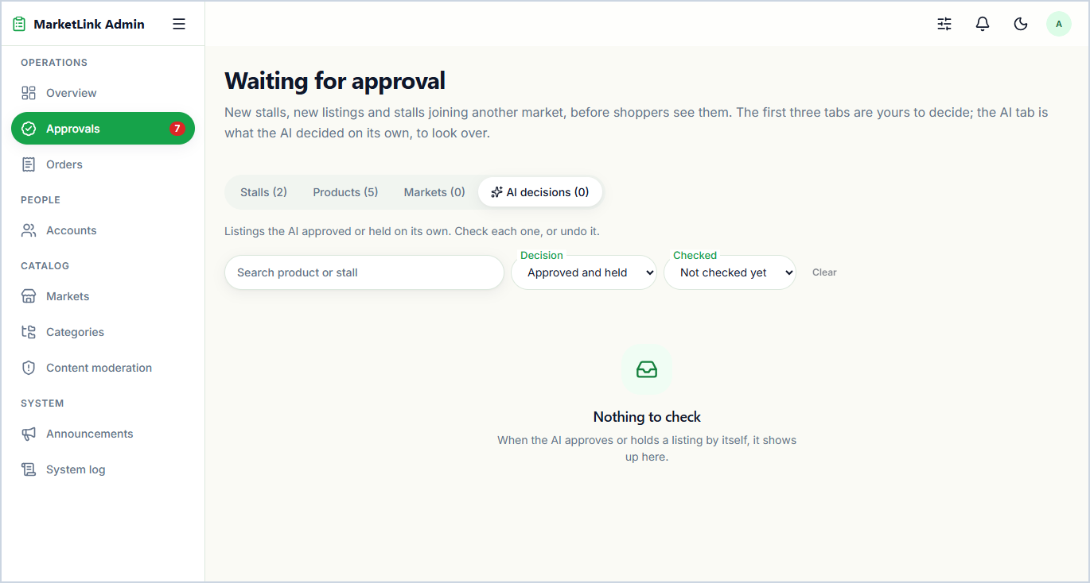  6.1 AI Automated Listing Moderation & Audit Queue  Workflow: Farmer submits product -> Gemini Vision/Text AI + Rule Engine checks photo, text & price -> Auto-approves or holds listing -> Admin confirms or overrides.  Bonus Value: Removes manual approval bottlenecks while catching prohibited items and mismatched product images automatically. | 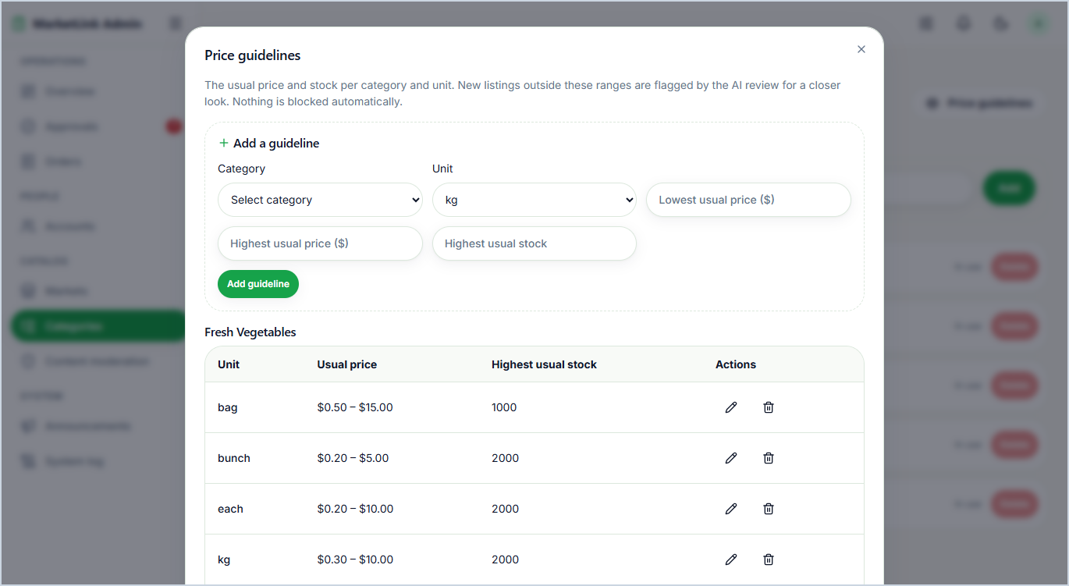  6.2 Category Price & Stock Anomaly Guidelines  Workflow: Open Category Guidelines -> Set min/max unit price & stock ceiling per unit (kg, bunch, pack, each) -> Save -> Auto-flag anomalous listings.  Bonus Value: Prevents accidental pricing typos (e.g., $150/kg) or unrealistic stock numbers from reaching shoppers.
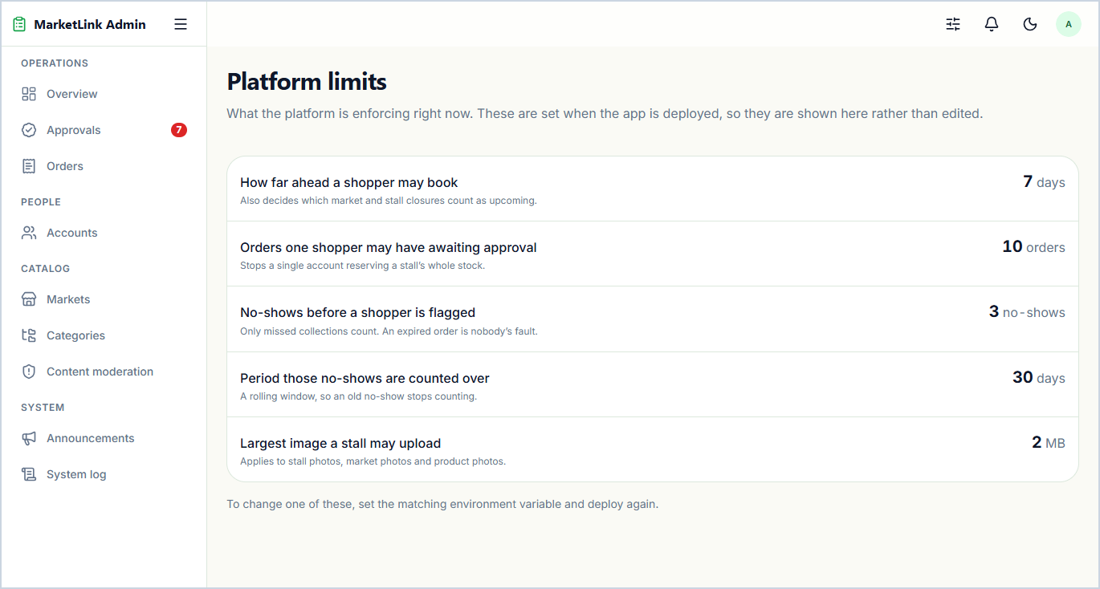  6.3 Configurable Platform Operational Limits  Workflow: Adjust max open pre-orders per customer, max items, default cut-off hours, or strike threshold -> Save settings -> Enforce guardrails at checkout.  Bonus Value: Protects farmers from unpaid cash-on-pickup inventory hoarding without requiring code redeployment. | 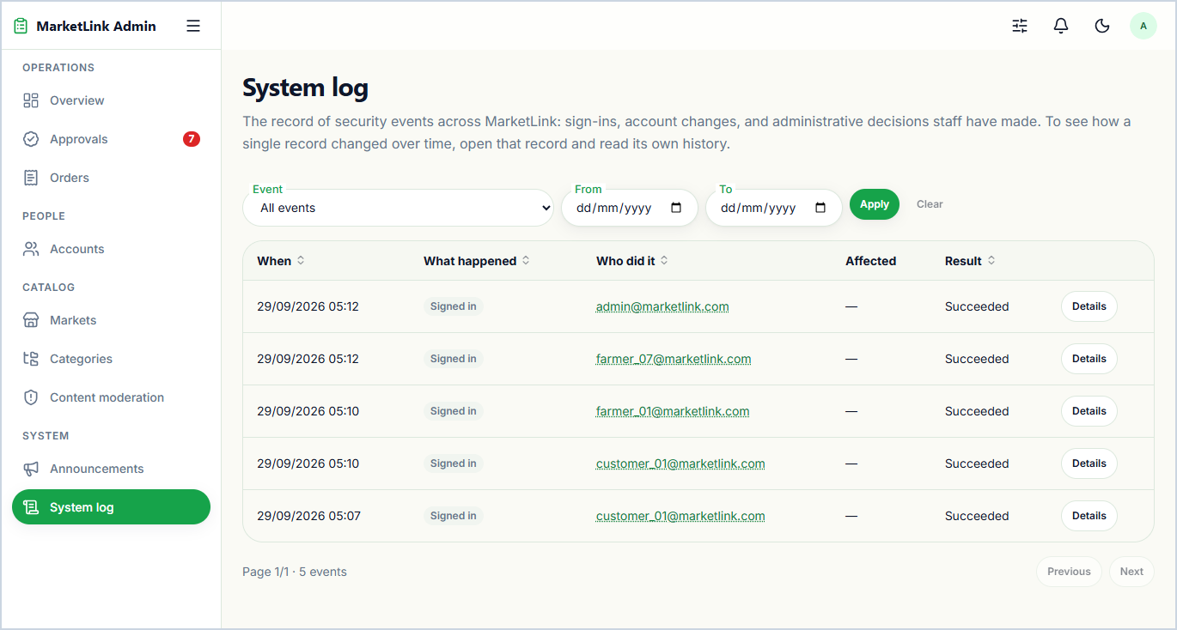  6.4 Immutable Security & Governance Audit Logs  Chronological, filterable security trail recording every admin and AI action (approvals, suspensions, takedowns, config changes) with actor, target, and reason.  Bonus Value: Provides enterprise-grade accountability and non-repudiation across all governance operations.
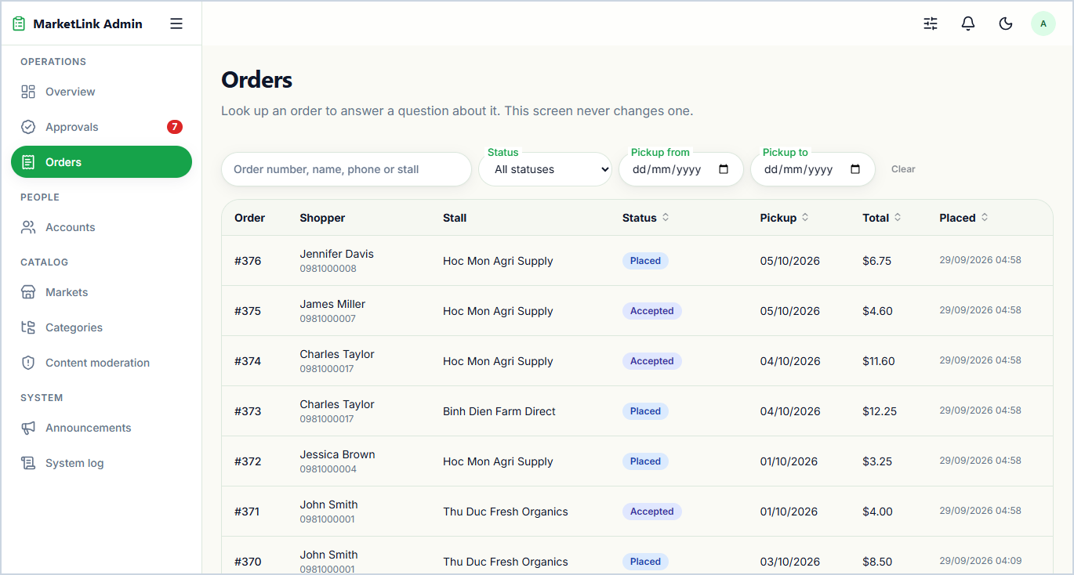
6.5 Cross-Market Read-Only Support Order Inspector
Read-only lookup console allowing administrators to search and inspect any pre-order timeline or change request across all markets to resolve support inquiries.
Bonus Value: Enables dispute investigation without risking accidental state mutations on live farmer fulfillment queues.

7. Extended Bonus — Pending Farmer Onboarding Sandbox (05-farmer-pending/)
Value-Add Features Beyond SRS — Guided Pre-Approval Vendor Workspace & Strict Product Publishing Lock
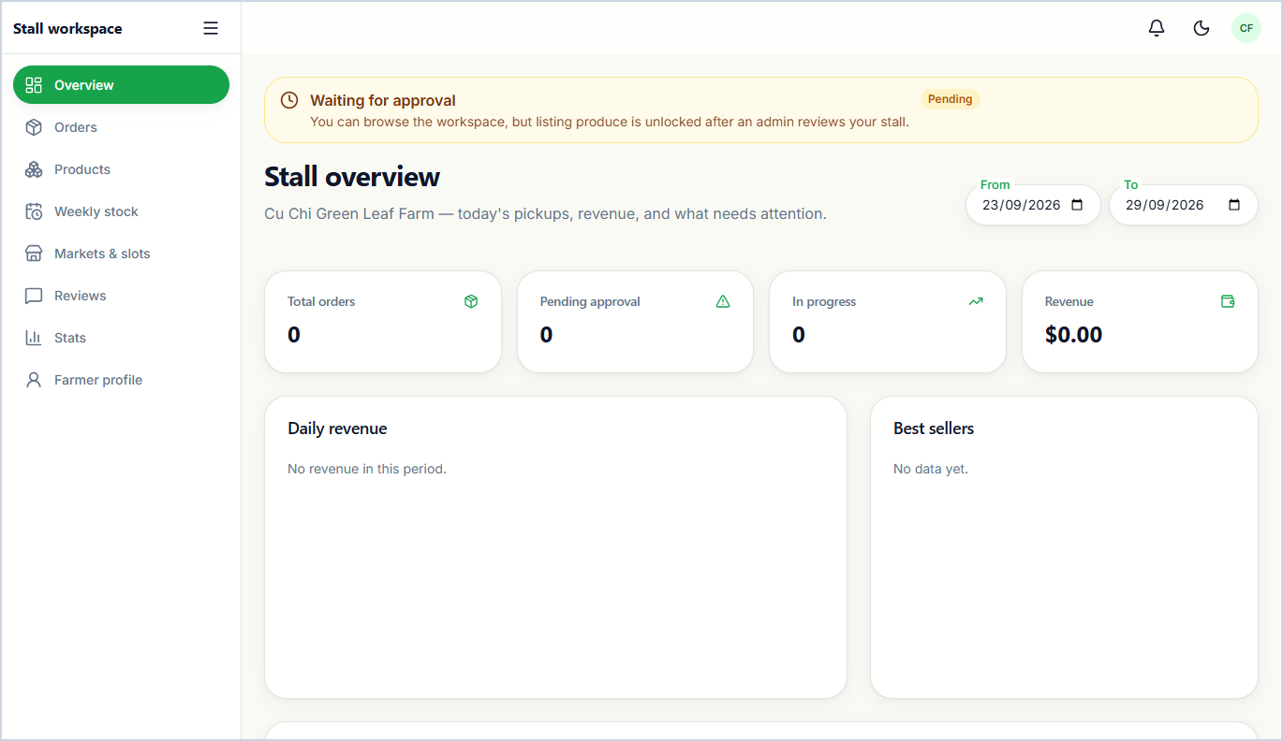  7.1 Pending Farmer Verification Sandbox Overview  Welcoming onboarding dashboard for newly registered stalls awaiting admin approval, displaying a verification status banner and setup checklist.  Bonus Value: Replaces a dead-end login block with a transparent, guided vendor onboarding experience. | 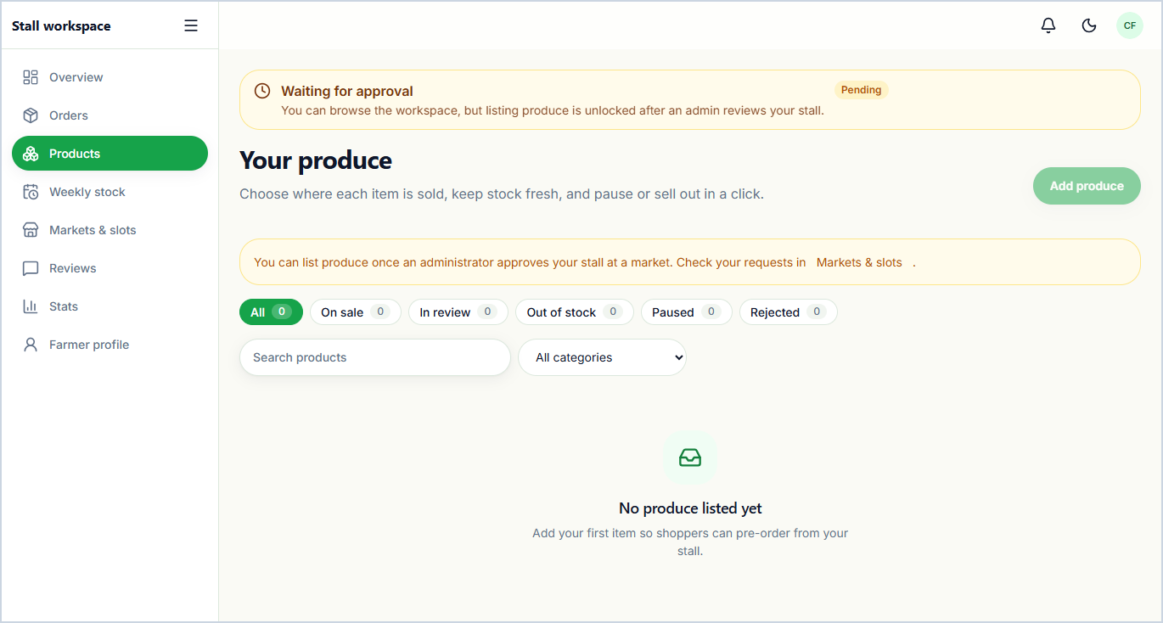  7.2 Pending Farmer Product Publishing Lock  Informative safeguard screen explaining that public product listing is locked until an administrator approves the stall and its initial market request.  Bonus Value: Strictly enforces the SRS rule that unapproved farmers cannot list products while guiding next steps.
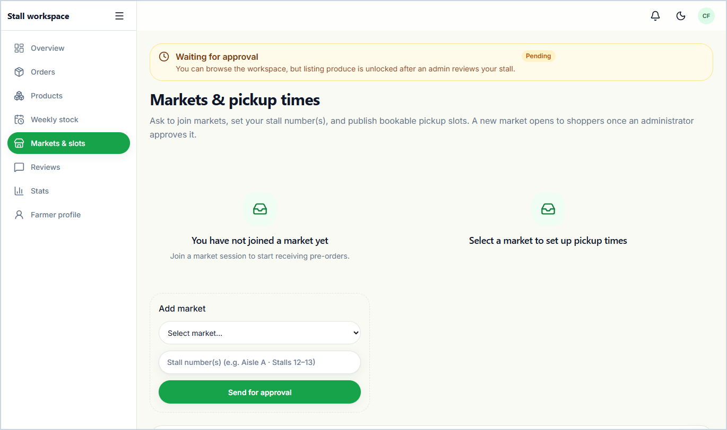  7.3 Pending Farmer Market Application Tracker  Displays the newly registered farmer's submitted market participation request, market operating hours, and live administrative review status.  Bonus Value: Gives prospective stall owners clear visibility into their market booth application. | 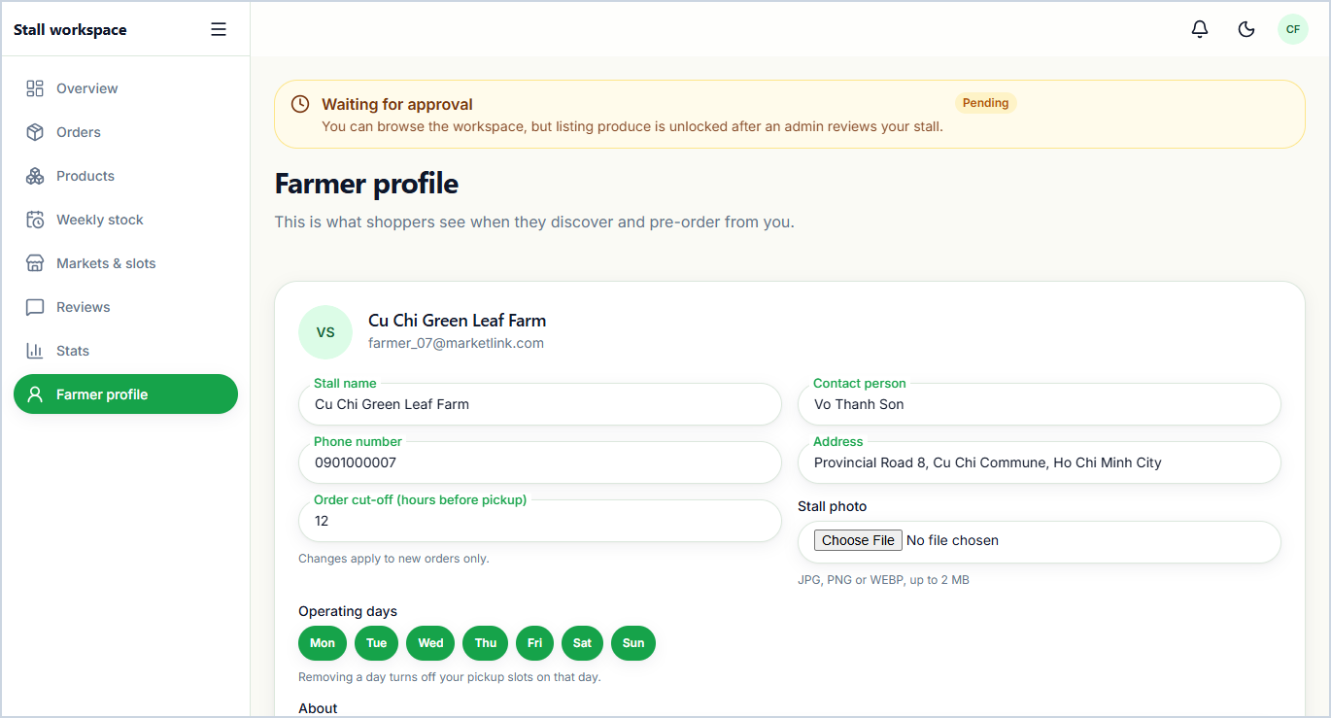  7.4 Pre-Approval Stall Profile Preparation  Workflow: Complete stall bio, operating days, cut-off lead hours, photo & GPS map pin while pending -> Save profile -> Go live immediately upon admin approval.  Bonus Value: Accelerates time-to-first-sale so approved stalls are storefront-ready immediately.

8. Extended Bonus — Farmer Alerts, Multi-Role Security & Public Trust
Value-Add Features Beyond SRS — Producer Real-Time Alerts, Role Password Rotation, Privacy Policy & Interactive Sitemap
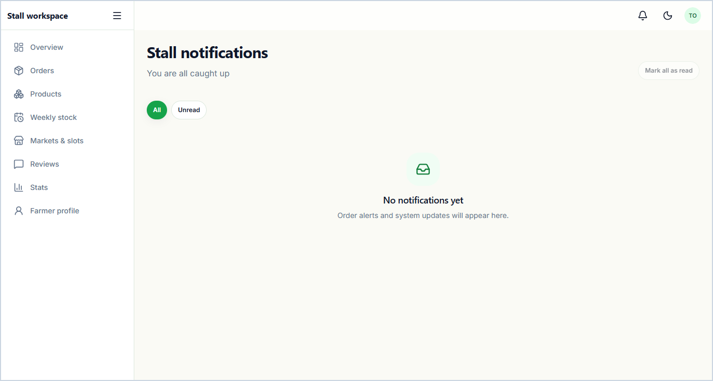  8.1 Farmer Real-Time Notification Center  In-app alert inbox for farmers delivering instant notifications for new pre-orders, customer order modification requests, market approvals, and announcements.  Bonus Value: Extends the SRS notification requirement from customers to farmers so time-sensitive orders are never missed. | 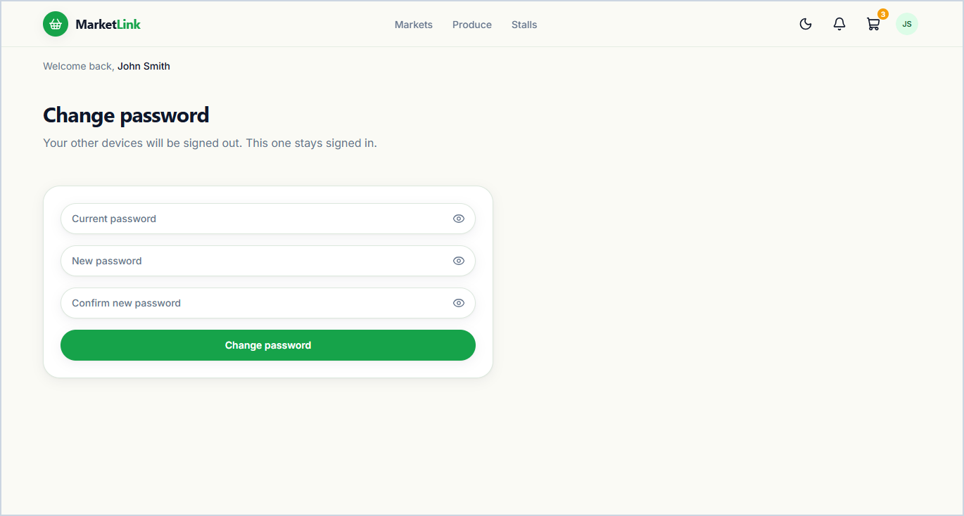  8.2 Customer Self-Service Password Rotation  Workflow: Enter current password & confirmed new password -> Validate password strength -> Update credential hash.  Bonus Value: Strengthens SRS 1.7 Security compliance for Customer accounts.
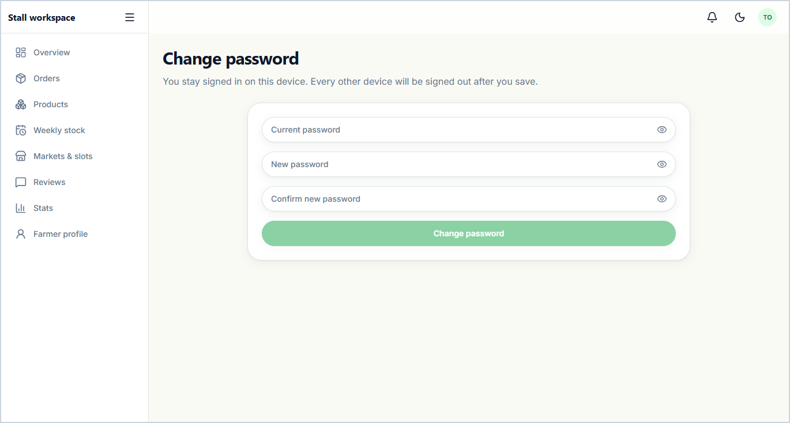  8.3 Farmer Self-Service Password Rotation  Workflow: Enter current password & confirmed new password -> Validate password strength -> Update stall account credential.  Bonus Value: Protects farmer inventory and order queues from unauthorized access. | 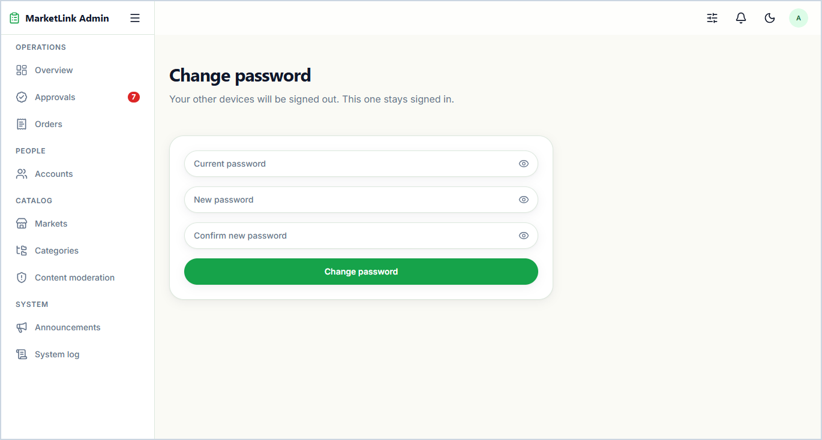  8.4 Administrator Self-Service Password Rotation  Workflow: Verify current admin password -> Submit strong new password -> Update credential & record security audit log.  Bonus Value: Secures high-privilege administrative accounts.
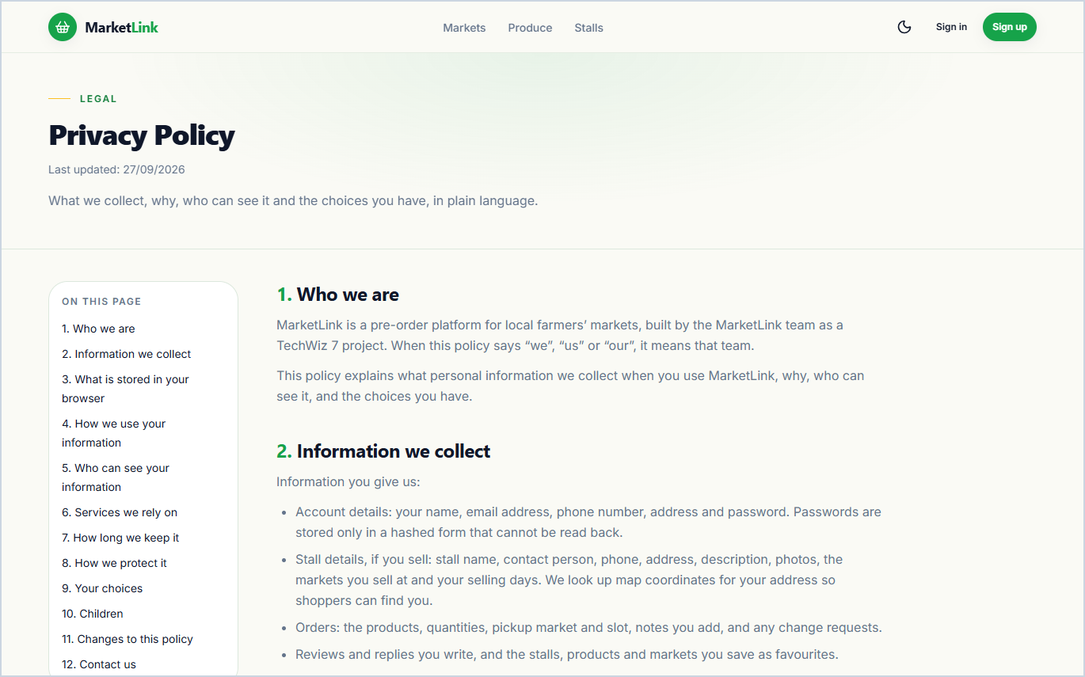  8.5 Data Privacy & Geolocation Policy  Public legal policy explaining how customer contact details, pre-order records, and browser geolocation coordinates are processed and protected.  Bonus Value: Addresses SRS 1.5 legal and data protection constraints. | 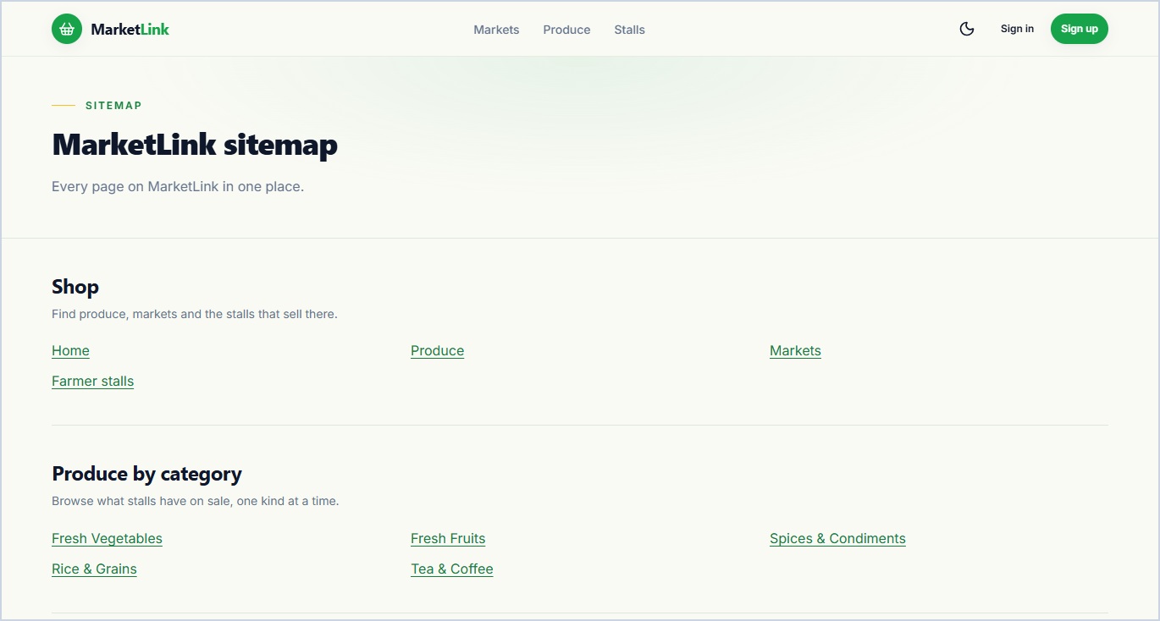  8.6 Interactive Full-Platform Sitemap  Structured directory linking to every public, authentication, customer, farmer, and administrator route across the application.  Bonus Value: Improves accessibility and allows evaluators to jump to any role screen in one click.

9. Additional Cross-Cutting Bonus Features Integrated Across Screens
9.1 Context-Aware AI Marketplace Assistant (Floating Chat Widget on Guest & Customer Screens)
Workflow: Click floating AI button -> Ask live question (market hours, stall availability, in-stock produce) -> Backend queries live database context with Google Gemini -> Return instant answer with direct links.
9.2 Two-Phase Order Modification & Farmer Approval Negotiation
Workflow: Customer edits pre-order before cut-off -> Applied immediately if order is still 'Placed', or sent as a structured Change Request if already 'Accepted' -> Farmer approves or rejects -> Stock & totals sync automatically.
9.3 Automated Missed-Pickup (No-Show) Strike Tracking & Harvest Picking List
Workflow: Farmer uses aggregated Picking List to pack accepted orders -> Marks uncollected overdue order as 'No-Show' -> System restores product stock & increments customer strike counter for admin oversight.

