1. Admin/Lib/Model/MisSystemDataRoamingModel.class.php 大约862行if括号里面添加一个判断

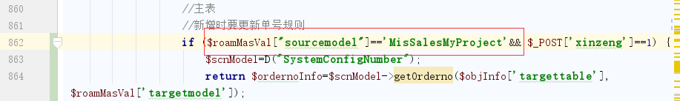

$roamMasVal["sourcemodel"]=='MisSalesMyProject' &&