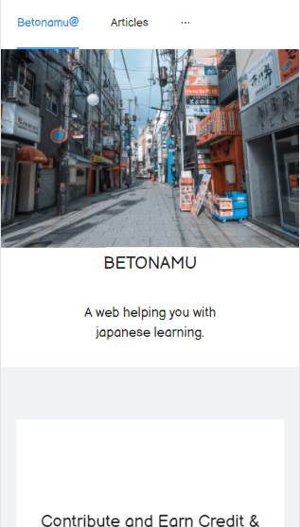

Beton@mu – Website

Prototype & Project Description

Instructor: Mr. Huy Anh | MULTIMEDIA_F2021 | 07/11/2021

# Business Idea

Languages are tools to communicate amongst humans, gates to lead to the true cultures, thoughts and soul of a nation, a society, an individual.

We believe that through Beton@mu, people who want to know more about Japan can come to enjoy, immerse themselves into its culture through articles of us. In addition, we want provide a way to learn the language itself, just for those who are really commit to study Japanese. With these two goals in mind, we are trying our best with the developing process to create this website.

We understand that this idea is not new anymore, though, we determine that our website can make the different. Not about article only like [Tofugu](https://www.tofugu.com/) or only practice tests like [jlpt](https://www.jlpt.jp/), our web is a combination of two, trying to balance the side of learning the culture as well as learning the language.

Not stopping with that, we propose a mechanism to get the contribution from community. Our website will receive the article from reader, writer who want to share more about anything related to Japan. The community’s articles then will be kept track of for their views number, the positive reaction they receive… And then when the article can produce a good amount of money through advertisement, donation … the authors themselves can receive it with their own credit amongst the community.

# Team Introduction

We are four students of Hanoi University – K18:

* Nguyen Long Vu – Project manager, Frontend developer
* Nguyen Van Huyen – Full-stack developer
* Tran Xuan Ninh – Backend developer, Database manager
* Pham Tien Thanh – Backend developer, Database manager

At the current time of this project, we are all in the very end of the four year journey of university life. The ending days are always containing surprise, obstacles and worries, enough to prevent us from being committed fully into this project. Clearly understand that fact, we all determine to keep the project manageable. The project plan, which will be discussed in the later section, is the important guide for us to get closer to our own project goals.

# System overview

## website functions

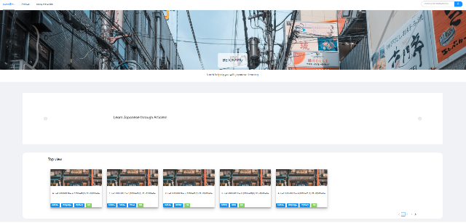**Homepage** is where the viewer get to understand more about the web. In here, we can have a brief introduction about our purpose, features that can help the one who need. Besides, it will propose some good topic for the newer can discover more.

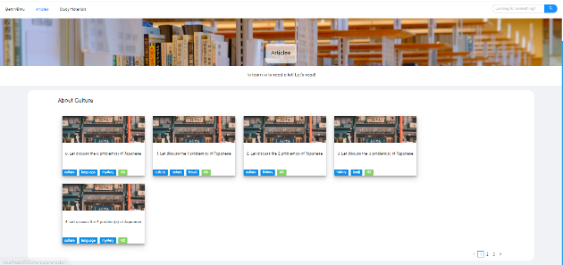

**Articles** section is where our valuable paper will be shown to the reader, the web can serve them in separated sets based on their themes.

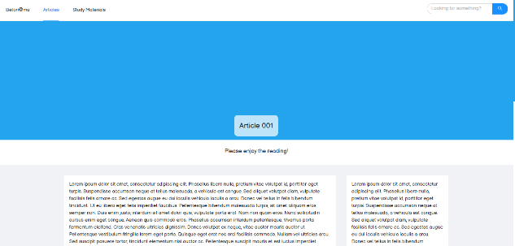**Article** will be in a new page with two parts, the bigger one is where the article content lied, and the smaller one is for the author information.

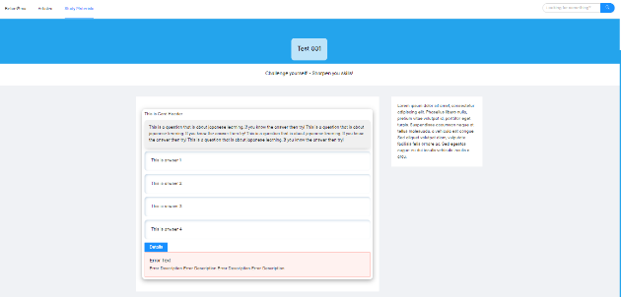**Test** is the section where the user can interact with the web, training their knowledge of Japanese, preparing for Japanese examination.

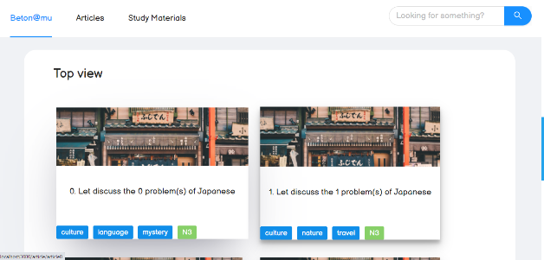

We support **Searching by tag and level**, as well as **Responsive** for small screen devices and mobile

## System operation

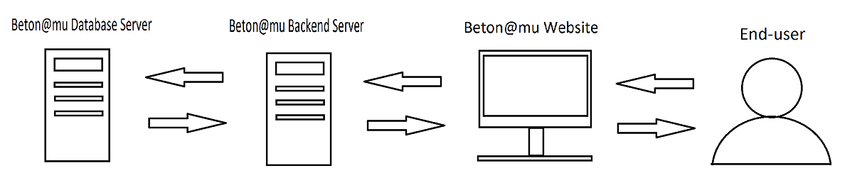

The Frontend server will provide the interface for end-users to interact with. When user request for any source from front end, the request then will be transfer back to the backend server. These two side communicate to each other through JSON format with the RESTful APIs approach.

We decide to use RESTful as a way to implement backend as a purpose to expand the project in the future, when the backend server no longer just serves only website but also other devices like mobile app. The RESTful API will help us to dynamically reuse the core business logic effortlessly.

The backend service will retrieve data from database server and also store user data into the database.

This model is the classical model of modern web service, simple yet effective. Due to the scope of the project, the limitation of time and human resources, we choose this model, hoping to apply our knowledge learned from our software engineering curriculum successfully.

## Tool & Technology

### Front-end



*React with the aid of Ant Design*

### Back-end



*Java Spring Boot implementing RESTful APIs*

### Database



*Database MySQL*

### Others



*Markdown language to format Articles*



*Netlify to help with CMS for uploading Article – Also deployment environment.*

# Project Plan

This is the proposed plan. We will be flexible but still keep this plan as skeleton, a main path to follow up, not getting lost in the scope creep. In each phase of the plan, we define the MVPs which need to be complete. The Plan is described as below:

|  |  |
| --- | --- |
|  | MVPs |
| Phase 1 | * Front end: Analyze the design requirement * Back end: Design the database system |
| Phase 2 | * Front end: Develop common components, all 6 major pages of viewing * Back end: Develop APIs to transfer the data |
| Phase 3 | * Deploy * User Test and Review |
| Phase 4 | * Improve the function * Write report |

In the moment of writing this proposal, we already finished the phase 1 and half of phase 2. With the current speed, we have a high hope of meeting the project goals.