**数据库模块测试：**

1. insertline

**public** **void** testinsert()

{

DBHelper db = **new** DBHelper(*ip*,*basename*,*table1*,*username*,*password*);

Map<String,Object> map = **new** HashMap<String,Object>();

map.put("filetype", "html");

map.put("filepath", "d:\\1.html");

map.put("url", "www.baidu.com");

map.put("encode", "utf-8");

map.put("isDeal", "0");

db.insertline(map);

db.release();

}

运行后数据库结果如下：

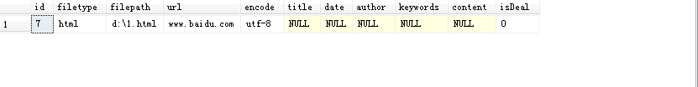

1. update:

**public** **void** testupdate() {

DBHelper db = **new** DBHelper(*ip*,*basename*,*table1*,*username*,*password*);

Map<String,Object> map = **new** HashMap<String,Object>();

map.put("title", "baidu");

map.put("date", "2010-9-1");

map.put("author", "QI");

map.put("keywords", "test1,rt2");

db.update(7, map);

db.release();

}

测试结果如下：

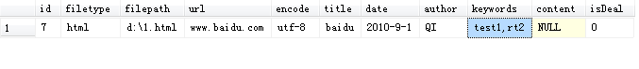

1. query:

**public** **void** testquery()

{

DBHelper db = **new** DBHelper(*ip*,*basename*,*table1*,*username*,*password*);

Map<String,Object> map = **new** HashMap<String,Object>();

map.put("filetype", "html");

ResultSet rs = db.query(-1,map);

**int** count;

String line = "";

**try** {

count = rs.getMetaData().getColumnCount();

**while**(rs.next()) {

line = "";

**for**(**int** i = 1;i <= count;i ++) {

line += rs.getString(i) + '\t';

}

System.***out***.println(line);

}

**if**(rs != **null**) {

rs.close();

}

} **catch** (SQLException e) {

// **TODO** Auto-generated catch block

e.printStackTrace();

}

db.release();

}

运行前数据库状态如下：

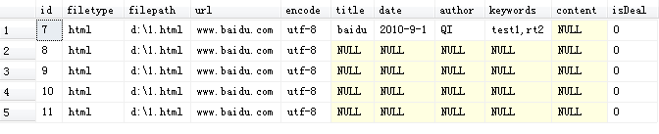

运行后控制台输出：

7 html d:\1.html www.baidu.com utf-8 baidu 2010-9-1 QI test1,rt2 null 0

8 html d:\1.html www.baidu.com utf-8 null null null null null 0

9 html d:\1.html www.baidu.com utf-8 null null null null null 0

10 html d:\1.html www.baidu.com utf-8 null null null null null 0

11 html d:\1.html www.baidu.com utf-8 null null null null null 0

1. delete

**public** **void** testdelete()

{

DBHelper db = **new** DBHelper(*ip*,*basename*,*table1*,*username*,*password*);

Map<String,Object> map = **new** HashMap<String,Object>();

map.put("author", "QI");

db.delete(map);

db.delete(8);

db.delete(9);

db.release();

}

运行前：



运行后：

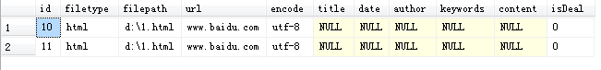

**Solr模块测试**

1. insert

**public** **void** testsolrinsert() {

SolrHelper solr = **new** SolrHelper(*solrip*,*port*);

Map<String, Object> map = **new** HashMap();

map.put("id", "webtest");

map.put("web_title", "baidu");

solr.insert(map);

solr.insert("webid", "title", "links", "date", "content", "author");

}

运行后Solr中增加2个doc。

1. delete

**public** **void** testsolrdelete() {

SolrHelper solr = **new** SolrHelper(*solrip*,*port*);

solr.delete("webtest");

}

运行后Solr中id为webtest的doc被删除

1. query

**public** **void** testsolrquery()

{

SolrHelper solr = **new** SolrHelper(*solrip*,*port*);

Map<String, Object> map = **new** HashMap();

**int** num = 0;

map.put("id", "web");

map.put("title", "baidu");

SolrDocumentList list = solr.query(map, 100, "id", "title", "links");

**for**(**int** i = 0;i < list.size();i ++) {

SolrDocument doc = list.get(i);

System.***out***.print(i + 1);

System.***out***.print("id: " + doc.getFieldValue("id"));

System.***out***.print("title: " + doc.getFieldValue("title"));

System.***out***.println("links: " + doc.getFieldValue("links"));

}

}

运行后输出：

1 id: webhttp://ir.baidu.com title: [Baidu | Business Overview] links: [http://ir.baidu.com]

2 id: webhttp://ir.baidu.com/phoenix.zhtml?c=188488&p=rssSubscription&t=&id=& title: [Baidu | RSS Subsoription Links] links: [http://ir.baidu.com/phoenix.zhtml?c=188488&p=rssSubscription&t=&id=&]

3 id: webhttp://ir.baidu.com/phoenix.zhtml?c=188488&p=irol-homeprofile_pf title: [Baidu | Business Overview] links: [http://ir.baidu.com/phoenix.zhtml?c=188488&p=irol-homeprofile_pf]